Comprehensive Plan Figures

# Population

### POP_bar_primarygeo_population_overtime:

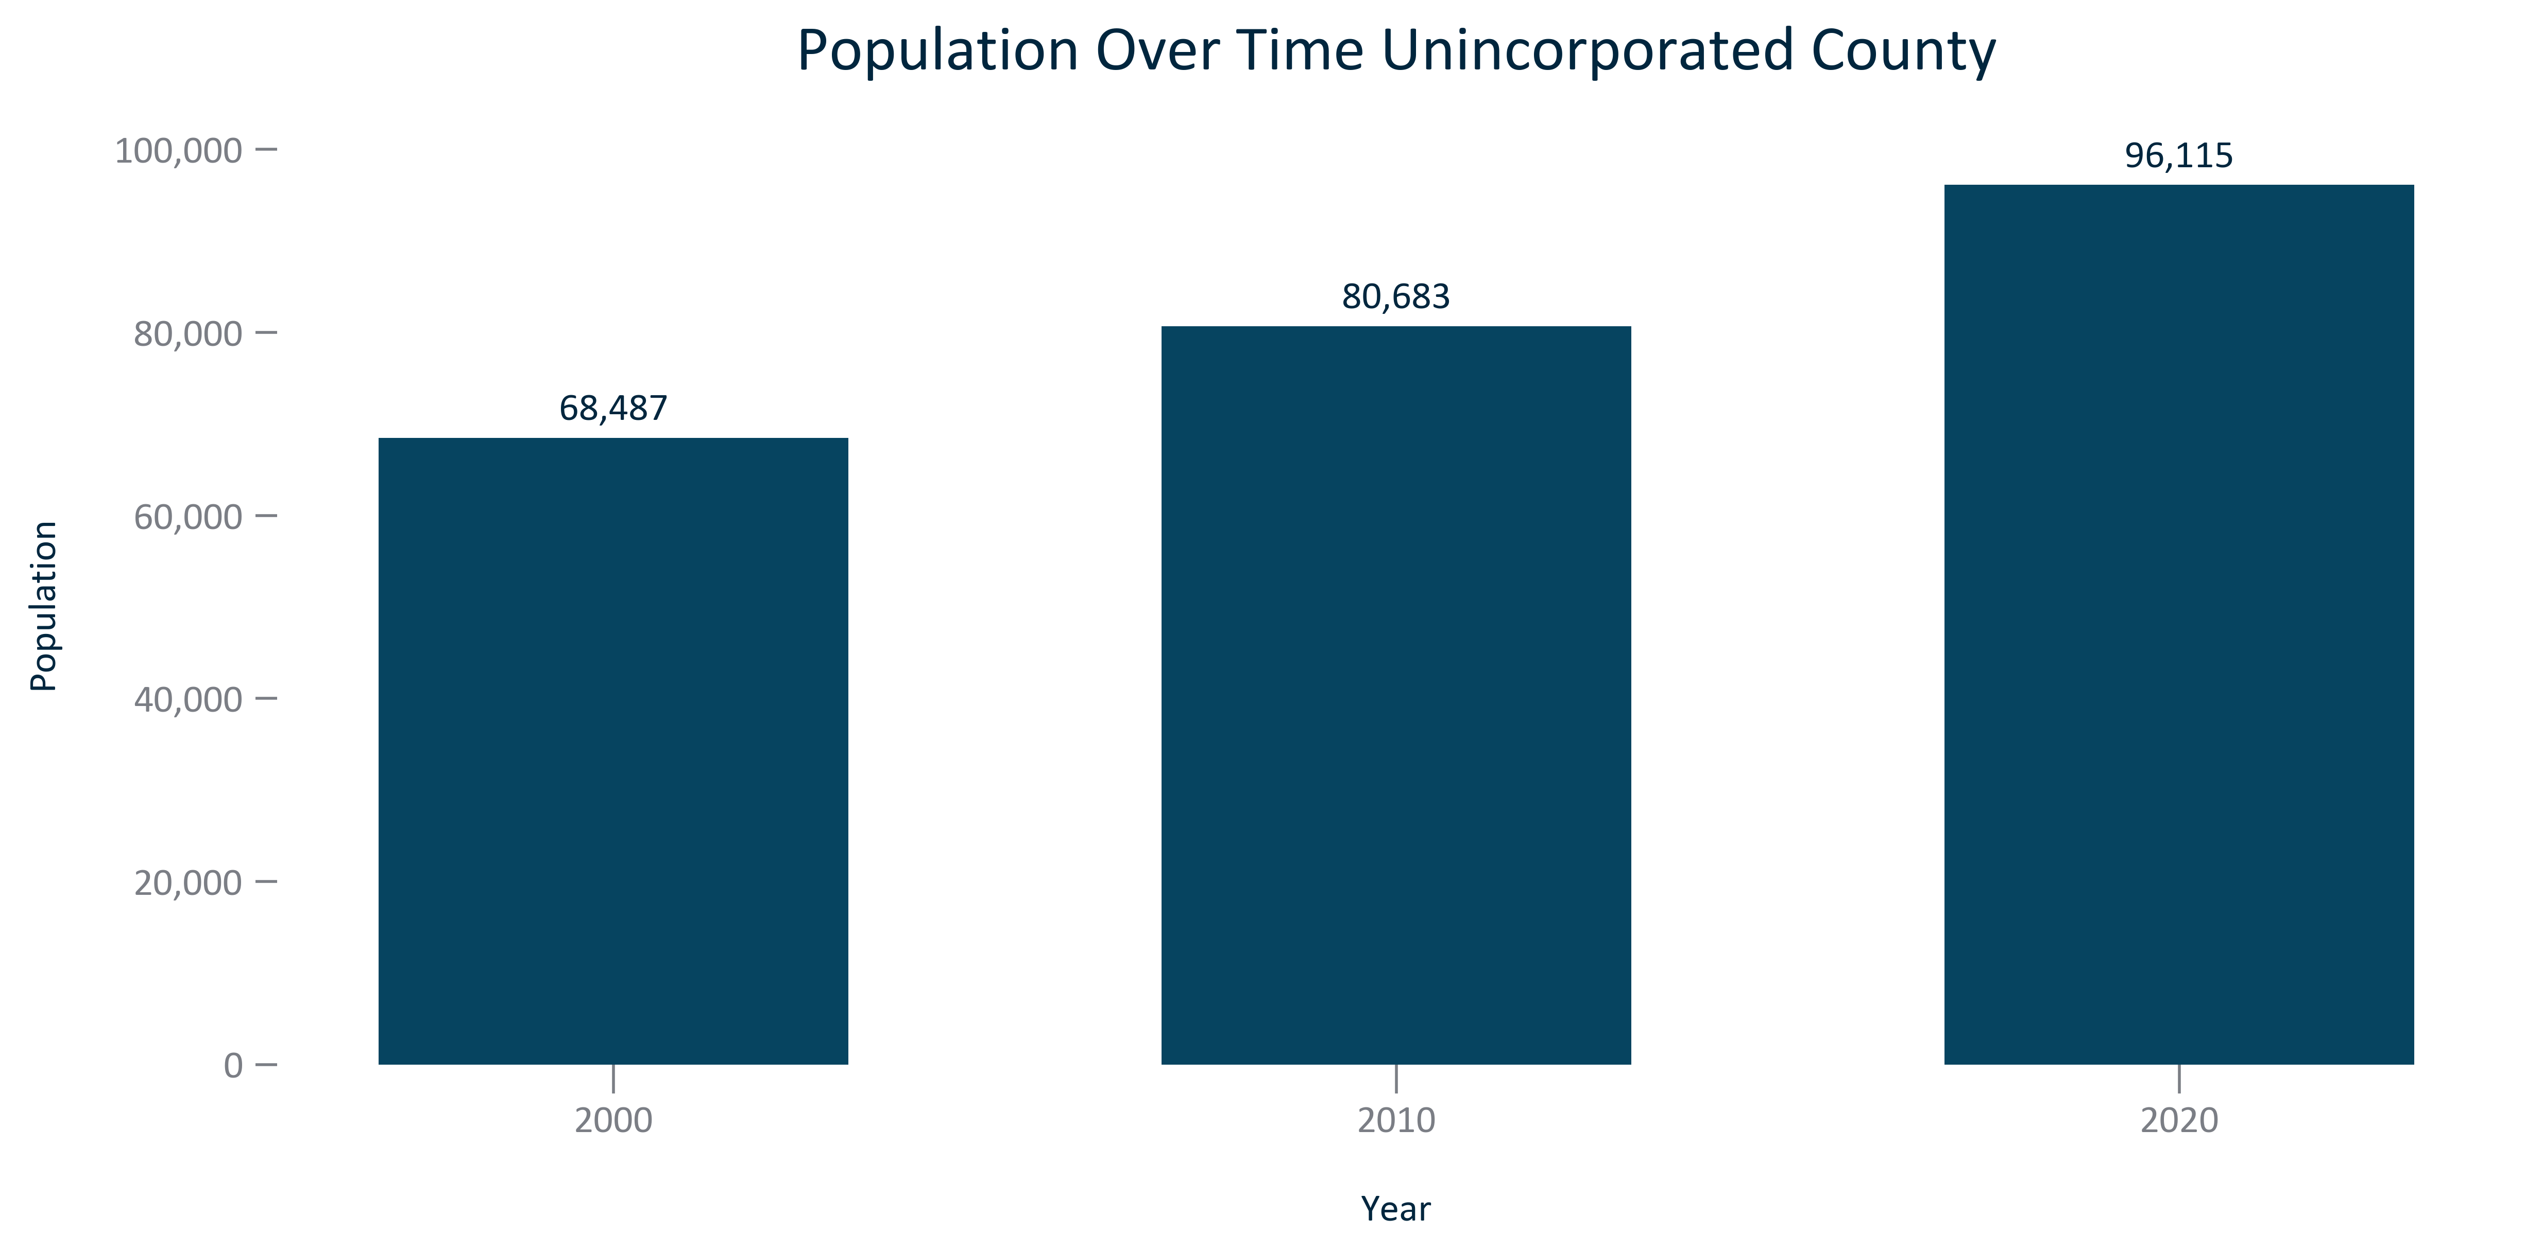

Citation: 2000, 2010, and 2020 Decennial Census

### POP_line_primarygeo_historicalpopulation_overtime:

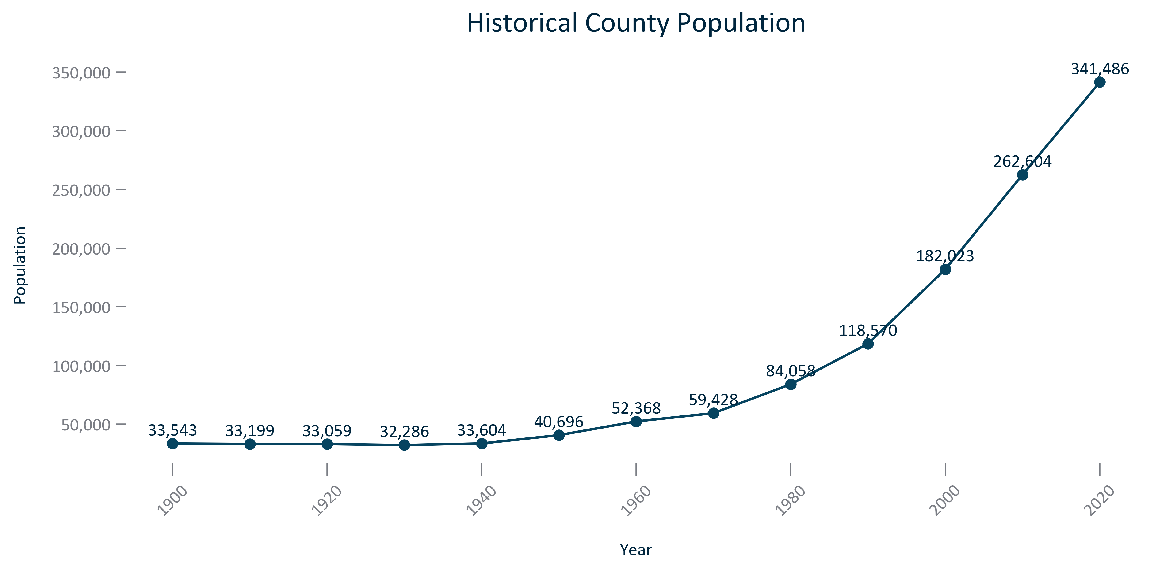

Citation: 1900-2020 Decennial Census

### POP_line_primarygeo_historicalpopulationchange_overtime:

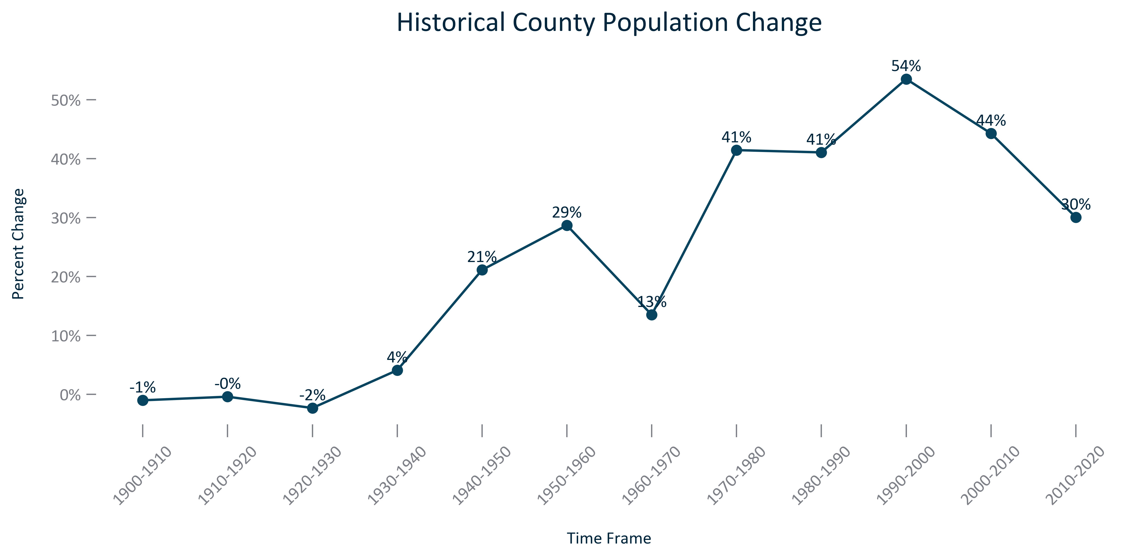

Citation: 1900-2020 Decennial Census

### POP_bar_primarygeo_projectedpopulation_overtime:

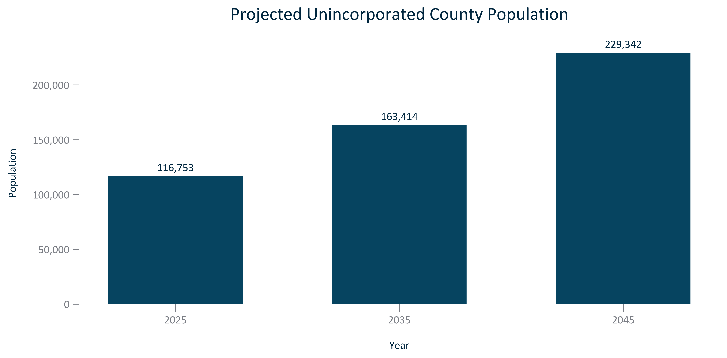

Citation: Woods and Poole Population Projections

### POP_bar_primarygeo_populationprojectionchange_overtime:

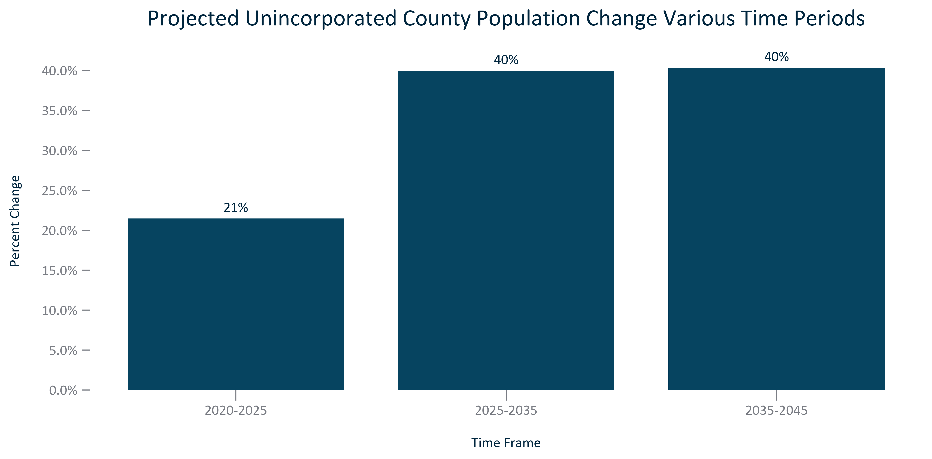

Citation: Woods and Poole Population Projections

### POP_line_geocomparative_population_overtime:

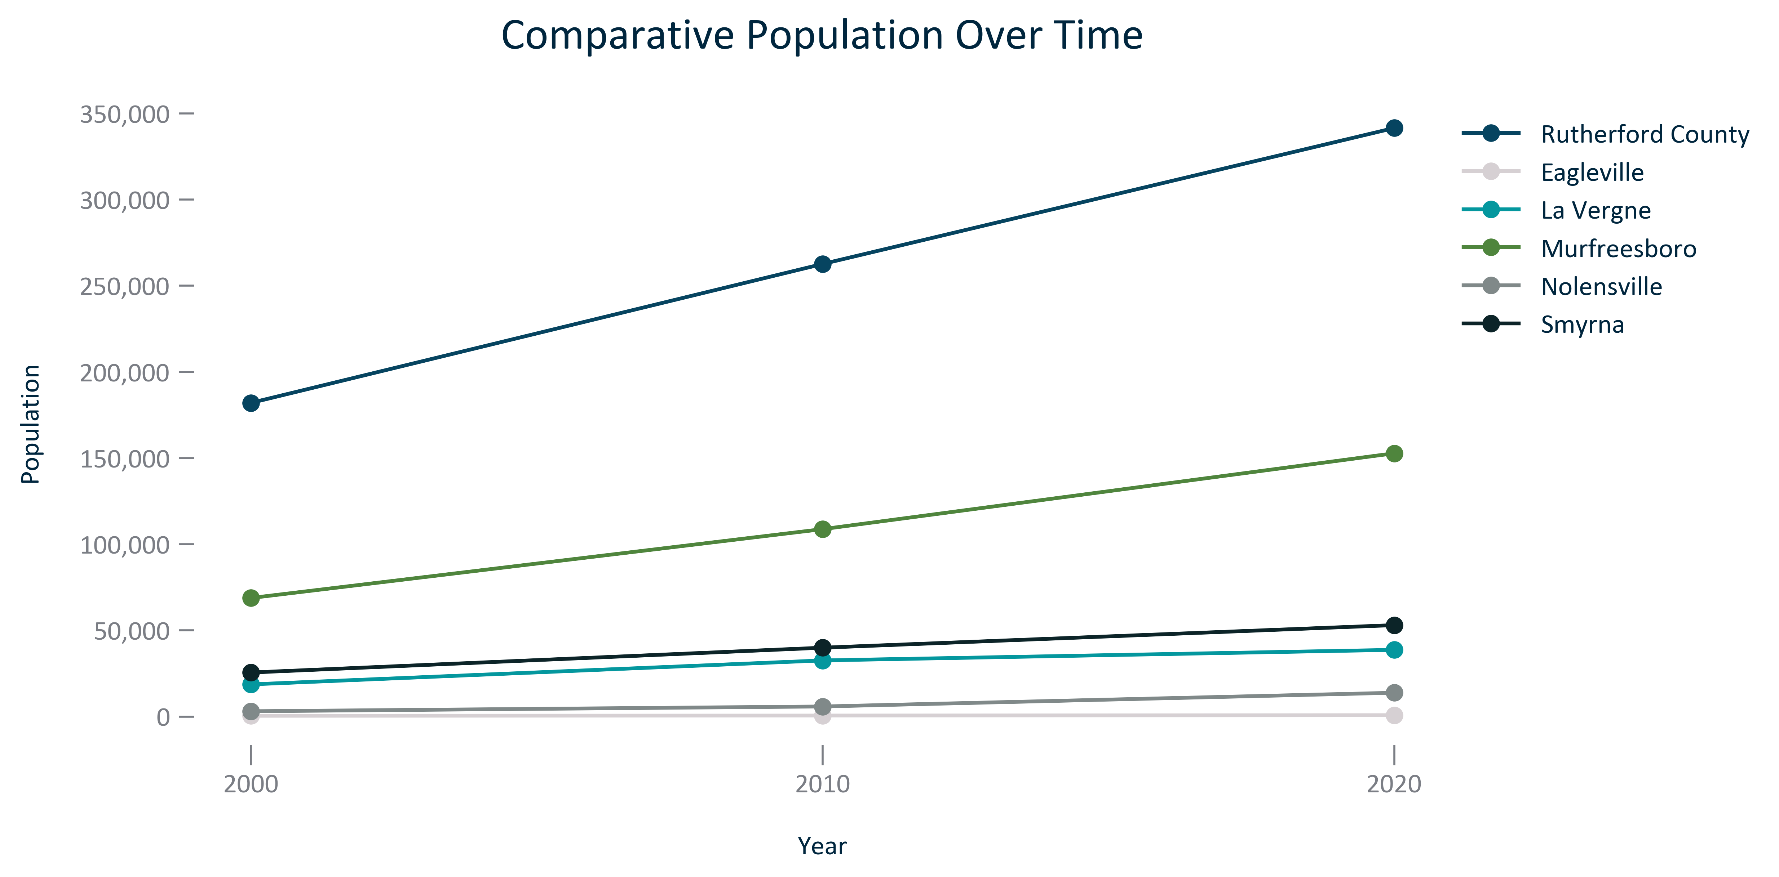

Citation: 2000, 2010, and 2020 Decennial Census

### POP_bar_geocomparative_populationchange_overtime:

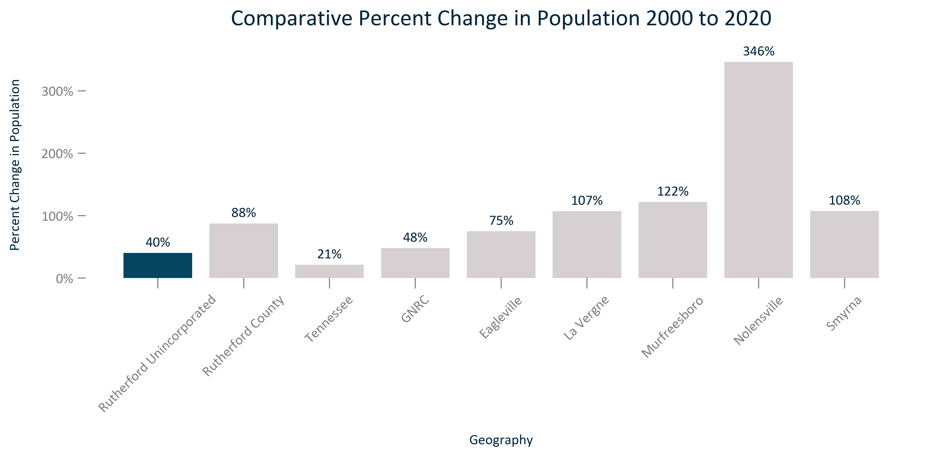

Citation: 2000 and 2020 Decennial Census

### POP_table_geocomparative_population_overtime:

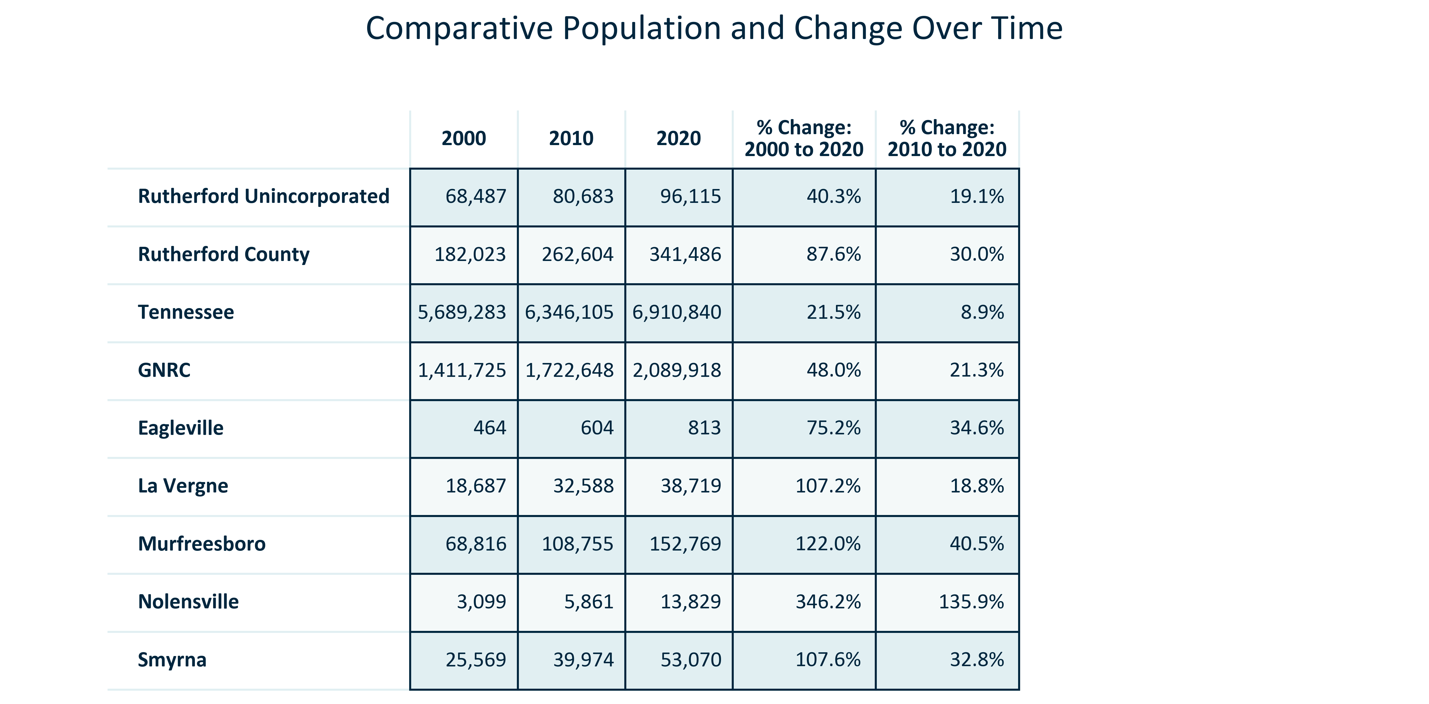

Citation: 2000, 2010, and 2020 Decennial Census

### POP_bar_geocomparative_populationprojectionchange_overtime:

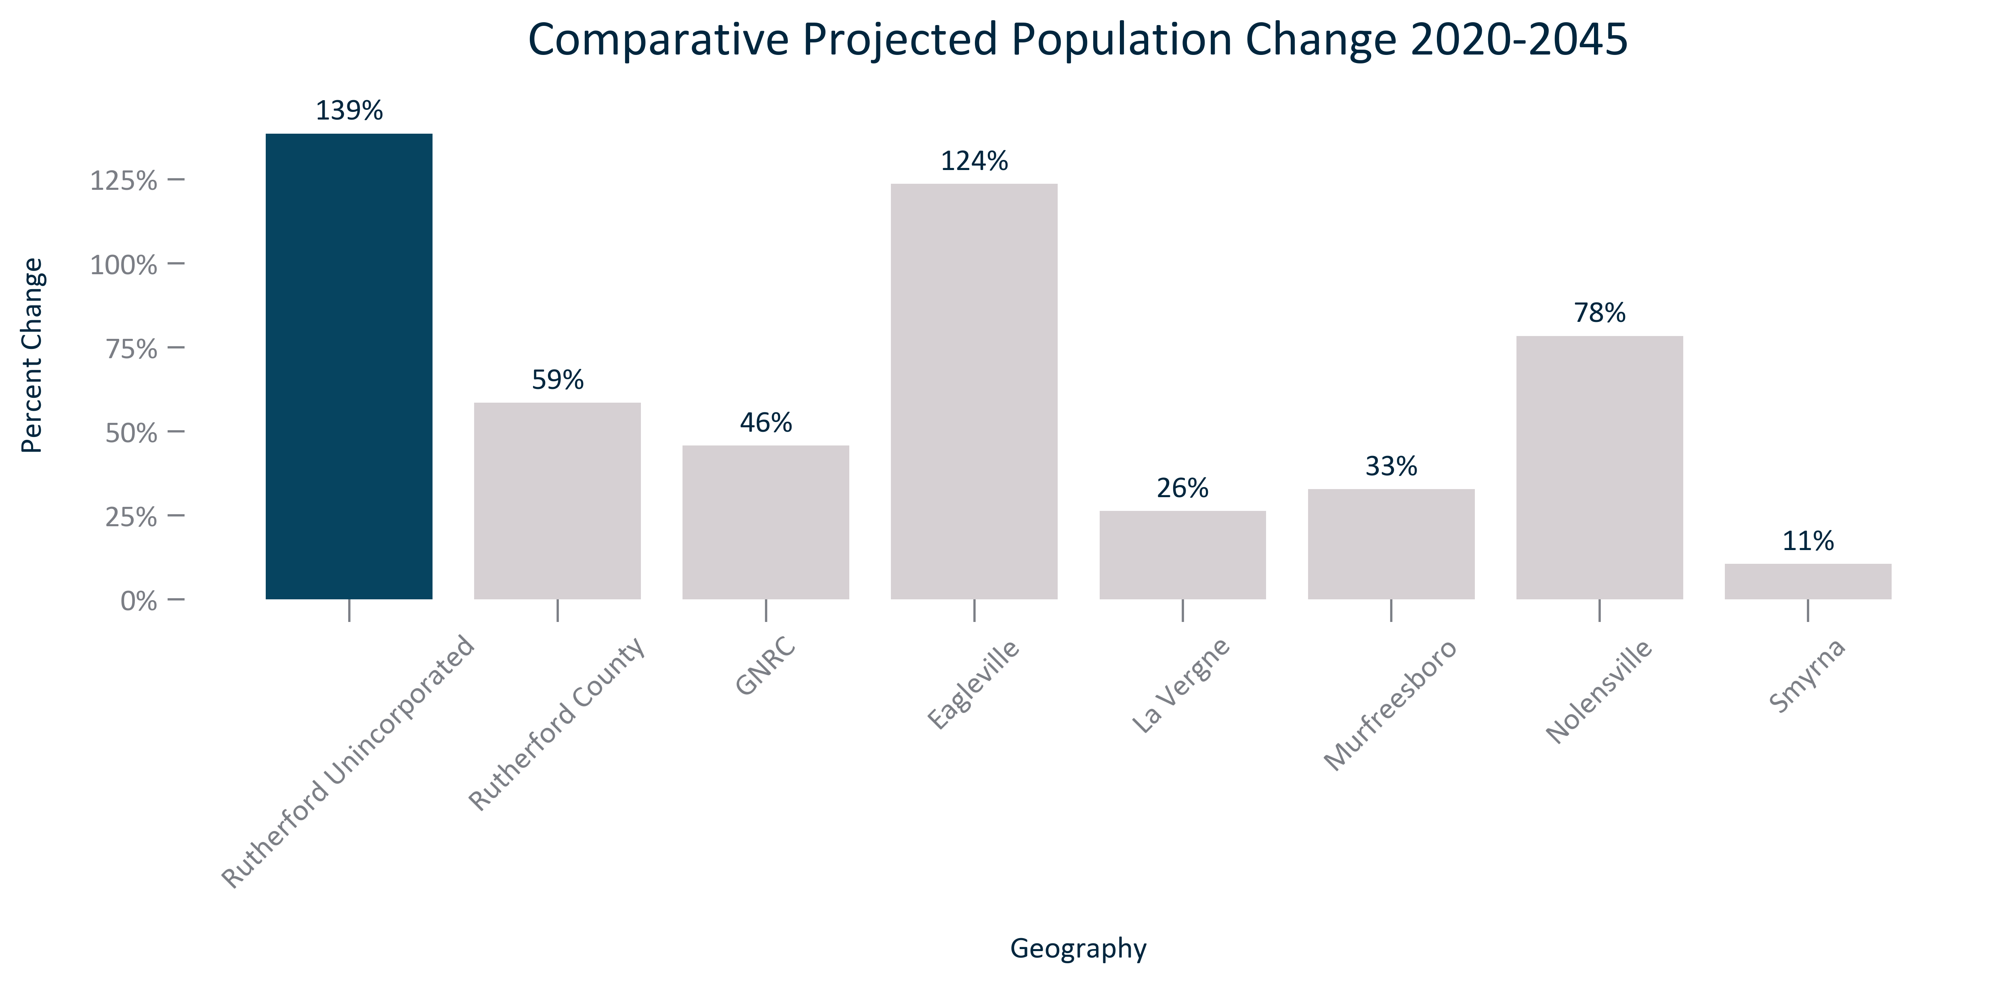

Citation: Woods and Poole Population Projections

### POP_table_geocomparative_populationprojectionandchange_overtime:

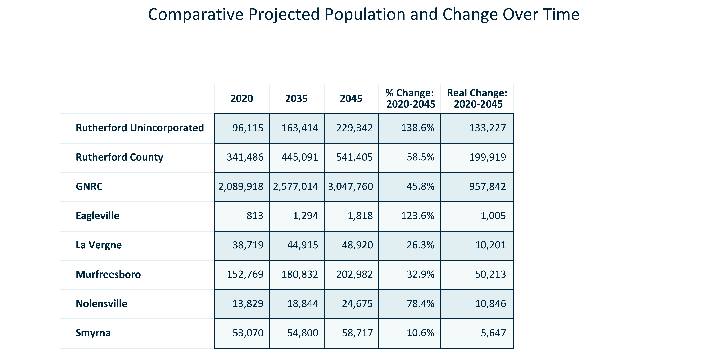

Citation: Woods and Poole Population Projections

# Age

### AGE_pyramid_primarygeo_populationpyramid_2021:

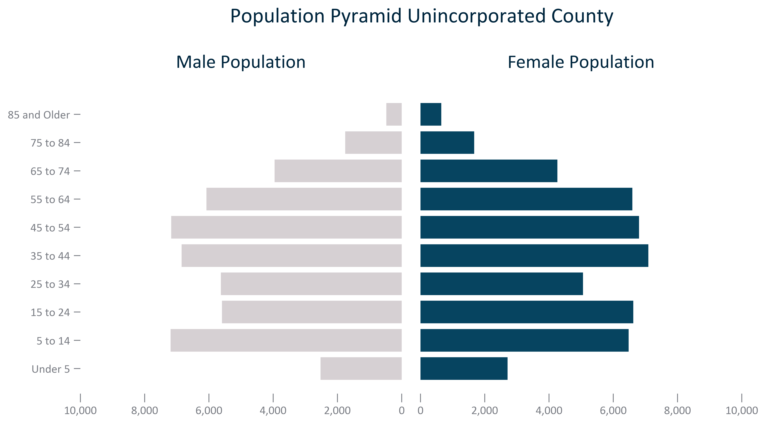

Citation: 2017-2021 ACS 5-Year Estimates

### AGE_bar_primarygeo_under5_overtime:

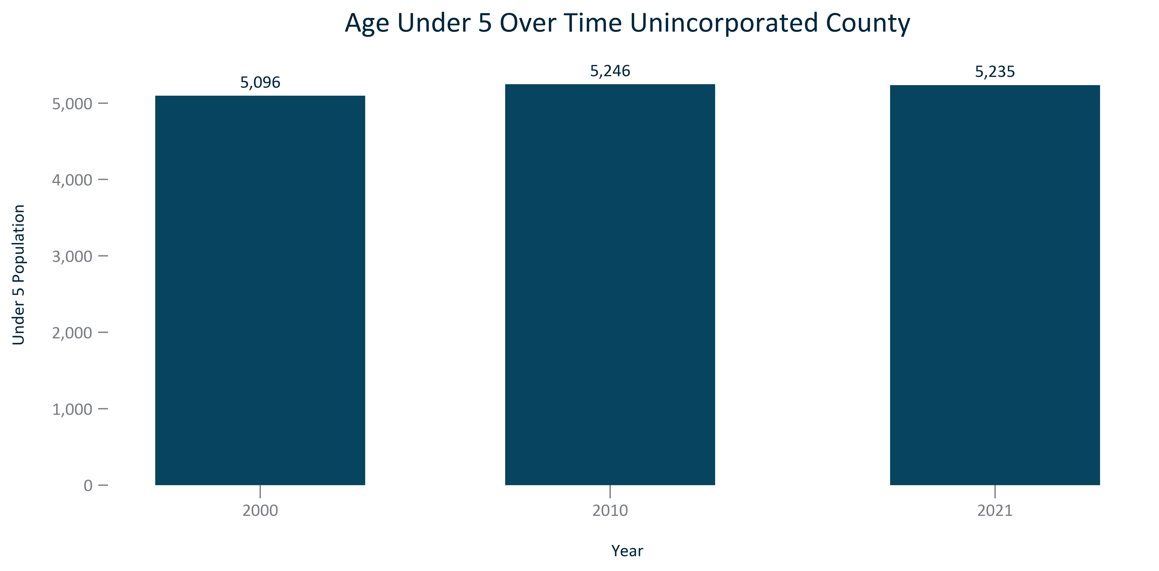

Citation: 2000 and 2010 Decennial Census, 2017-2021 American Community Survey 5-Year Estimates

### AGE_bar_primarygeo_under18_overtime:

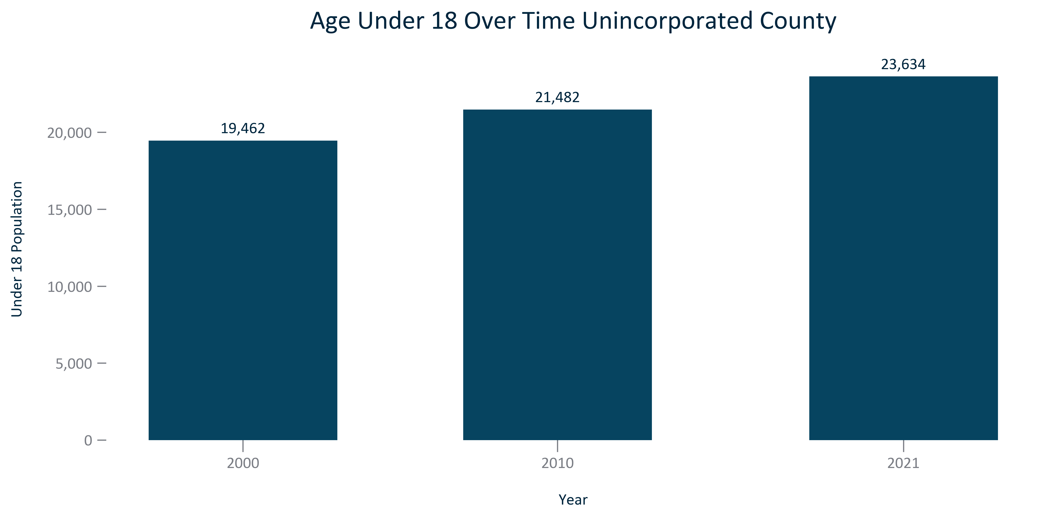

Citation: 2000 and 2010 Decennial Census, 2017-2021 American Community Survey 5-Year Estimates

### AGE_bar_primarygeo_18to54_overtime:

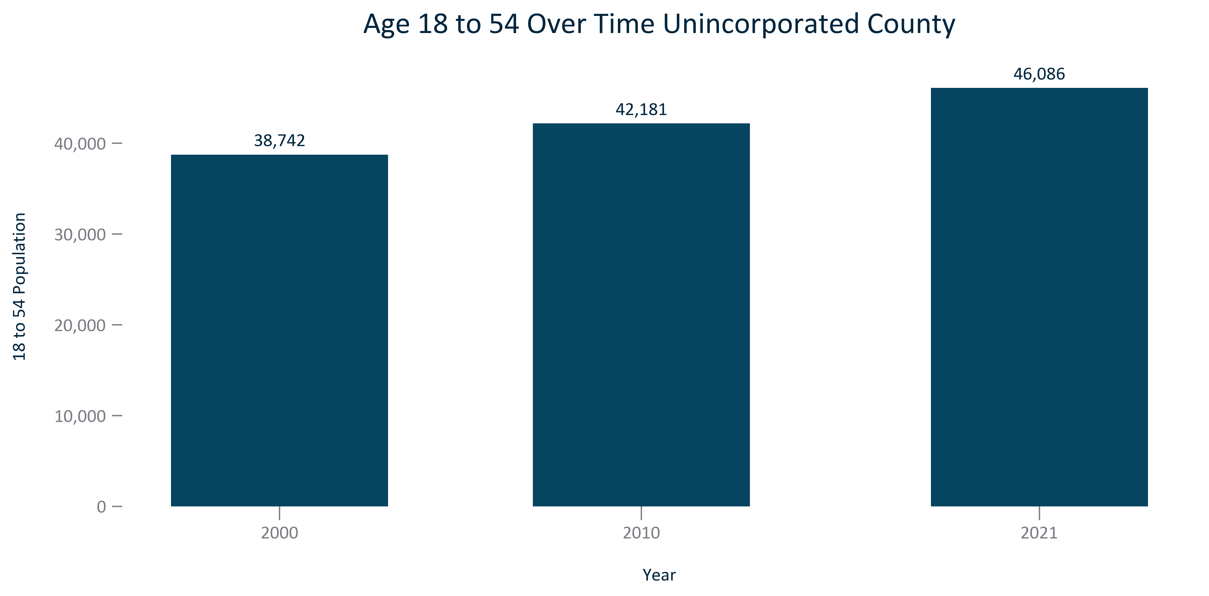

Citation: 2000 and 2010 Decennial Census, 2017-2021 American Community Survey 5-Year Estimates

### AGE_bar_primarygeo_55older_overtime:

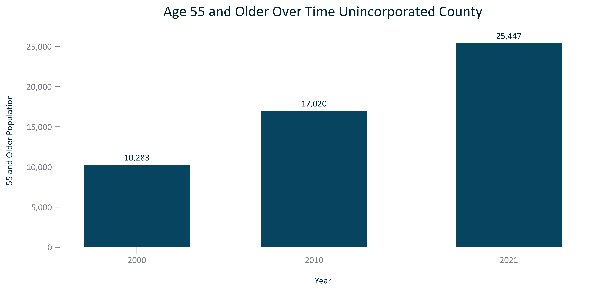

Citation: 2000 and 2010 Decennial Census, 2017-2021 American Community Survey 5-Year Estimates

### AGE_bar_primarygeo_65older_overtime:

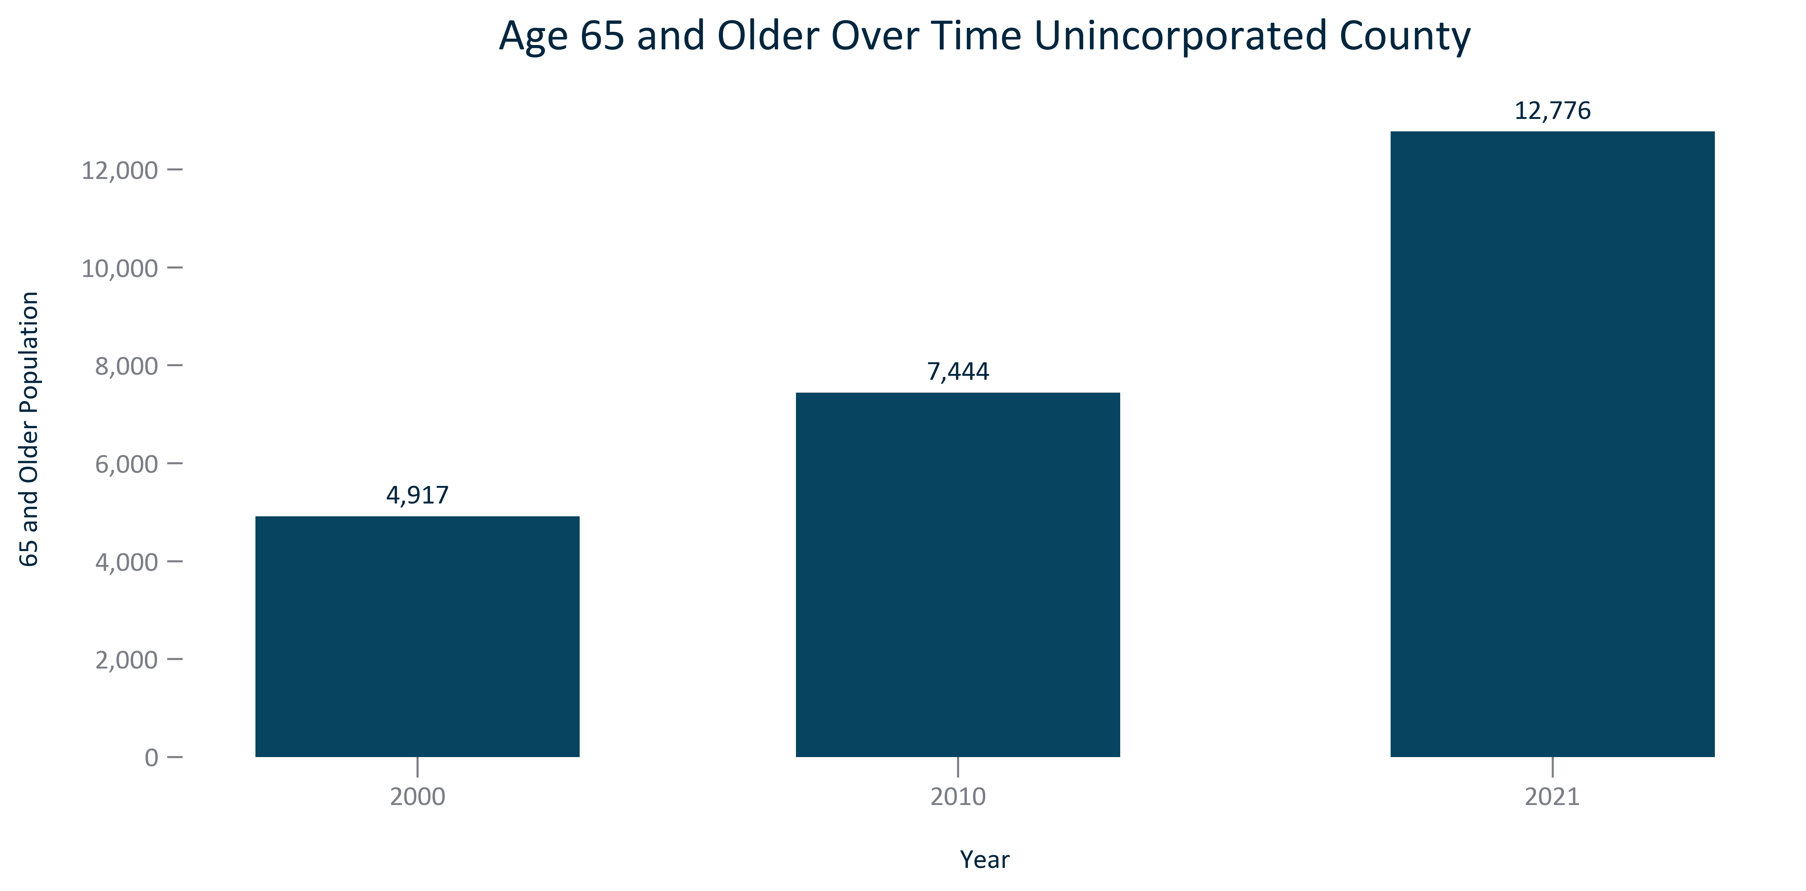

Citation: 2000 and 2010 Decennial Census, 2017-2021 American Community Survey 5-Year Estimates

### AGE_table_primarygeo_under18breakout_overtime:

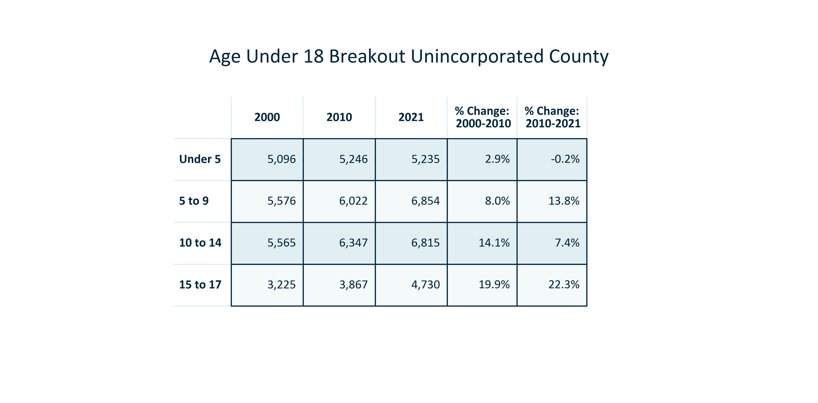

Citation: 2000 and 2010 Decennial Census, 2017-2021 ACS

### AGE_table_primarygeo_18to54breakout_overtime:

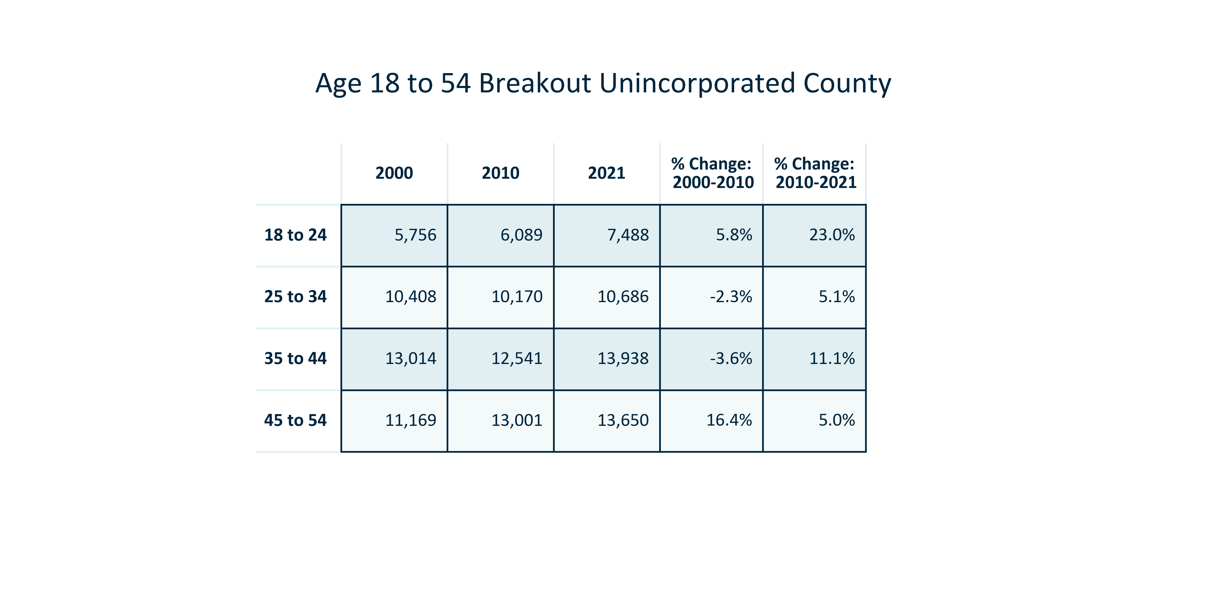

Citation: 2000 and 2010 Decennial Census, 2017-2021 ACS

### AGE_table_primarygeo_55olderbreakout_overtime:

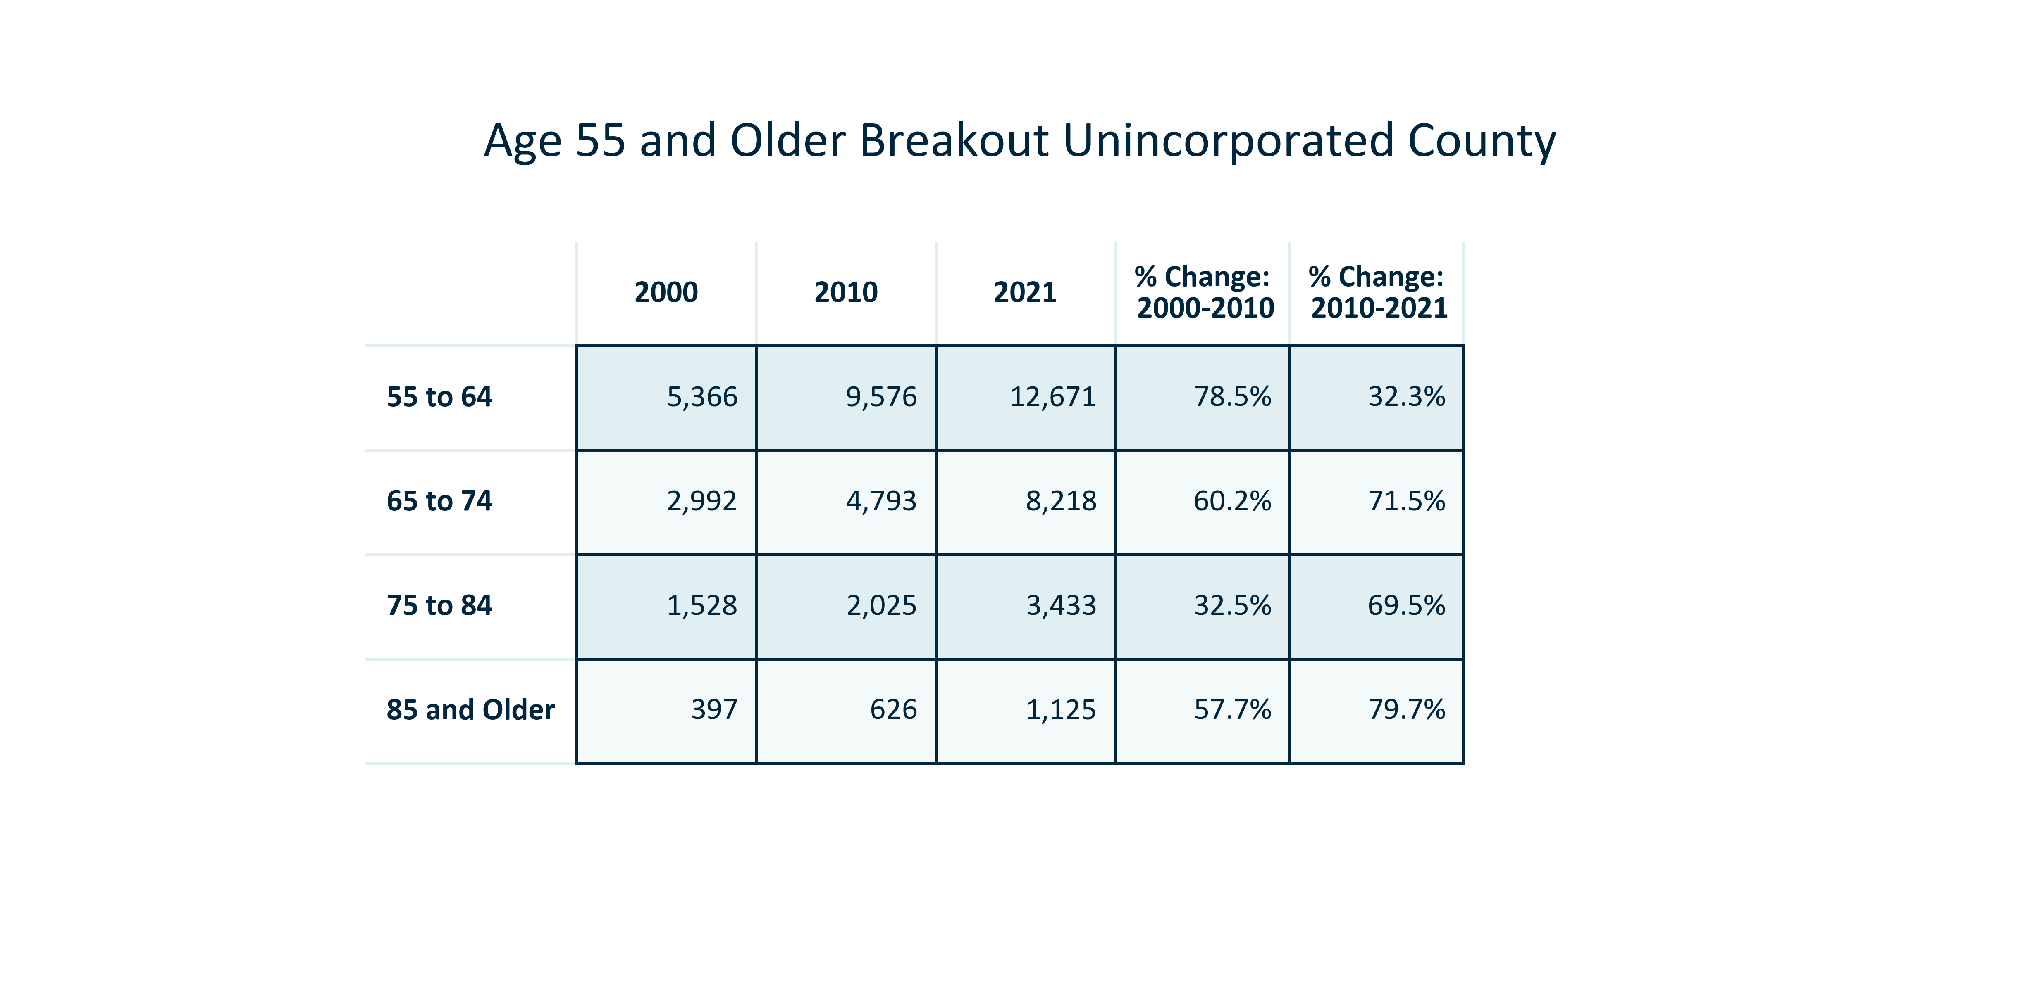

Citation: 2000 and 2010 Decennial Census, 2017-2021 ACS

### AGE_stackedbar_primarygeo_agegroups_overtime:

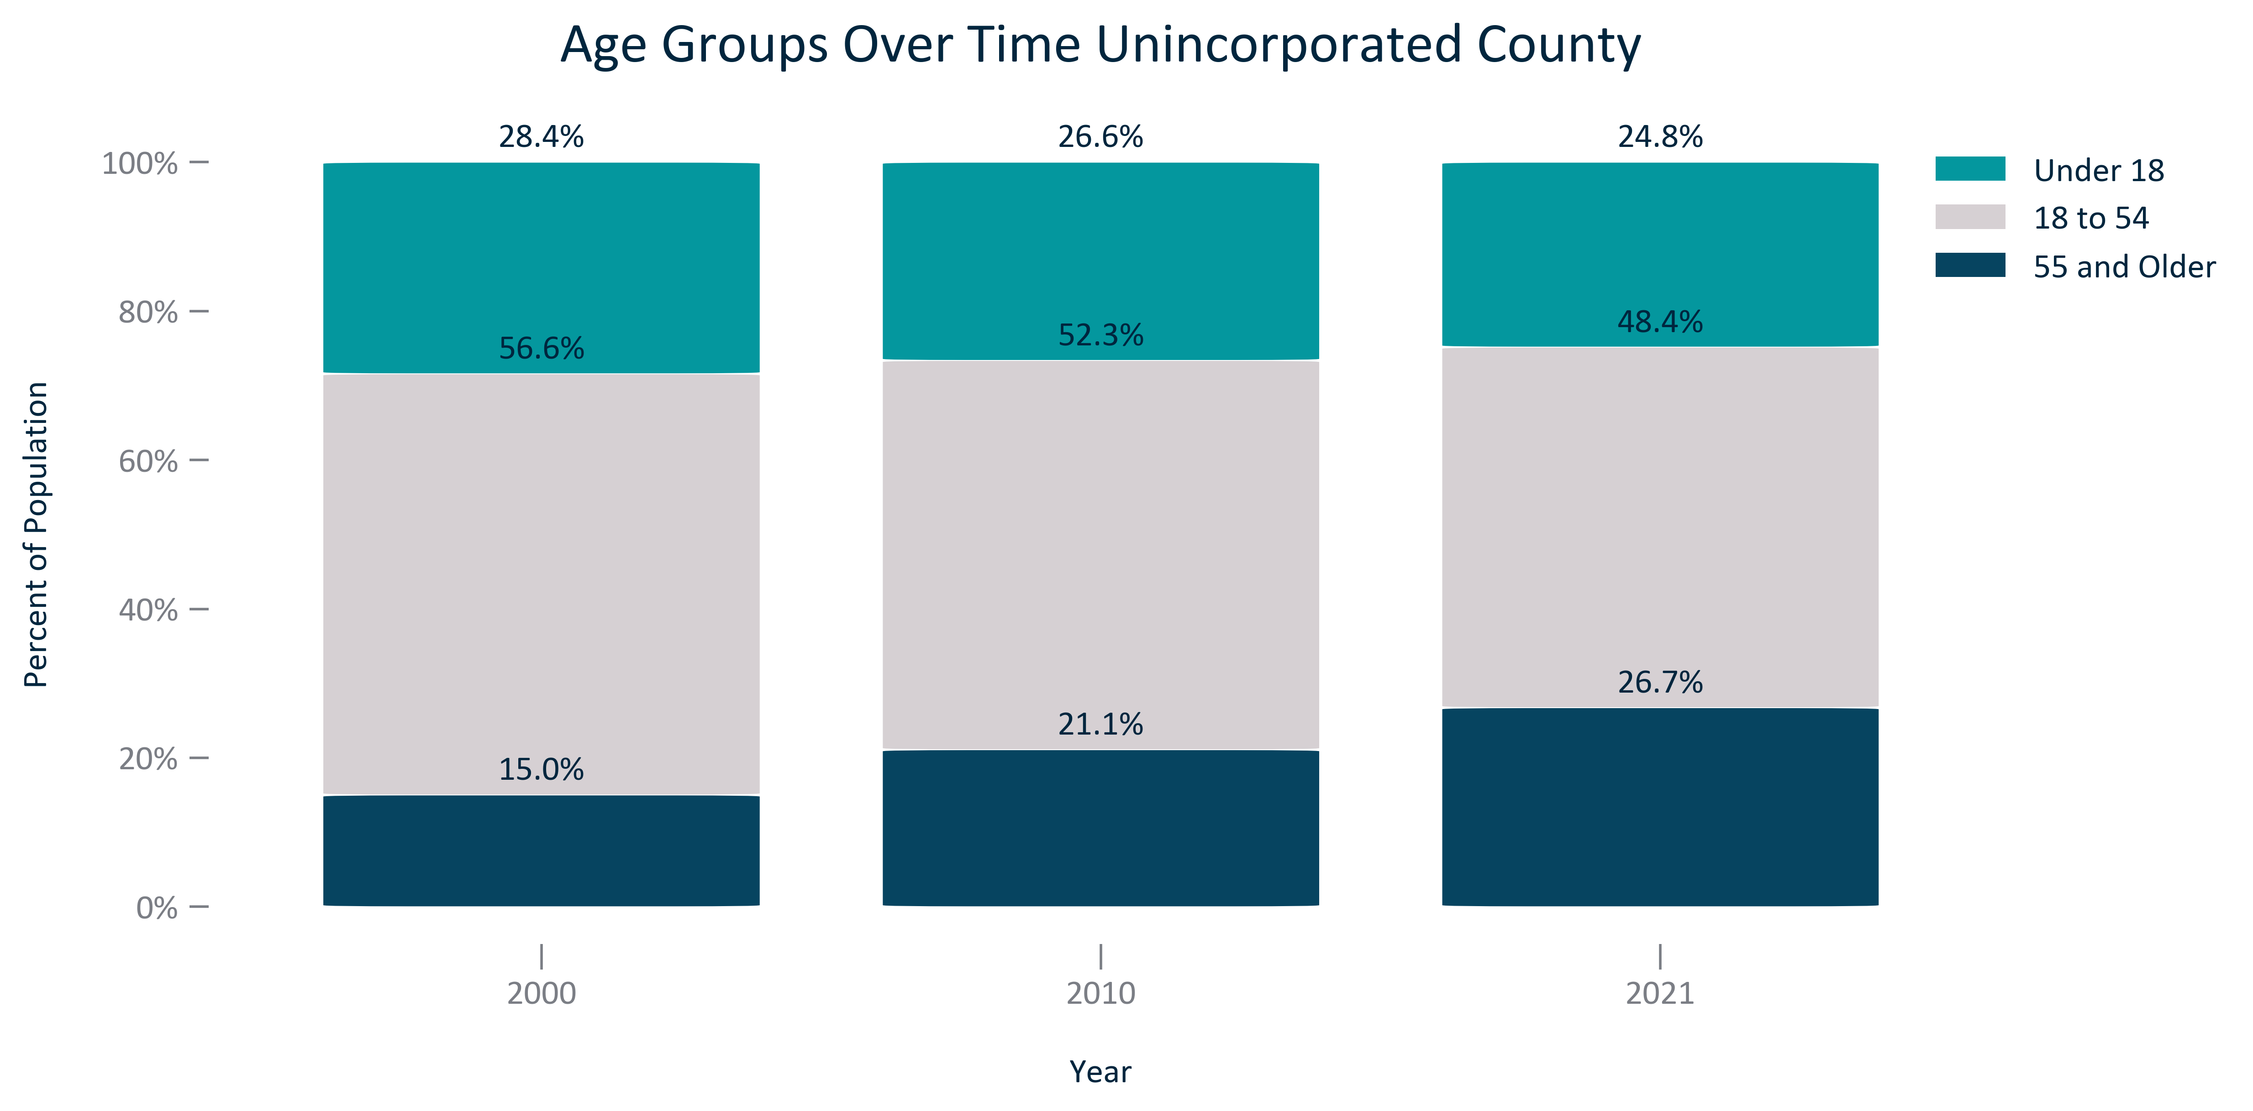

Citation: 2000 and 2010 Decennial Census, 2017-2021 ACS

### AGE_clusterbar_primarygeo_changeingroups_overtime:

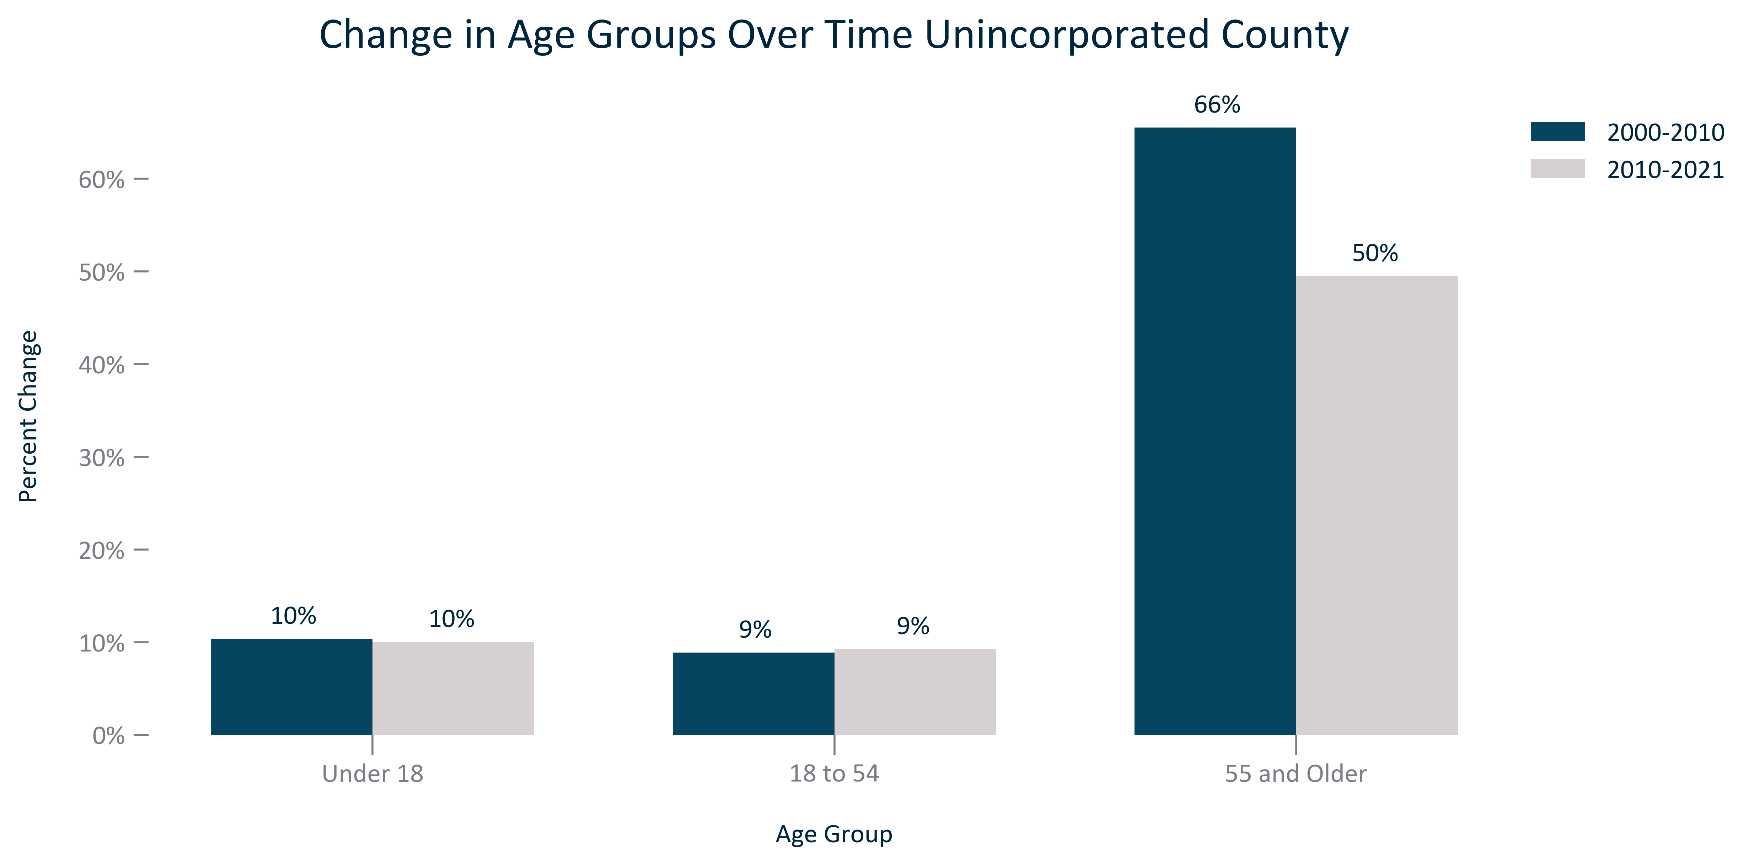

Citation: 2000 and 2010 Decennial Census, 2017-2021 ACS

### AGE_table_geocomparative_agecomposition_2000:

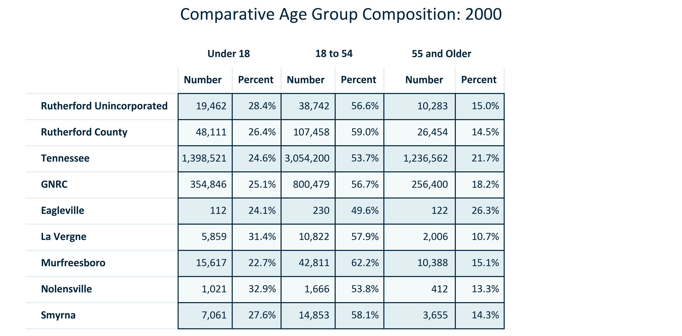

Citation: 2000 Decennial Census

### AGE_table_geocomparative_agecomposition_2010:

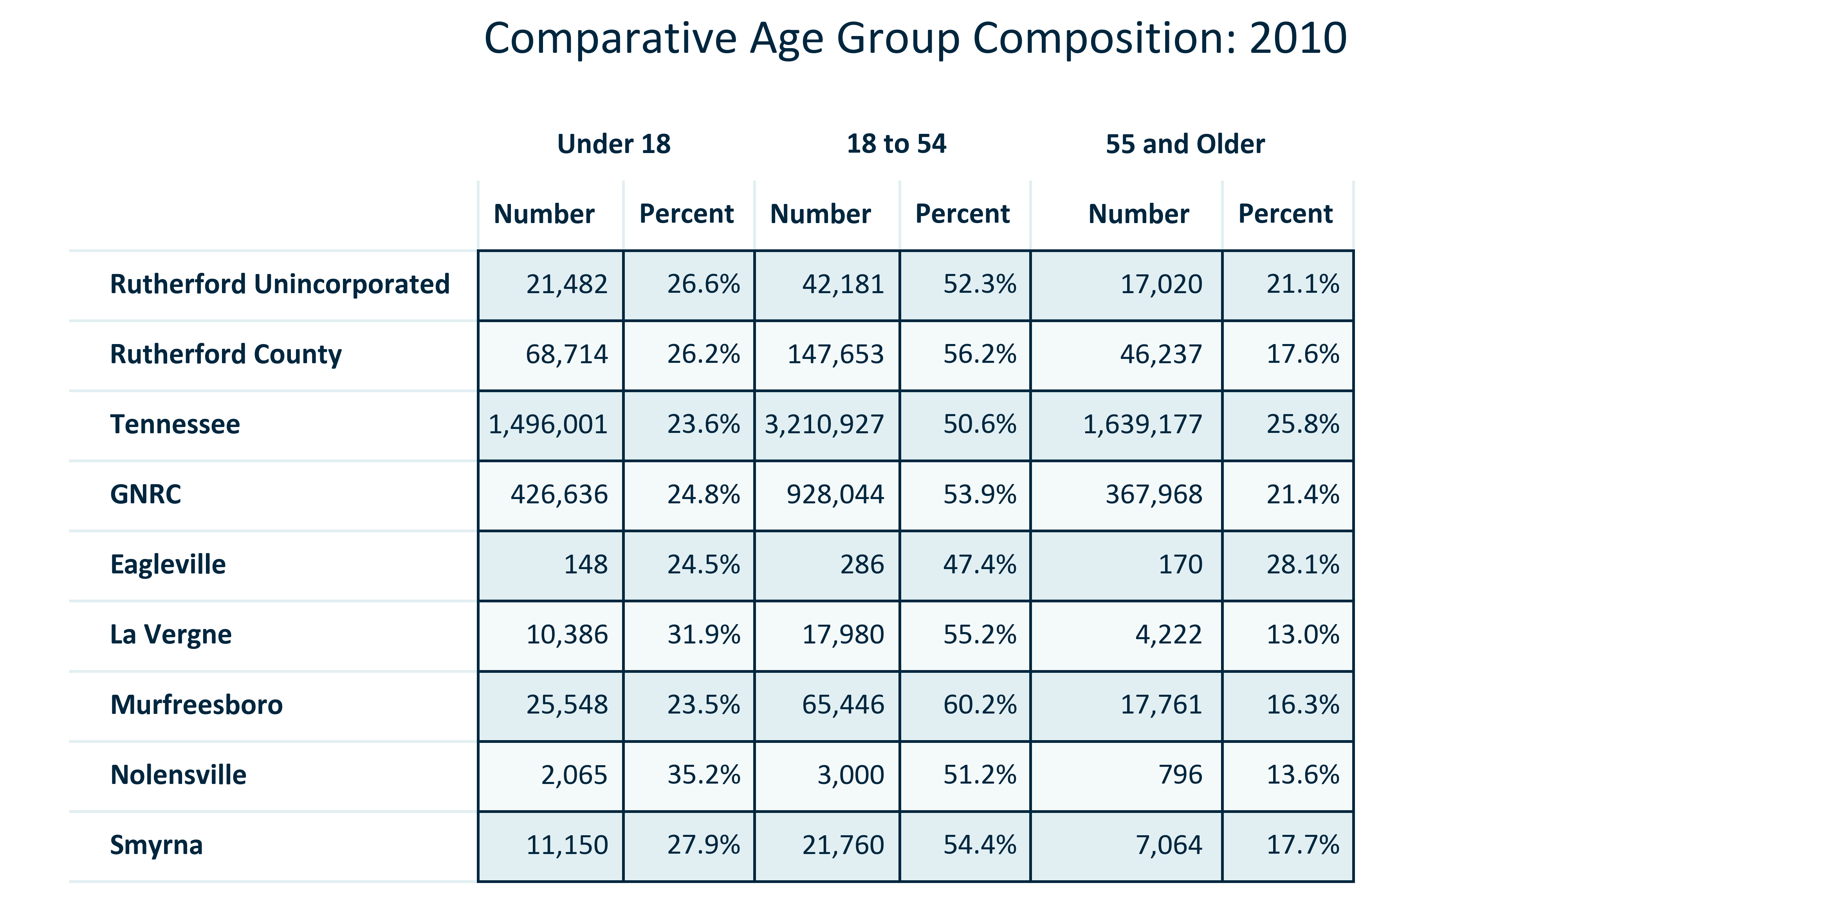

Citation: 2010 Decennial Census

### AGE_table_geocomparative_agecomposition_2021:

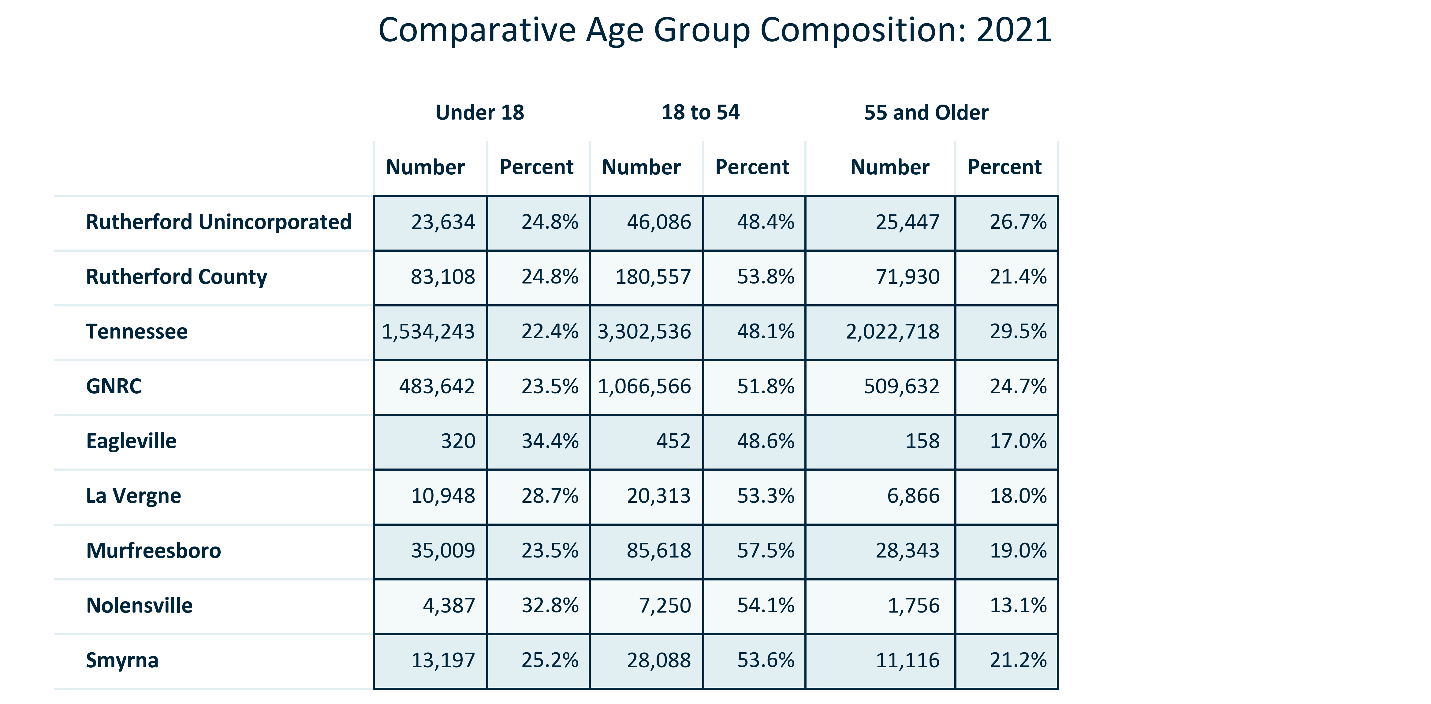

Citation: 2017-2021 American Community Survey 5-Year Estimates

### AGE_table_geocomparative_changeinagegroups_00to10:

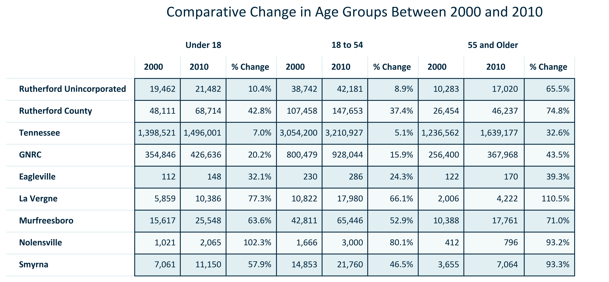

Citation: 2000 and 2010 Decennial Census

### AGE_table_geocomparative_changeinagegroups_10to21:

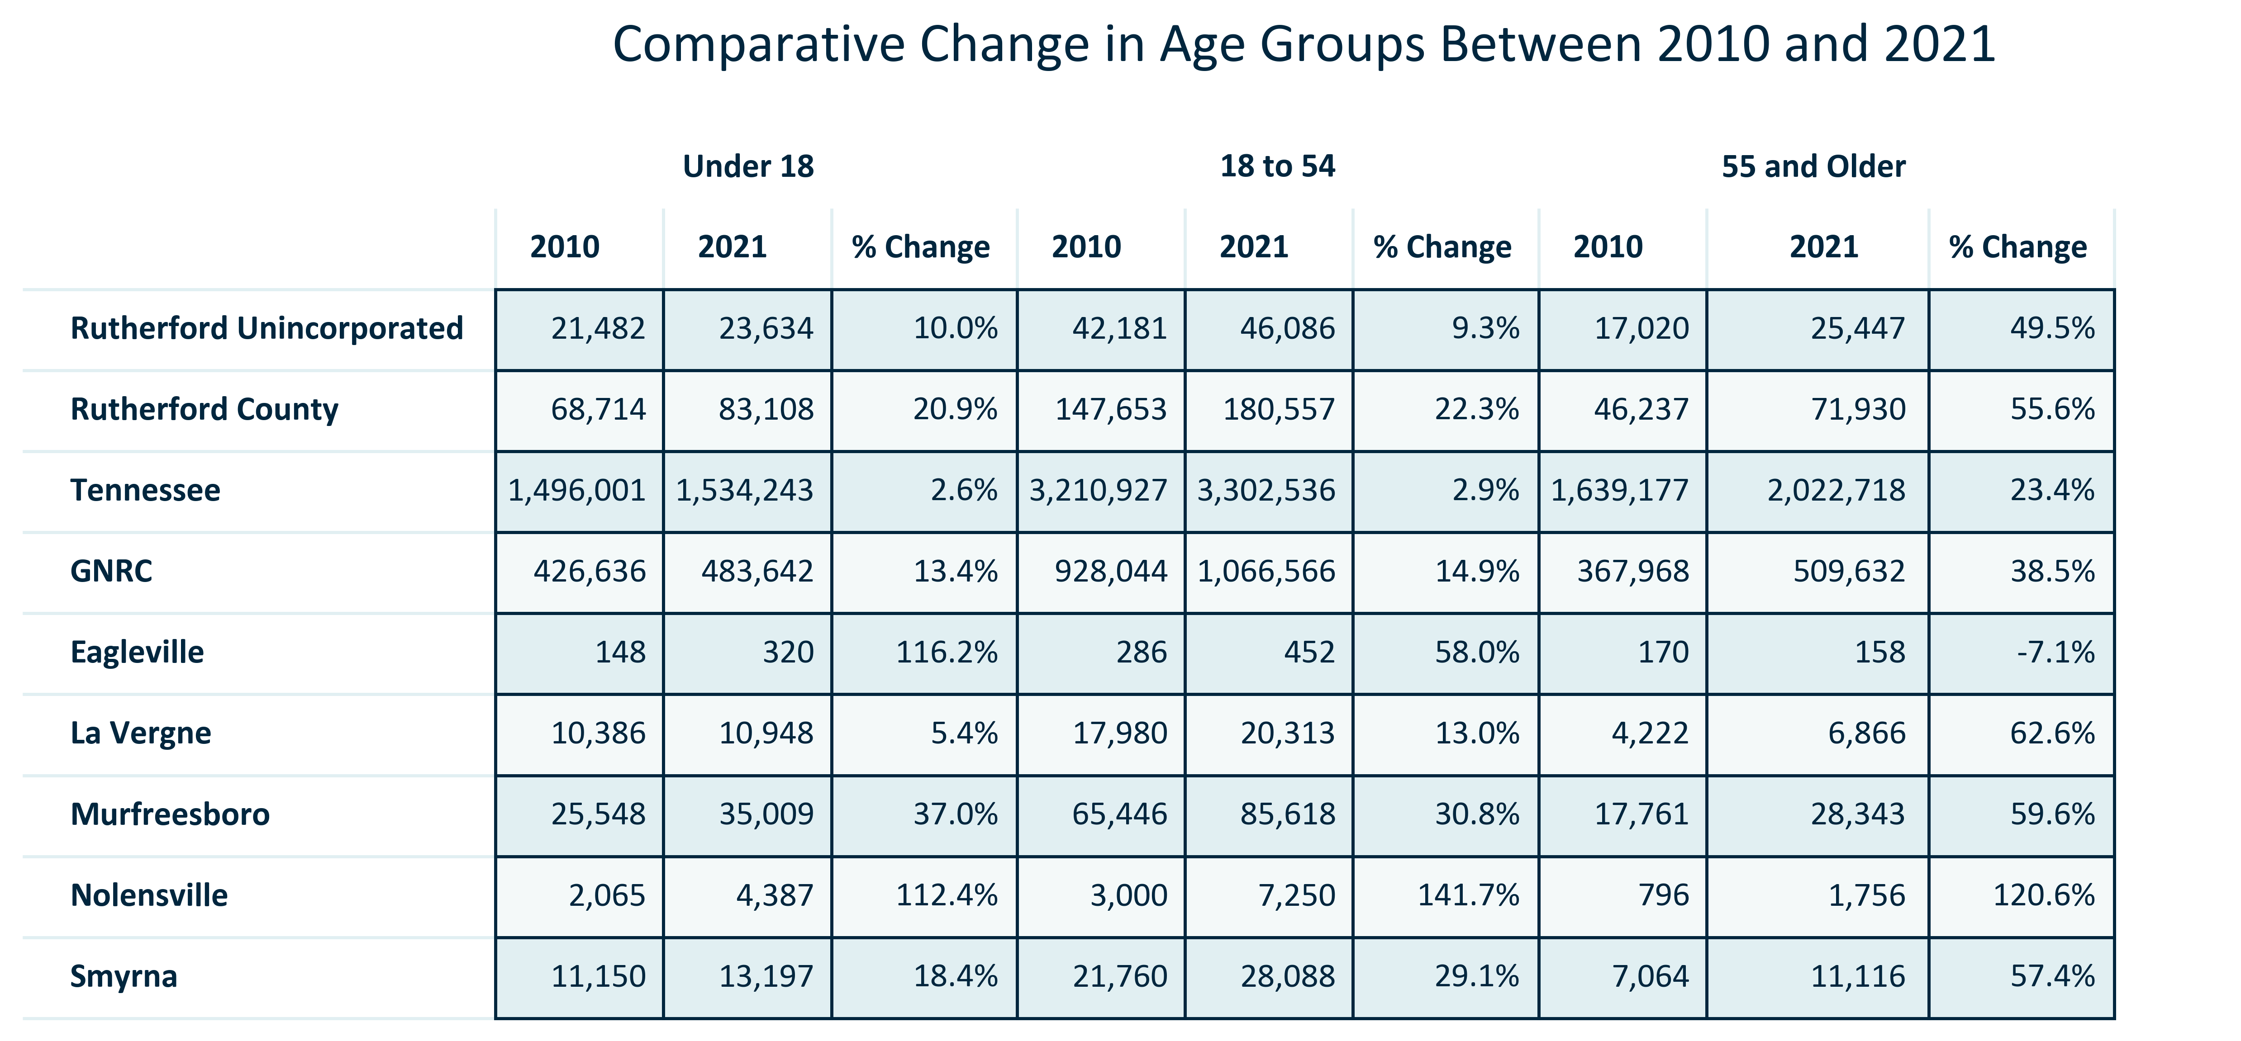

Citation: 2010 Decennial Census, 2017-2021 American Community Survey 5-Year Estimates

### AGE_table_geocomparative_changeinagegroups_00to21:

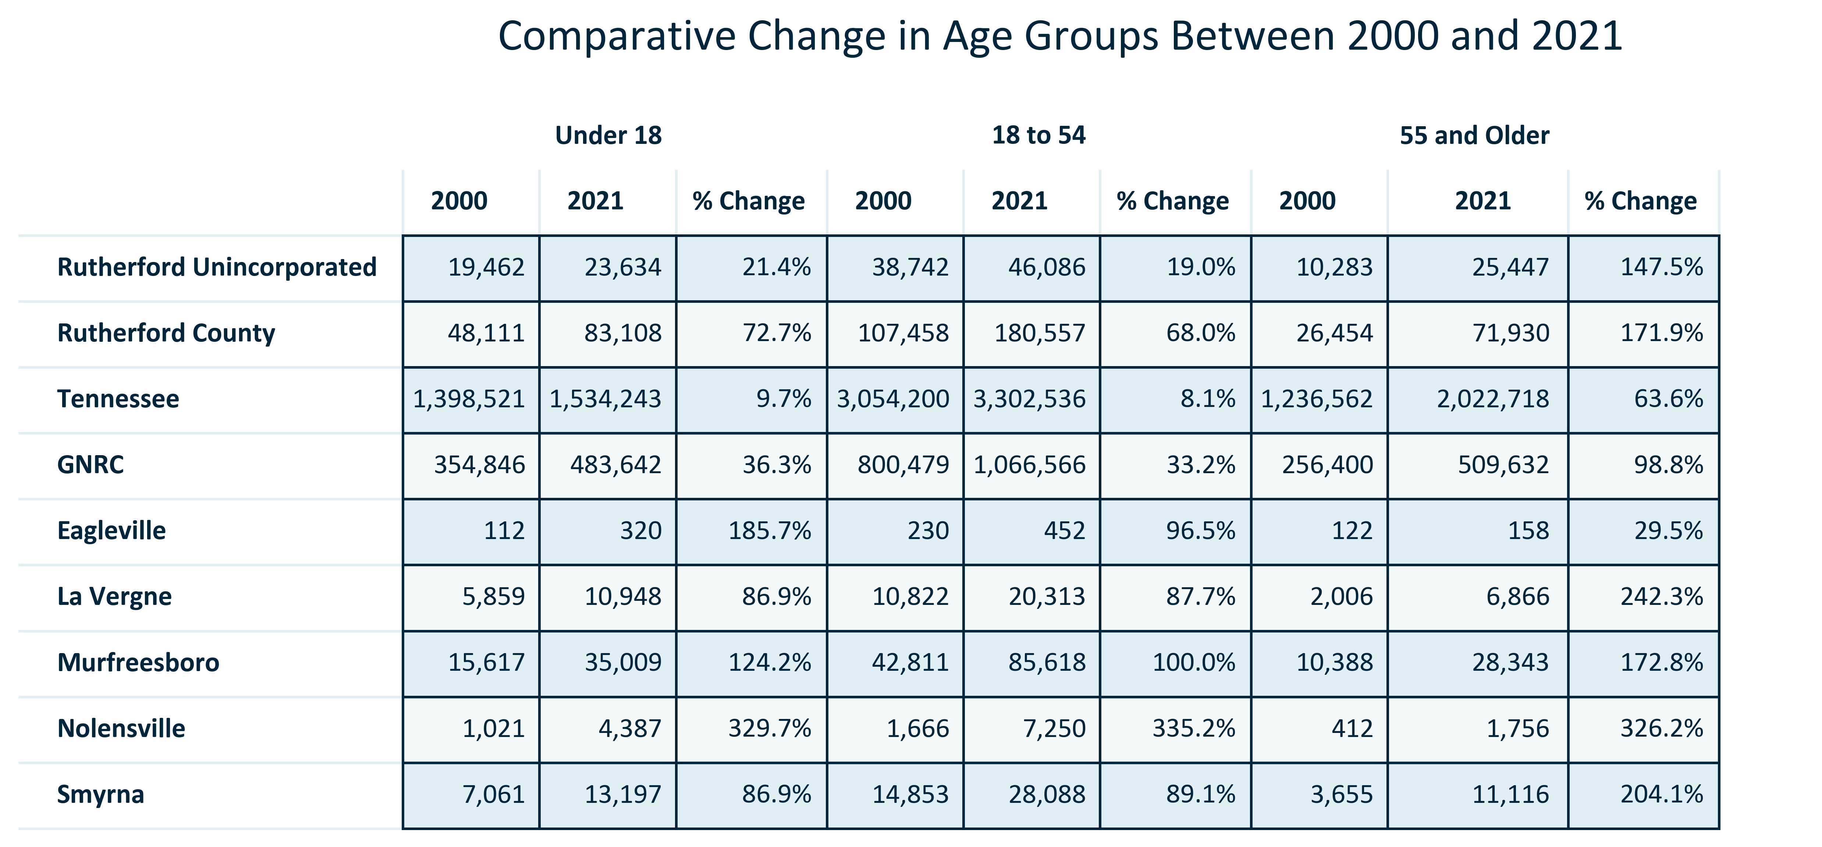

Citation: 2000 Decennial Census, 2017-2021 American Community Survey 5-Year Estimates

# Race and Ethnicity

### RACEETH_stackedbar_primarygeo_sharehispanicorlatino_overtime:

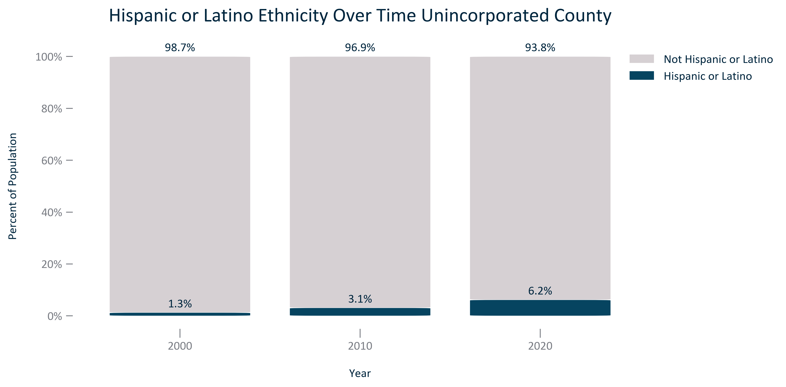

Citation: 2000, 2010, and 2020 Decennial Census

### RACEETH_table_primarygeo_hispaniclatinoethnicityandchange_overtime:

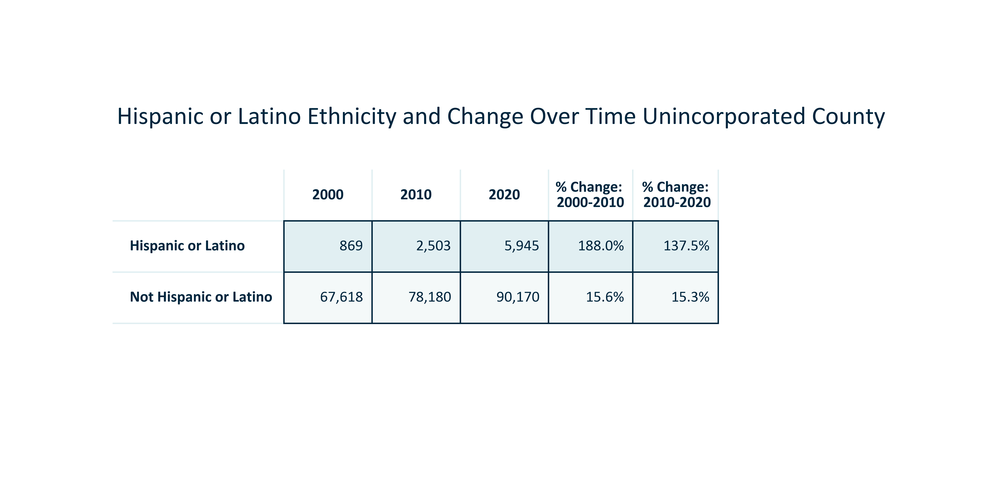

Citation: 2000, 2010, and 2020 Decennial Census

### RACEETH_stackedbar_primarygeo_minoritystatus_overtime:

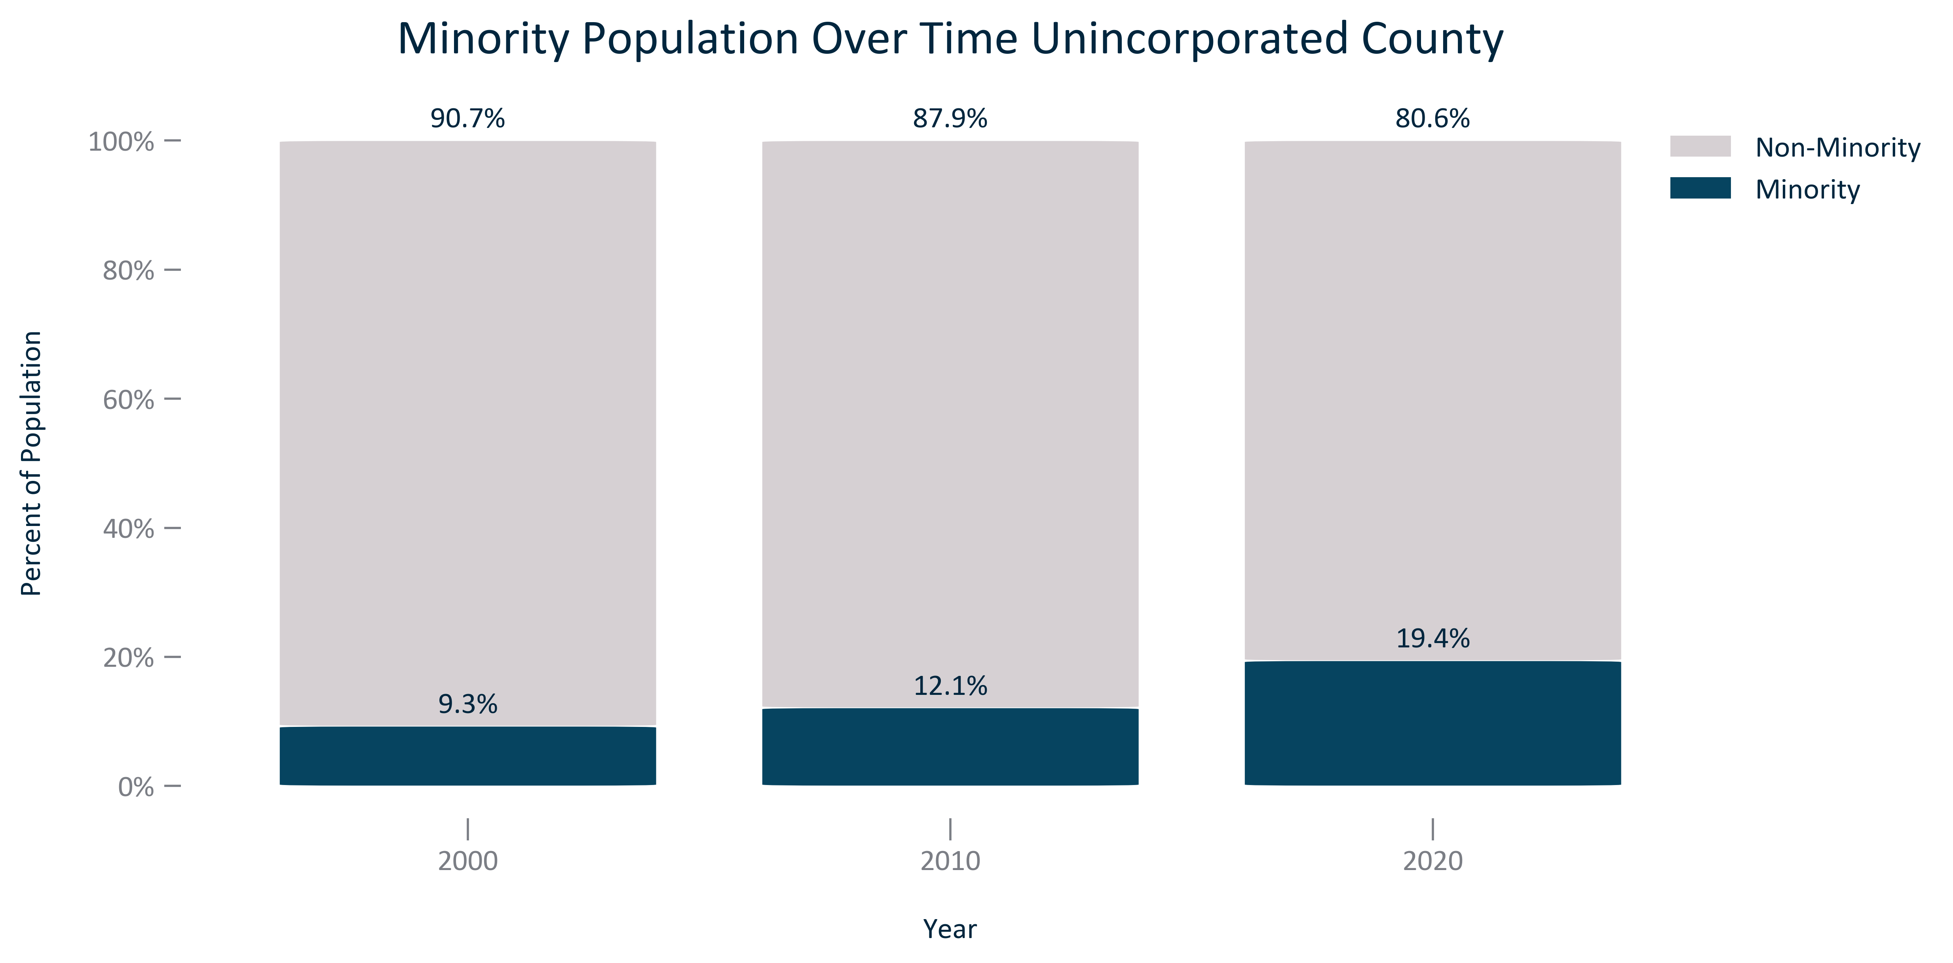

Citation: 2000, 2010, and 2020 Decennial Census

### RACEETH_table_primarygeo_minoritystatusandchange_overtime:

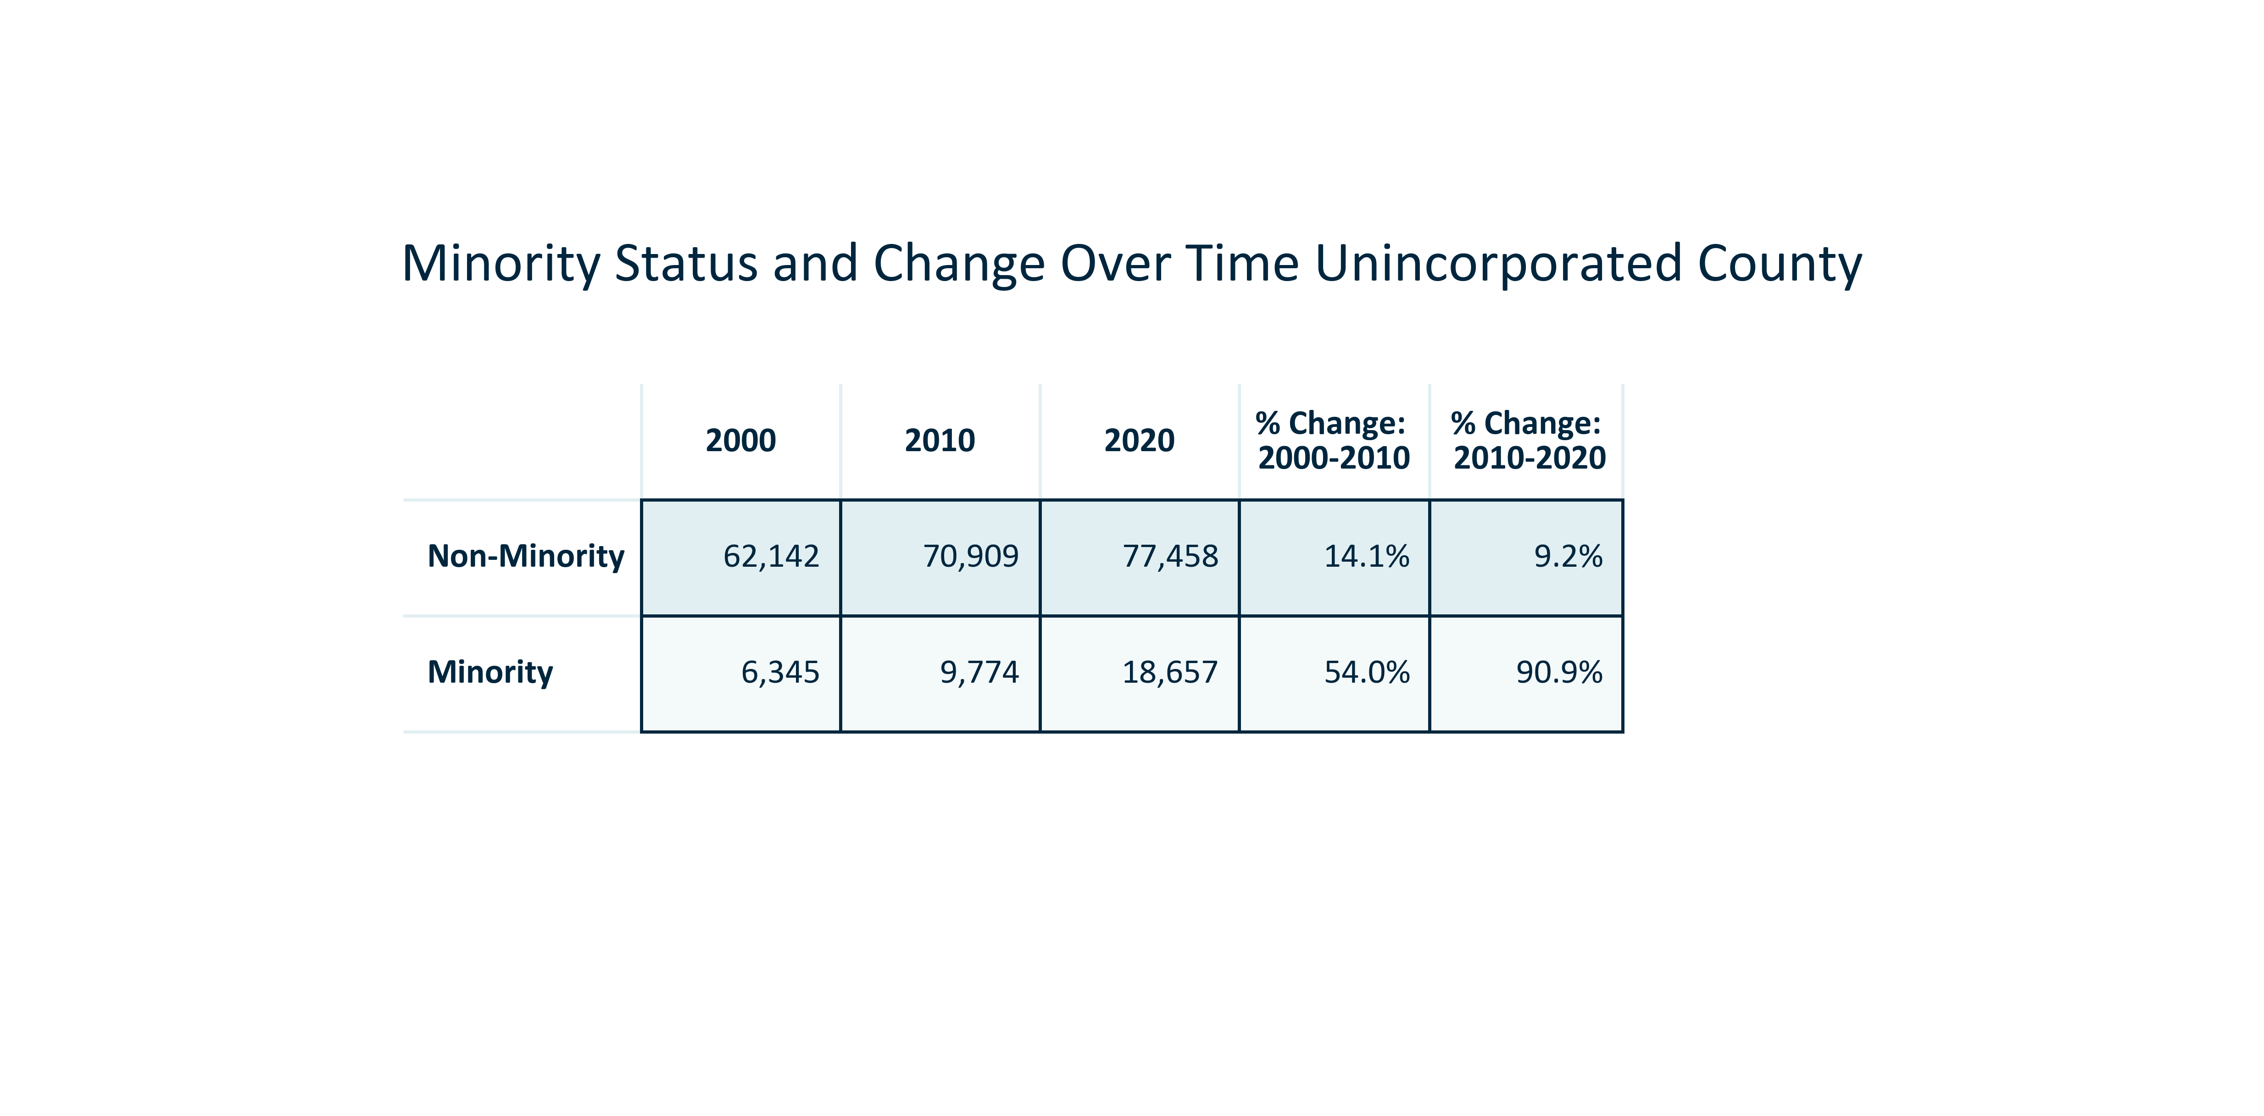

Citation: 2000, 2010, and 2020 Decennial Census

### RACEETH_clusterbar_geocomparative_percentchangetotalvsminority_overtime:

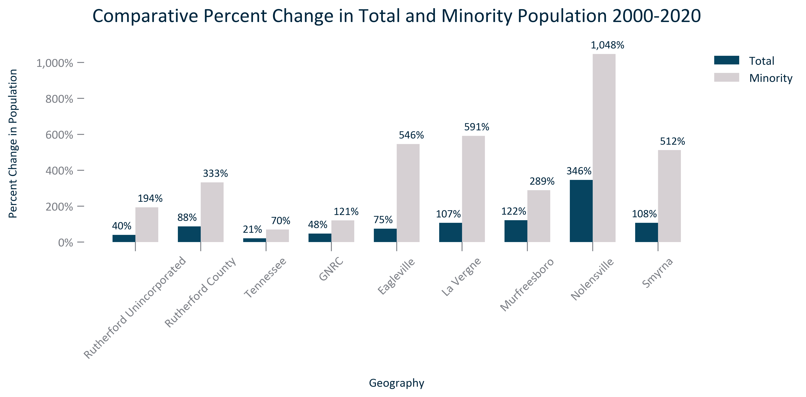

Citation: 2000 and 2020 Decennial Census

### RACEETH_table_geocomparative_allchangeminority_overtime:

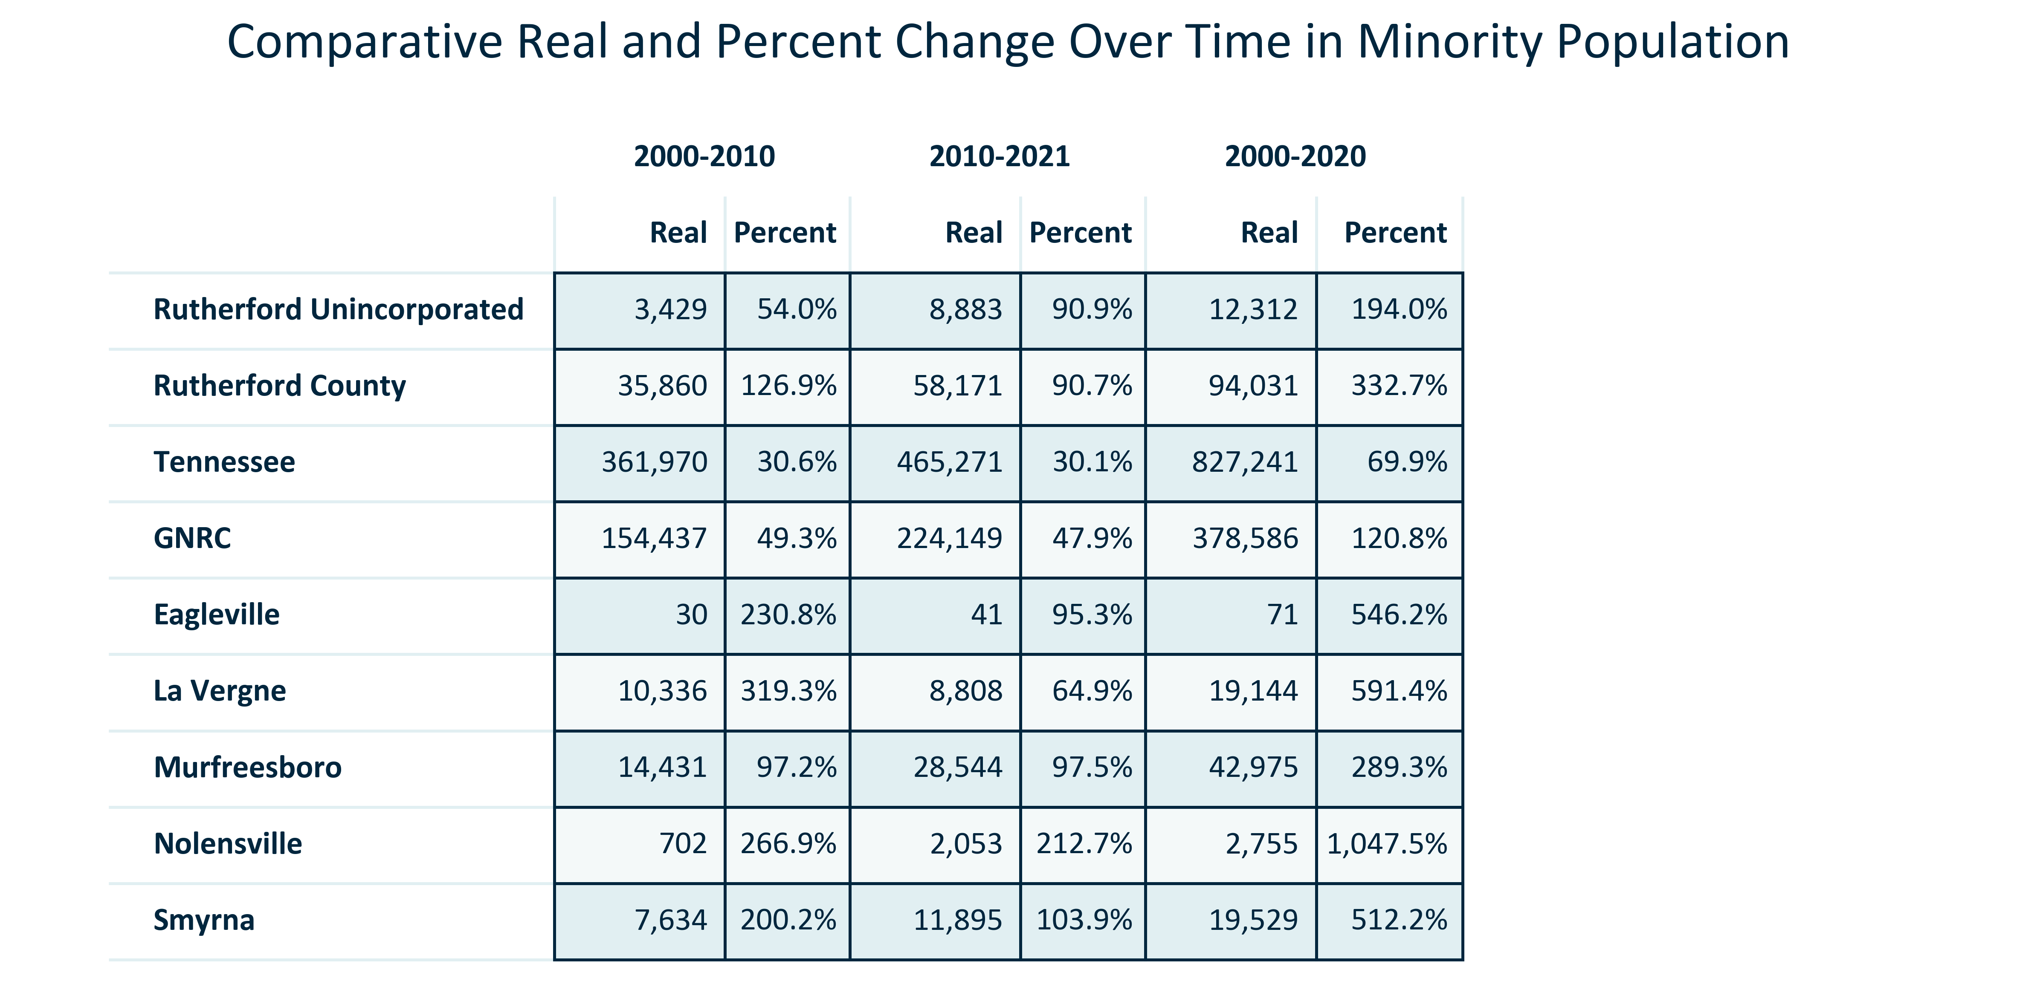

Citation: 2000, 2010, and 2020 Decennial Census

### RACEETH_bar_primarygeo_numberrace_2020:

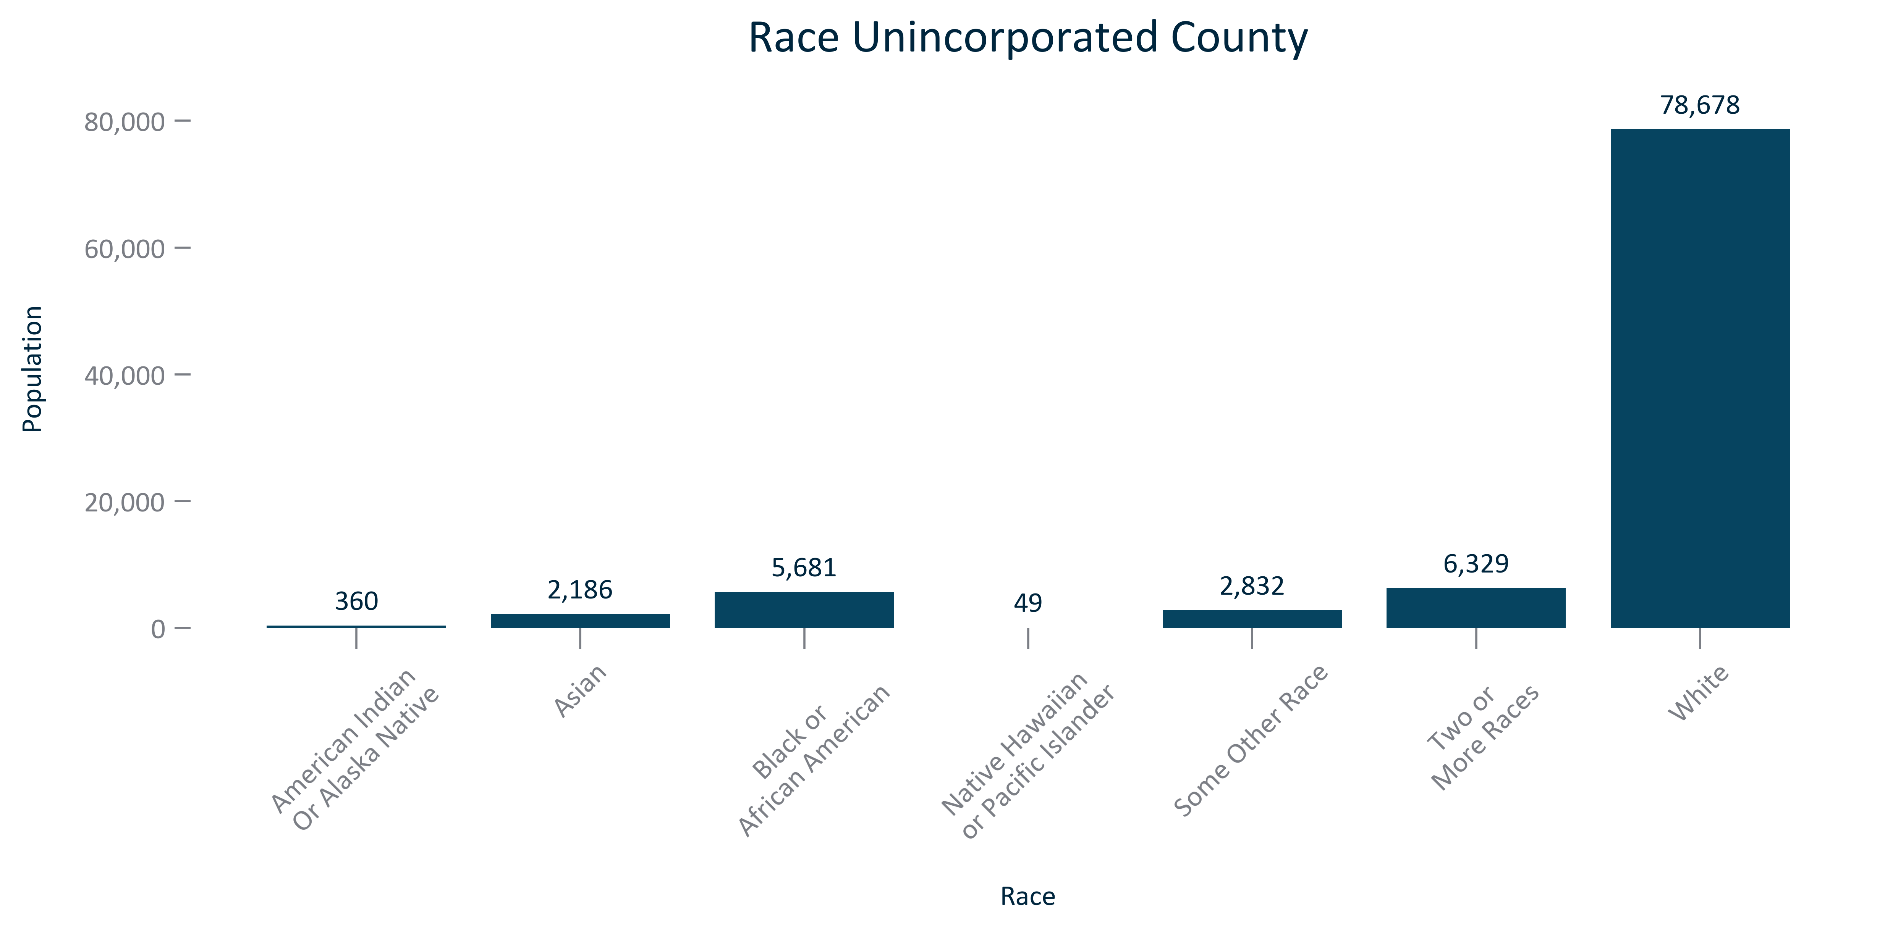

Citation: 2020 Decennial Census

### RACEETH_table_primarygeo_raceandchange_overtime:

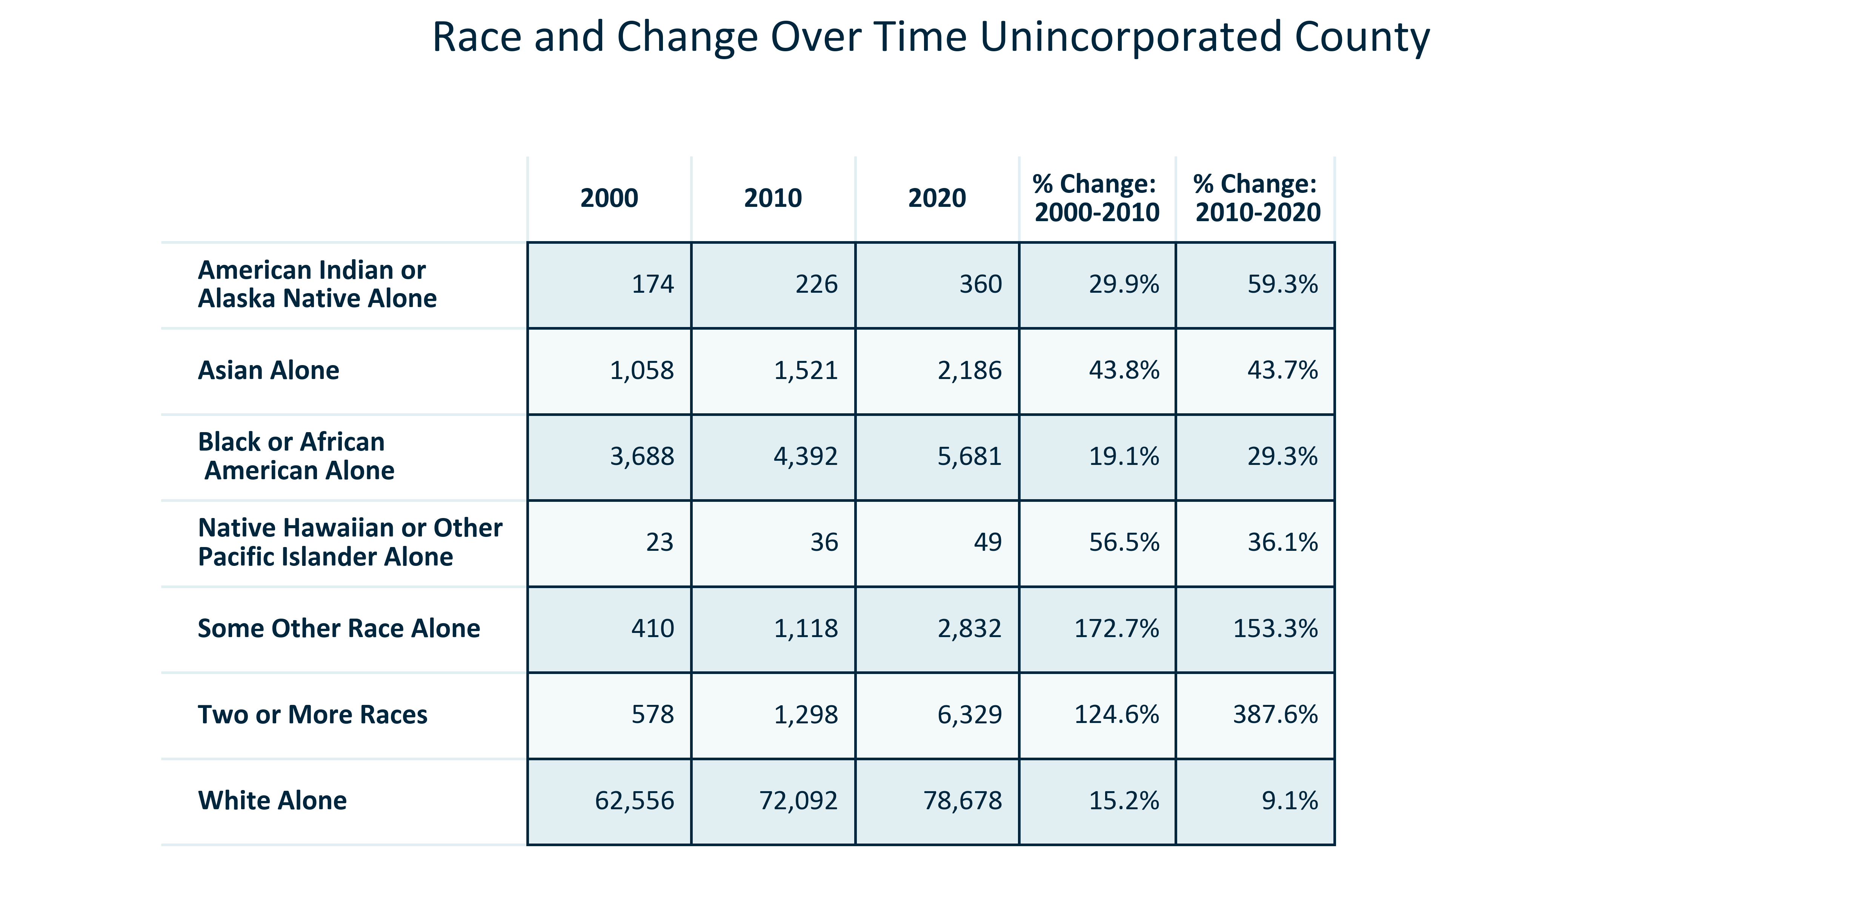

Citation: 2000, 2010, and 2020 Decennial Census

### RACEETH_clusterbar_primarygeo_changeinracialgroups_overtime:

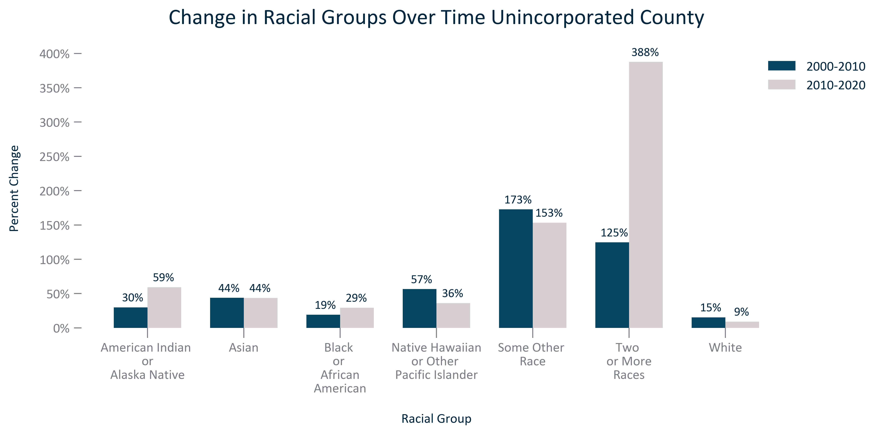

Citation: 2000, 2010, and 2020 Decennial Census

### RACEETH_stackedbar_primarygeo_sharenonwhite_overtime:

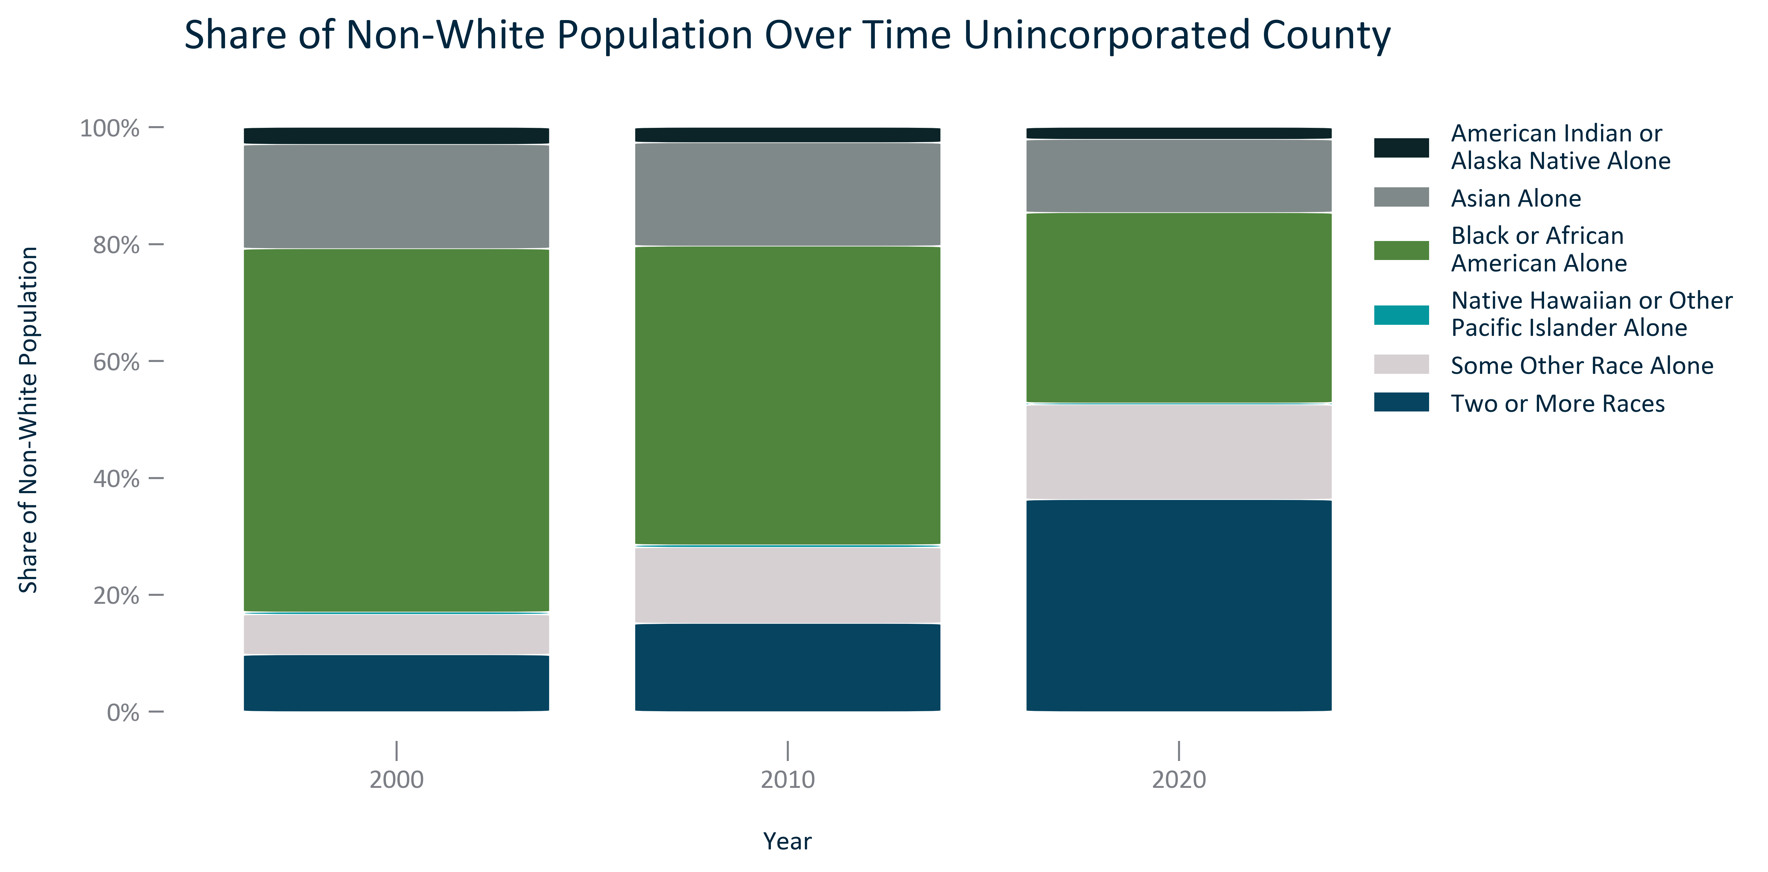

Citation: 2000, 2010, and 2020 Decennial Census

### RACEETH_table_primarygeo_nonwhite_overtime:

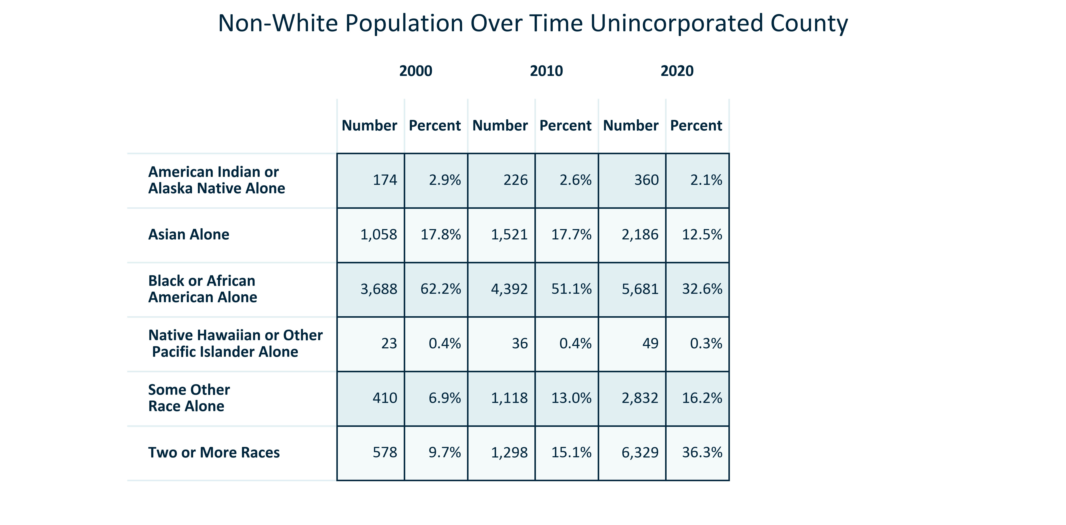

Citation: 2000, 2010, and 2020 Decennial Census

### RACEETH_table_geocomparative_percentracegroups_2000:

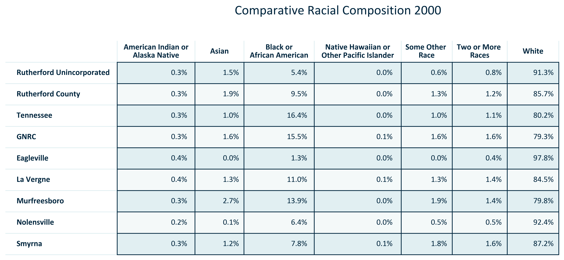

Citation: 2000 Decennial Census

### RACEETH_table_geocomparative_numberracegroups_2000:

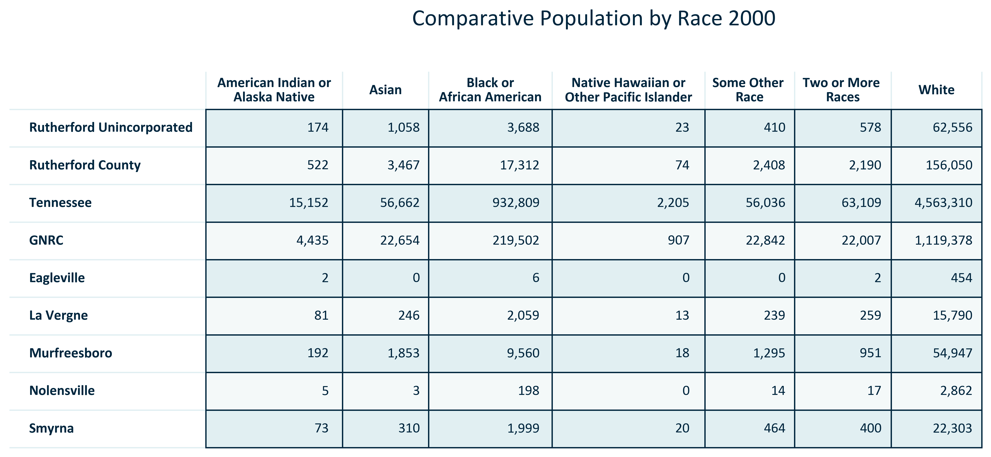

Citation: 2000 Decennial Census

### RACEETH_table_geocomparative_percentracegroups_2010:

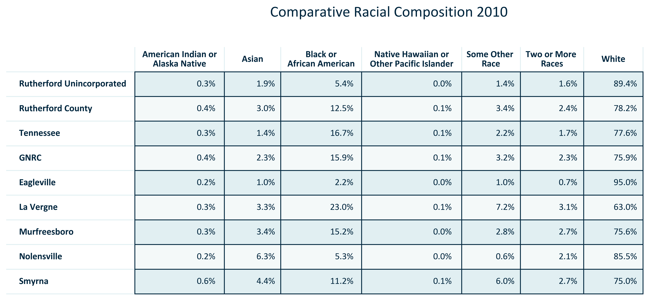

Citation: 2010 Decennial Census

### RACEETH_table_geocomparative_numberracegroups_2010:

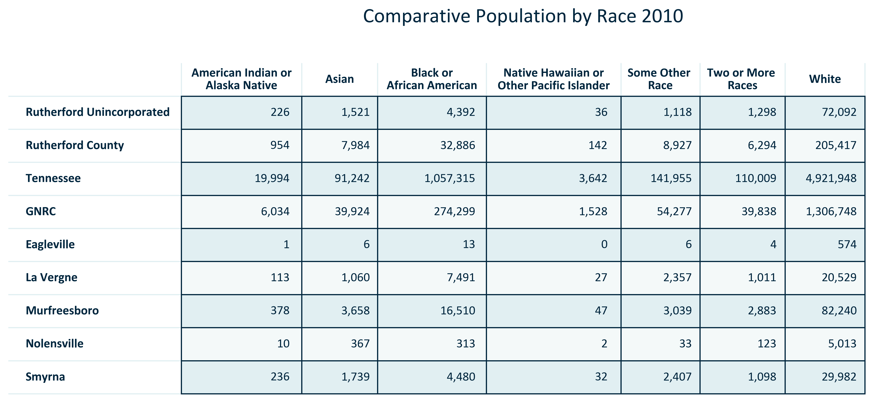

Citation: 2010 Decennial Census

### RACEETH_table_geocomparative_percentracegroups_2020:

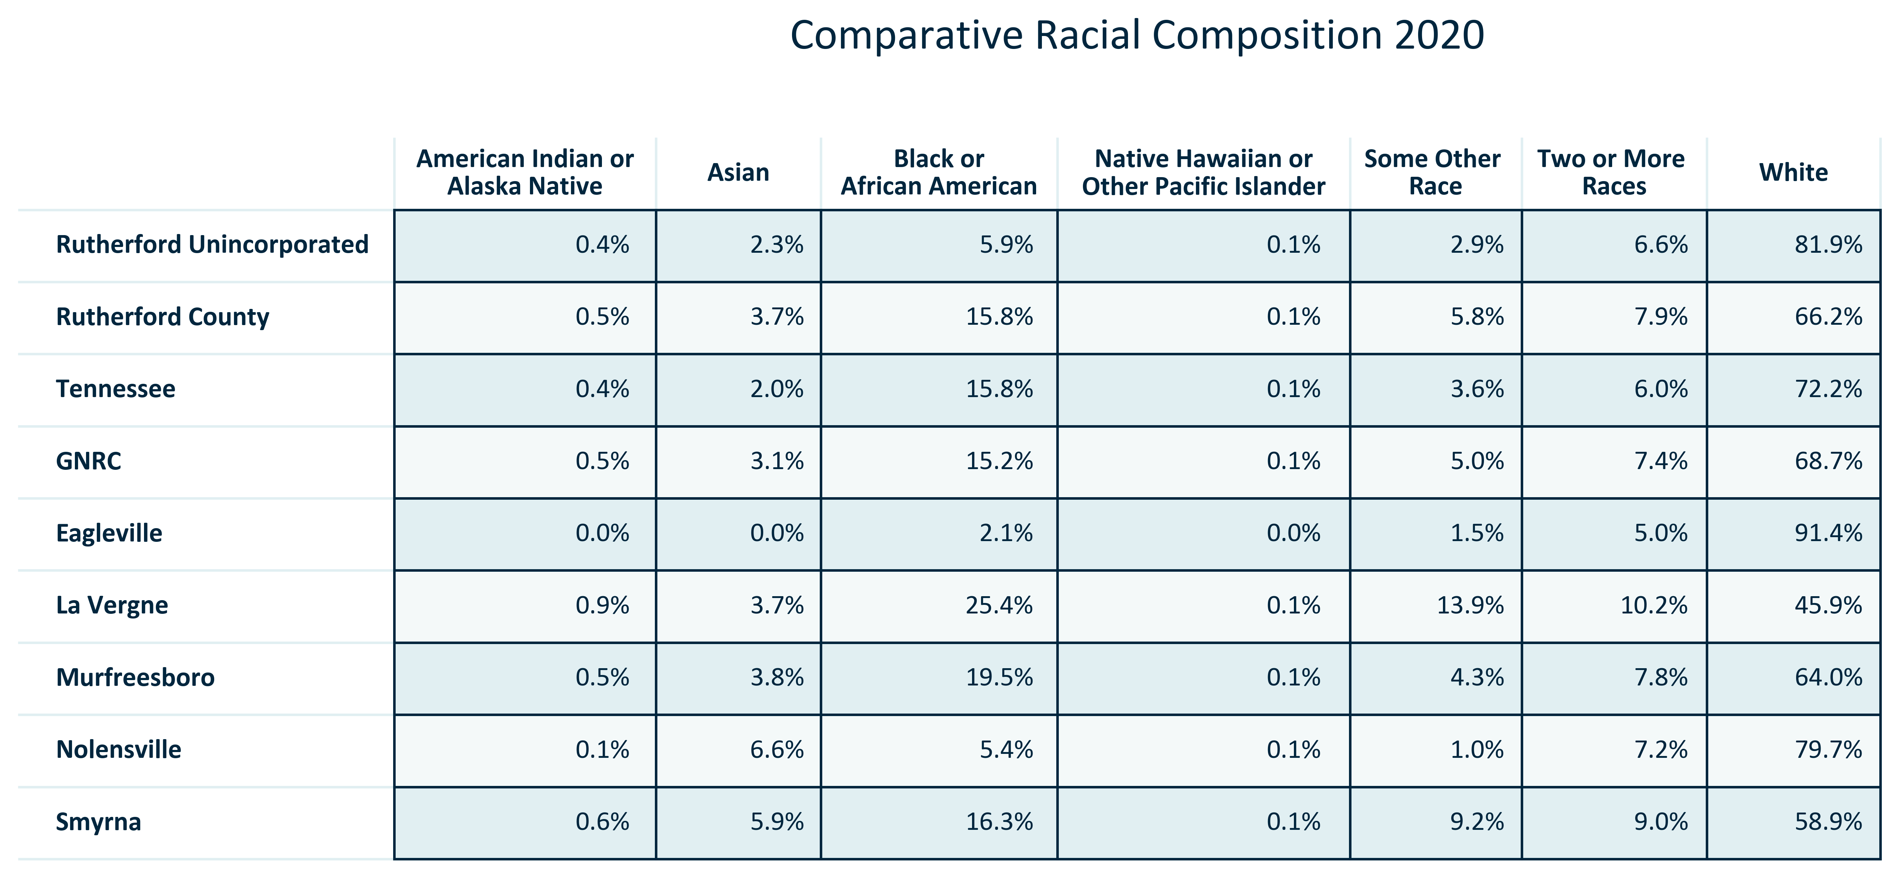

Citation: 2020 Decennial Census

### RACEETH_table_geocomparative_numberracegroups_2020:

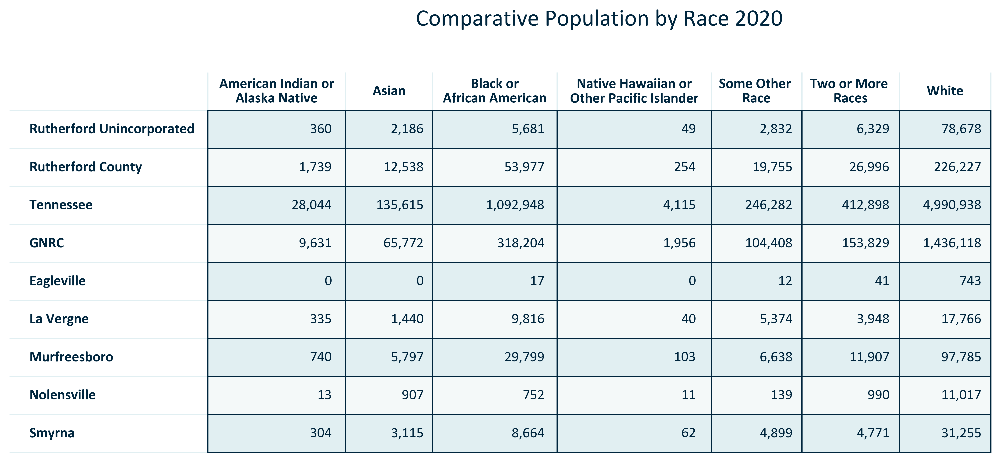

Citation: 2020 Decennial Census

### RACEETH_table_geocomparative_percentchangeracegroups_00to10:

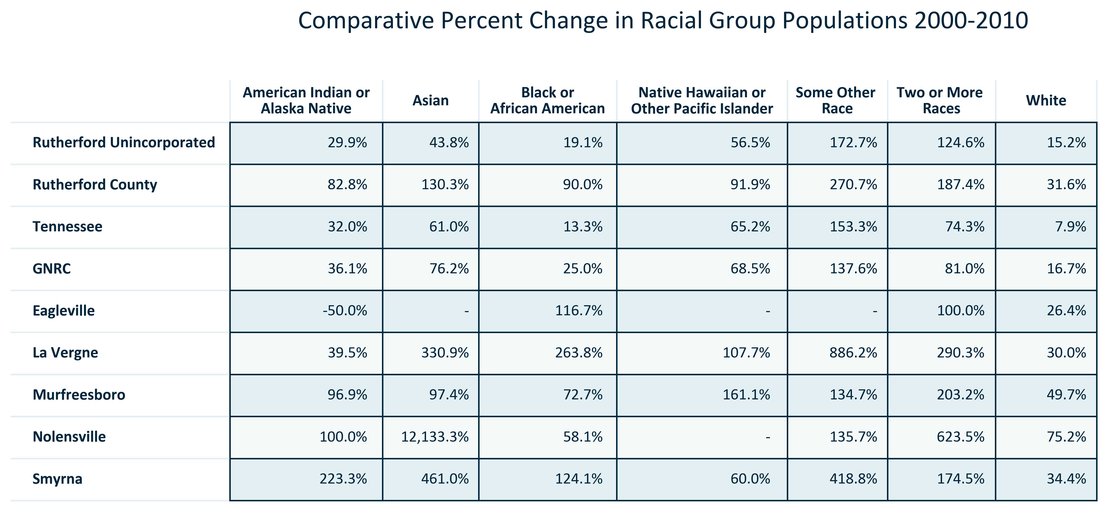

Citation: 2000 and 2010 Decennial Census

### RACEETH_table_geocomparative_realchangeracegroups_00to10:

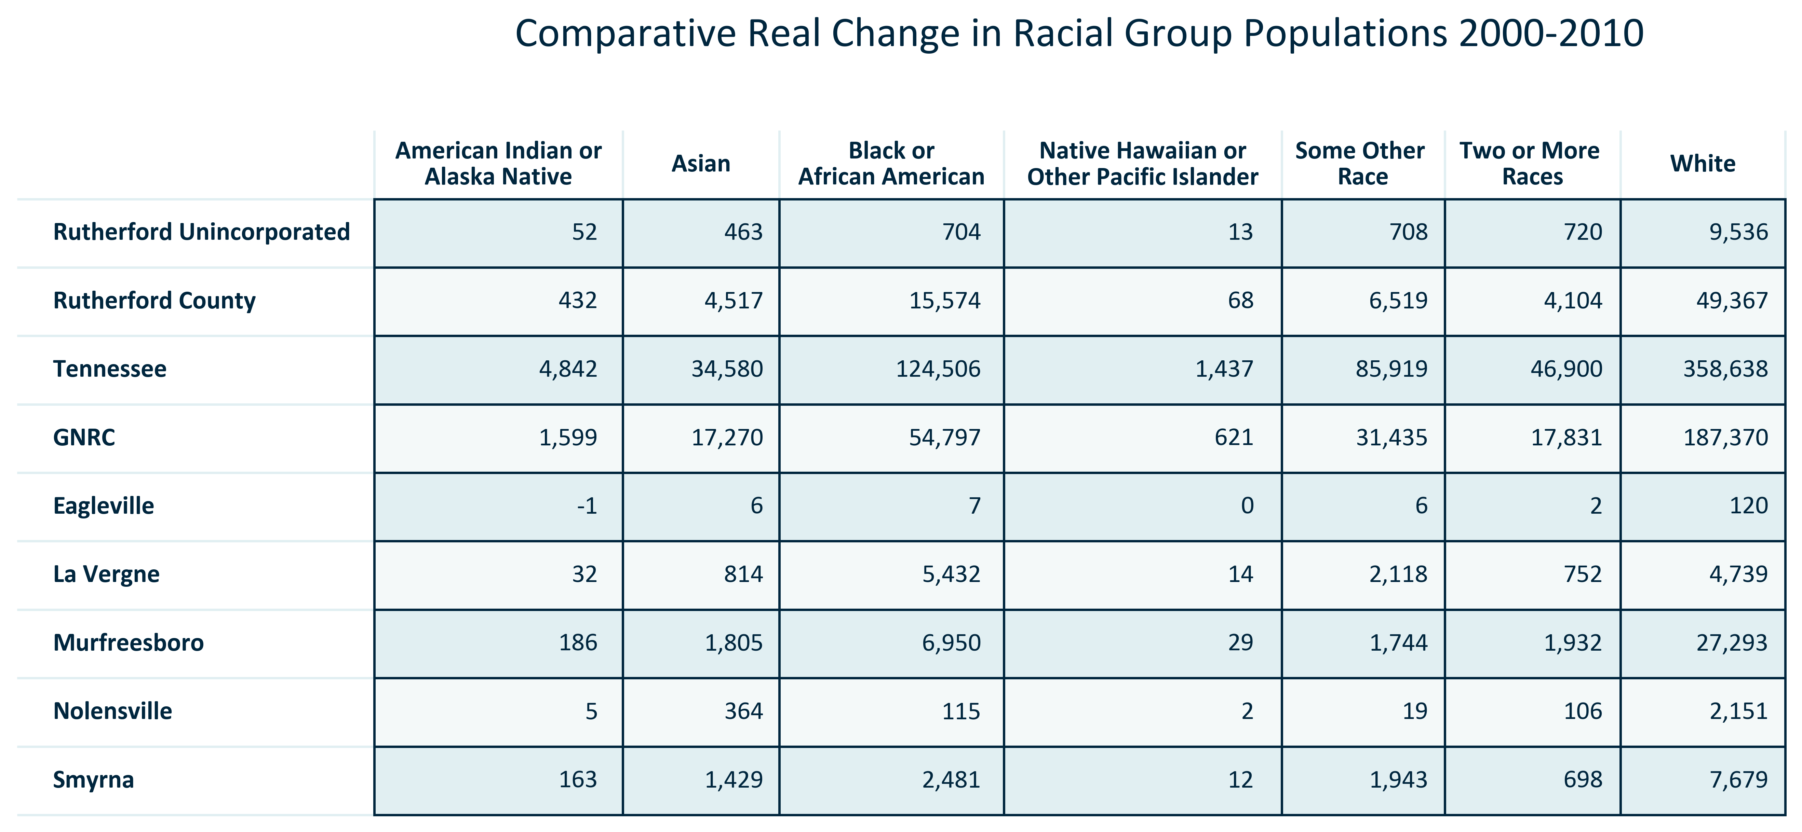

Citation: 2000 and 2010 Decennial Census

### RACEETH_table_geocomparative_percentchangeracegroups_10to20:

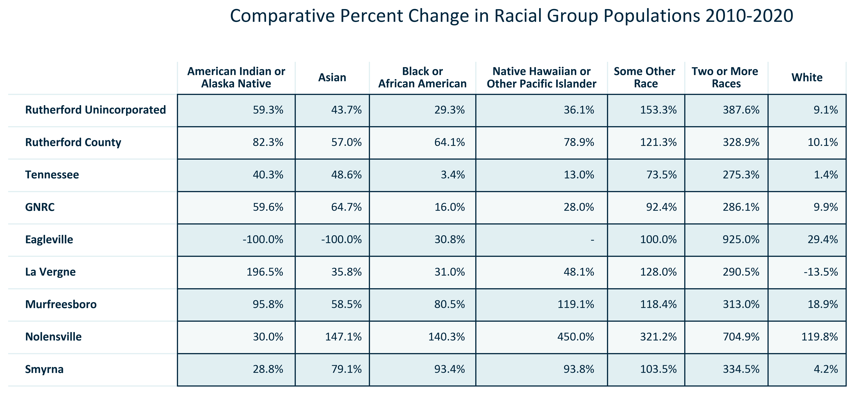

Citation: 2010 and 2020 Decennial Census

### RACEETH_table_geocomparative_realchangeracegroups_10to20:

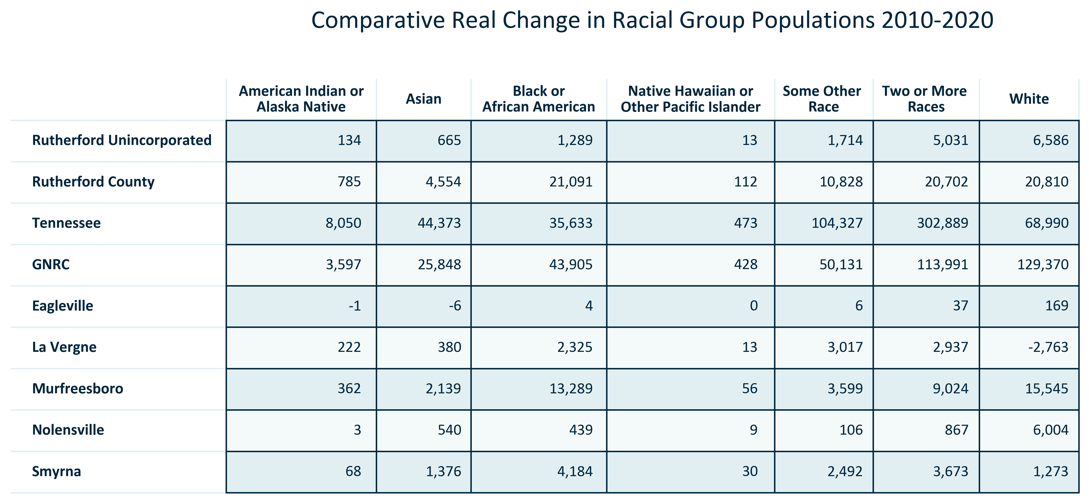

Citation: 2010 and 2020 Decennial Census

### RACEETH_table_geocomparative_percentchangeracegroups_00to20:

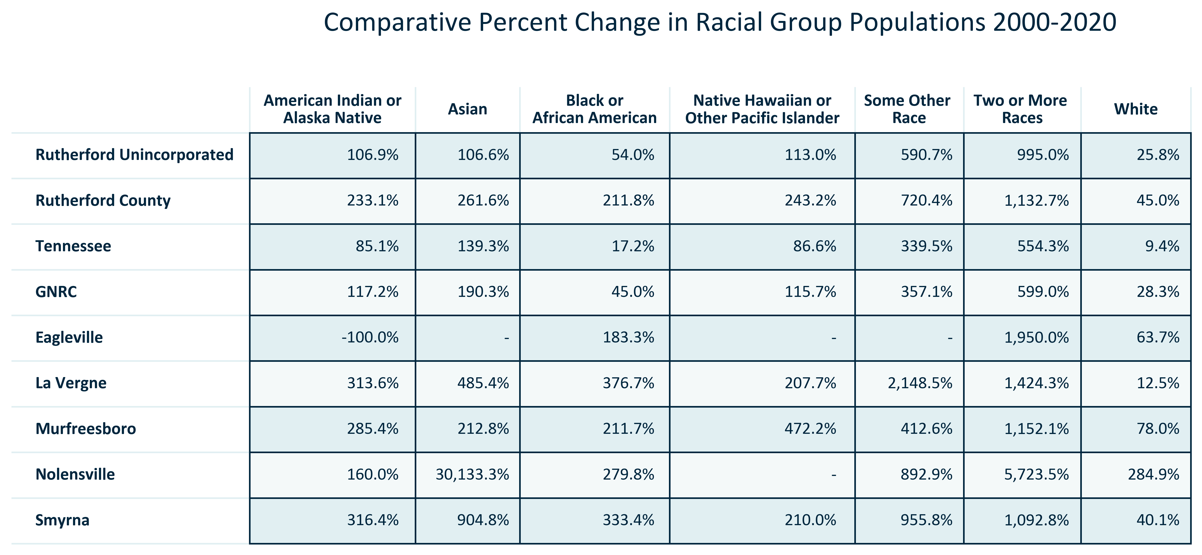

Citation: 2000 and 2020 Decennial Census

### RACEETH_table_geocomparative_realchangeracegroups_00to20:

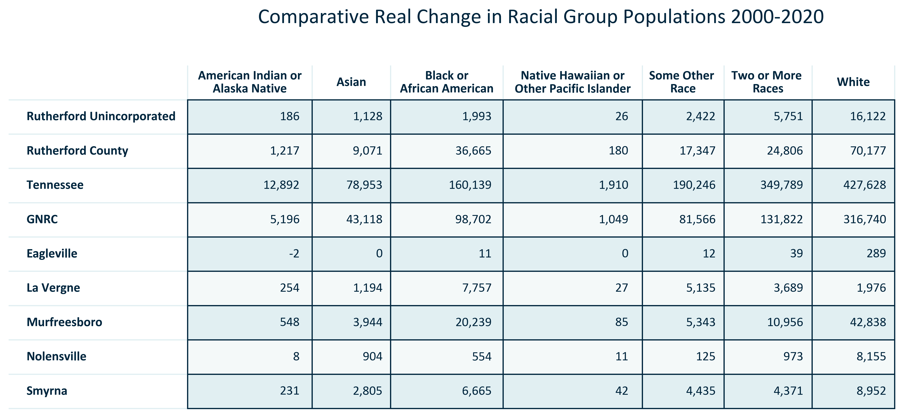

Citation: 2000 and 2020 Decennial Census

# Foreign-Born Population

### FOREIGNBORN_stackedbar_primarygeo_shareforeignandnativeborn_overtime:

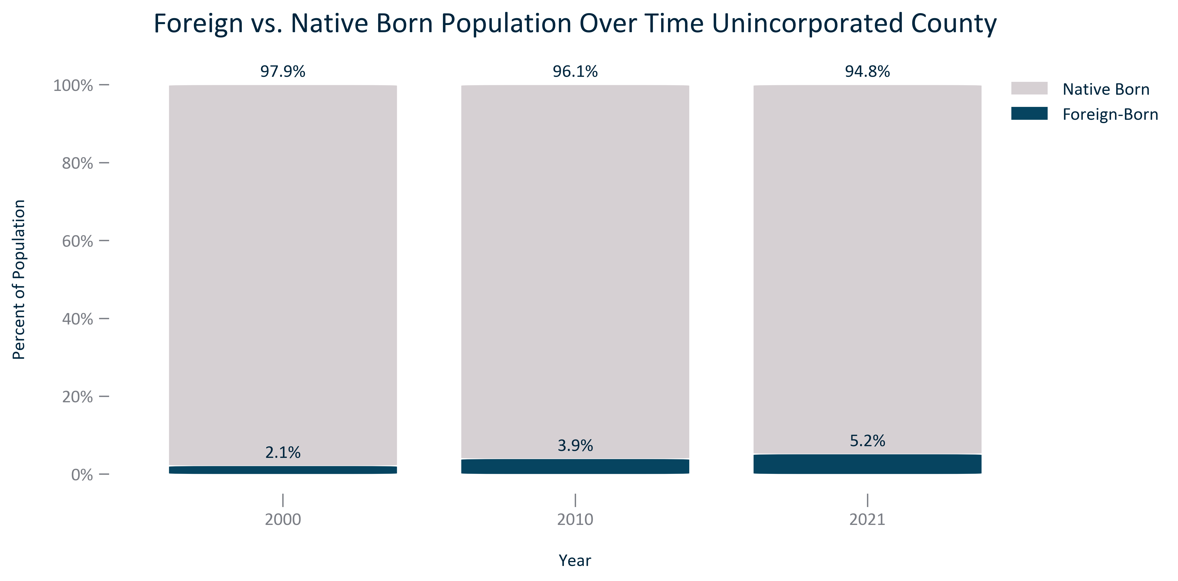

Citation: 2000 Decennial Census, 2006-2010 and 2017-2021 ACS 5-Year Estimates

### FOREIGNBORN_table_primarygeo_foreignbornstatusandchange_overtime:

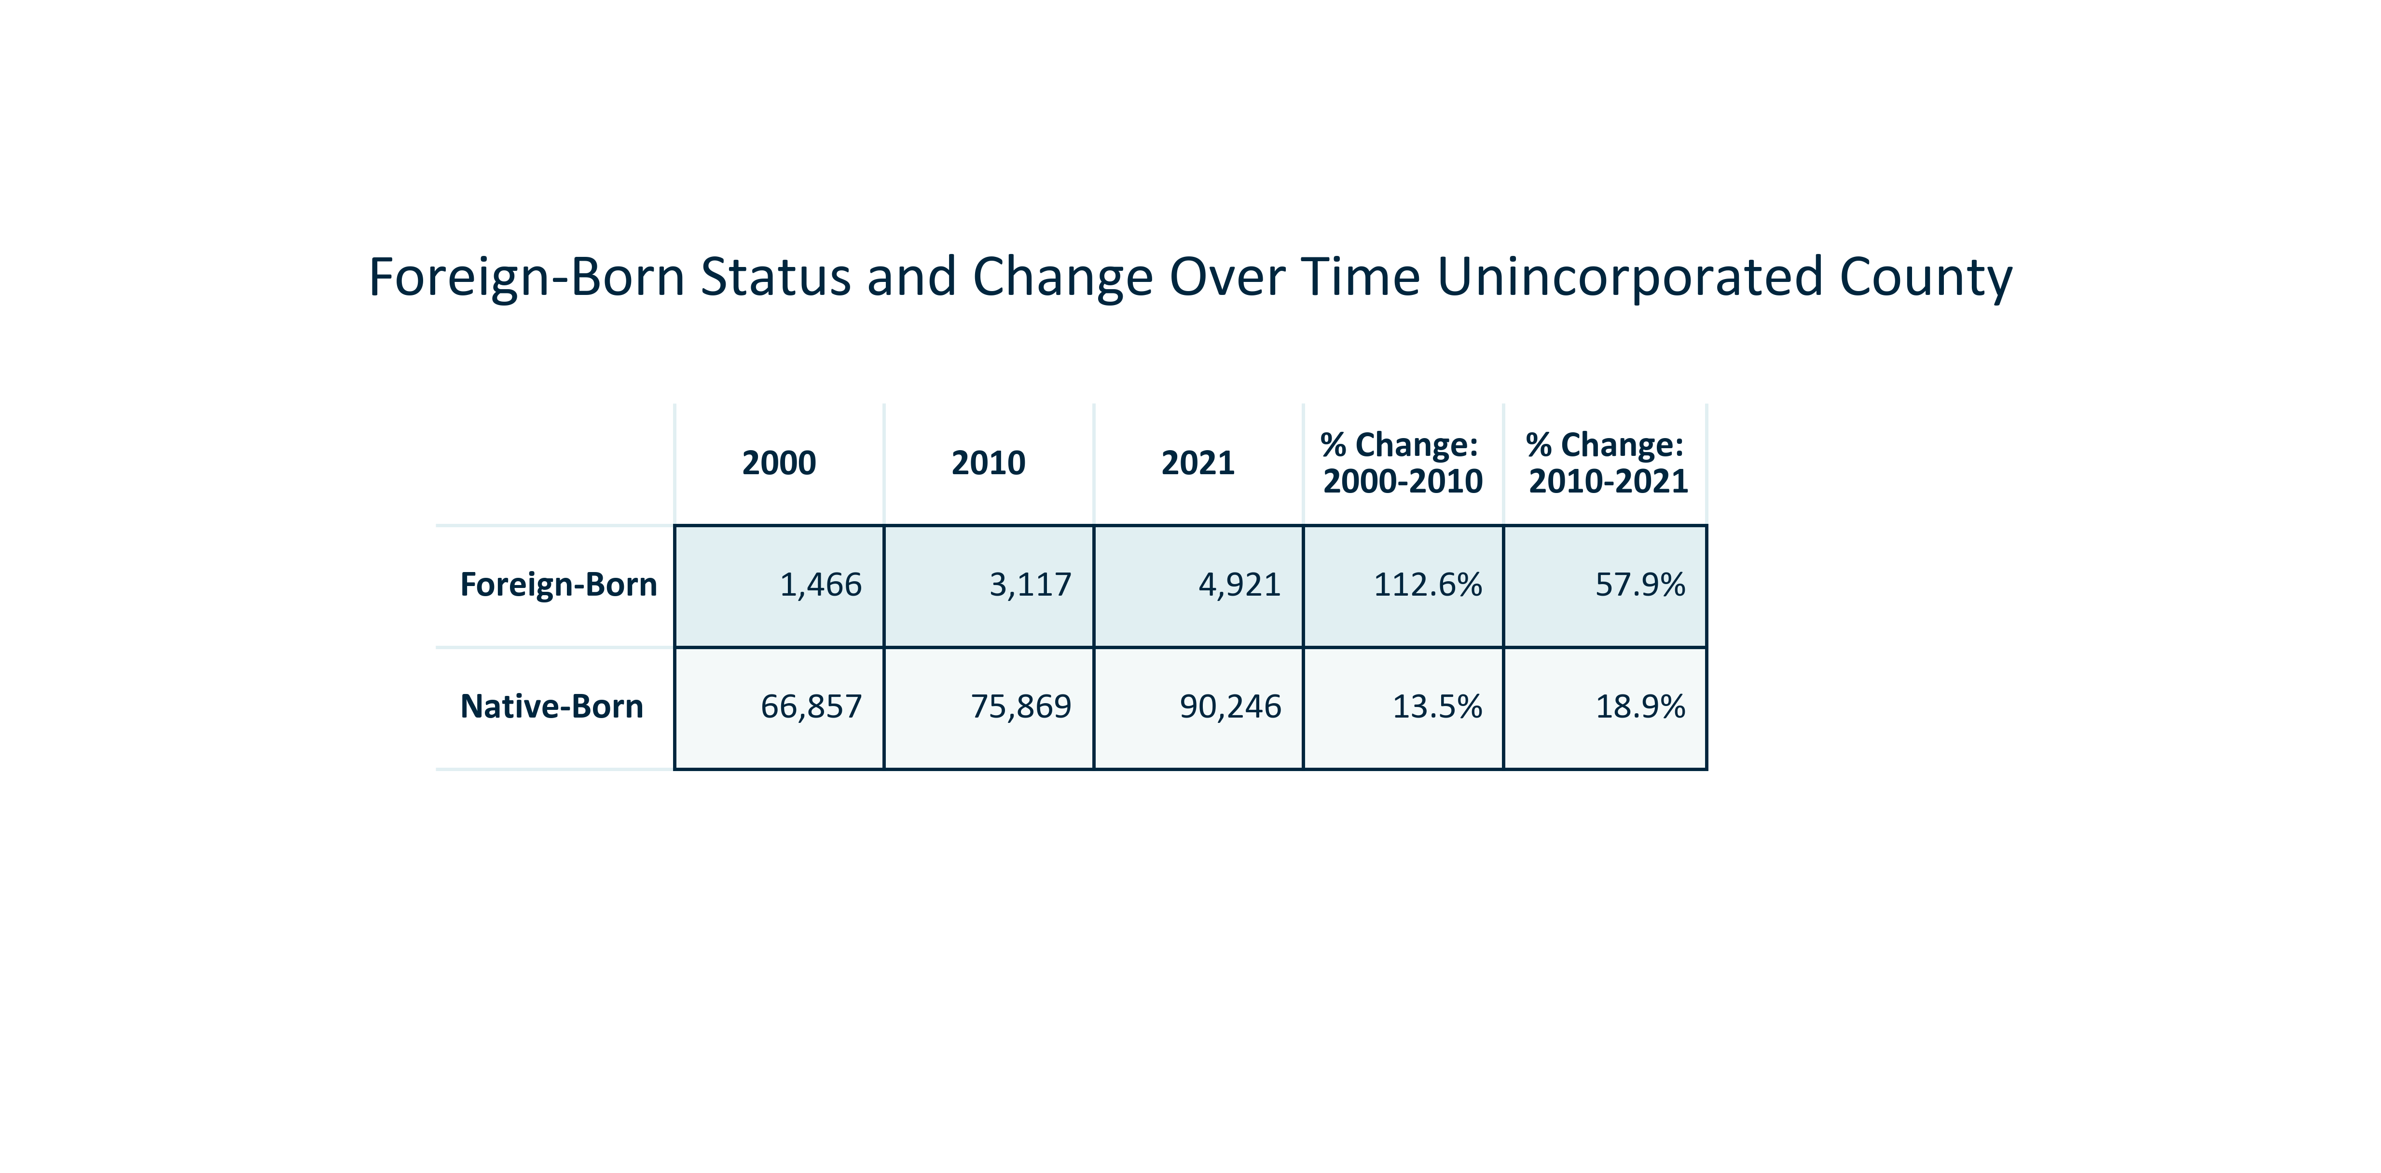

Citation: 2000 Decennial Census, 2006-2010 and 2017-2021 ACS 5-Year Estimates

### FOREIGNBORN_table_primarygeo_foreignbornorigin_overtime:

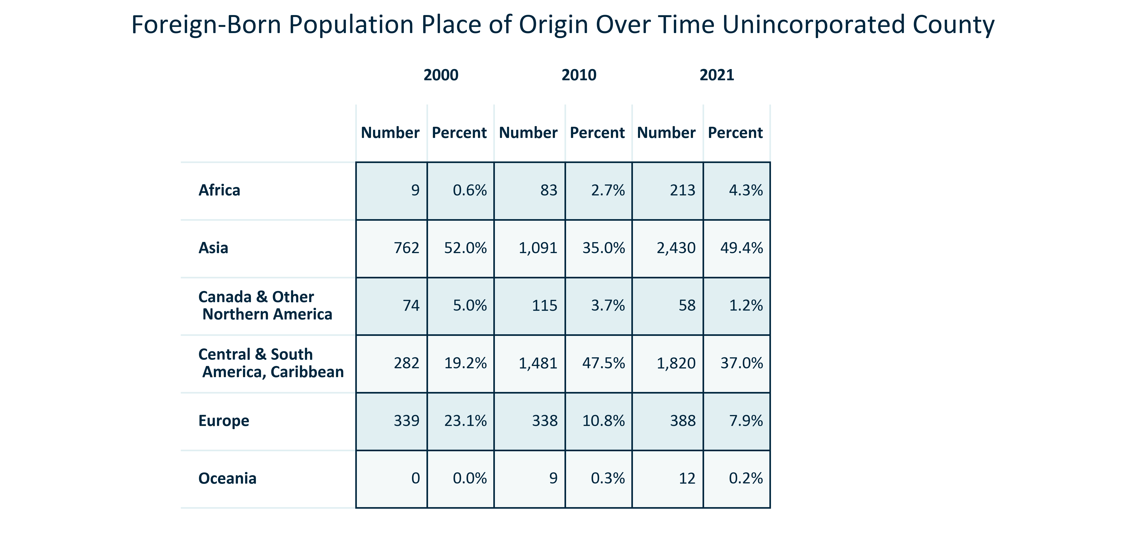

Citation: 2000, 2010, and 2020 Decennial Census

### FOREIGNBORN_table_geocomparative_percentplaceoforigin_2000:

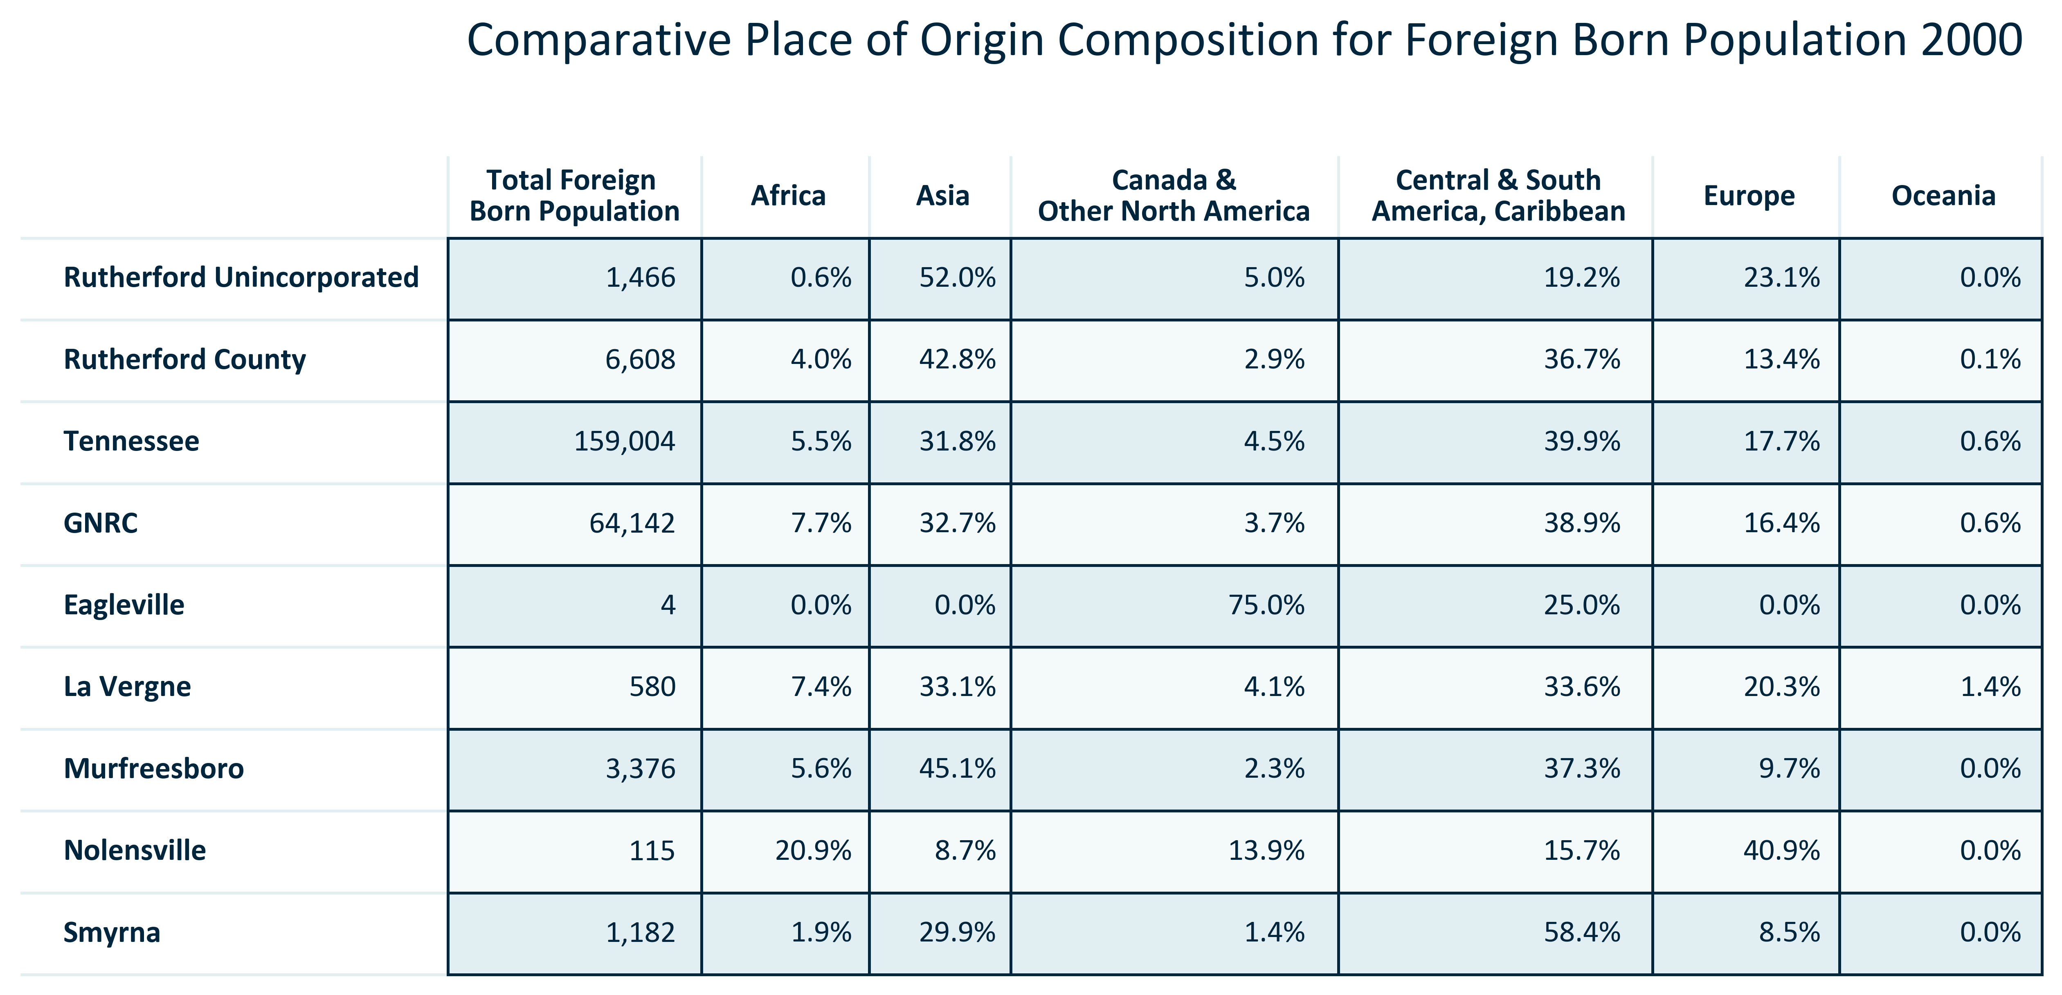

Citation: 2000 Decennial Census

### FOREIGNBORN_table_geocomparative_numberplaceoforigin_2000:

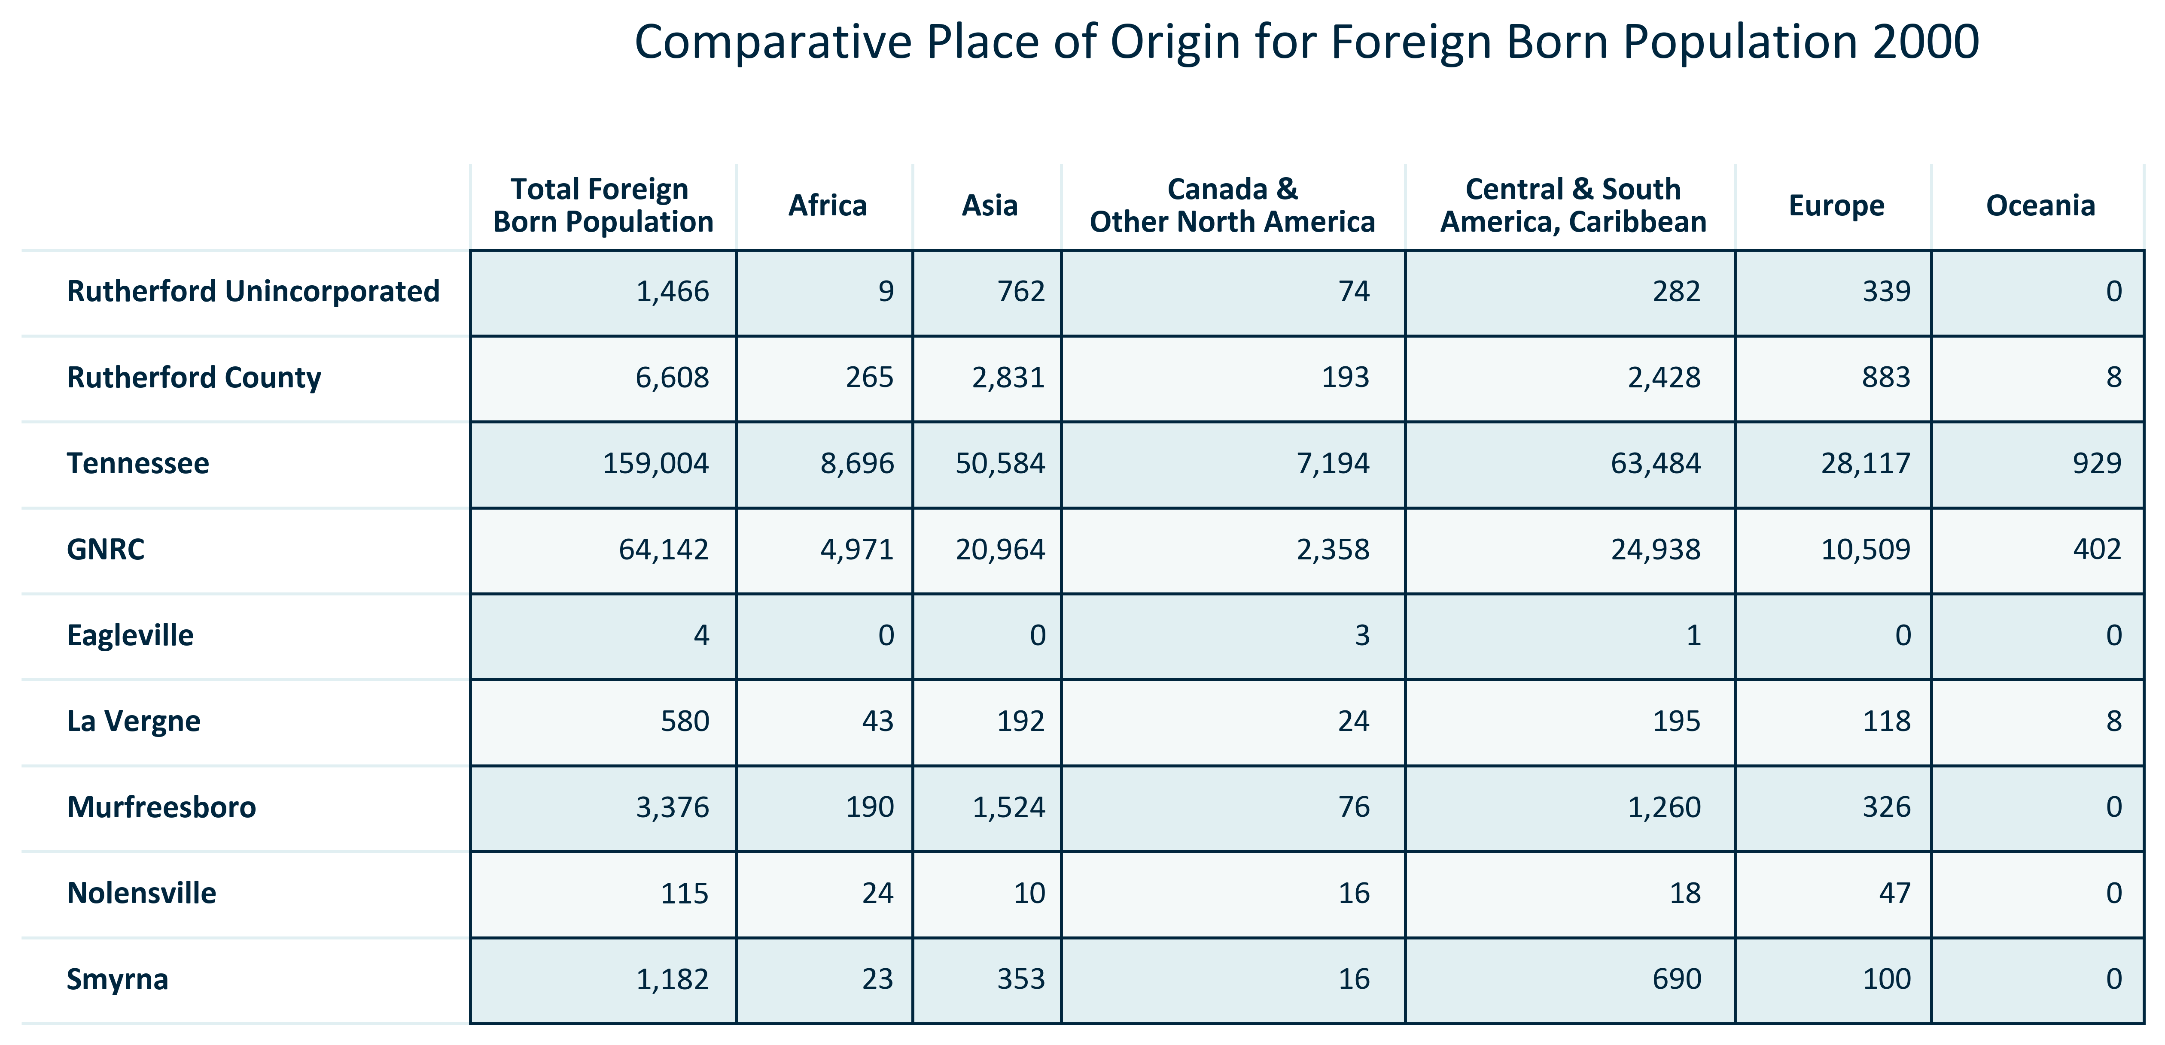

Citation: 2000 Decennial Census

### FOREIGNBORN_table_geocomparative_percentplaceoforigin_2010:

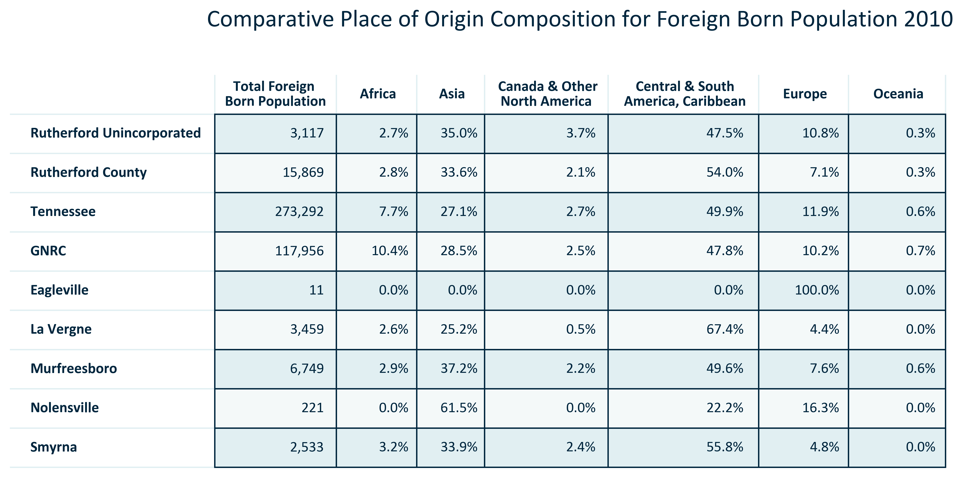

Citation: 2006-2010 American Community Survey 5-Year Estimates

### FOREIGNBORN_table_geocomparative_numberplaceoforigin_2010:

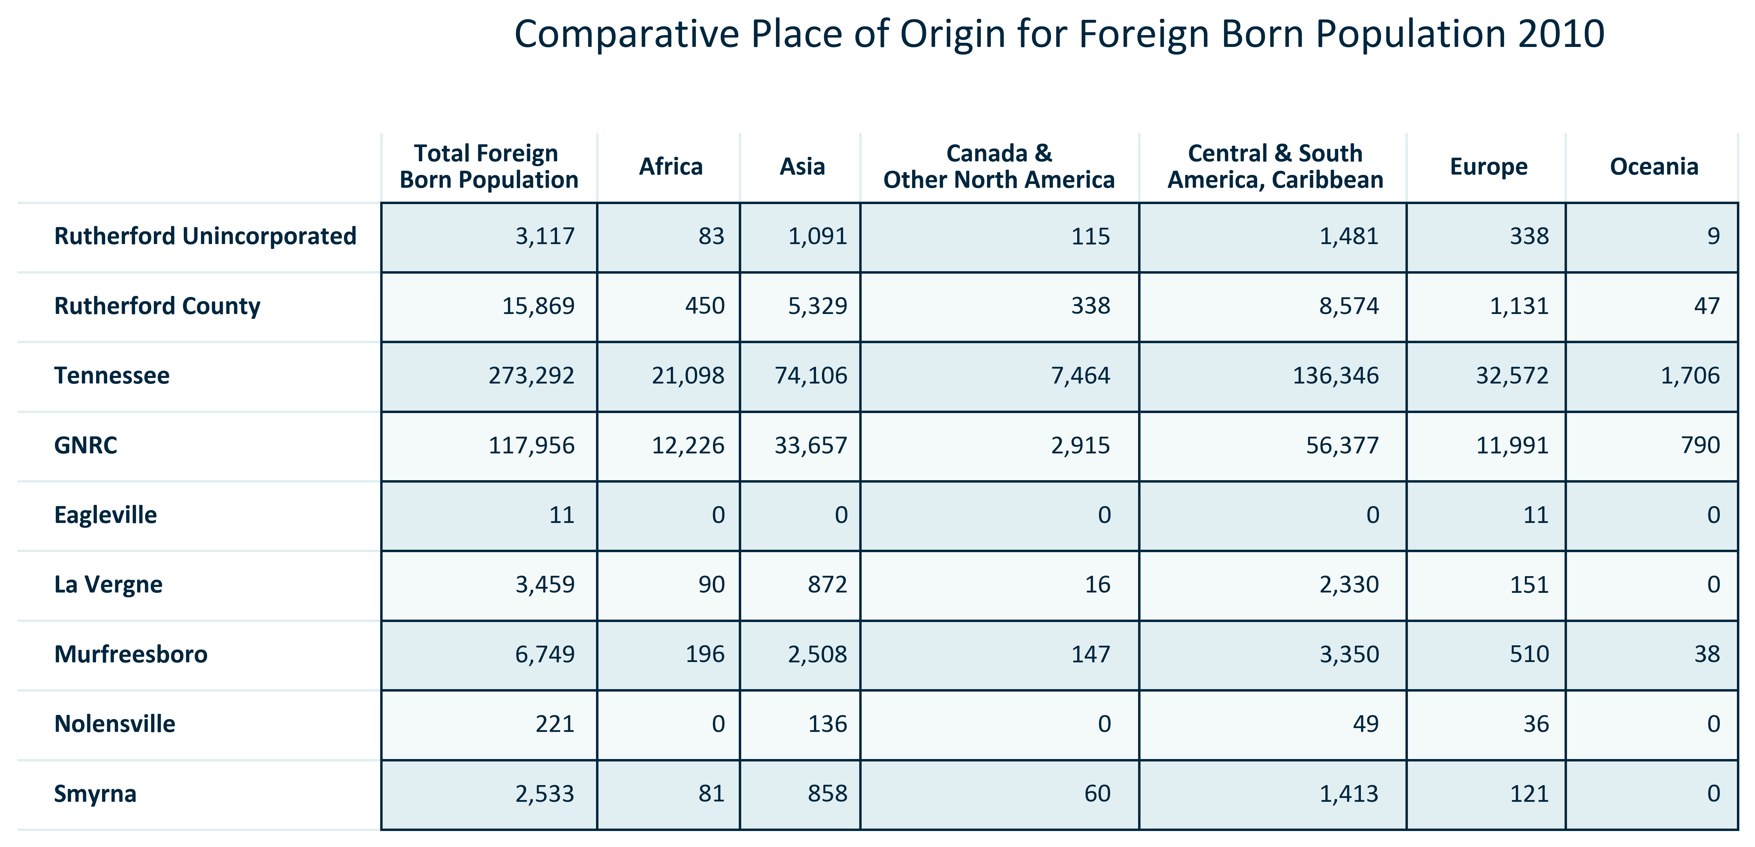

Citation: 2006-2010 American Community Survey 5-Year Estimates

### FOREIGNBORN_table_geocomparative_percentplaceoforigin_2021:

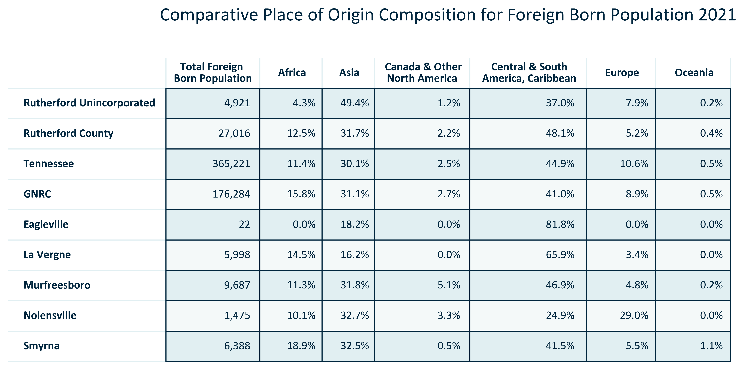

Citation: 2017-2021 American Community Survey 5-Year Estimates

### FOREIGNBORN_table_geocomparative_numberplaceoforigin_2021:

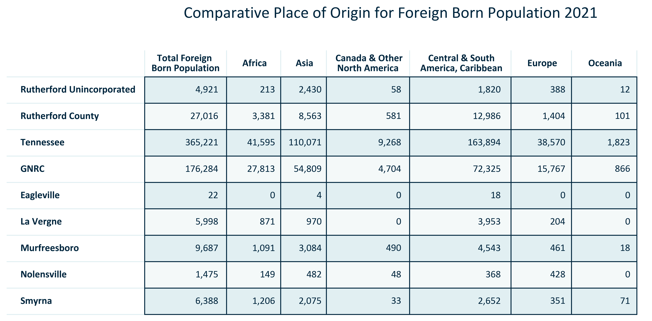

Citation: 2017-2021 American Community Survey 5-Year Estimates

### FOREIGNBORN_table_geocomparative_allchangeforeignborn_overtime:

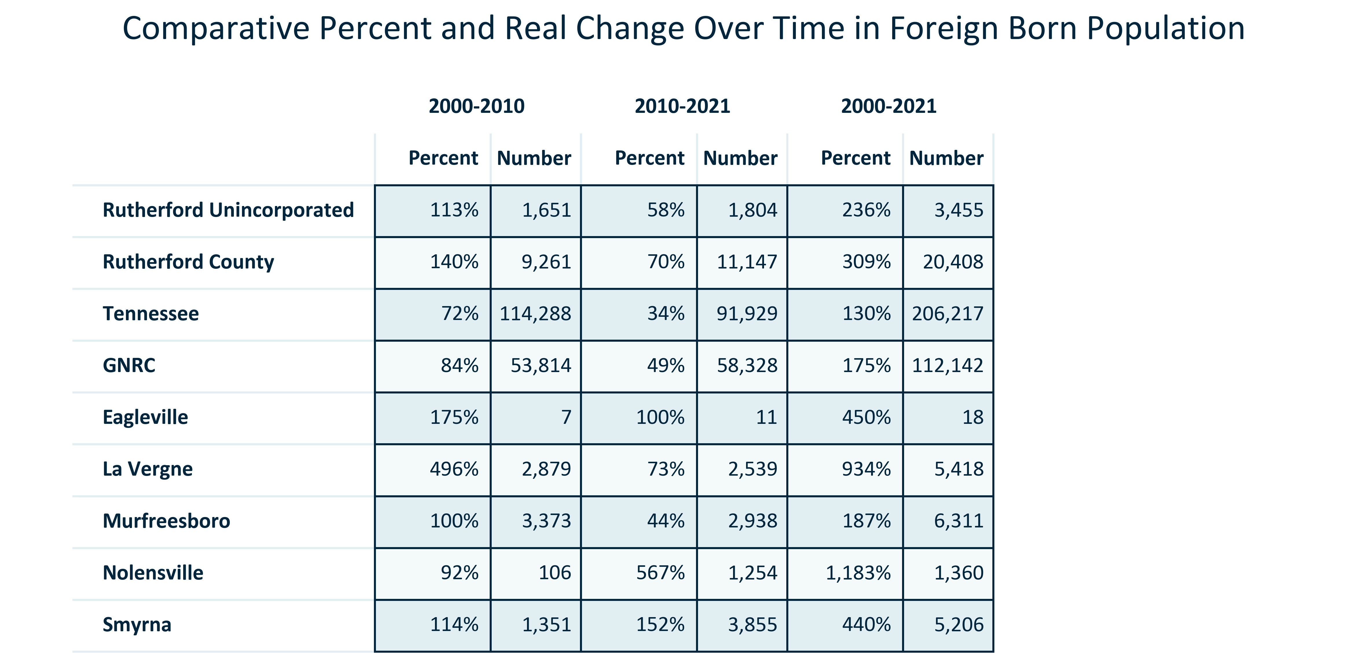

Citation: 2000 Decennial Census, 2006-2010 and 2017-2021 ACS 5-Year Estimates

### FOREIGNBORN_clusterbar_geocomparative_realchangetotalvsforeignborn_overtime:

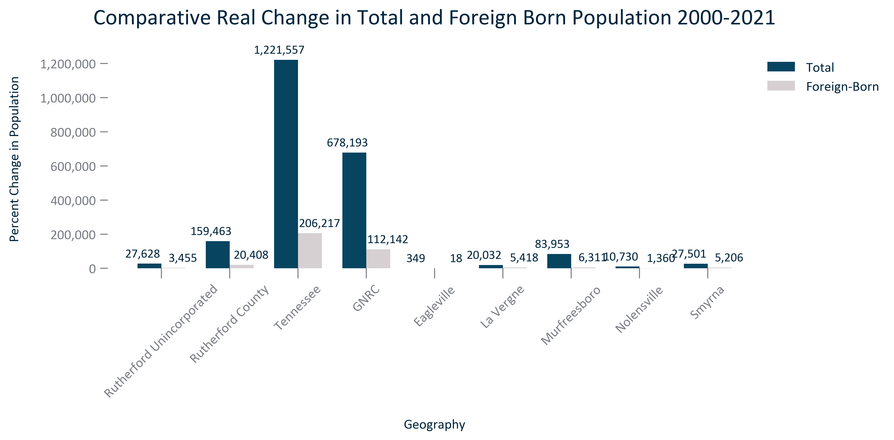

Citation: 2000 Decennial Census, 2017-2021 ACS 5-Year Estimates, 2020 PL

### FOREIGNBORN_clusterbar_geocomparative_percentchangetotalvsforeignborn_overtime:

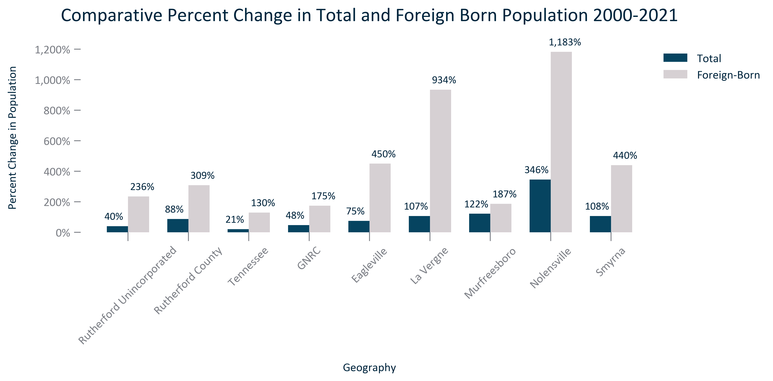

Citation: 2000 Decennial Census, 2017-2021 ACS 5-Year Estimates, 2020 PL

### FOREIGNBORN_stackedbar_primarygeo_sharefbcitizenandnot_overtime:

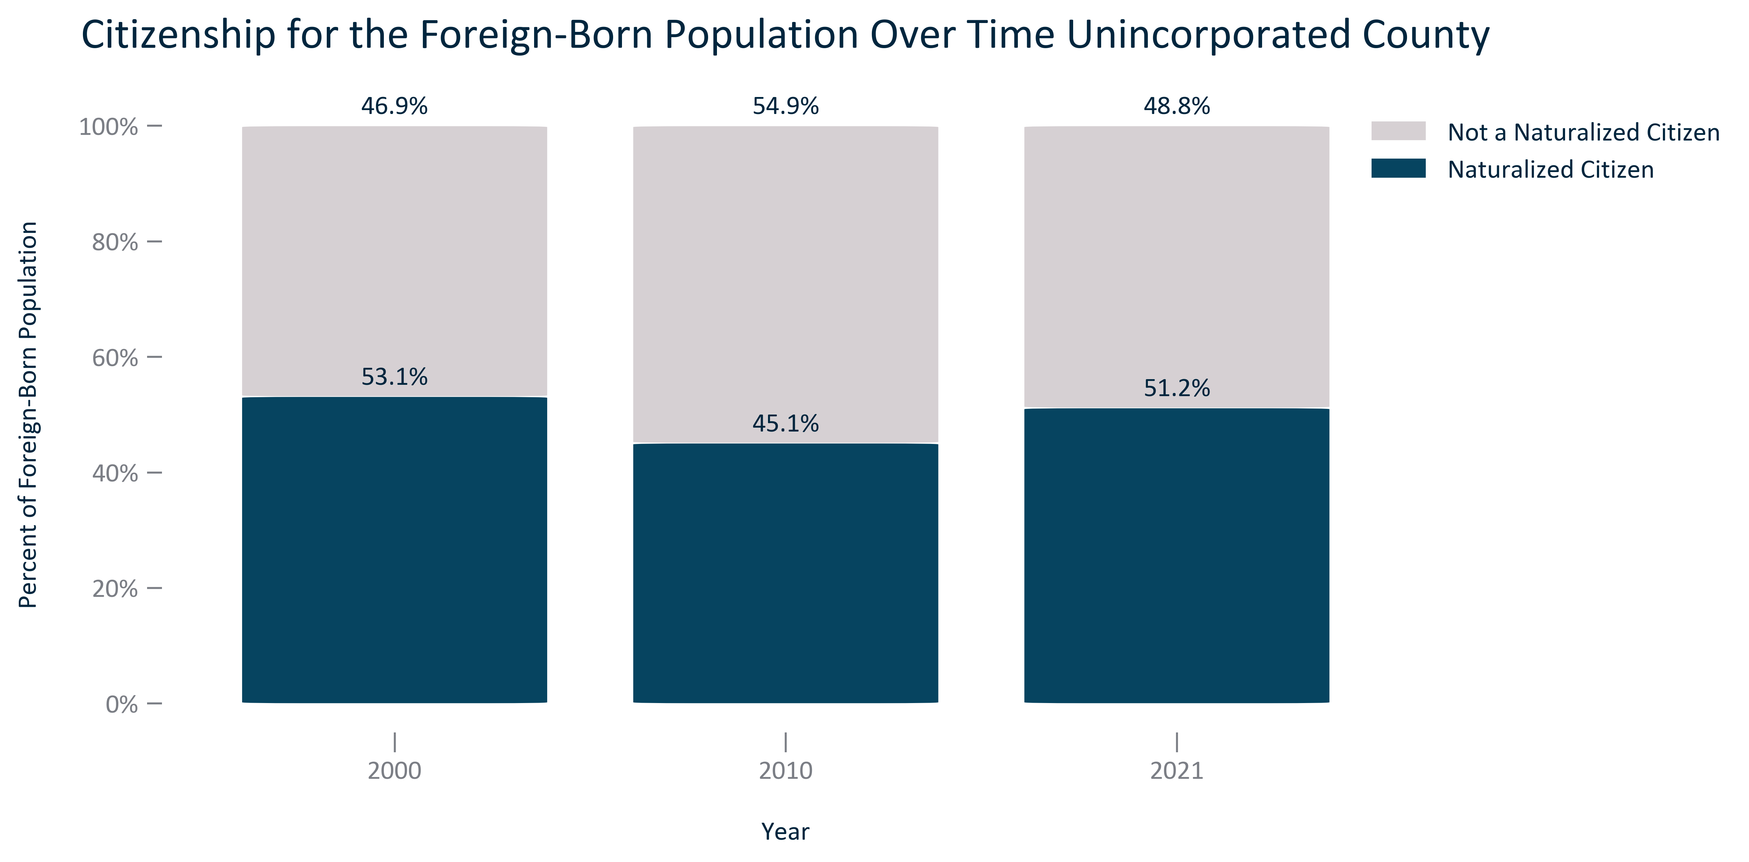

Citation: 2000 Decennial Census, 2006-2010 and 2017-2021 ACS 5-Year Estimates

### FOREIGNBORN_table_primarygeo_citizenshipstatus_overtime:

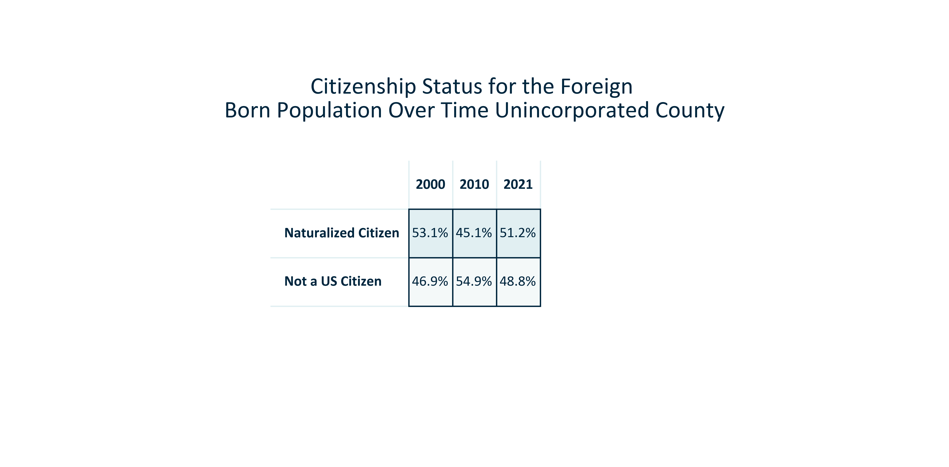

Citation: 2000 Decennial Census, 2006-2010 and 2017-2021 ACS 5-Year Estimates

# Language

### LANGUAGE_stackedbar_primarygeo_shareenglishornon_overtime:

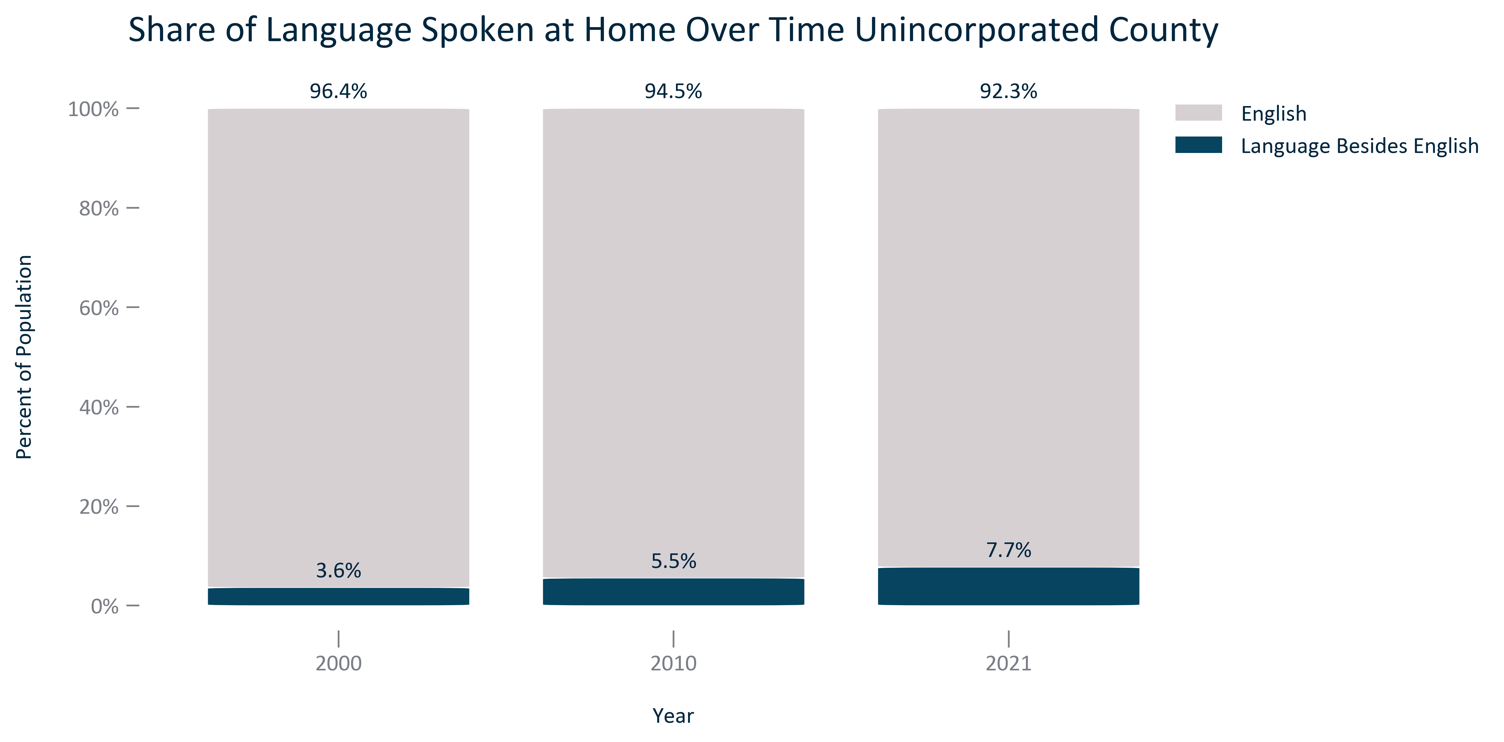

Citation: 2000 Decennial Census, 2006-2010 and 2017-2021 ACS 5-Year Estimates

### LANGUAGE_stackedbar_primarygeo_sharenonenglishlanguages_overtime:

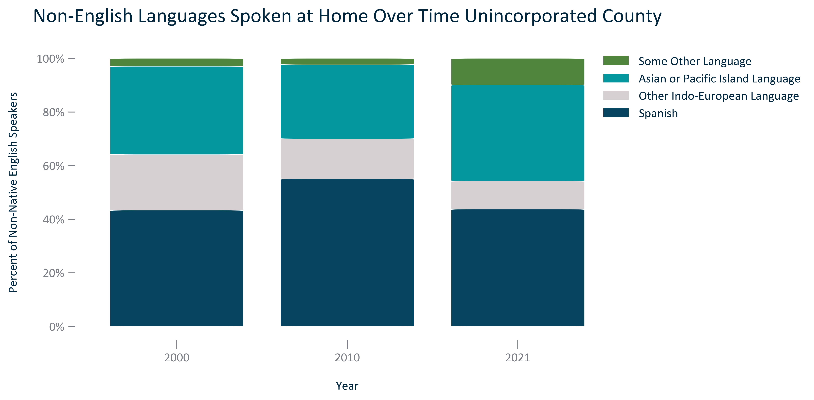

Citation: 2000 Decennial Census, 2006-2010 and 2017-2021 ACS 5-Year Estimates

### LANGUAGE_table_primarygeo_languagebesidesenglish_2021:

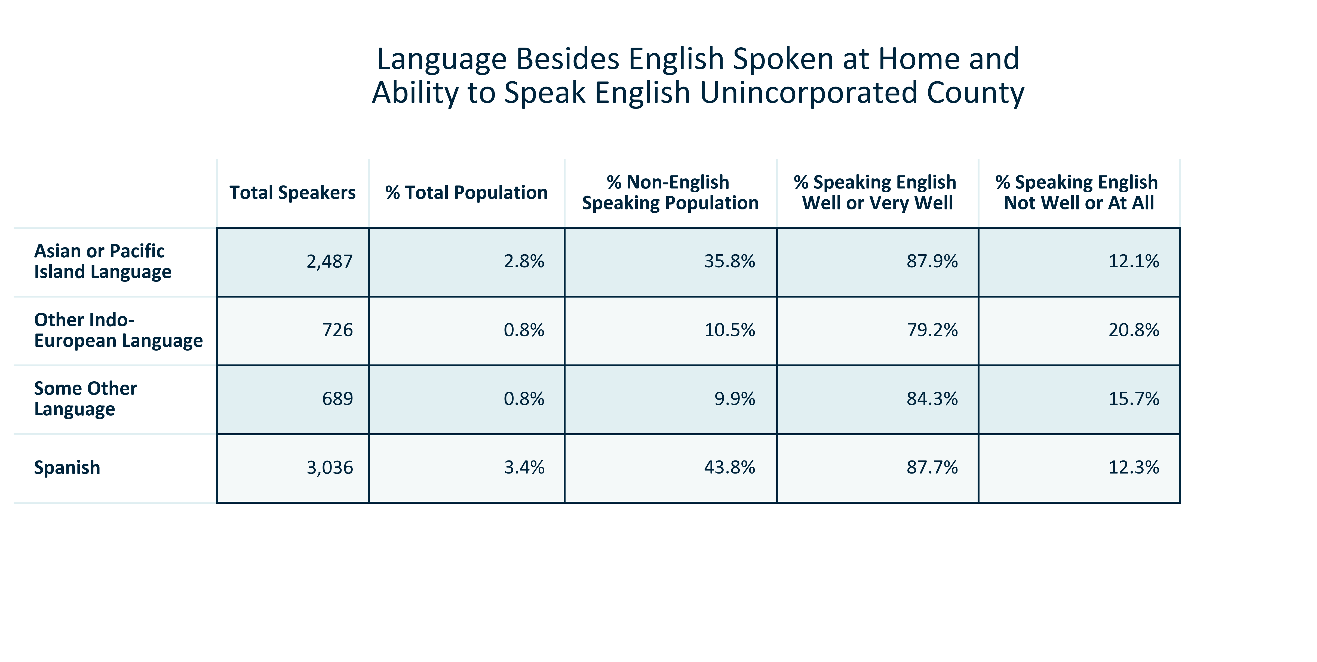

Citation: 2017-2021 ACS 5-Year Estimates

### LANGUAGE_table_primarygeo_languagespokenathome_overtime:

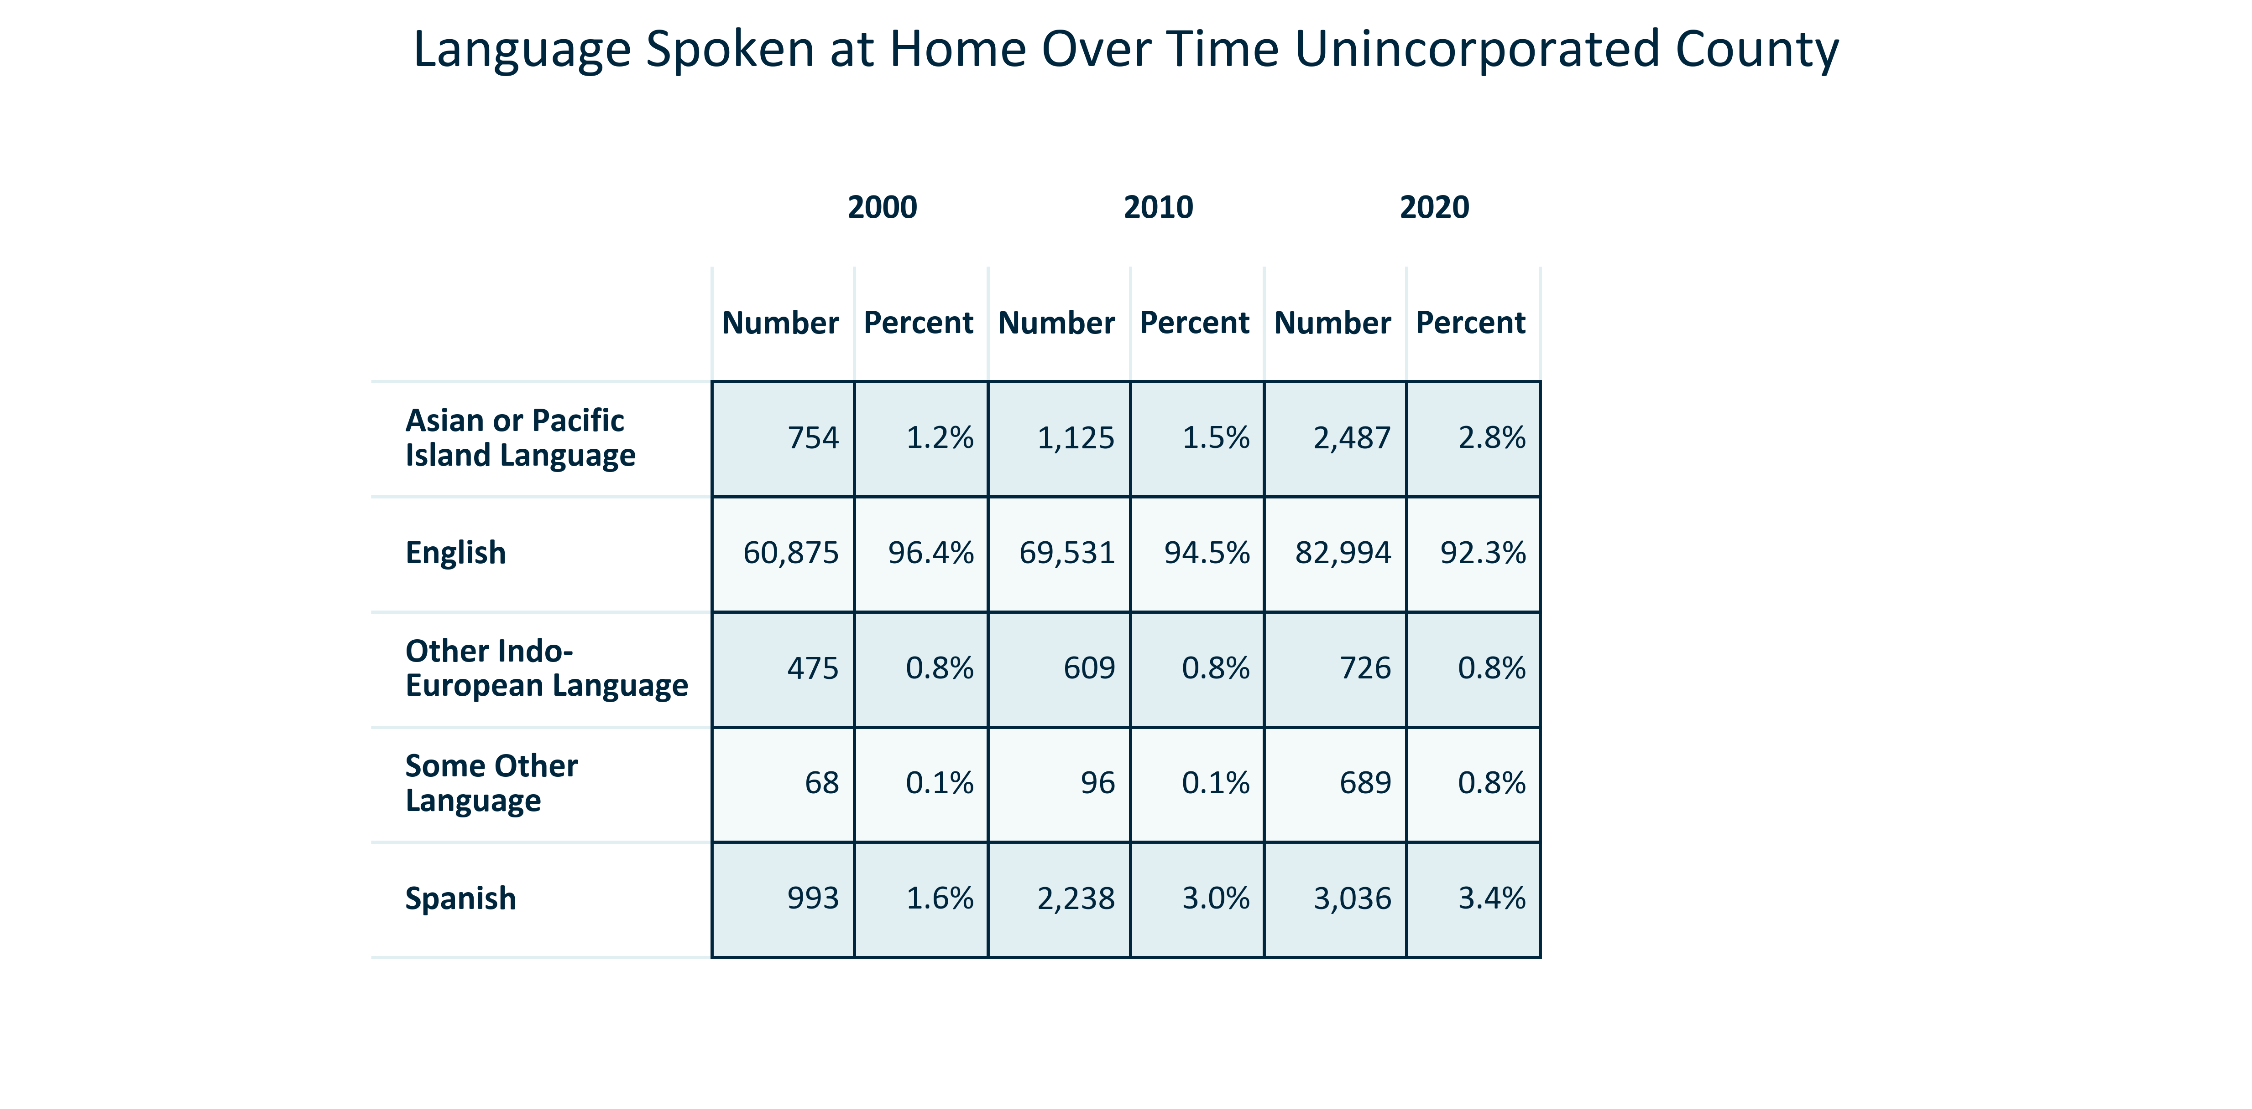

Citation: 2000 Decennial Census, 2006-2010 and 2017-2021 ACS 5-Year Estimates

### LANGUAGE_bar_primarygeo_englishwellorverywell_2021:

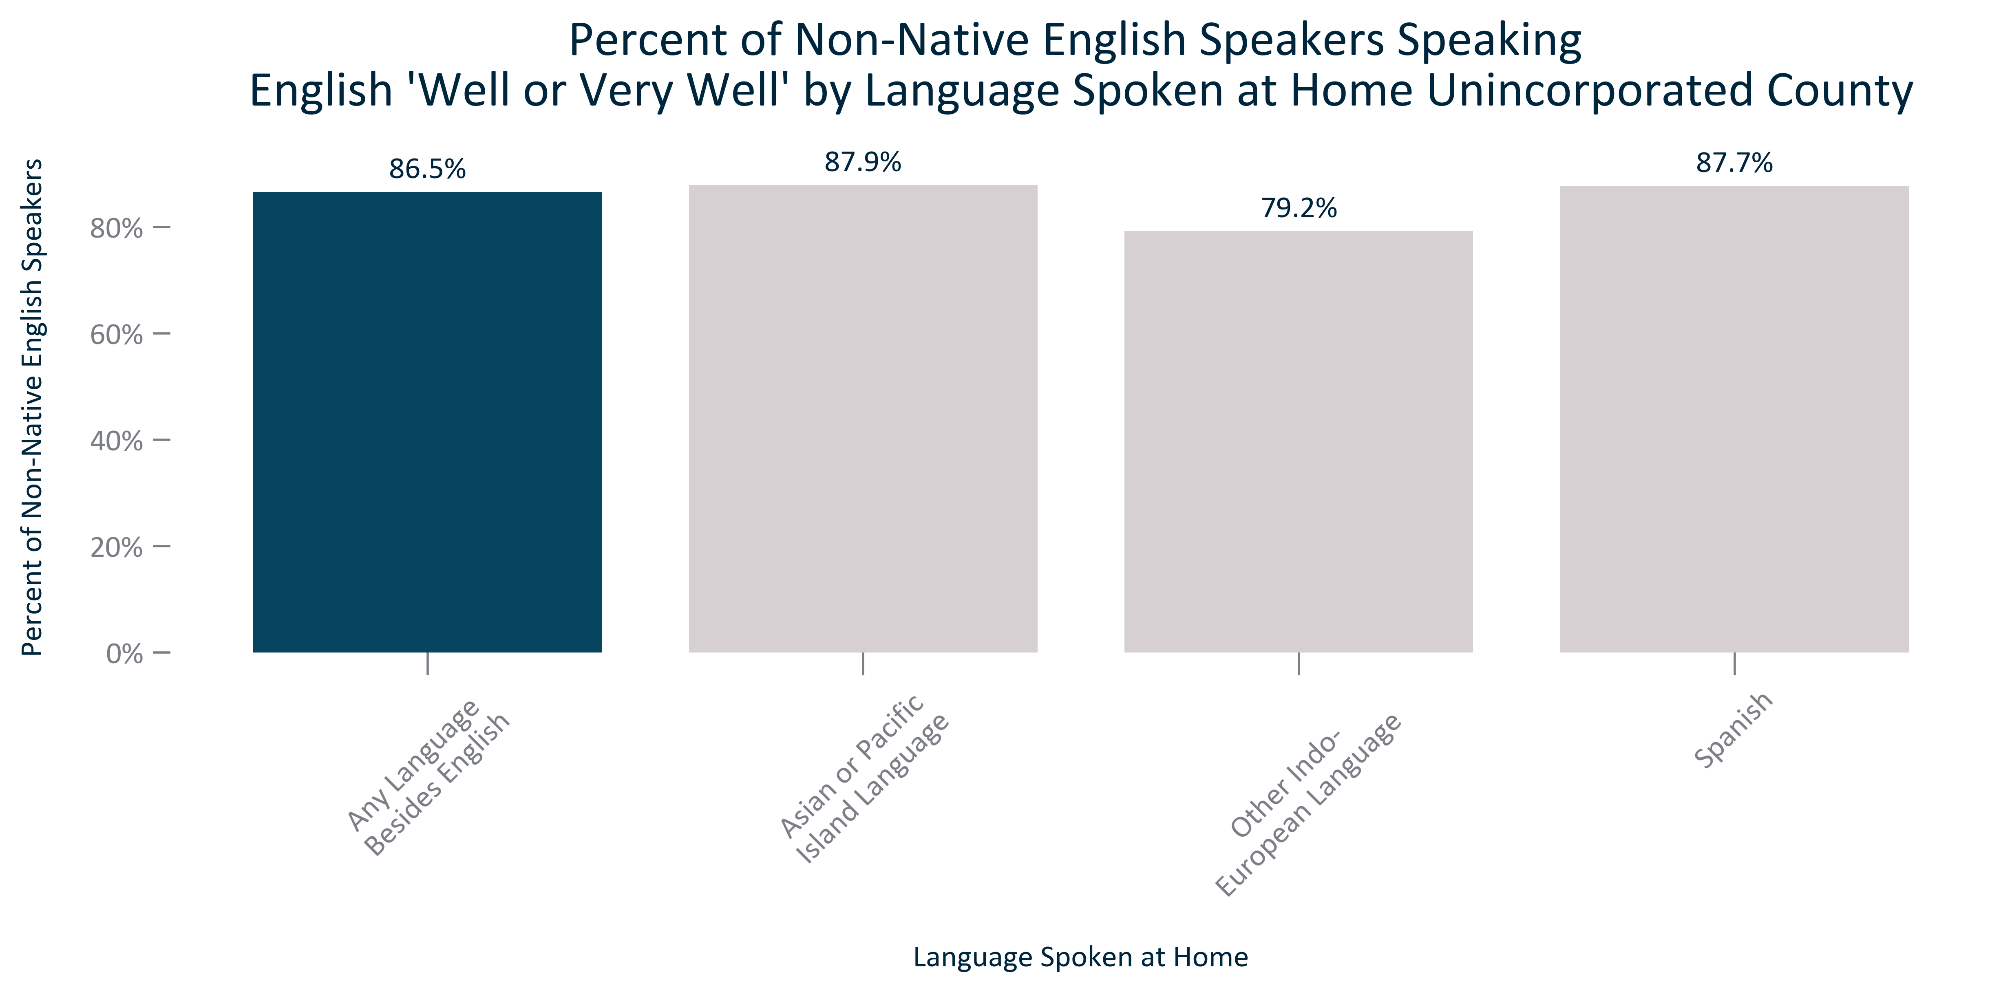

Citation: 2017-2021 ACS 5-Year Estimates

### LANGUAGE_bar_primarygeo_englishnotwelloratall_2021:

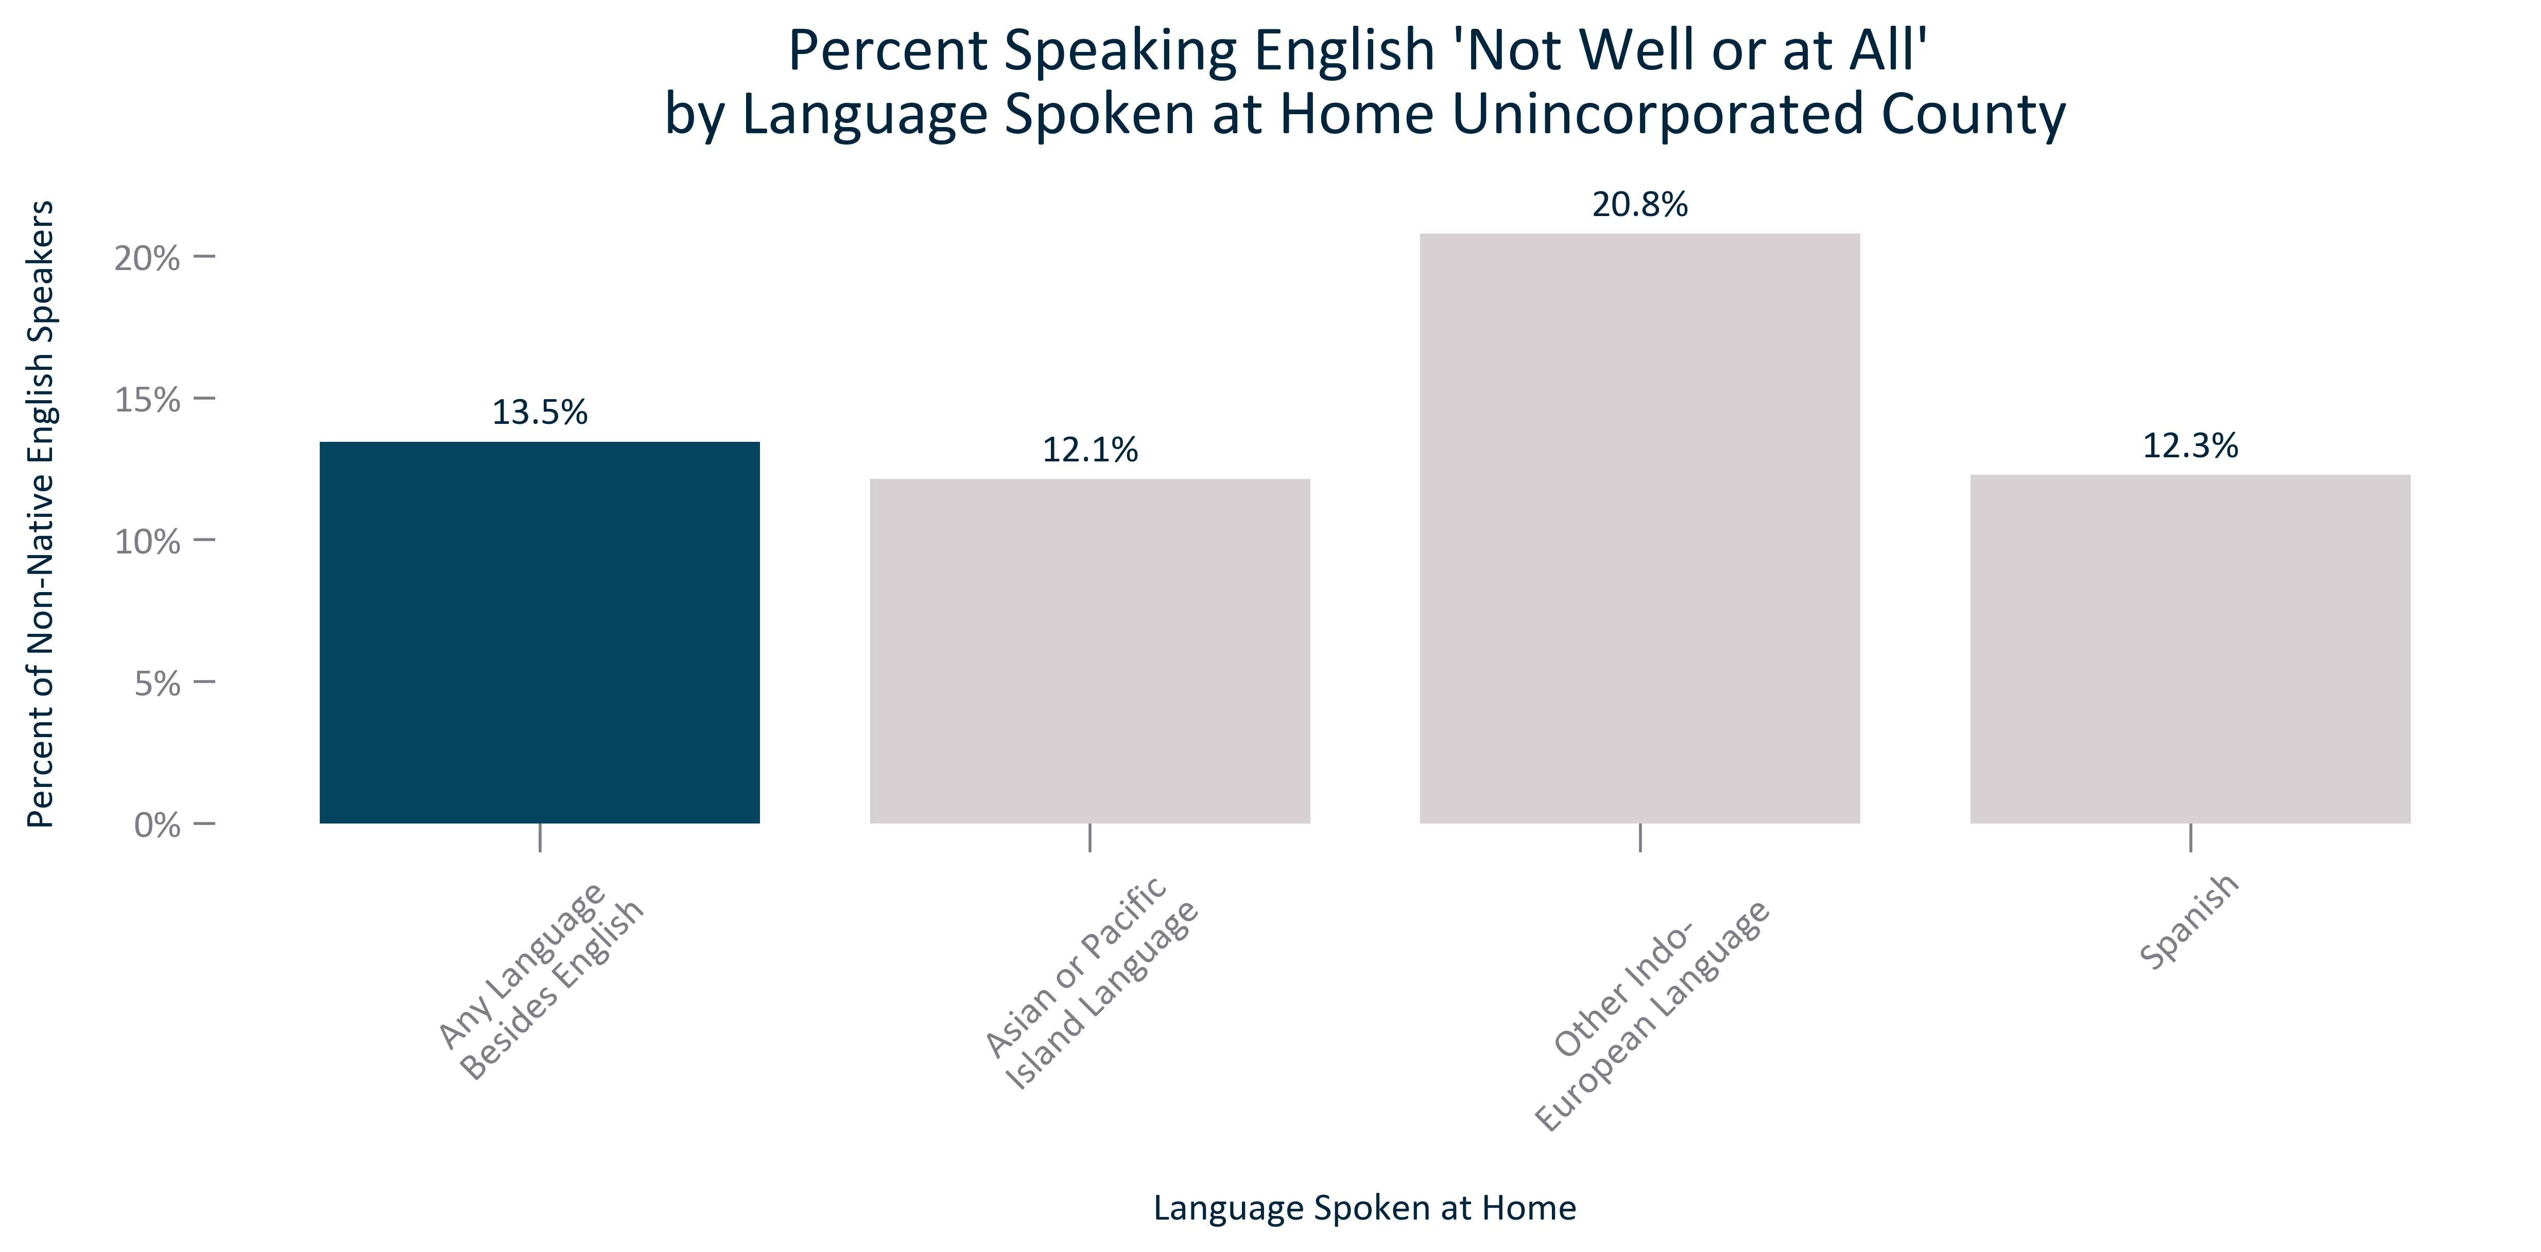

Citation: 2017-2021 ACS 5-Year Estimates

### LANGUAGE_table_geocomparative_englishornon_overtime:

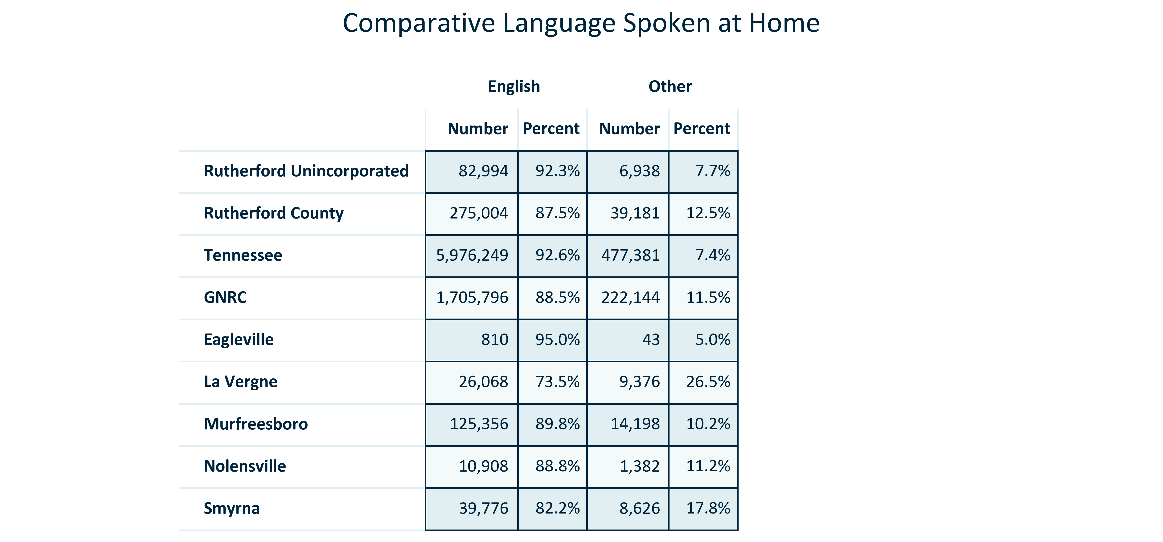

Citation: 2017-2021 American Community Survey 5-Year Estimates

# Poverty

### POVERTY_bar_primarygeo_populationbelowpovertylevel_overtime:

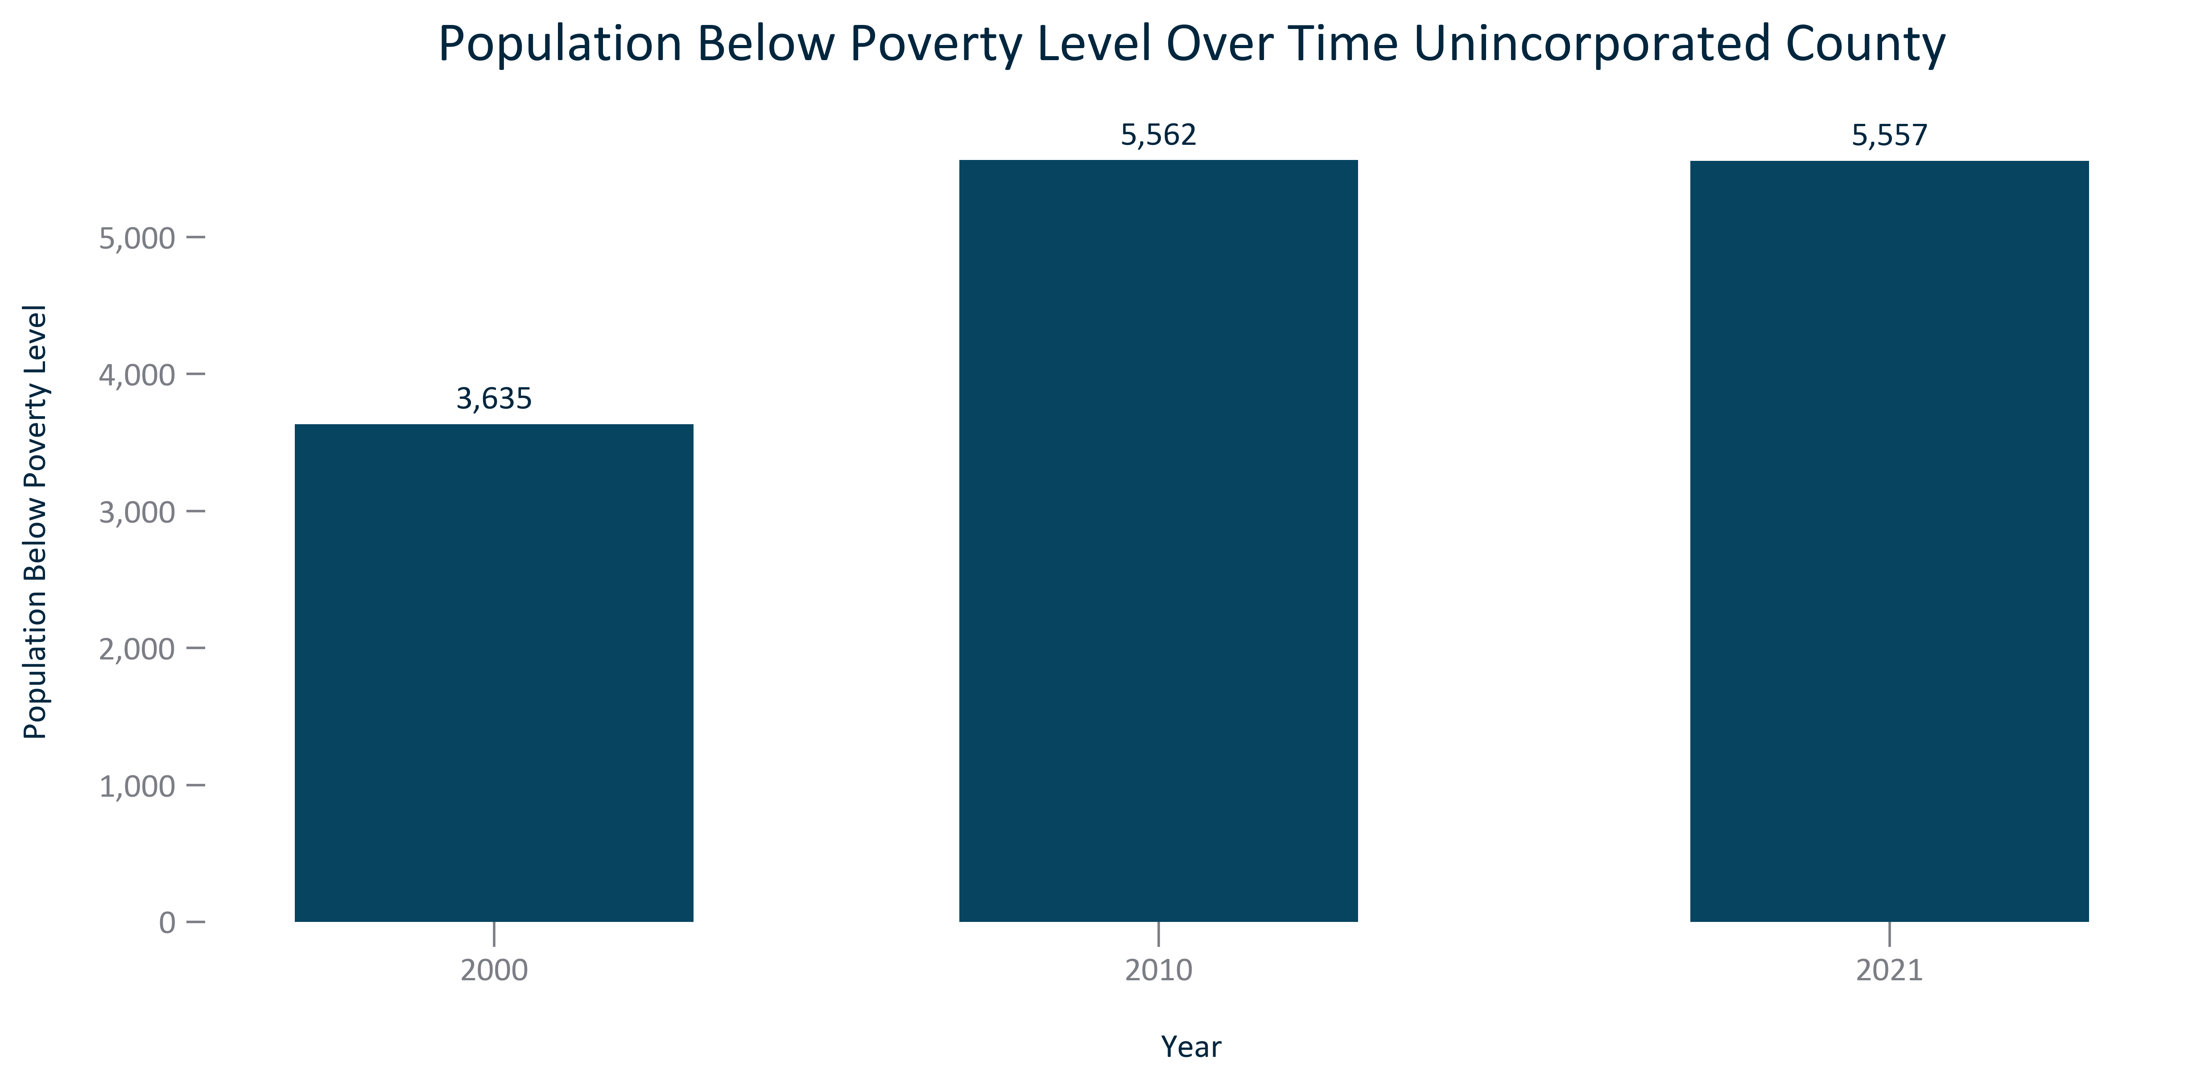

Citation: 2000 Decennial Census, 2006-2010 and 2017-2021 ACS 5-Year Estimates

### POVERTY_bar_primarygeo_percentpopulationbelowpovertylevel_overtime:

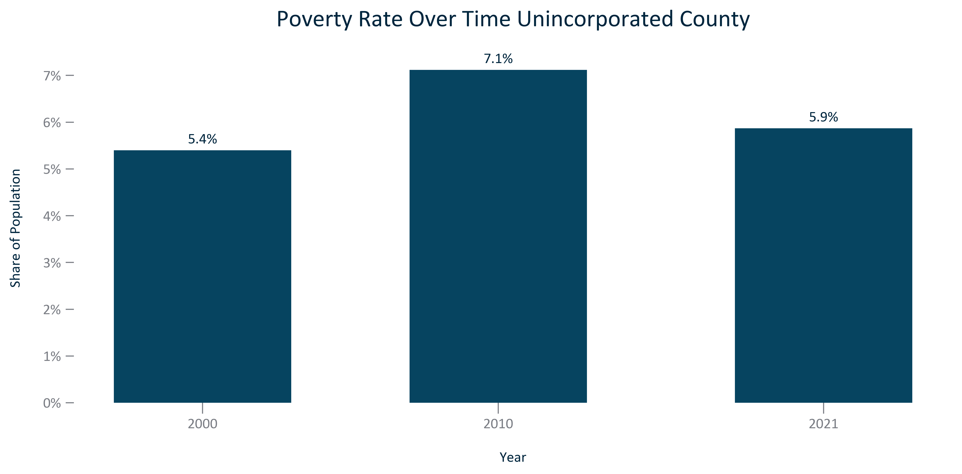

Citation: 2000 Decennial Census, 2006-2010 and 2017-2021 ACS 5-Year Estimates

### POVERTY_bar_geocomparative_povertyrate_2021:

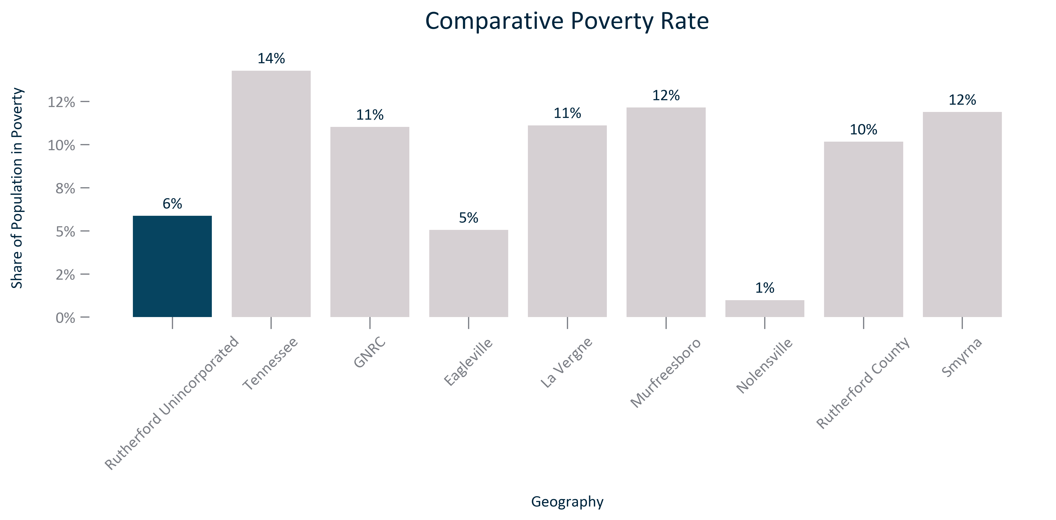

Citation: 2017-2021 ACS 5-Year Estimates

### POVERTY_line_geocomparative_sharebelowpovertylevel_overtime:

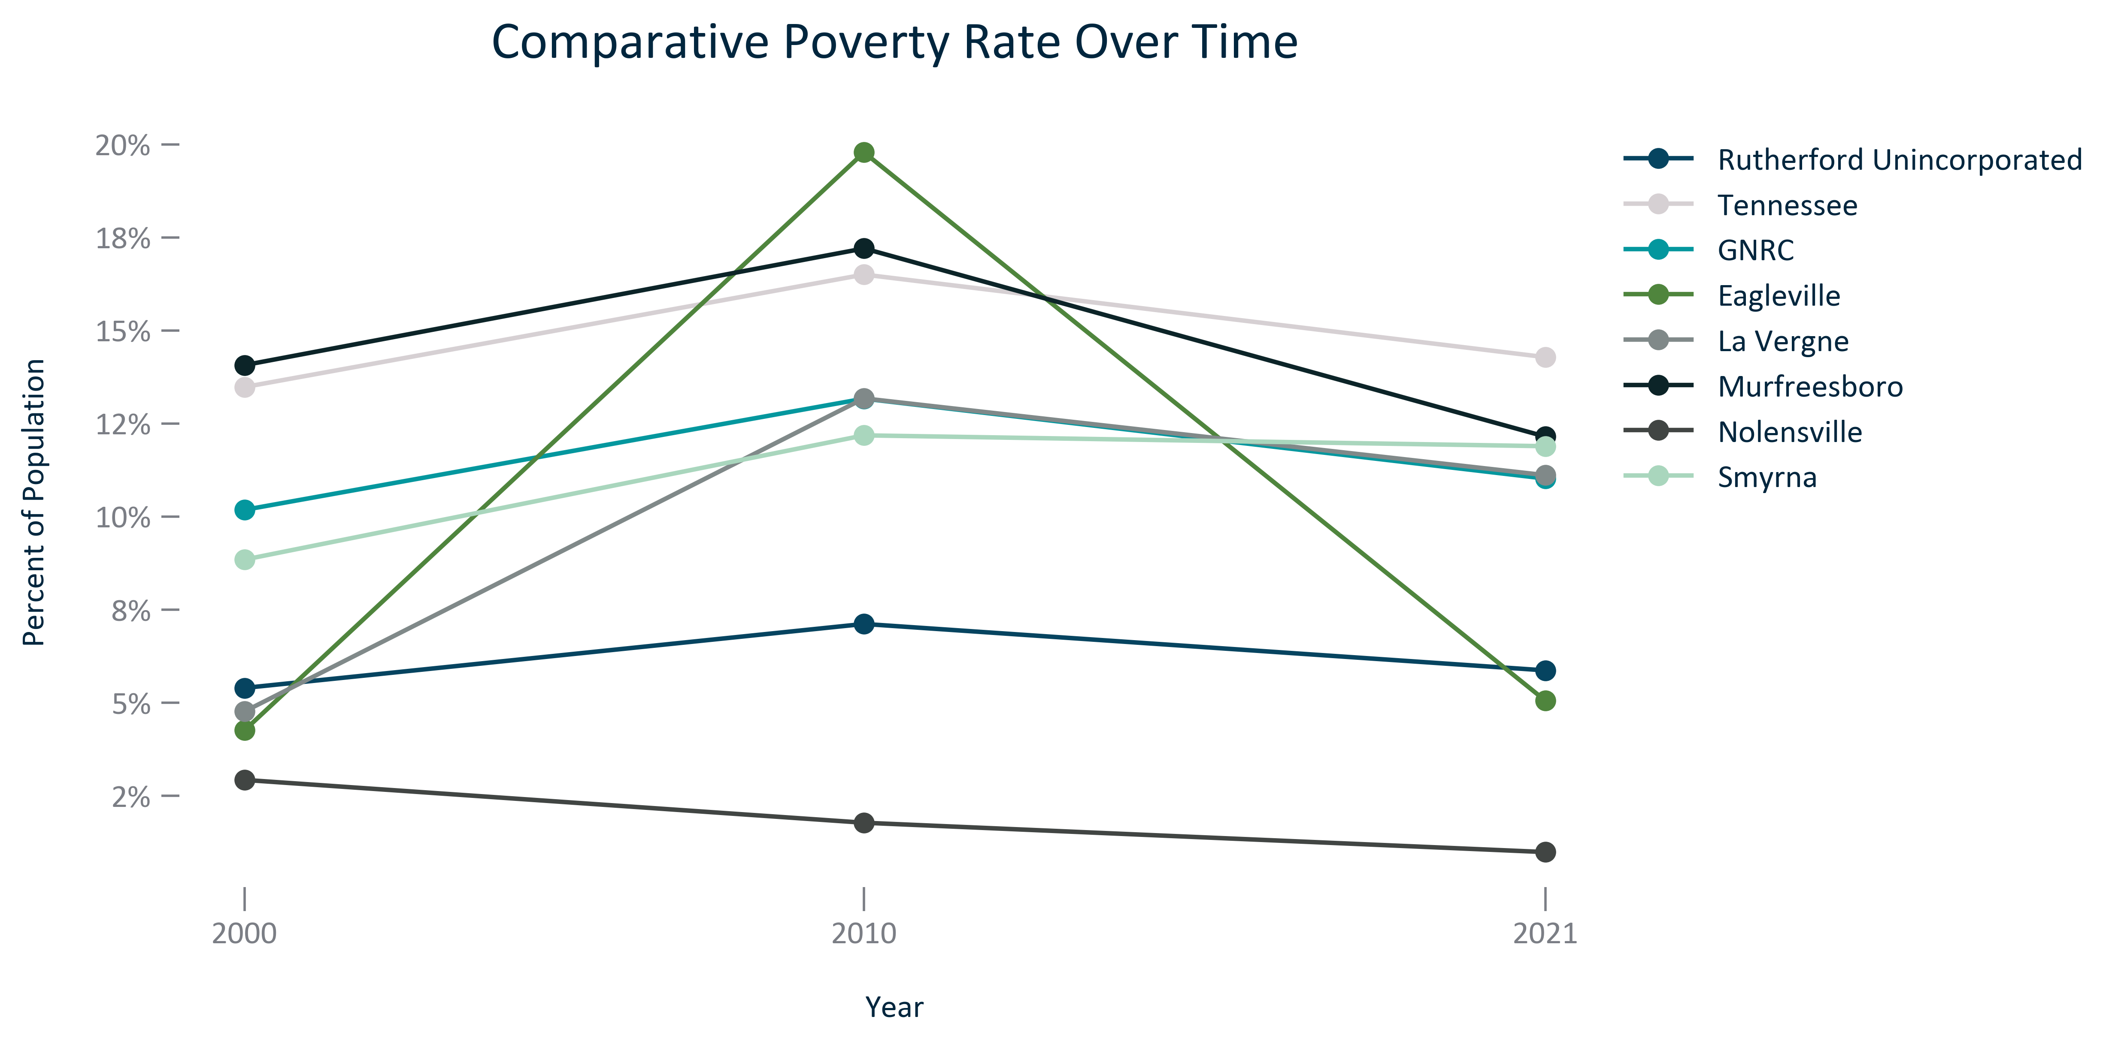

Citation: 2000 Decennial Census, 2006-2010 and 2016-2020 ACS 5-Year Estimates

### POVERTY_table_geocomparative_rateandchange_overtime:

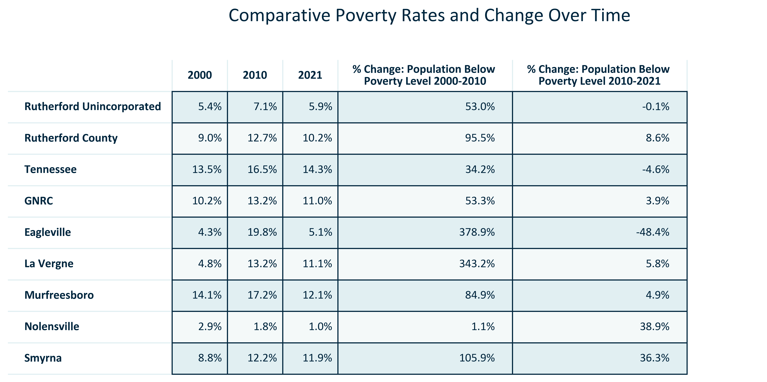

Citation: 2000 Decennial Census, 2006-2010 and 2017-2021 ACS 5-Year Estimates

### POVERTY_clusterbar_primarygeo_u18popsharevspovertypopshare_overtime:

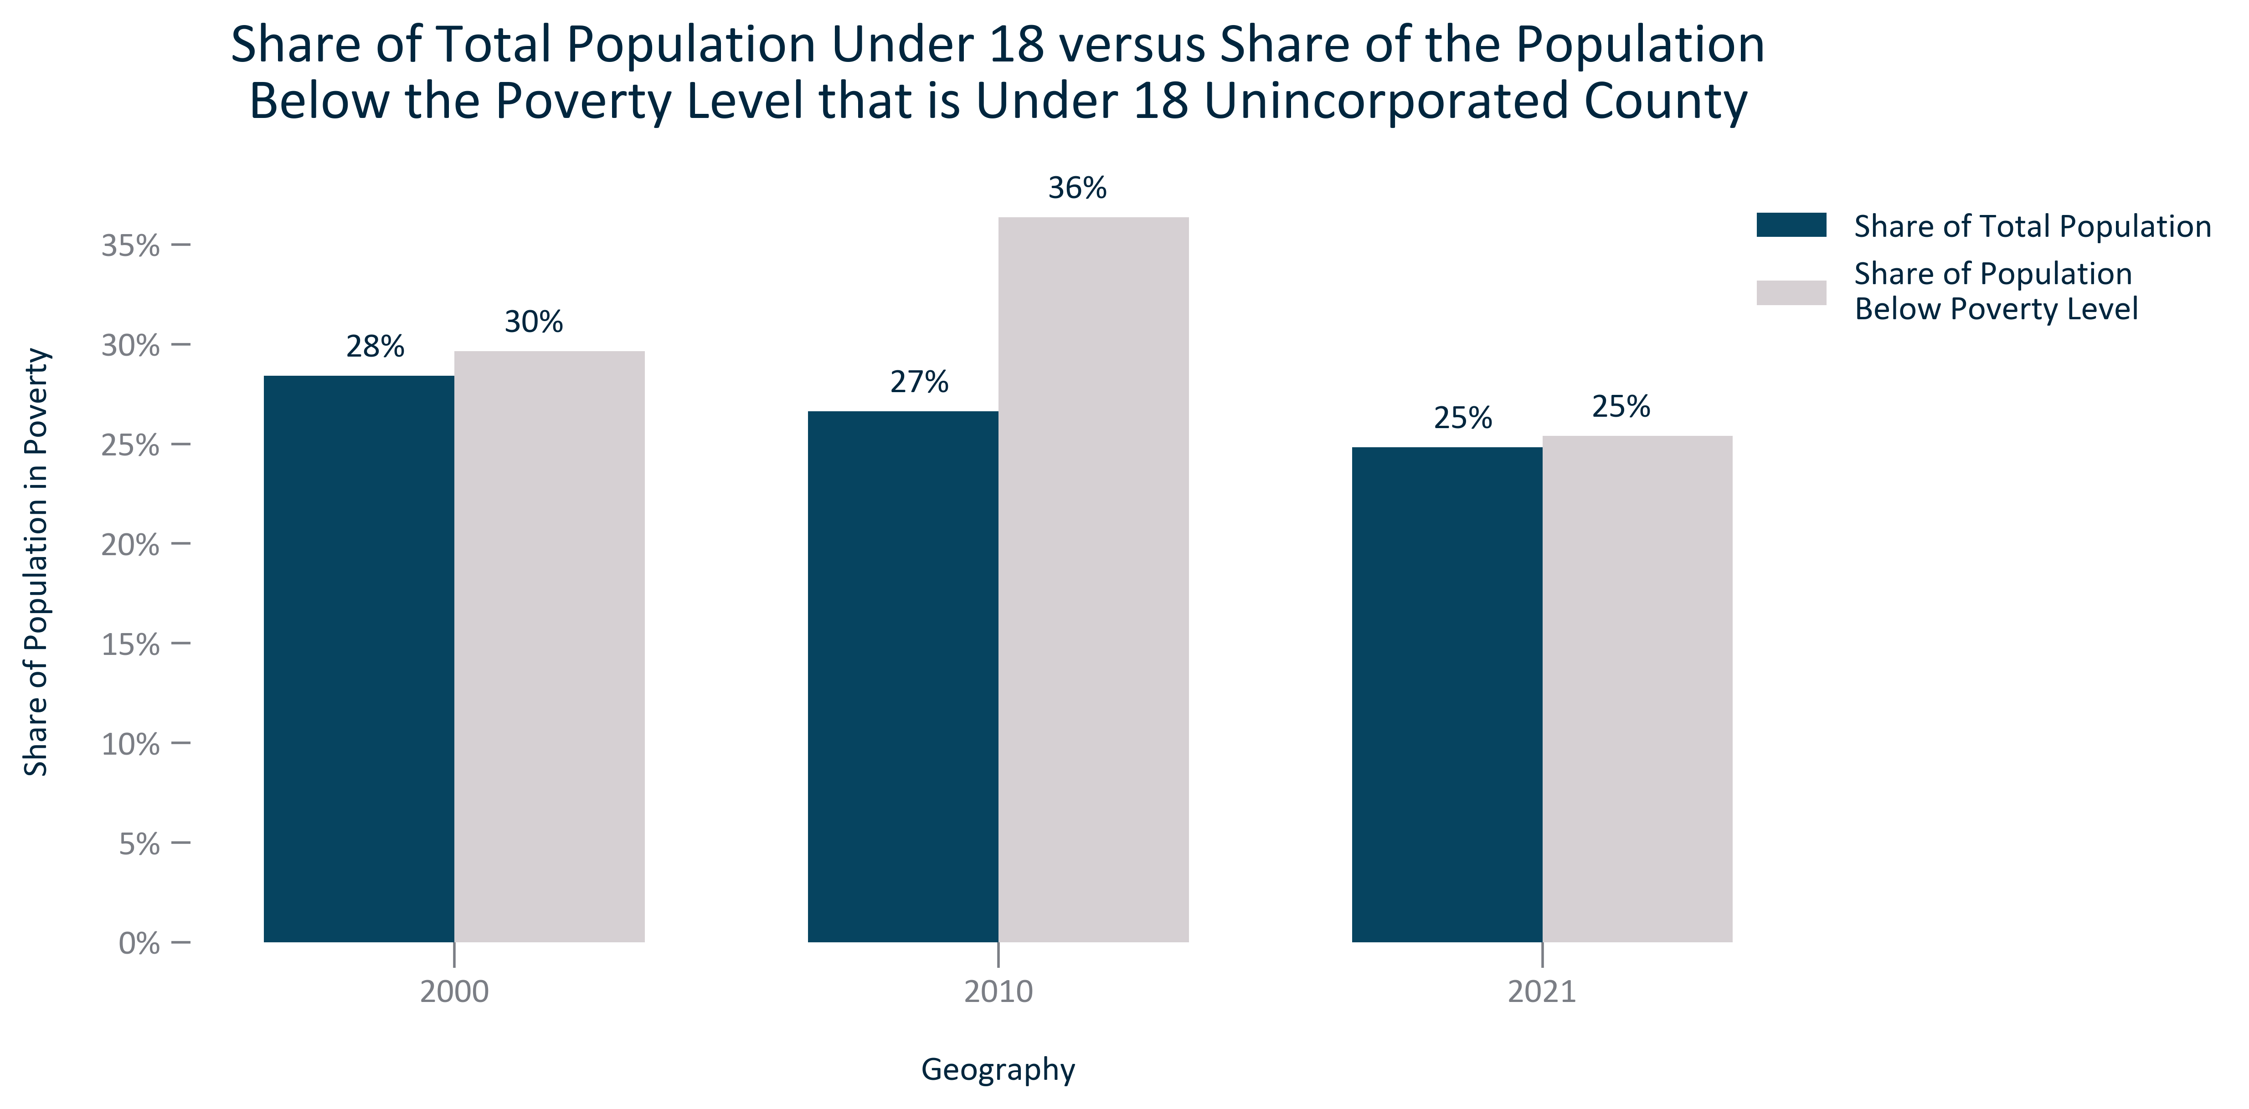

Citation: 2000 Decennial Census, 2006-2010 and 2017-2021 ACS 5-Year Estimates

### POVERTY_clusterbar_primarygeo_18to64popsharevspovertypopshare_overtime:

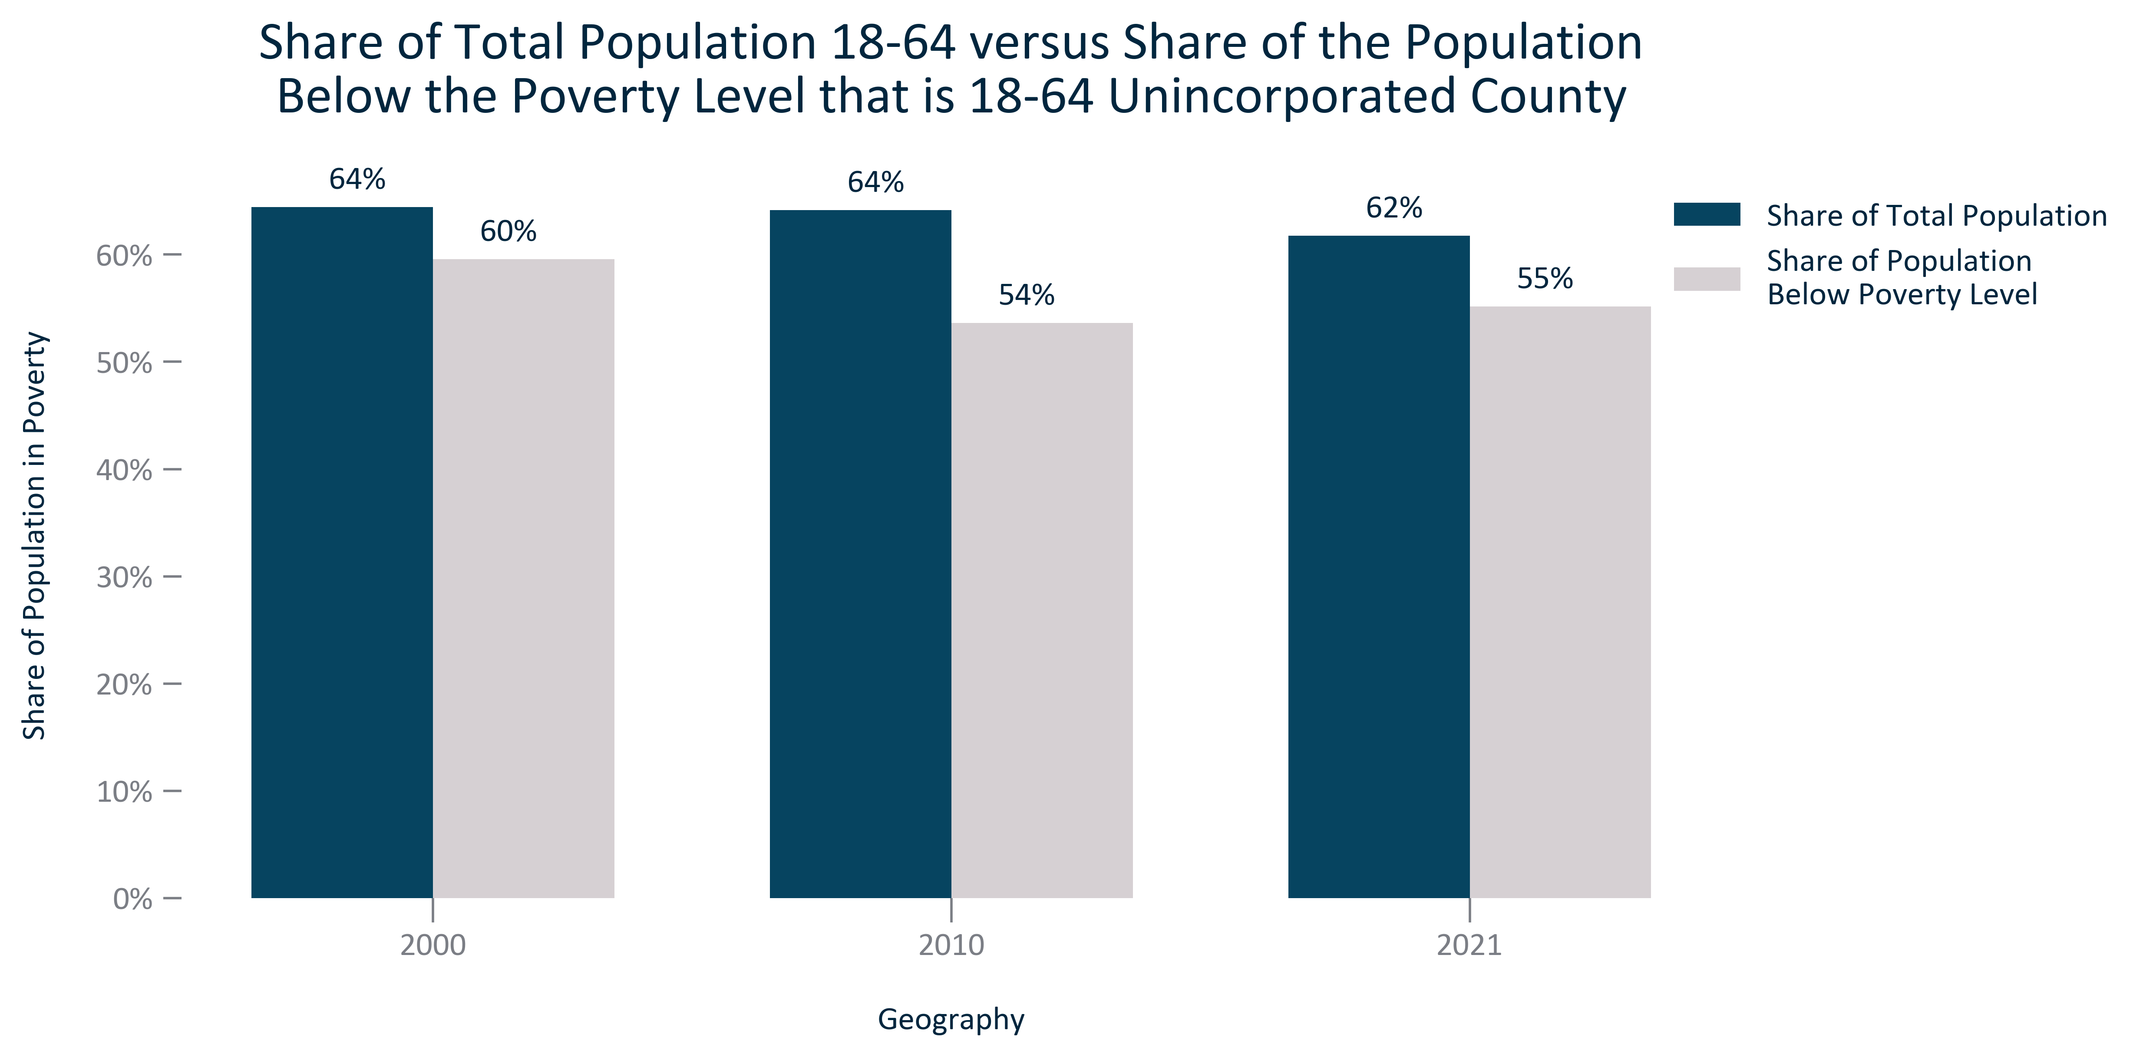

Citation: 2000 Decennial Census, 2006-2010 and 2017-2021 ACS 5-Year Estimates

### POVERTY_clusterbar_primarygeo_65overpopsharevspovertypopshare_overtime:

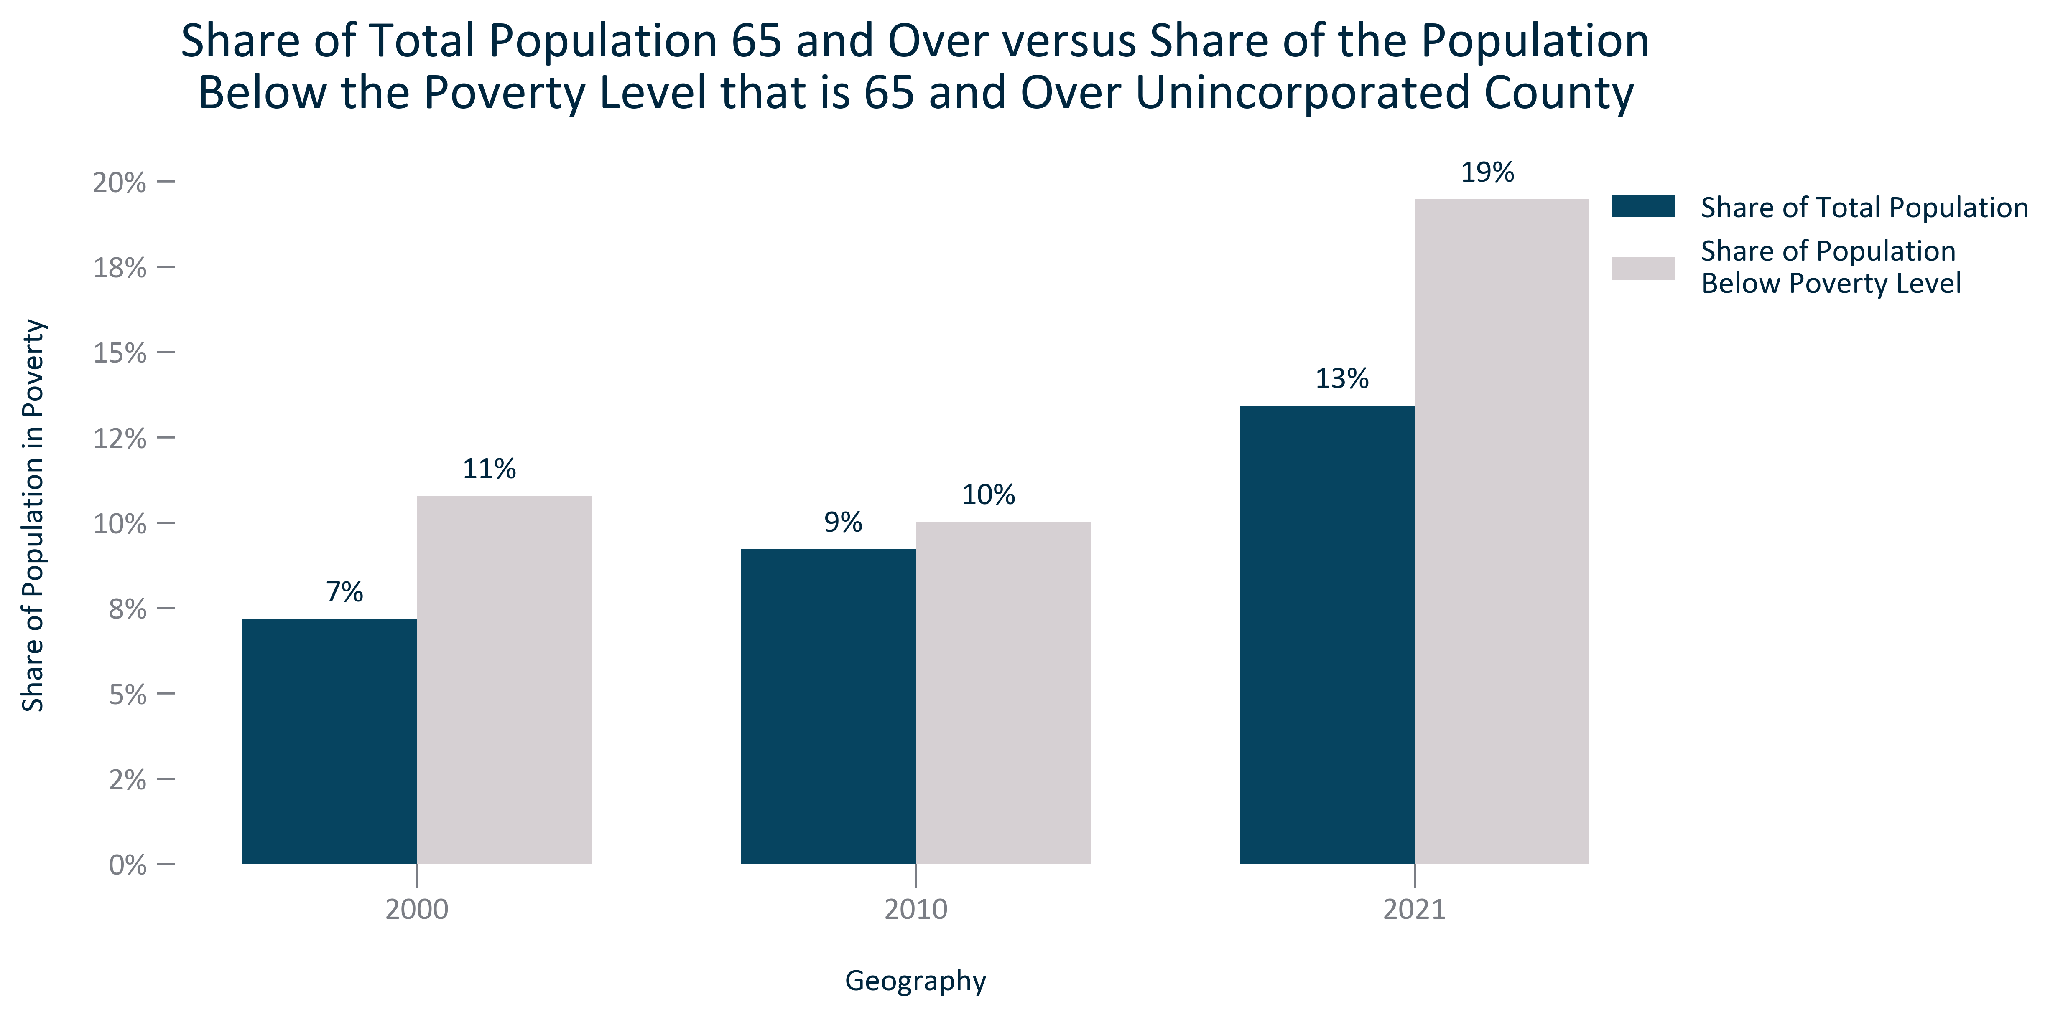

Citation: 2000 Decennial Census, 2006-2010 and 2017-2021 ACS 5-Year Estimates

### POVERTY_table_primarygeo_byagegroups_2021:

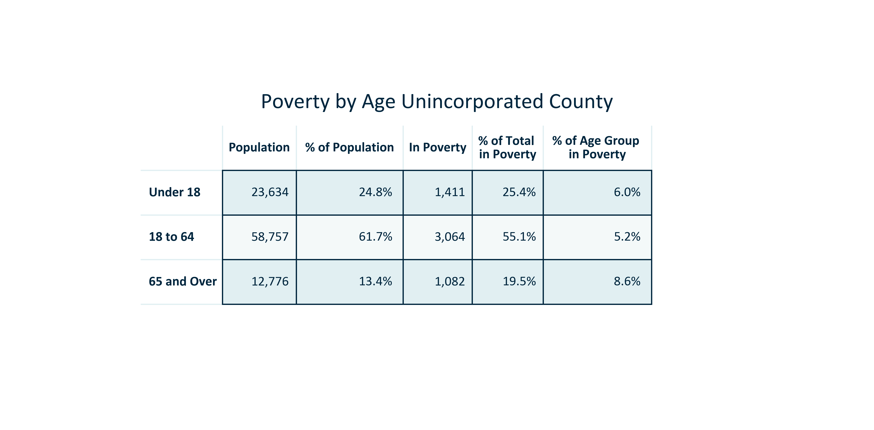

Citation: 2017-2021 ACS 5-Year Estimates

### POVERTY_clusterbar_primarygeo_raceethpopulationsharevspovertypopulationshare_2021:

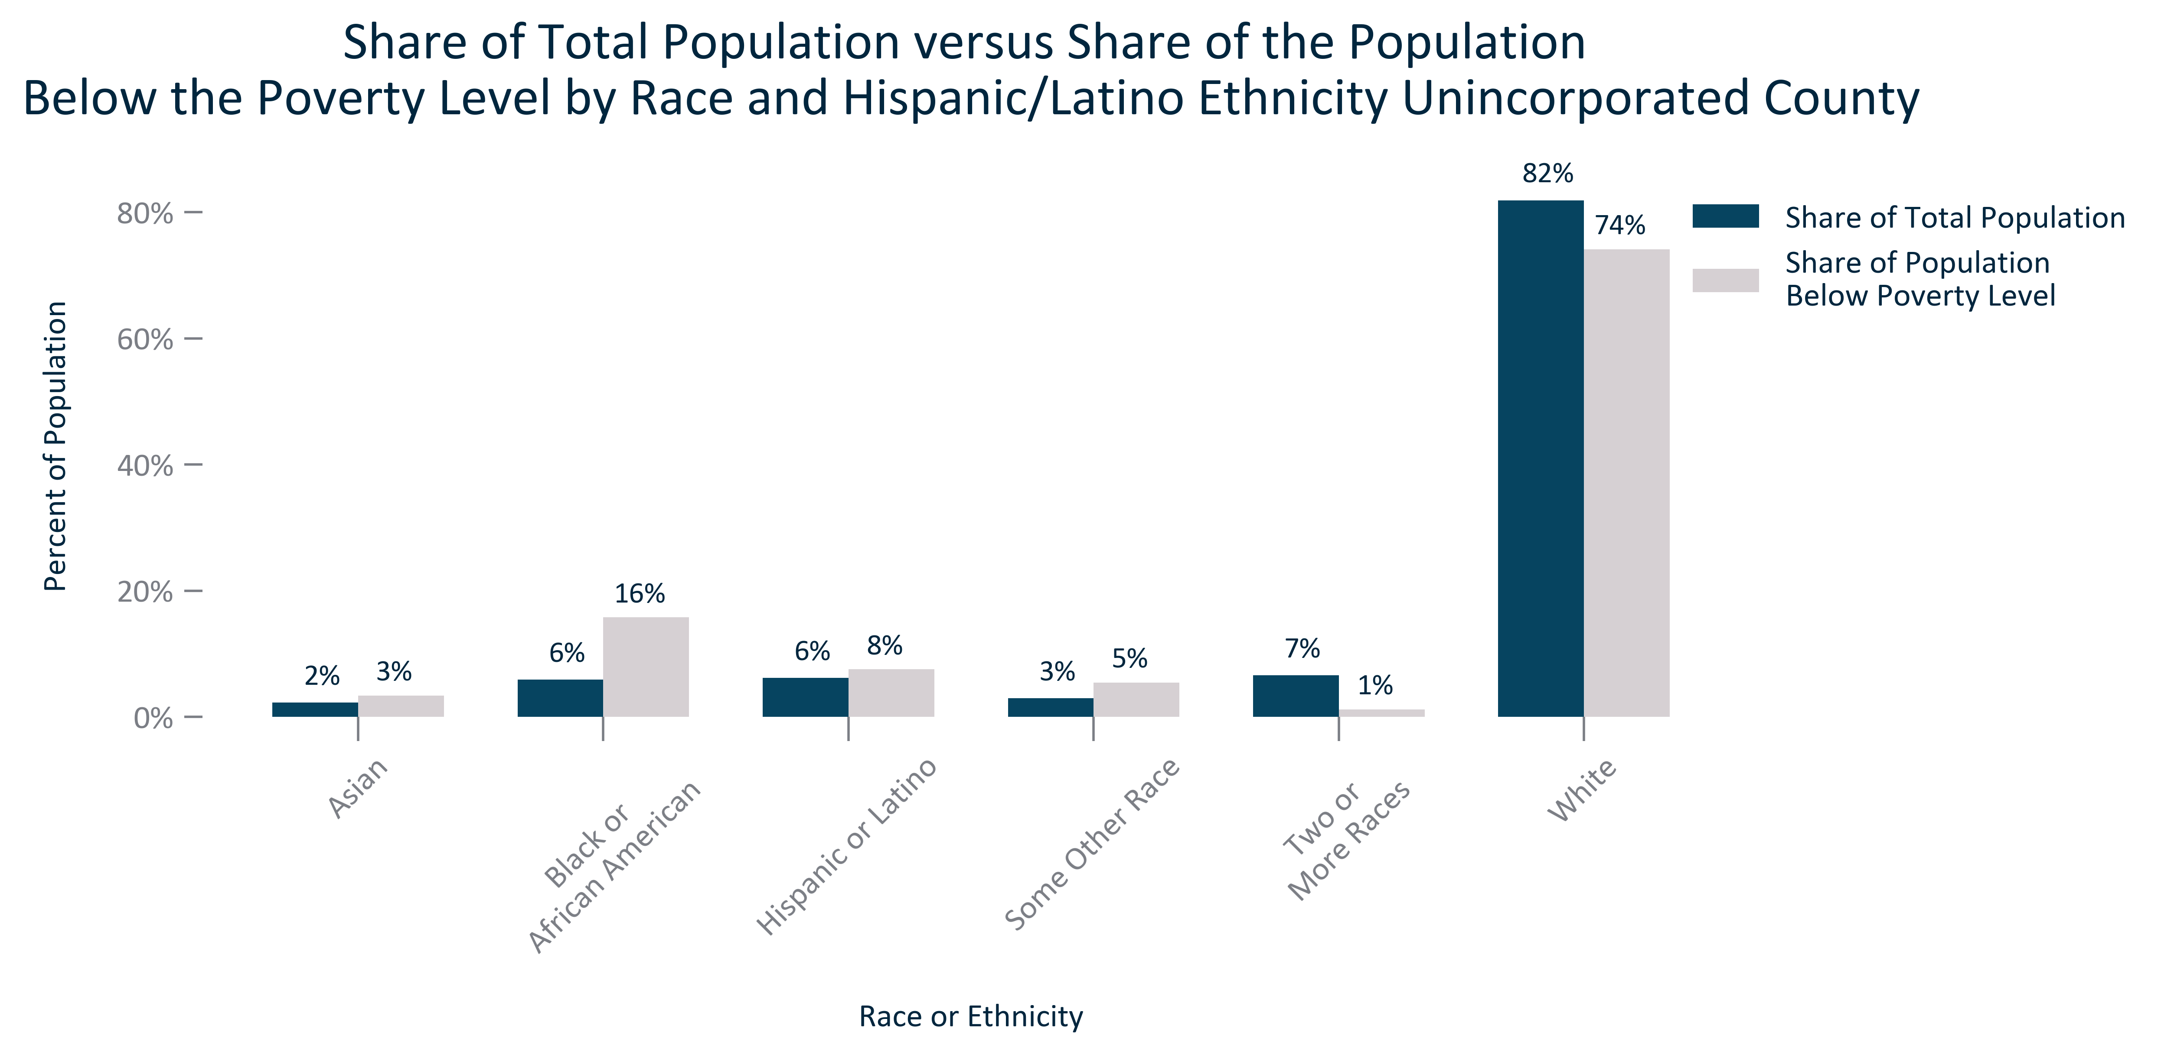

Citation: 2017-2021 ACS 5-Year Estimates and 2020 PL.... other races excluded because they make up less than 1% of population

### POVERTY_table_primarygeo_byraceeth_2021:

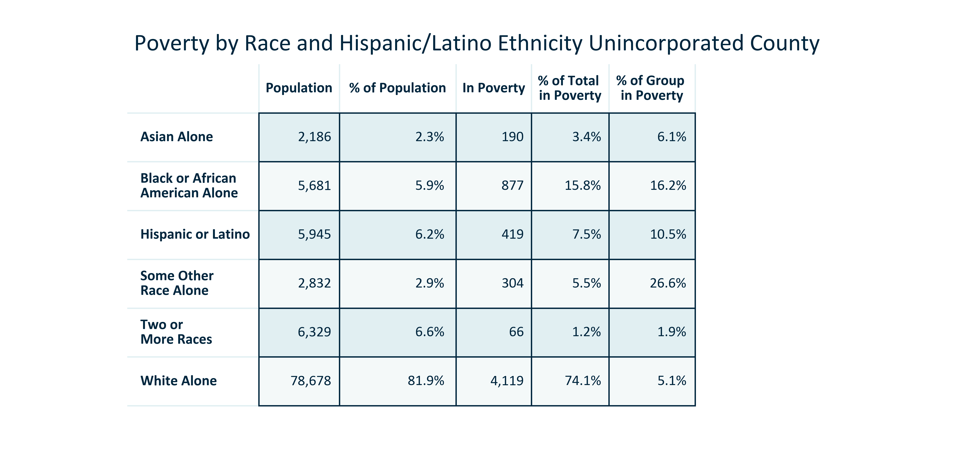

Citation: 2017-2021 ACS 5-Year Estimates and 2020 PL

# Income

### INCOME_bar_primarygeo_medianhouseholdincome_overtime:

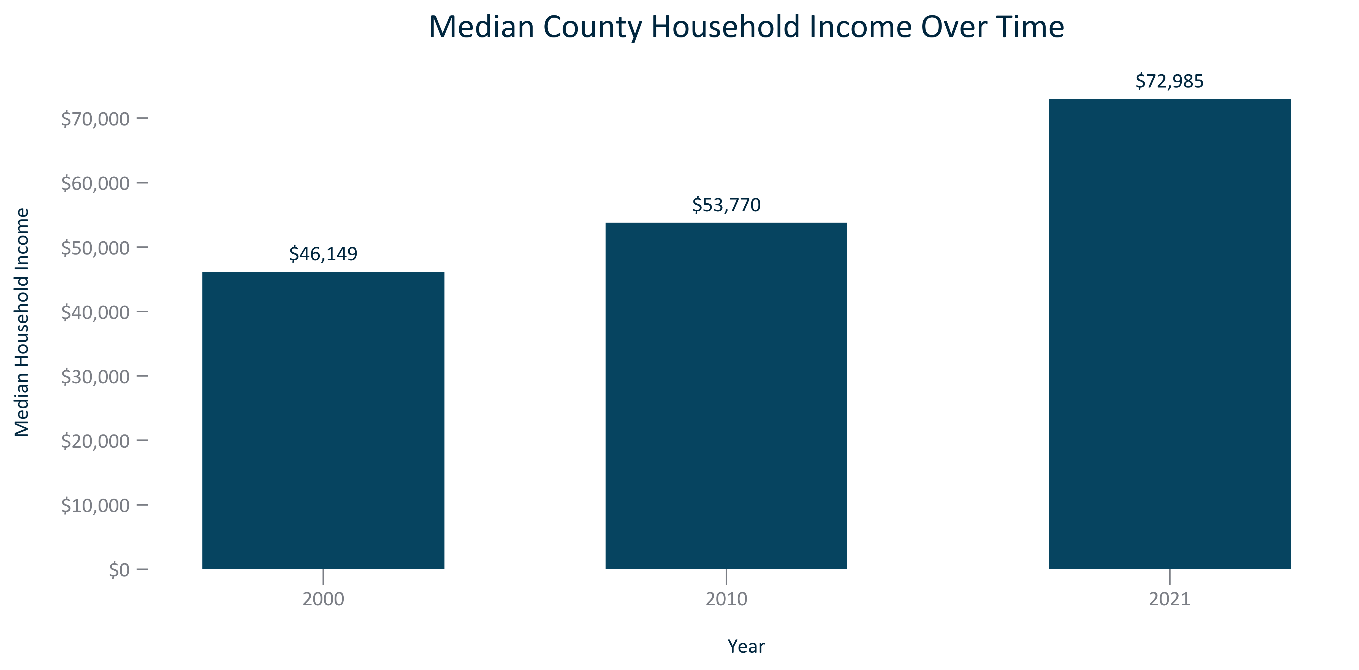

Citation: 2000 Decennial Census, 2006-2010 and 2017-2021 ACS 5-Year Estimates

### INCOME_bar_primarygeo_medianhhincomedistribution_2021:

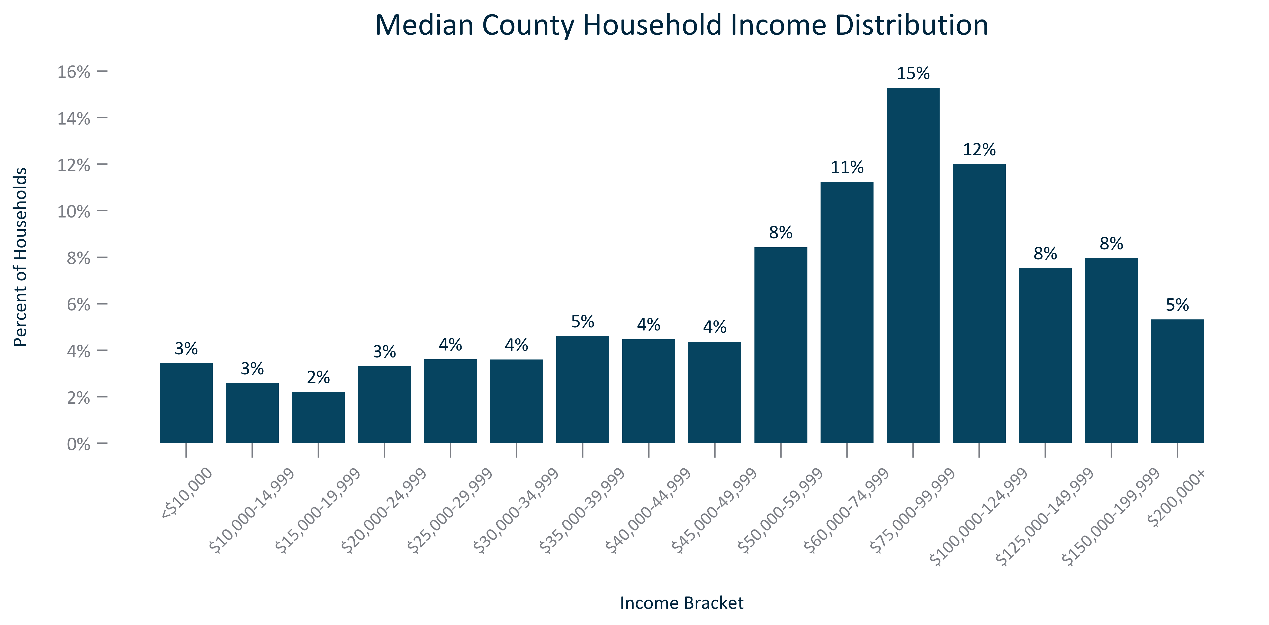

Citation: 2017-2021 ACS 5-Year Estimates

### INCOME_table_geocomparative_medianhhincomeandchange_overtime:

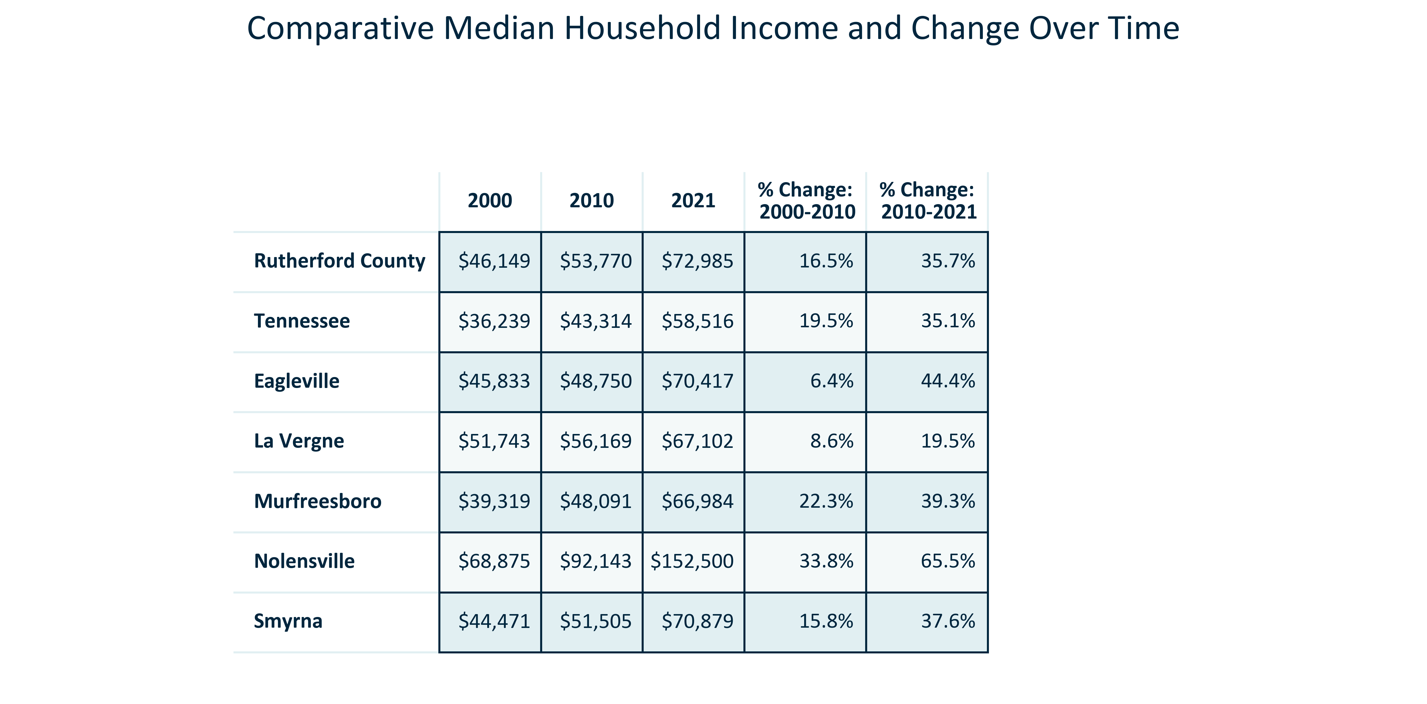

Citation: 2000 Decennial Census, 2006-2010 and 2017-2021 ACS 5-Year Estimates

### INCOME_bar_geocomparative_changemedianhhincomevsinflation_overtime:

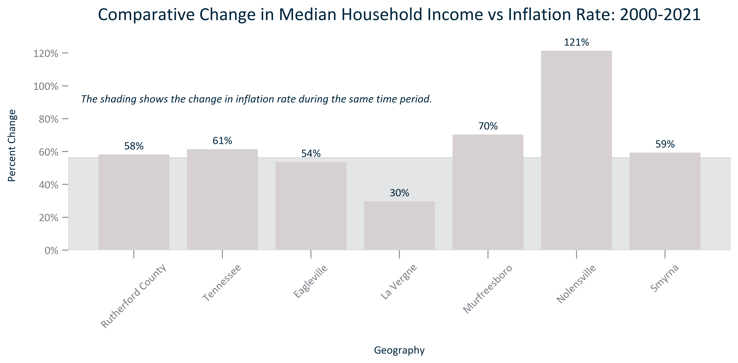

Citation: 2000 Decennial Census, 2017-2021 ACS 5-Year Estimates, BLS CPI All Urban Consumers South Region 2000 and 2021

# Households

### HOUSEHOLDS_bar_primarygeo_avgsize_overtime:

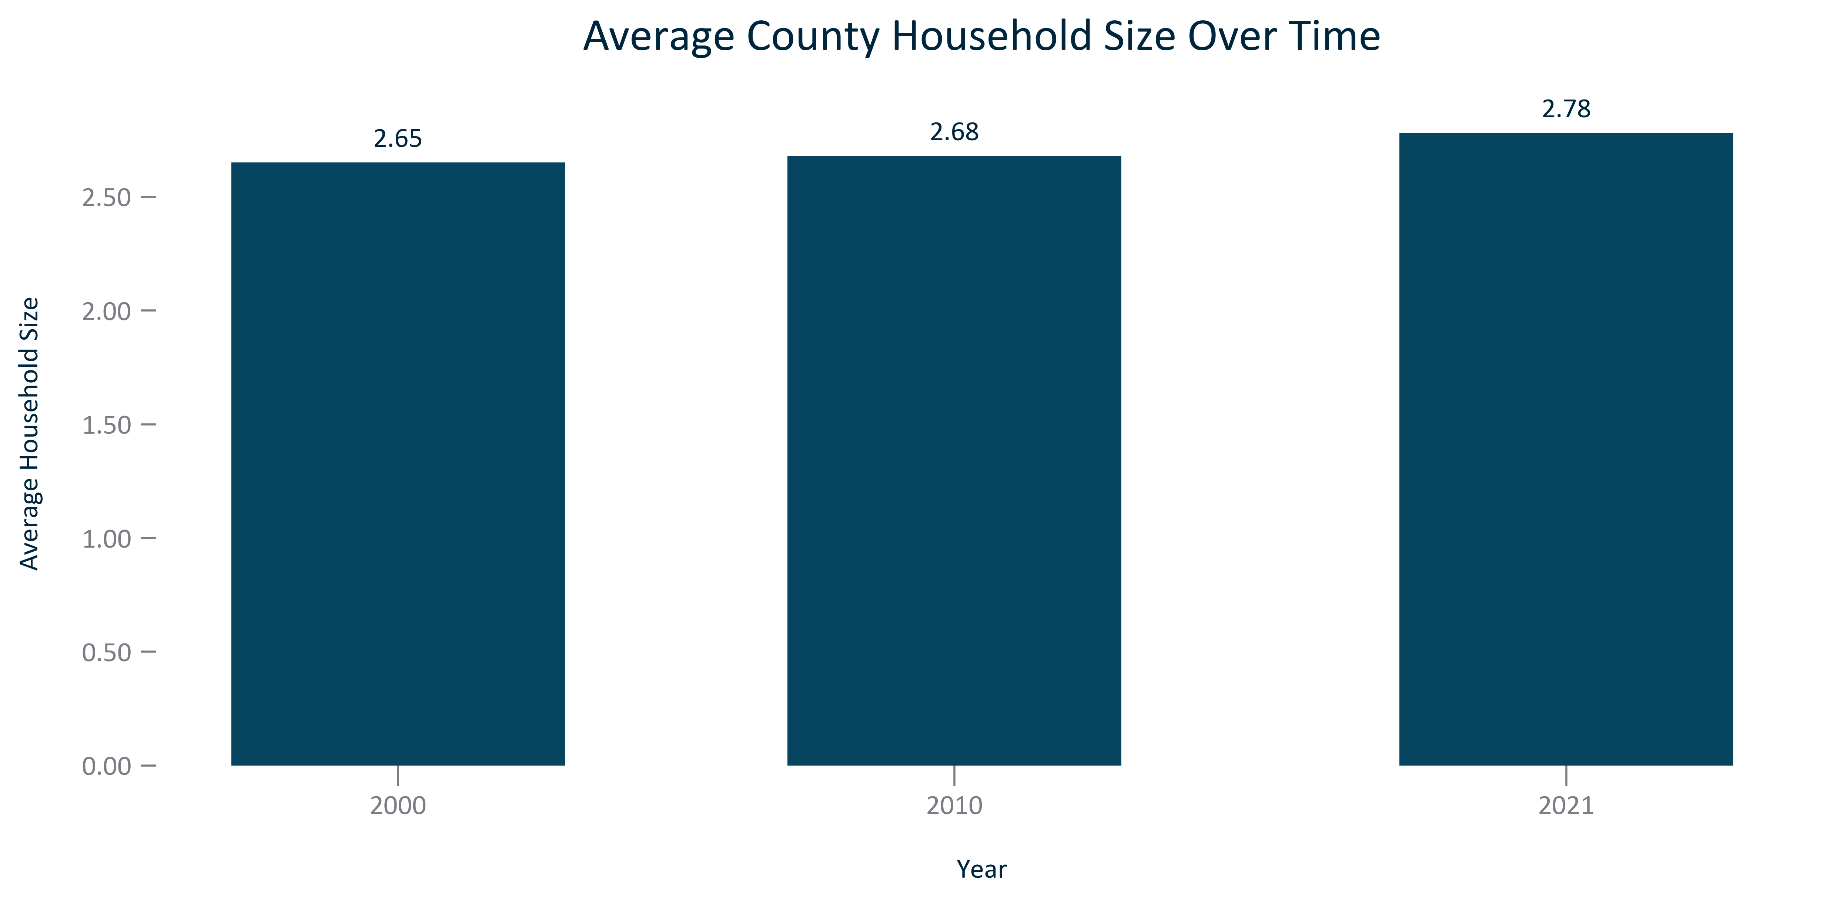

Citation: 2000 Decennial Census, 2006-2010 and 2017-2021 ACS 5-Year Estimates

### HOUSEHOLDS_bar_geocomparative_avgsize_2021:

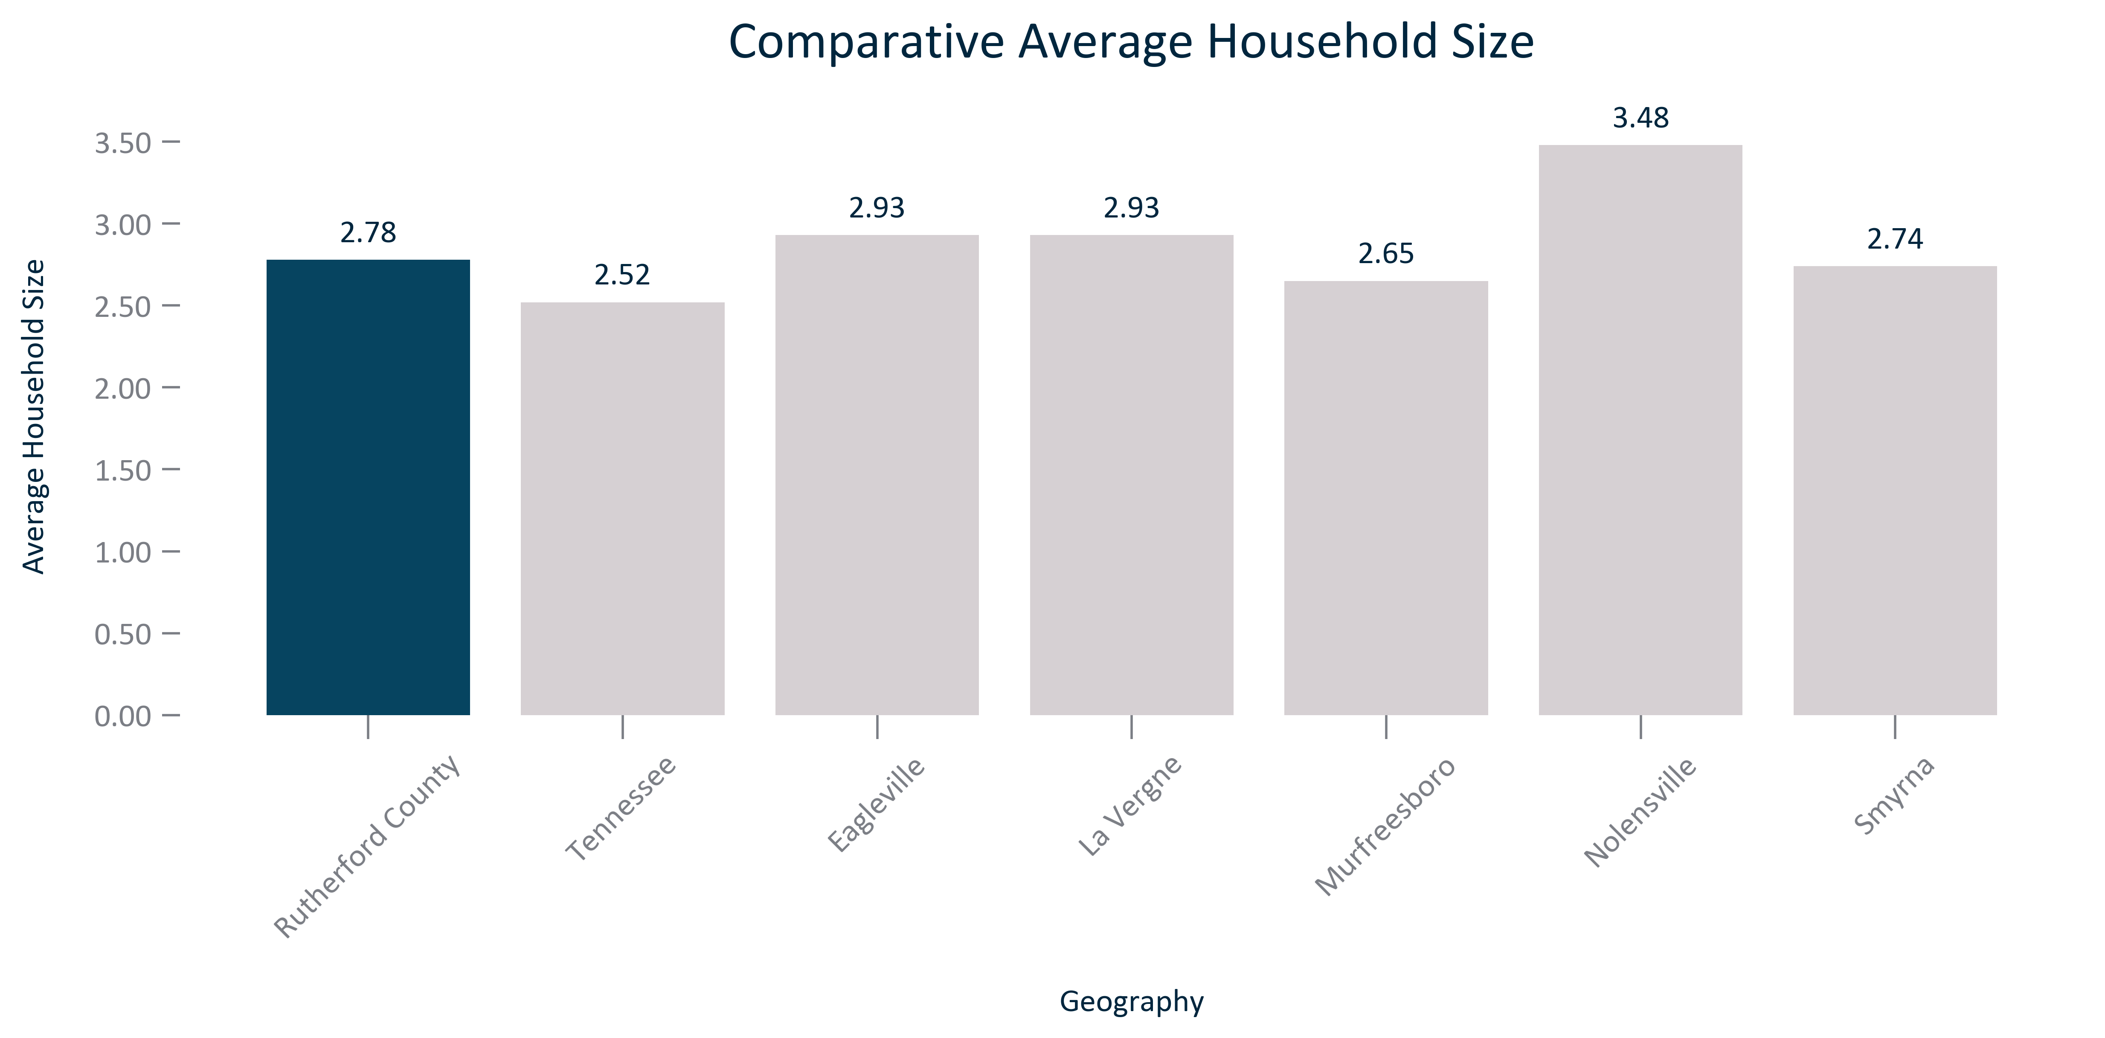

Citation: 2017-2021 ACS 5-Year Estimates

### HOUSEHOLDS_line_geocomparative_HUDresidentialpermits_overtime:

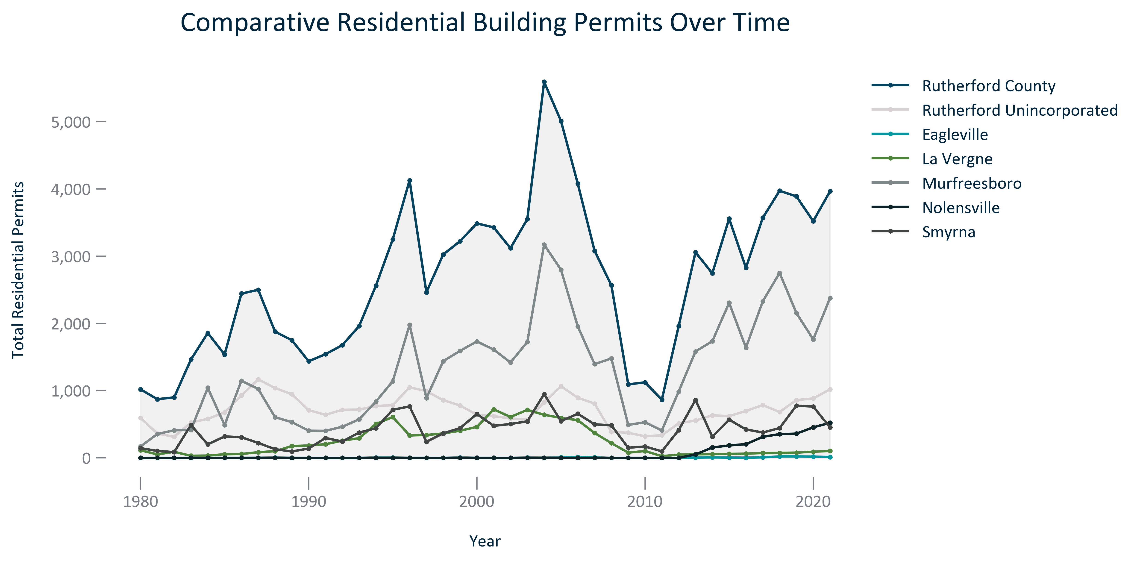

Citation: HUD SOC Data

### HOUSEHOLDS_stackedbar_geocomparative_HUDresidentialbuildingtypeandmix_2021:

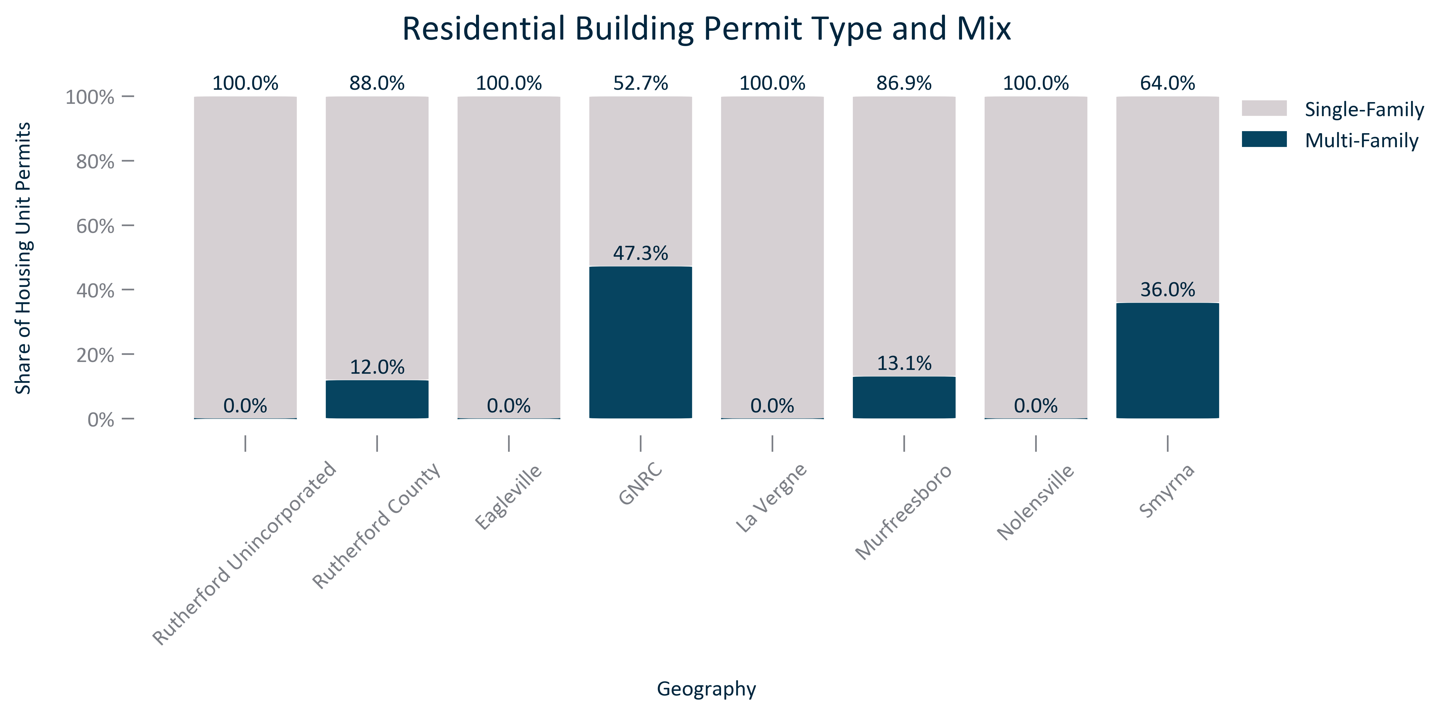

Citation: HUD SOC Data 2021

### HOUSEHOLDS_table_geocomparative_HUDresidentialpermitperunittype_2021:

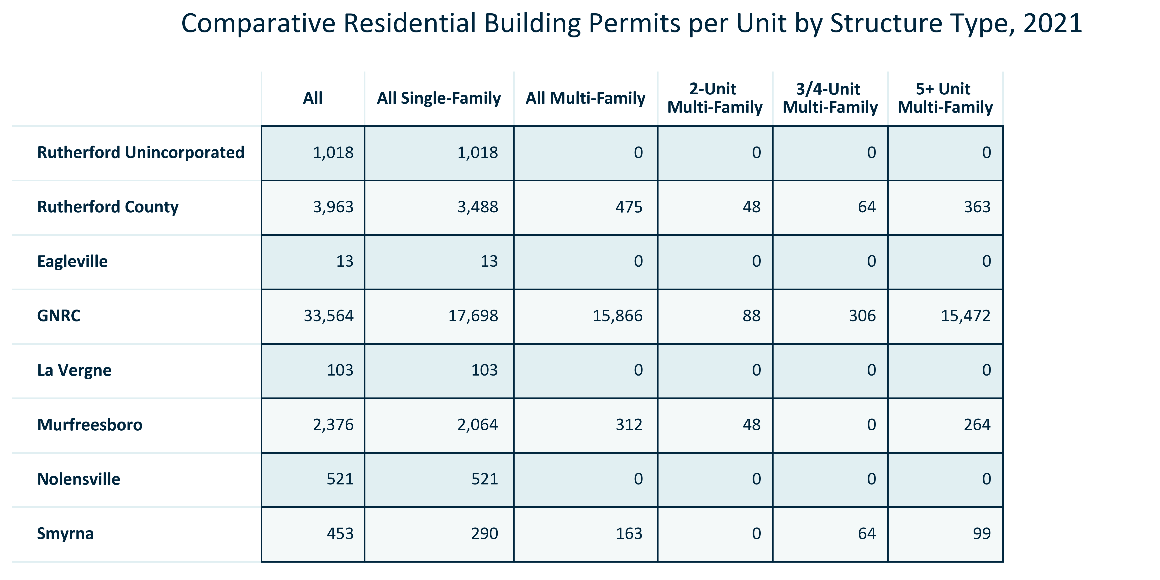

Citation: HUD SOC Data 2021

### HOUSEHOLDS_stackedbar_primarygeo_type_overtime:

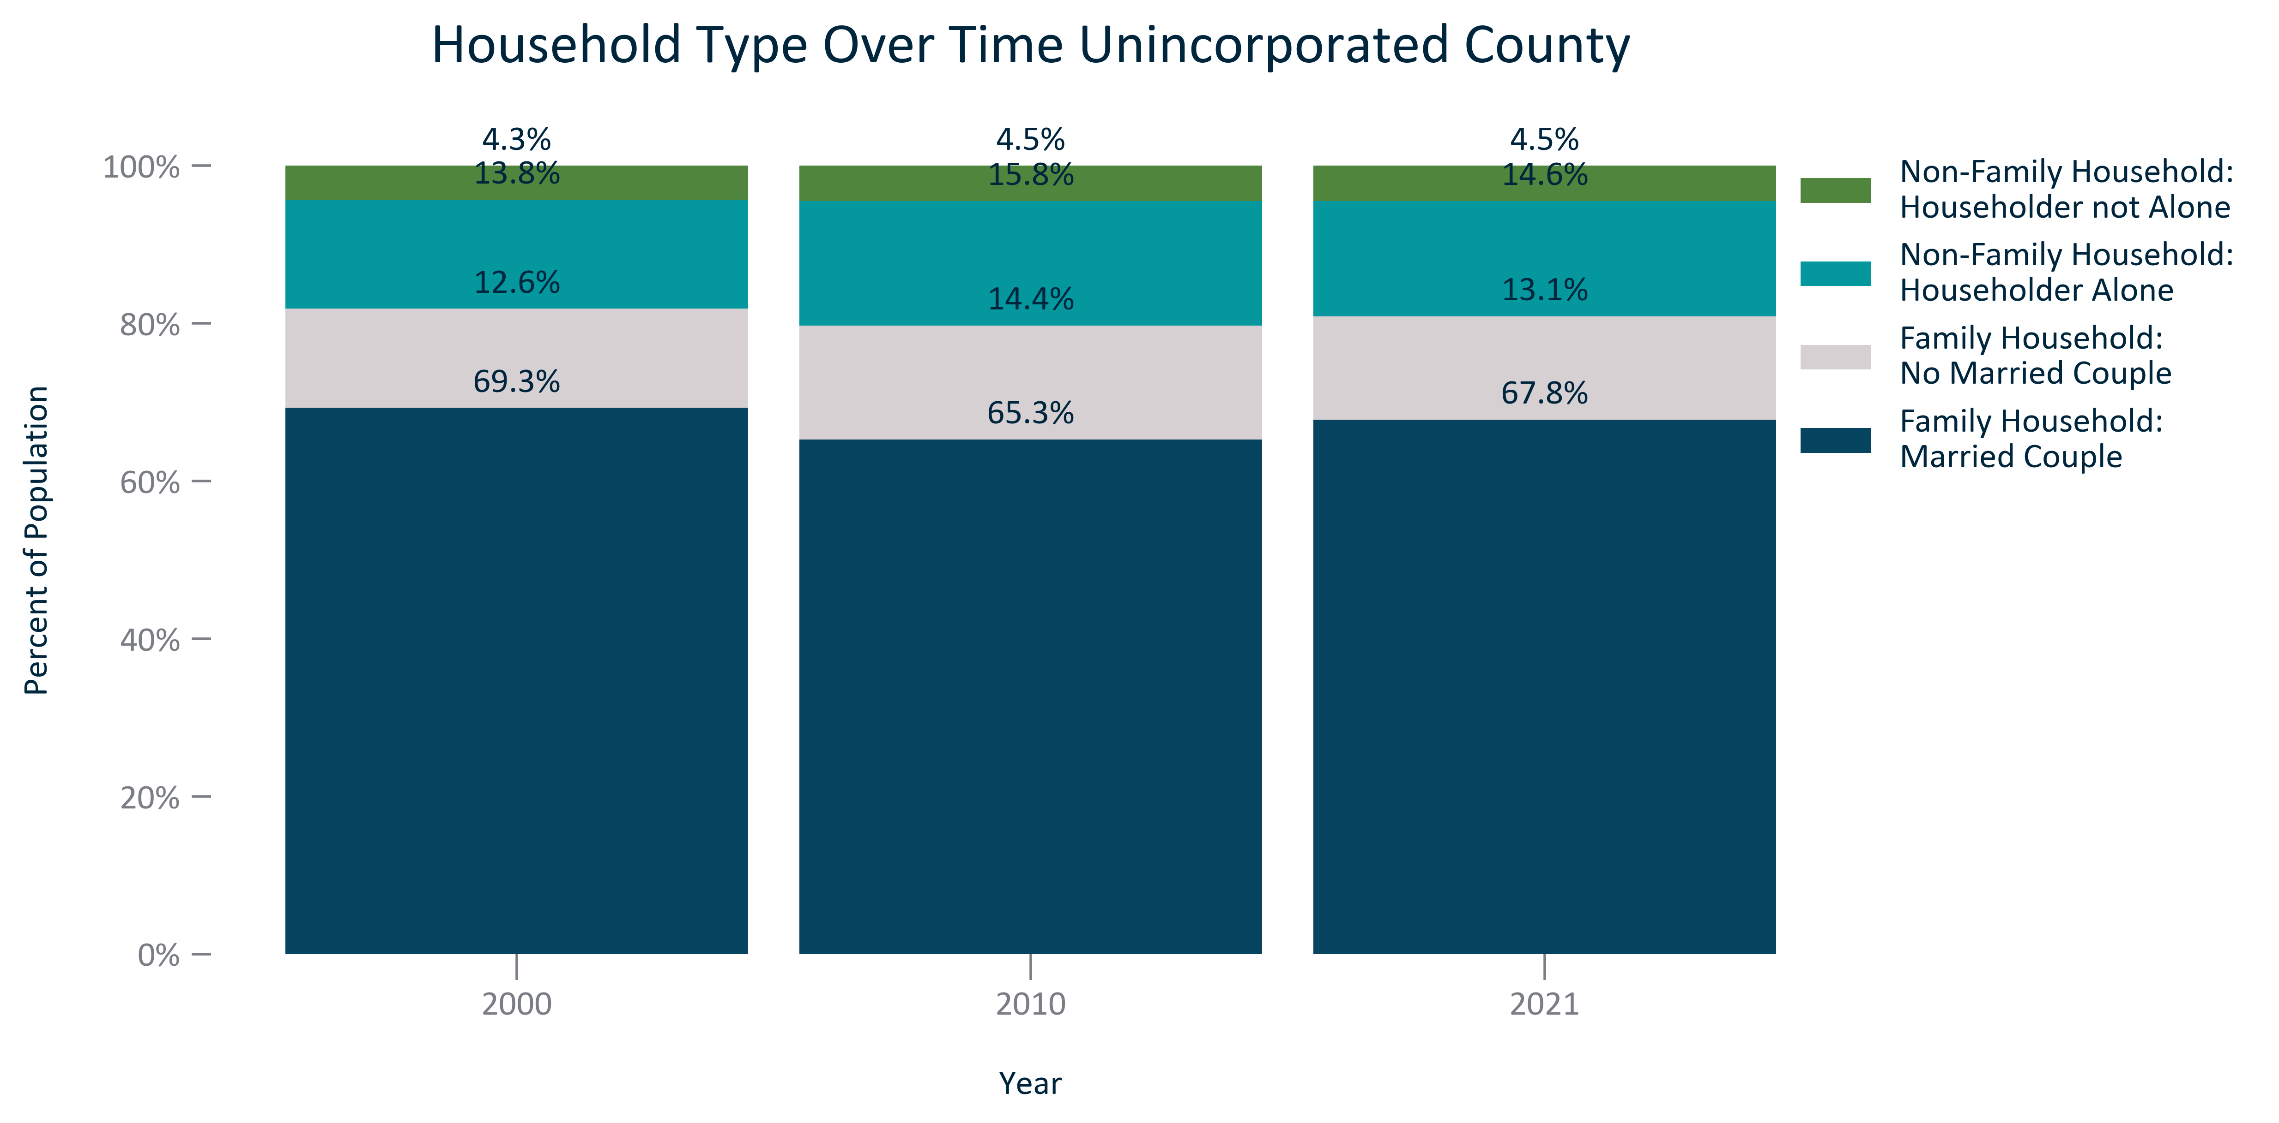

Citation: 2000 and 2010 Decennial Census, 2017-2021 ACS 5-Year Estimates

### HOUSEHOLDS_stackedbar_geocomparative_type_2021:

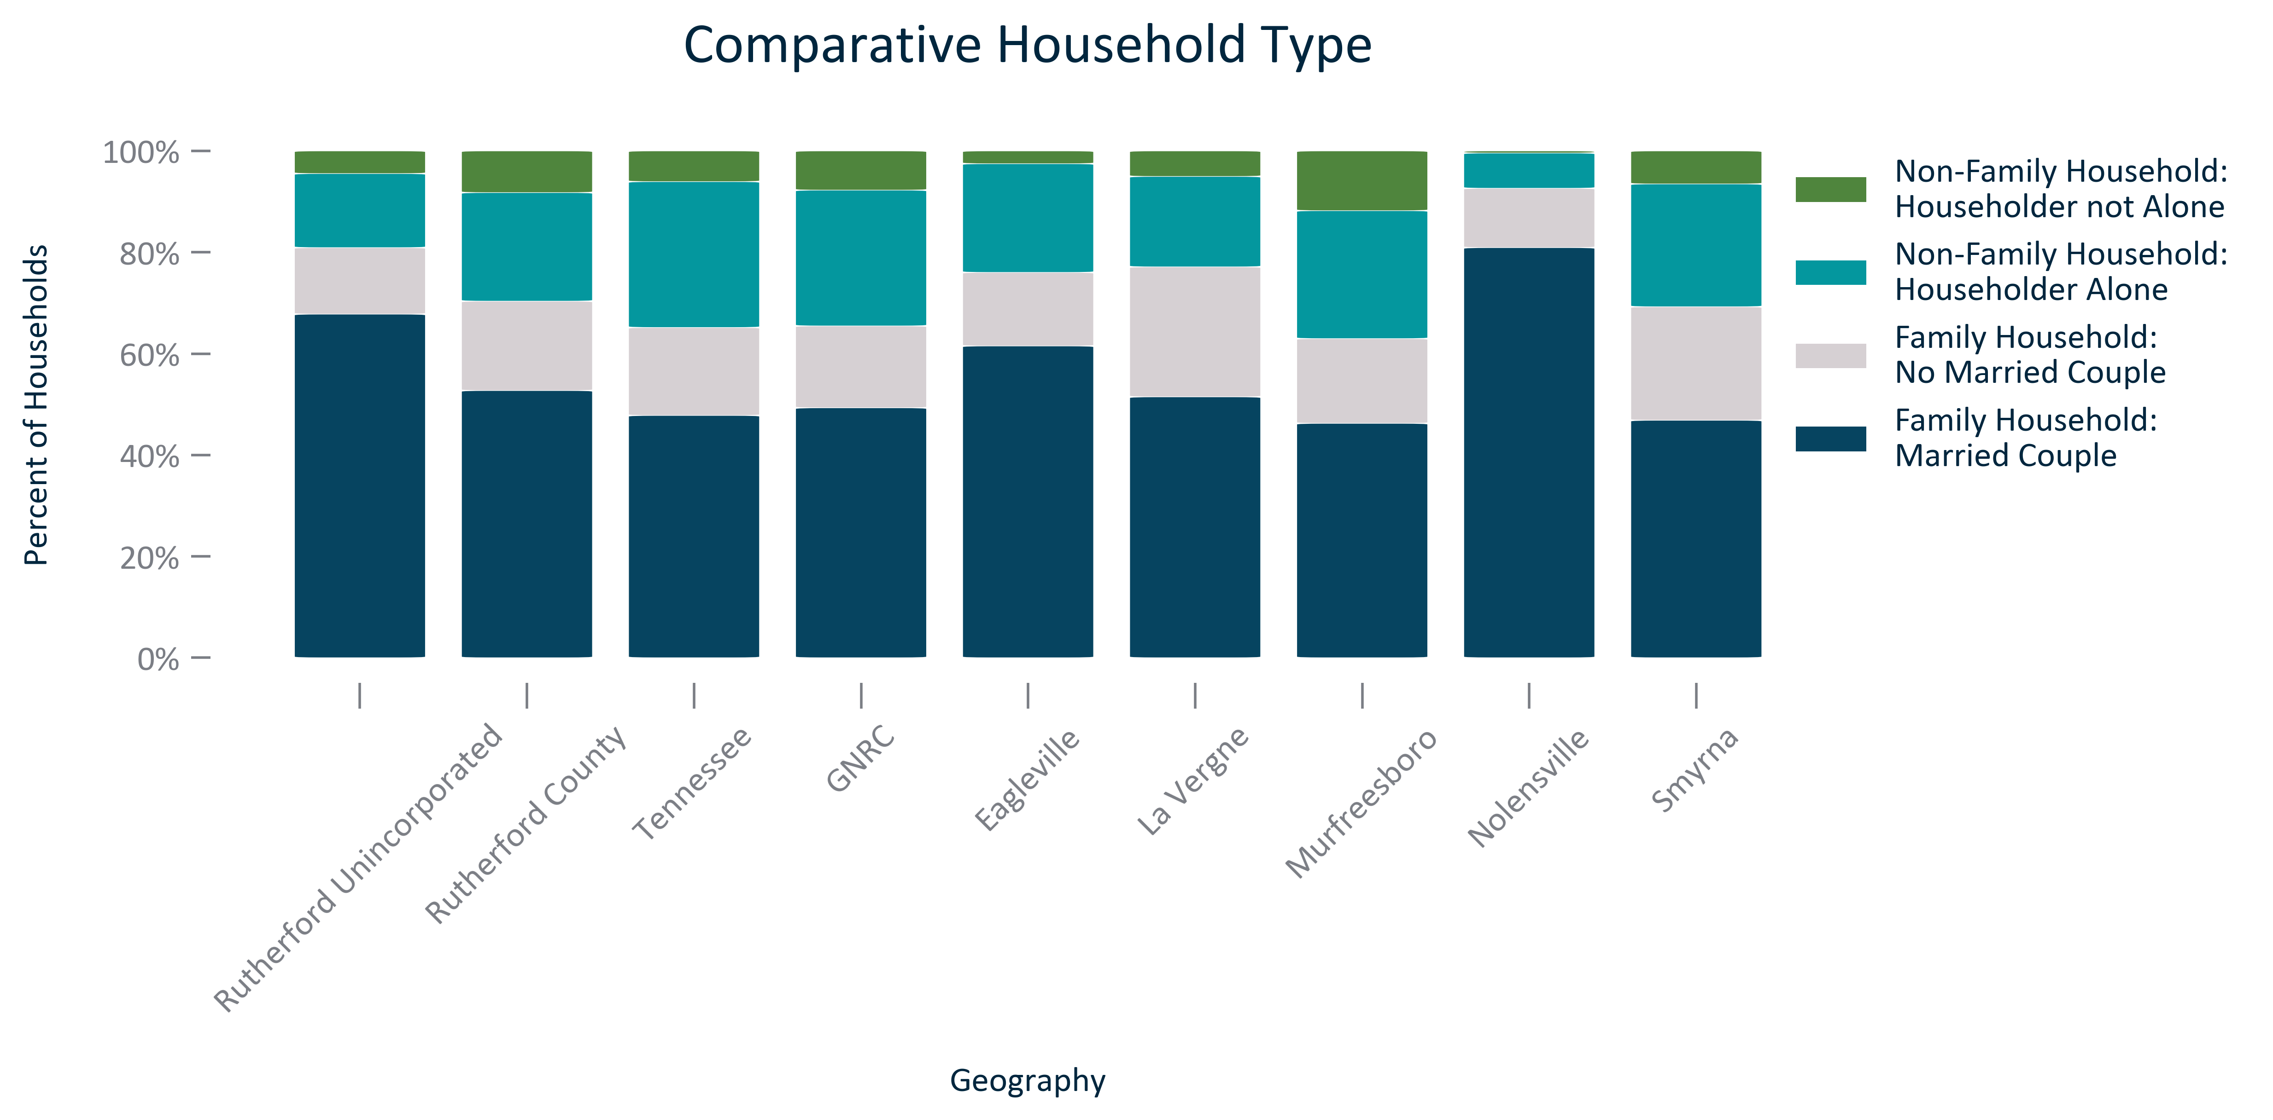

Citation: 2017-2021 ACS 5-Year Estimates

### HOUSEHOLDS_table_primarygeo_type_overtime:

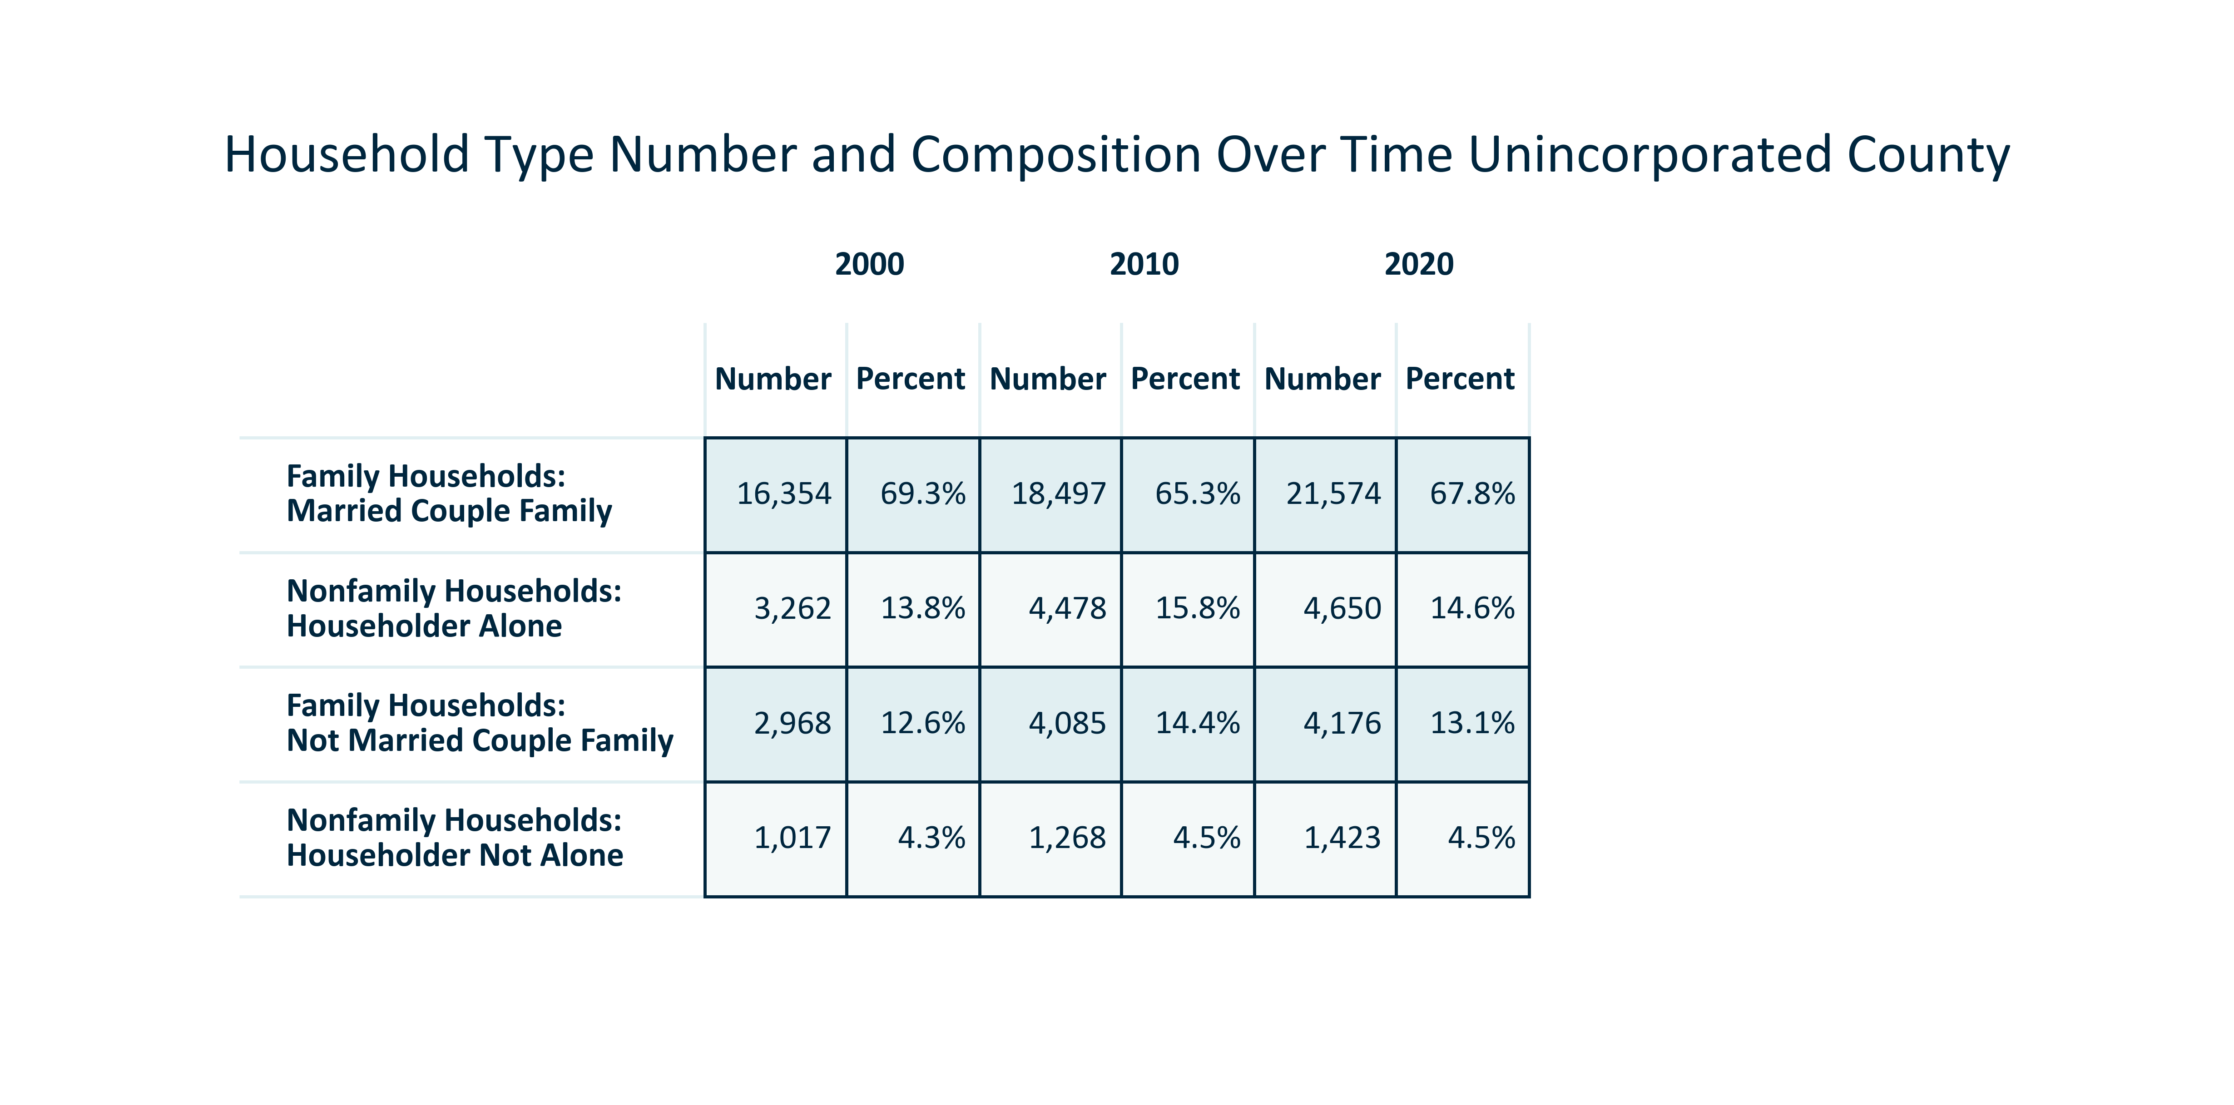

Citation: 2000 and 2010 Decennial Census, 2017-2021 ACS 5-Year Estimates

### HOUSEHOLDS_bar_primarygeo_ageofhousingstock_2021:

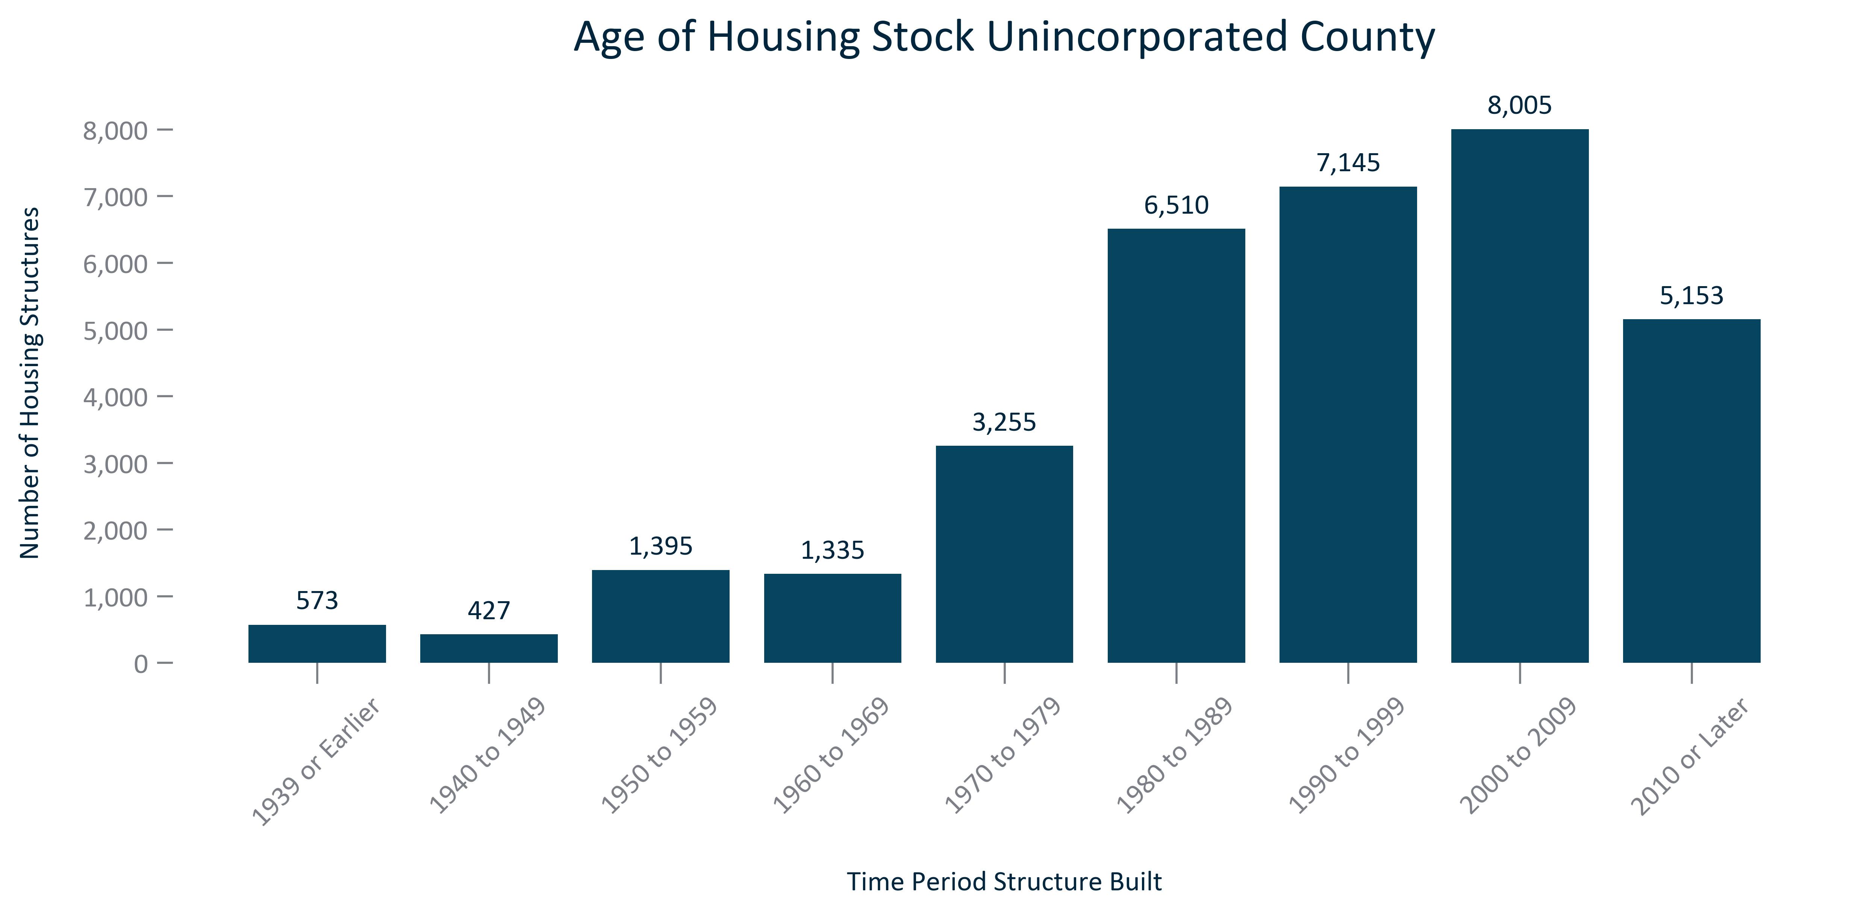

Citation: 2017-2021 ACS 5-Year Estimates

### HOUSEHOLDS_table_geocomparative_medianyearbuiltandageforresidentialstructures_2021:

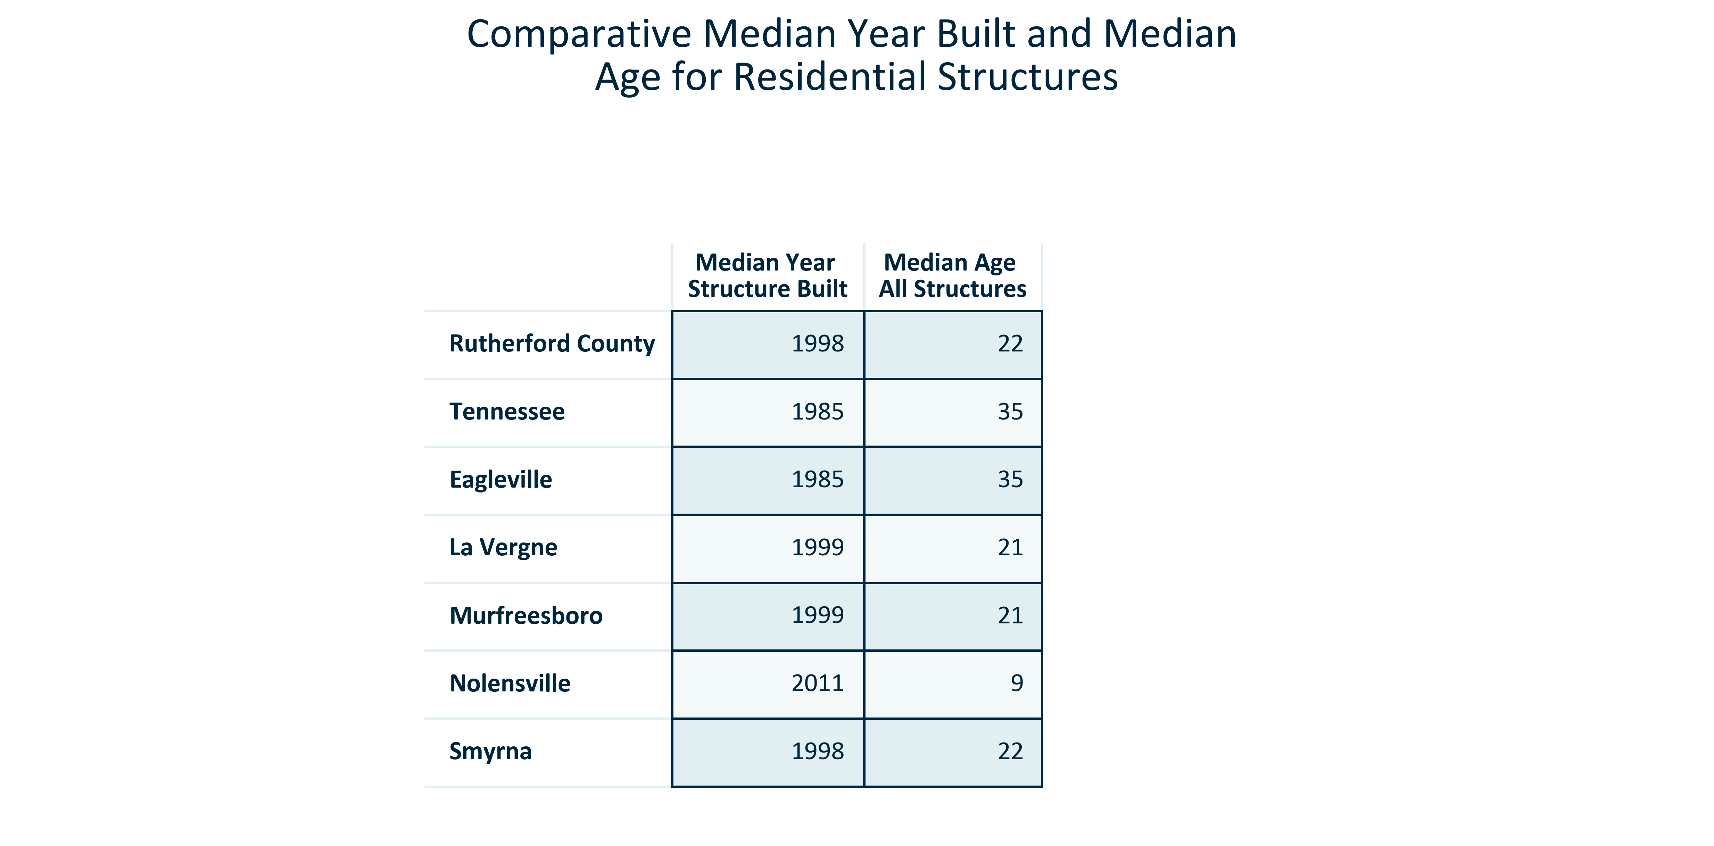

Citation: 2017-2021 ACS 5-Year Estimates

### HOUSEHOLDS_bar_primarygeo_changeinunitsbytype_overtime:

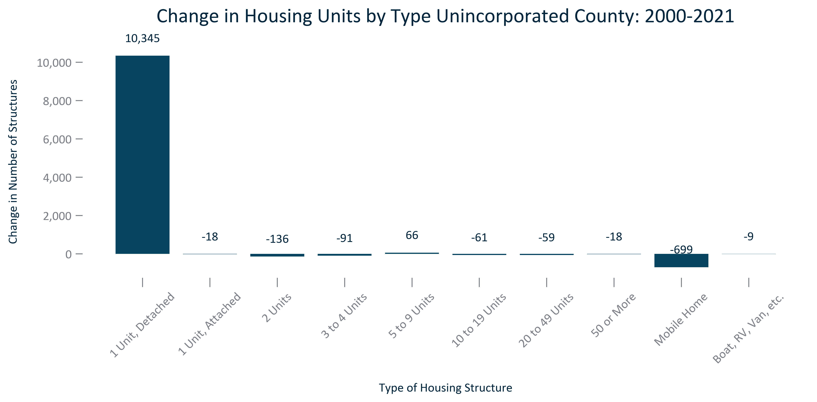

Citation: 2000 Decennial Census, 2017-2021 ACS 5-Year Estimates

# Vacancy

### VACANCY_bar_primarygeo_vacantunits_overtime:

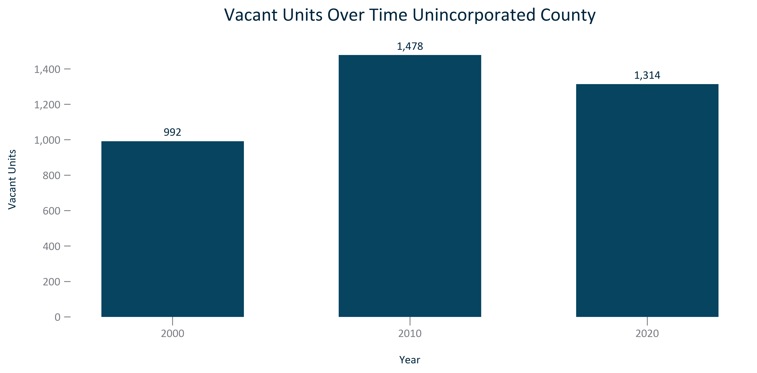

Citation: 2000, 2010, and 2020 Decennial Census

### VACANCY_bar_primarygeo_vacancyrate_overtime:

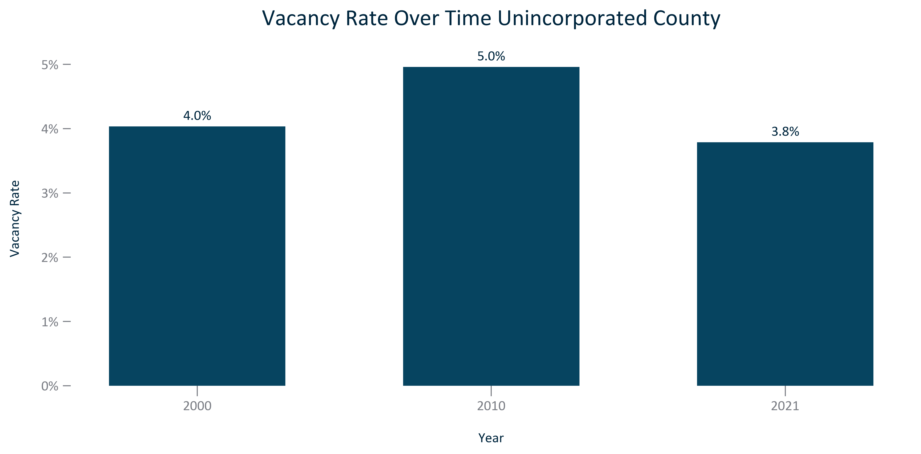

Citation: 2000, 2010, and 2020 Decennial Census

### VACANCY_bar_geocomparative_vacantunits_2020:

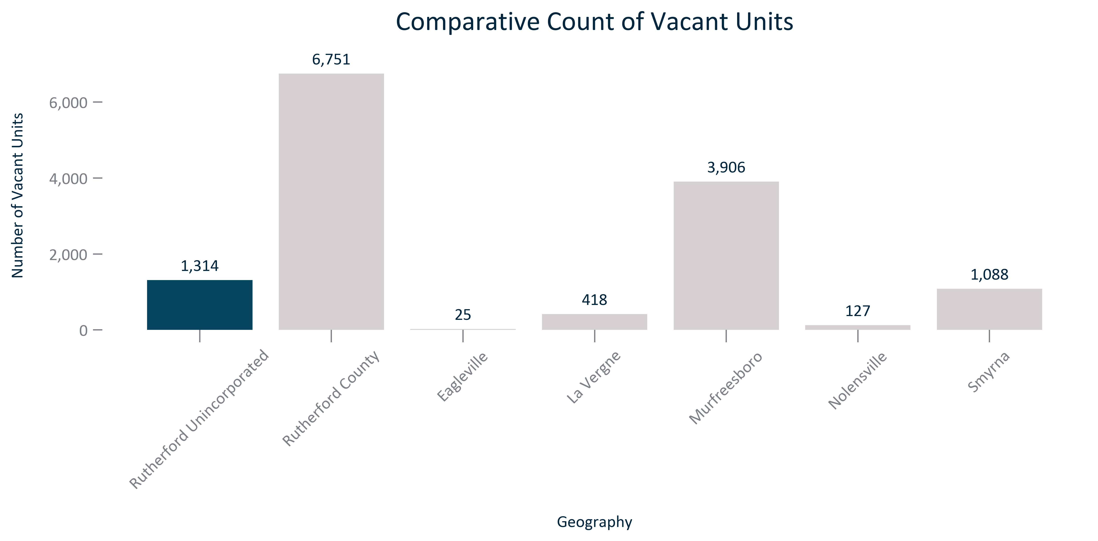

Citation: 2020 Decennial Census

### VACANCY_bar_geocomparative_vacancyrate_2020:

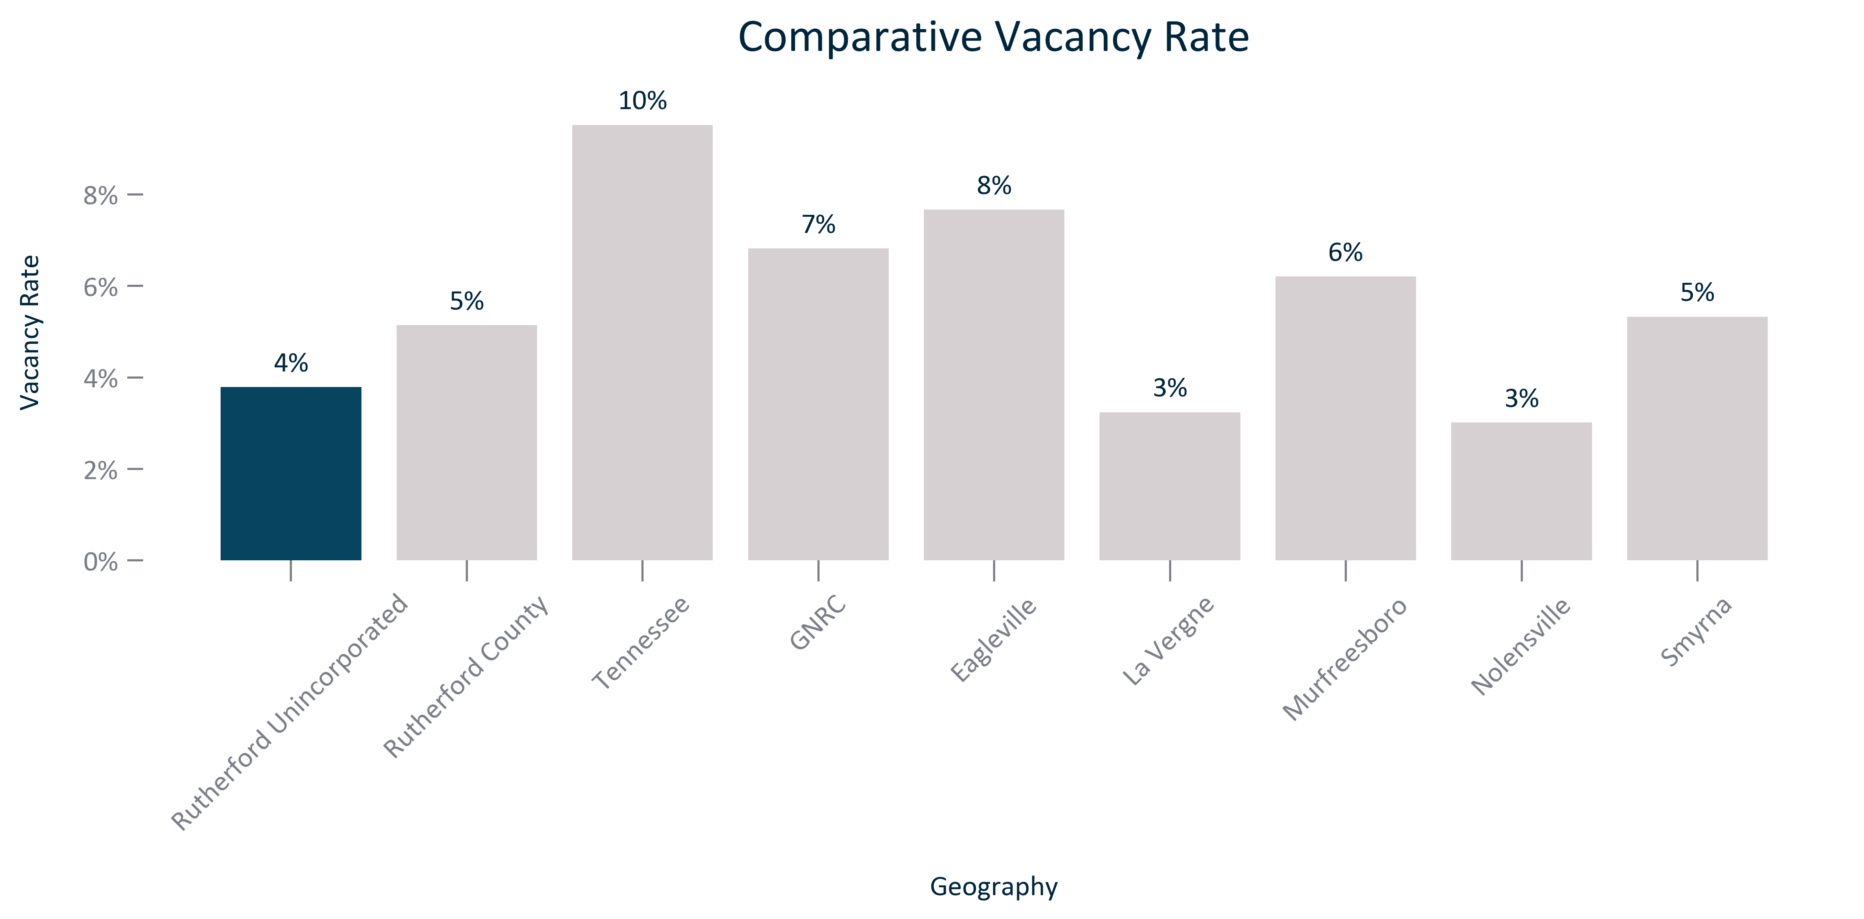

Citation: 2020 Decennial Census

### VACANCY_table_geocomparative_vacancyratesandchange_overtime:

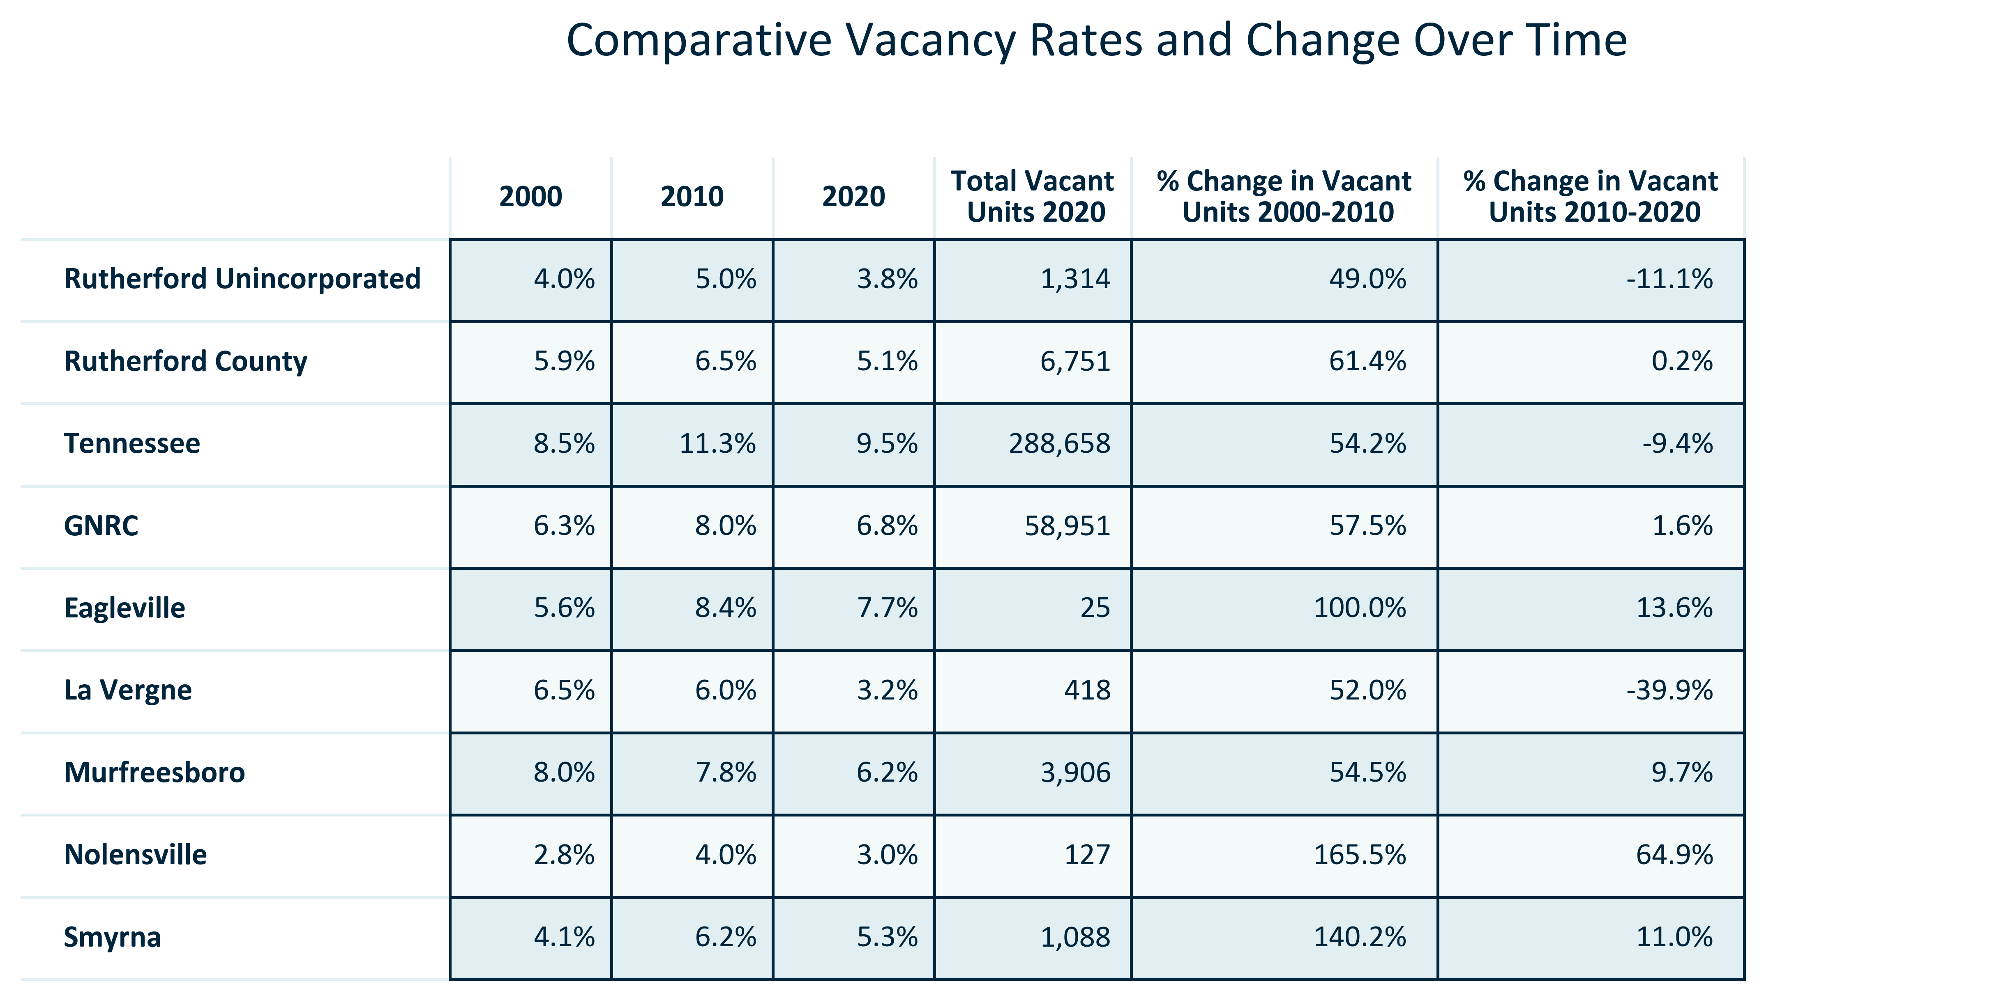

Citation: 2000, 2010, and 2020 Decennial Census

# Tenure & Cost

### TENURECOST_stackedbar_primarygeo_shareownvsrent_overtime:

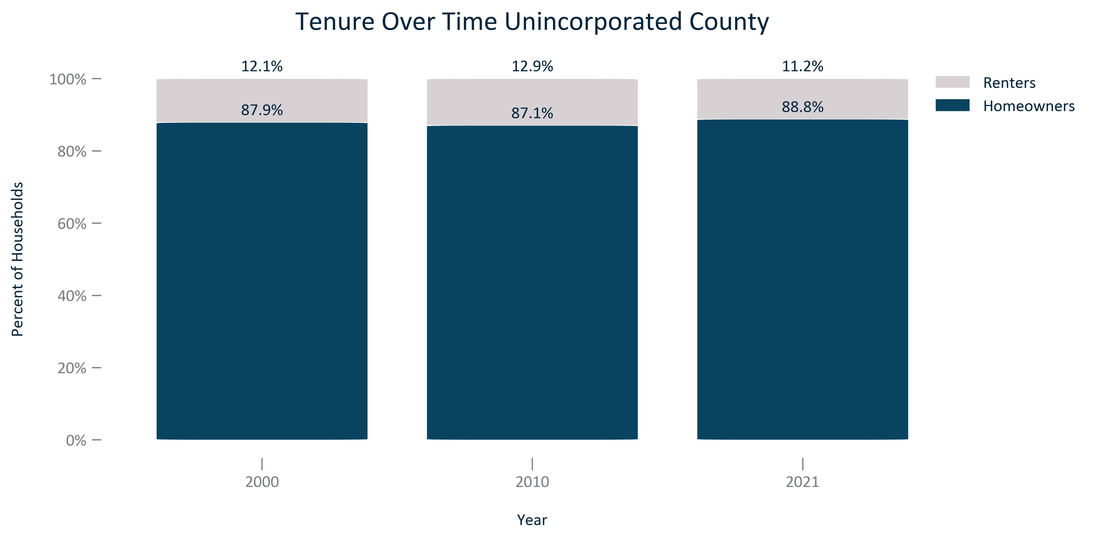

Citation: 2000 Decennial Census, 22006-2010 and 2017-2021 ACS 5-Year Estimates

### TENURECOST_stackedbar_primarygeo_mortgagestatus_overtime:

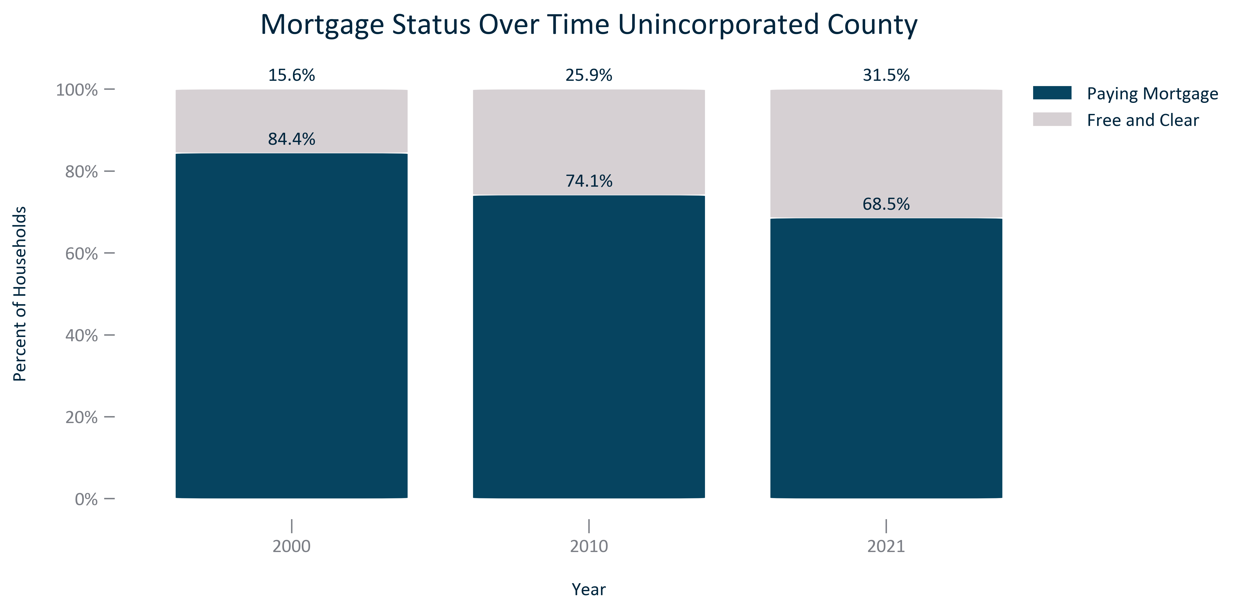

Citation: 2000 Decennial Census, 2006-2010 and 2017-2021 ACS 5 Year Estimates

### TENURECOST_bar_geocomparative_homeownershiprate_2021:

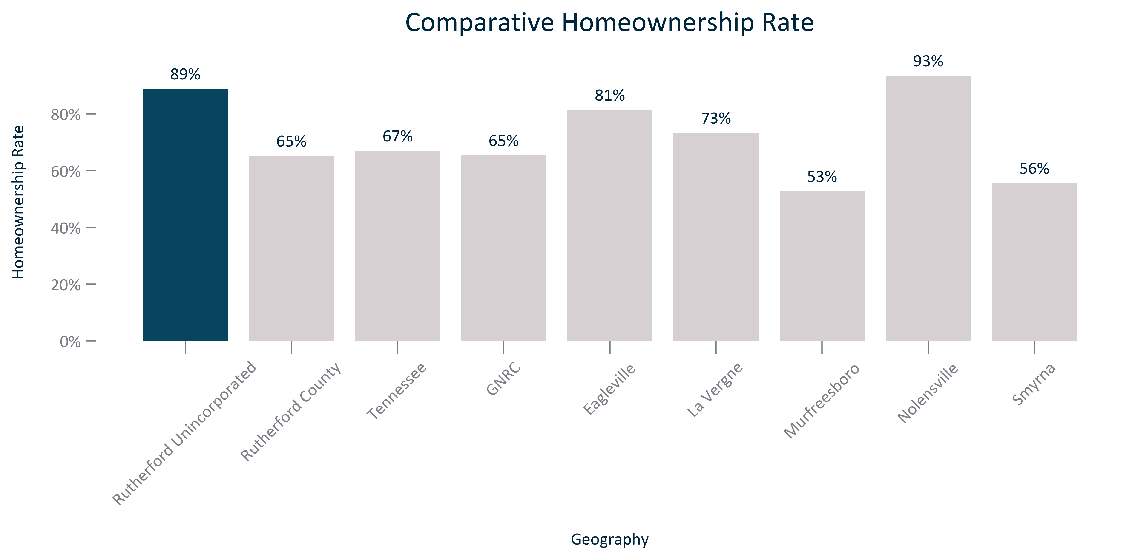

Citation: 2017-2021 ACS 5-Year Estimates

### TENURECOST_clusterbar_geocomparative_homeownershiprate_overtime:

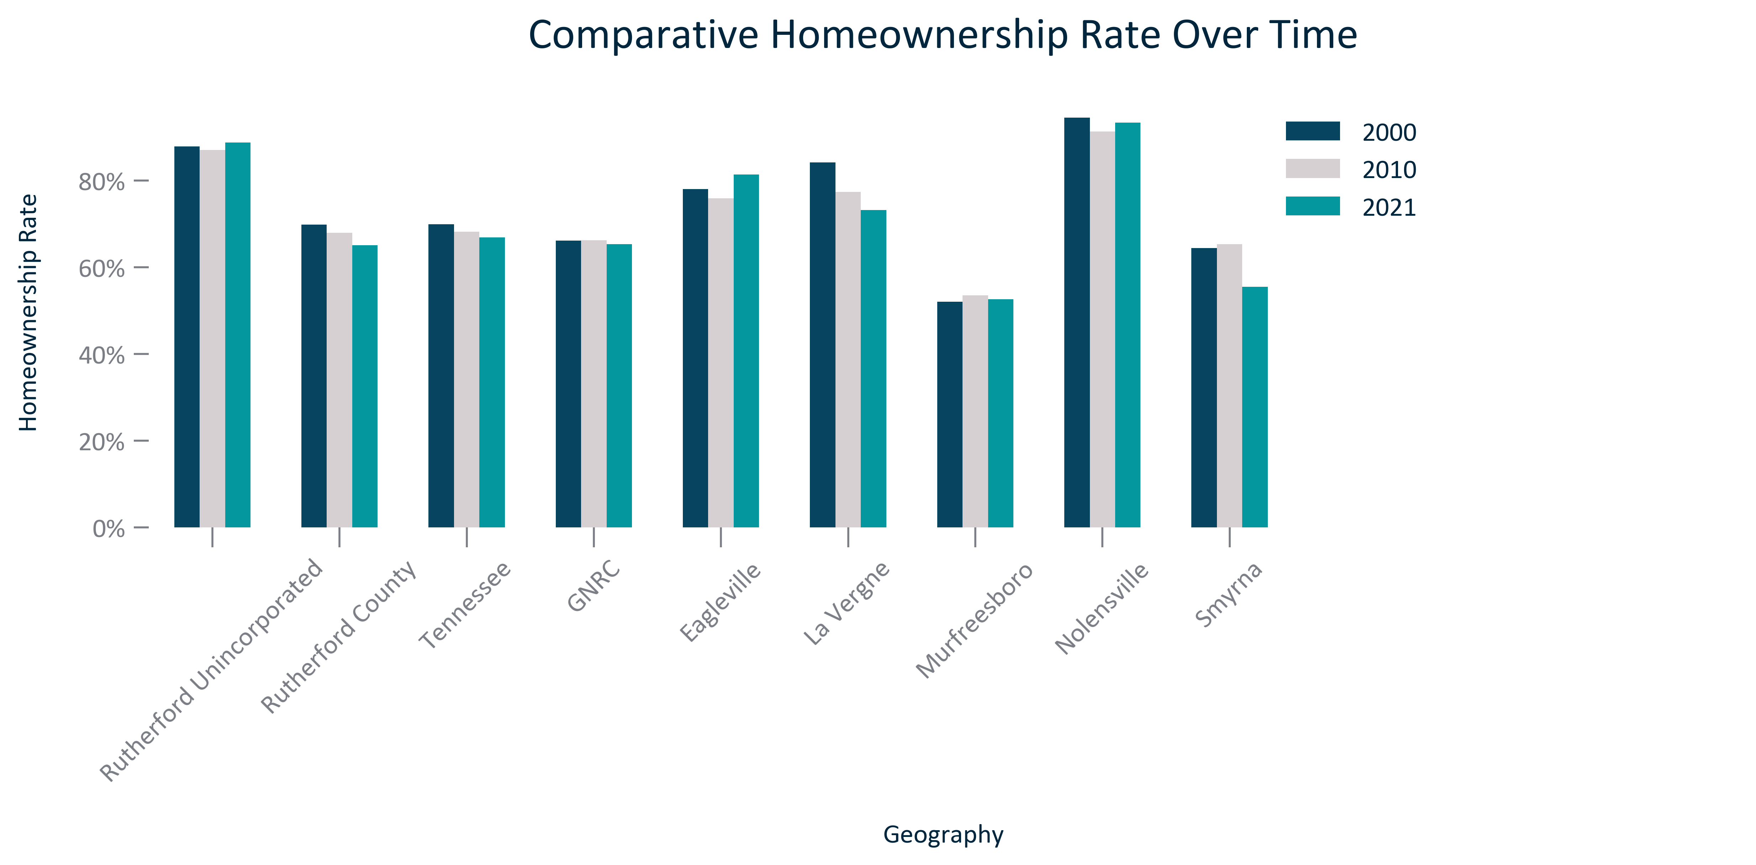

Citation: 2000 Decennial Census, 2006-2010 and 2017-2021 ACS 5-Year Estimates

### TENURECOST_bar_geocomparative_rentalrate_2021:

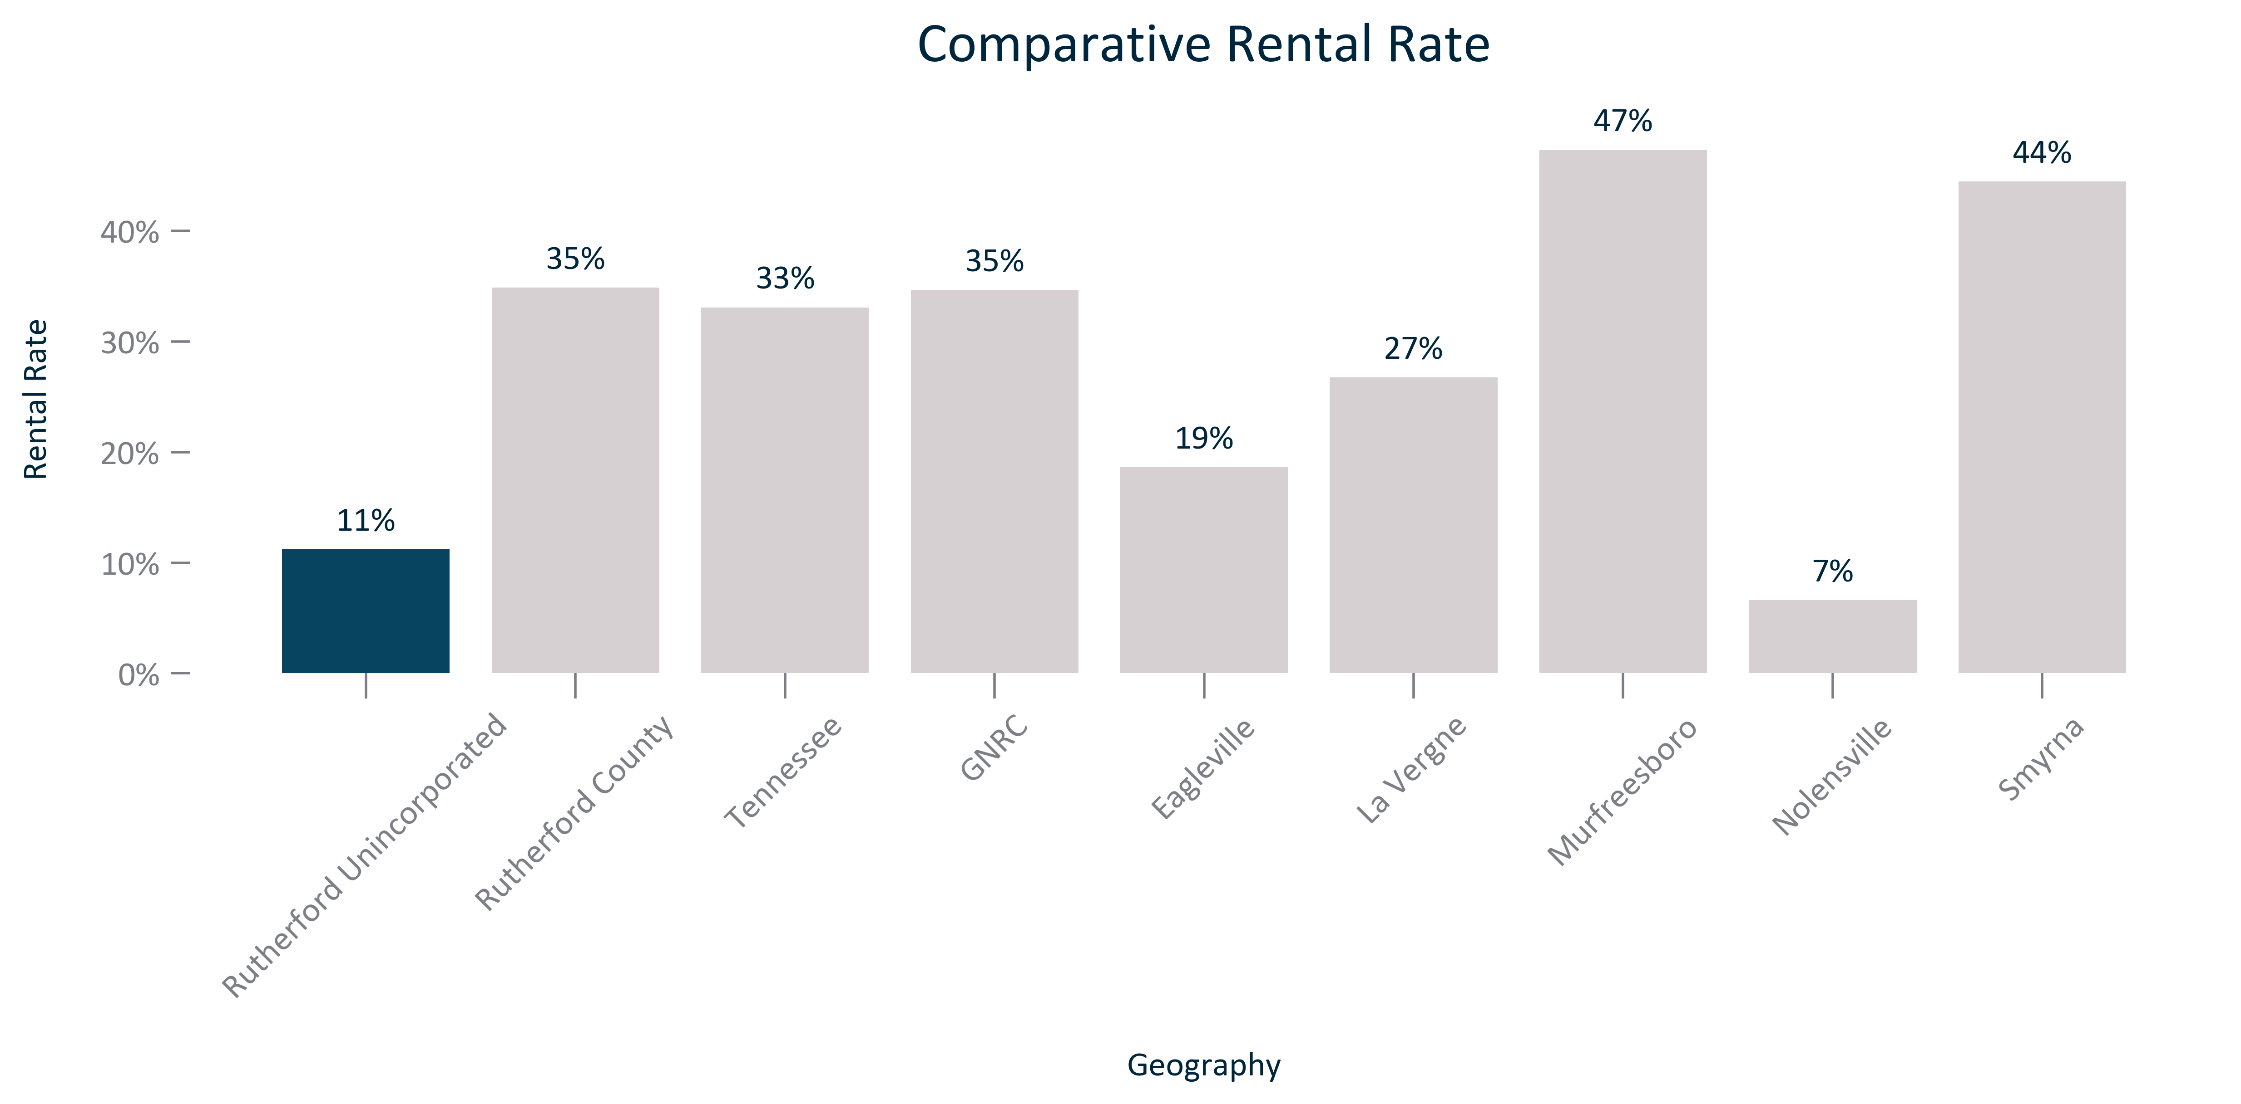

Citation: 2017-2021 ACS 5-Year Estimates

### TENURECOST_clusterbar_geocomparative_rentalrate_overtime:

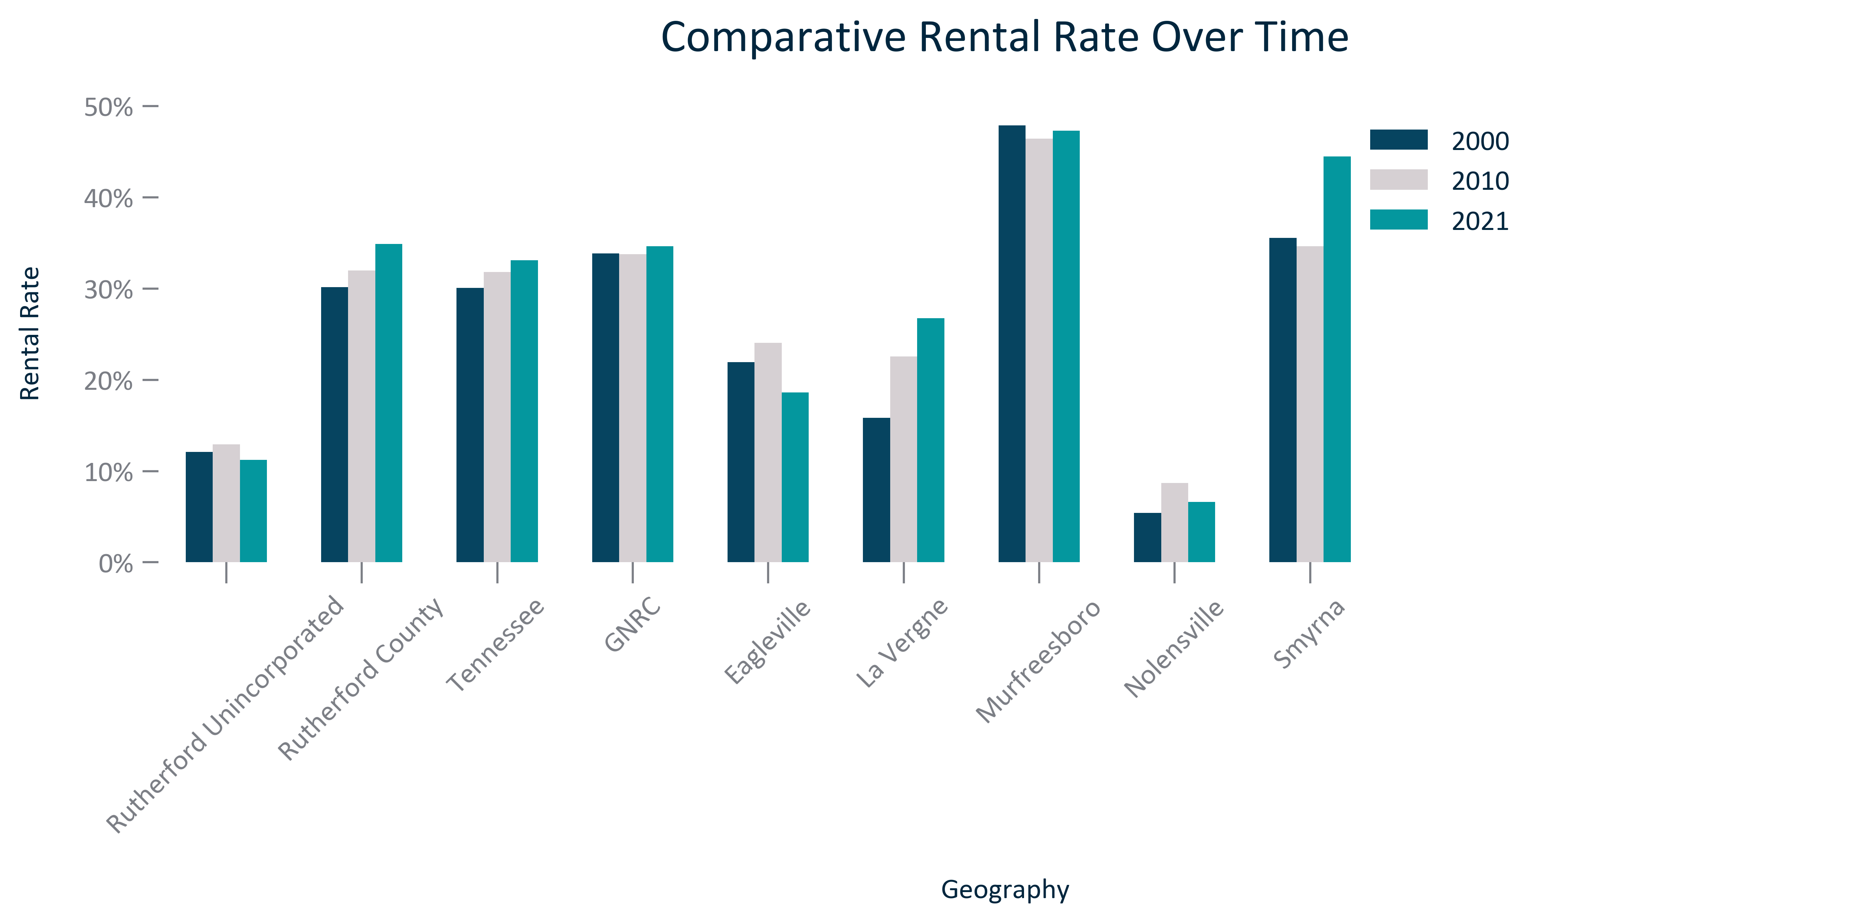

Citation: 2000 Decennial Census, 2006-2010 and 2017-2021 ACS 5-Year Estimates

### TENURECOST_table_geocomparative_tenureandchange_overtime:

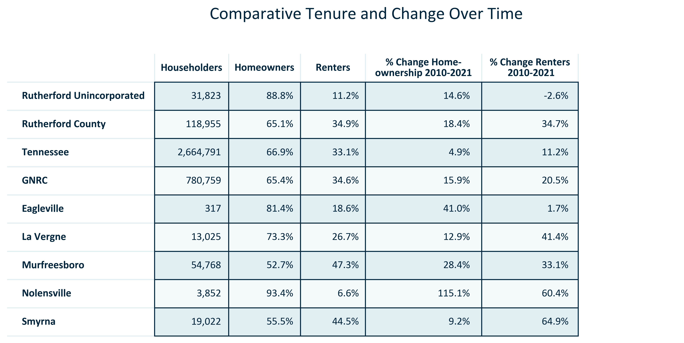

Citation: 2006-2010 and 2017-2021 ACS 5-Year Estimates

### TENURECOST_table_primarygeo_tenurebyraceandethnicity_overtime:

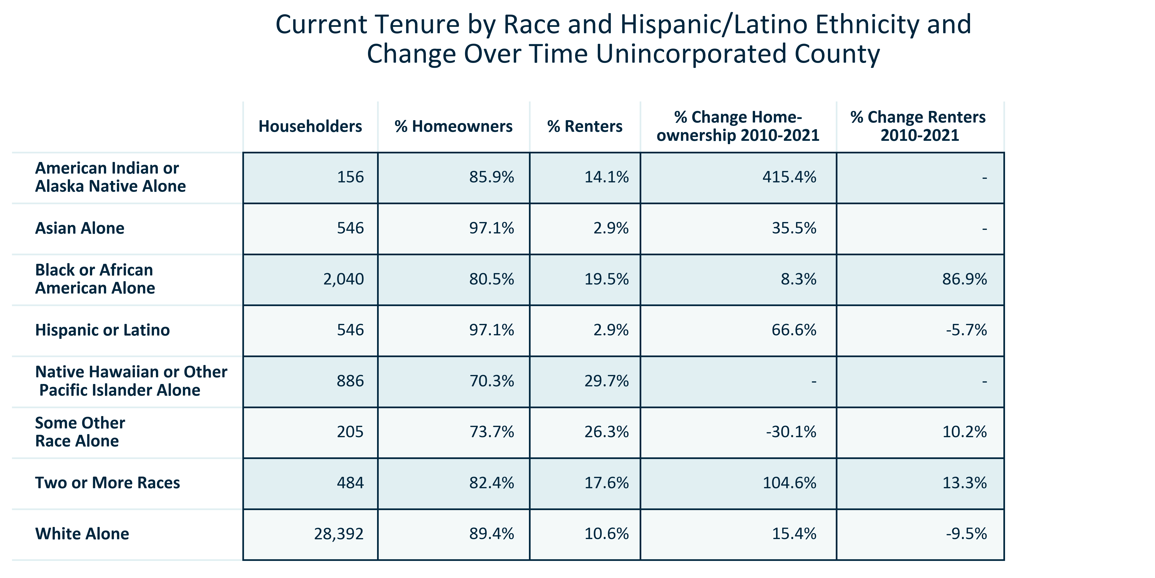

Citation: 2006-2010 and 2017-2021 5-Year American Community Survey Estimates

### TENURECOST_table_primarygeo_tenureandchangebyagegroup_overtime:

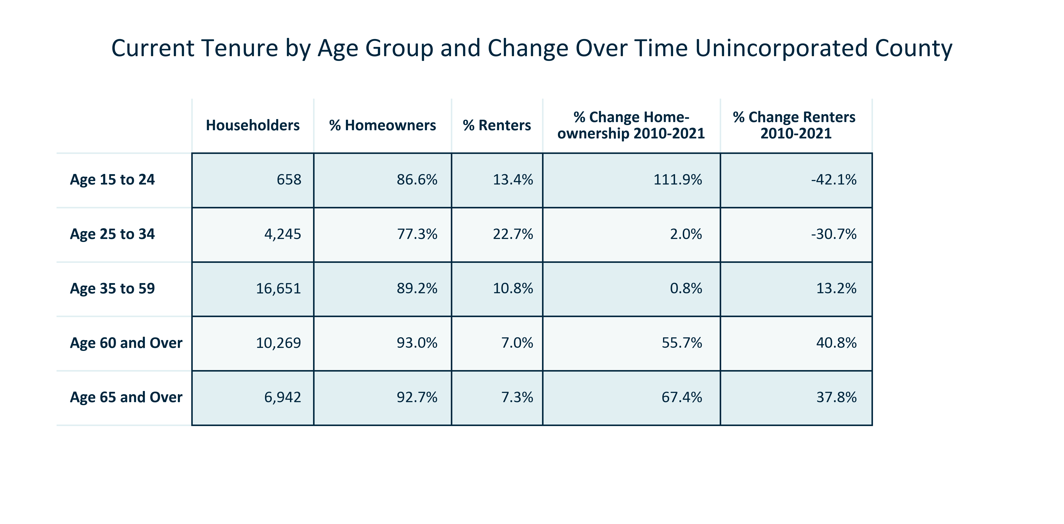

Citation: 2006-2010 and 2017-2021 5-Year American Community Survey Estimates

### TENURECOST_bar_primarygeo_mediangrossrent_overtime:

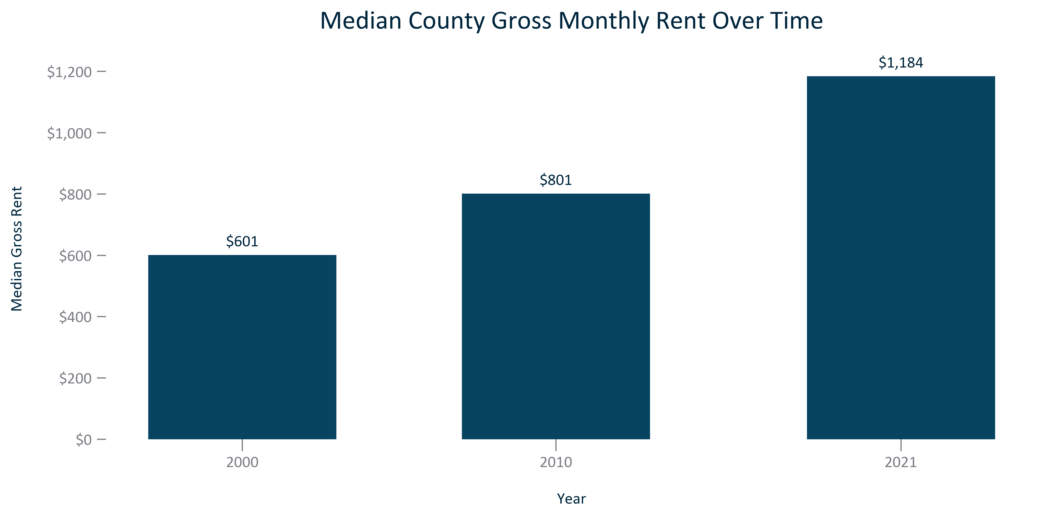

Citation: 2000 Decennial Census, 2006-2010 and 2017-2021 ACS 5 Year Estimates

### TENURECOST_clusterbar_geocomparative_changemediangrossrent_overtime:

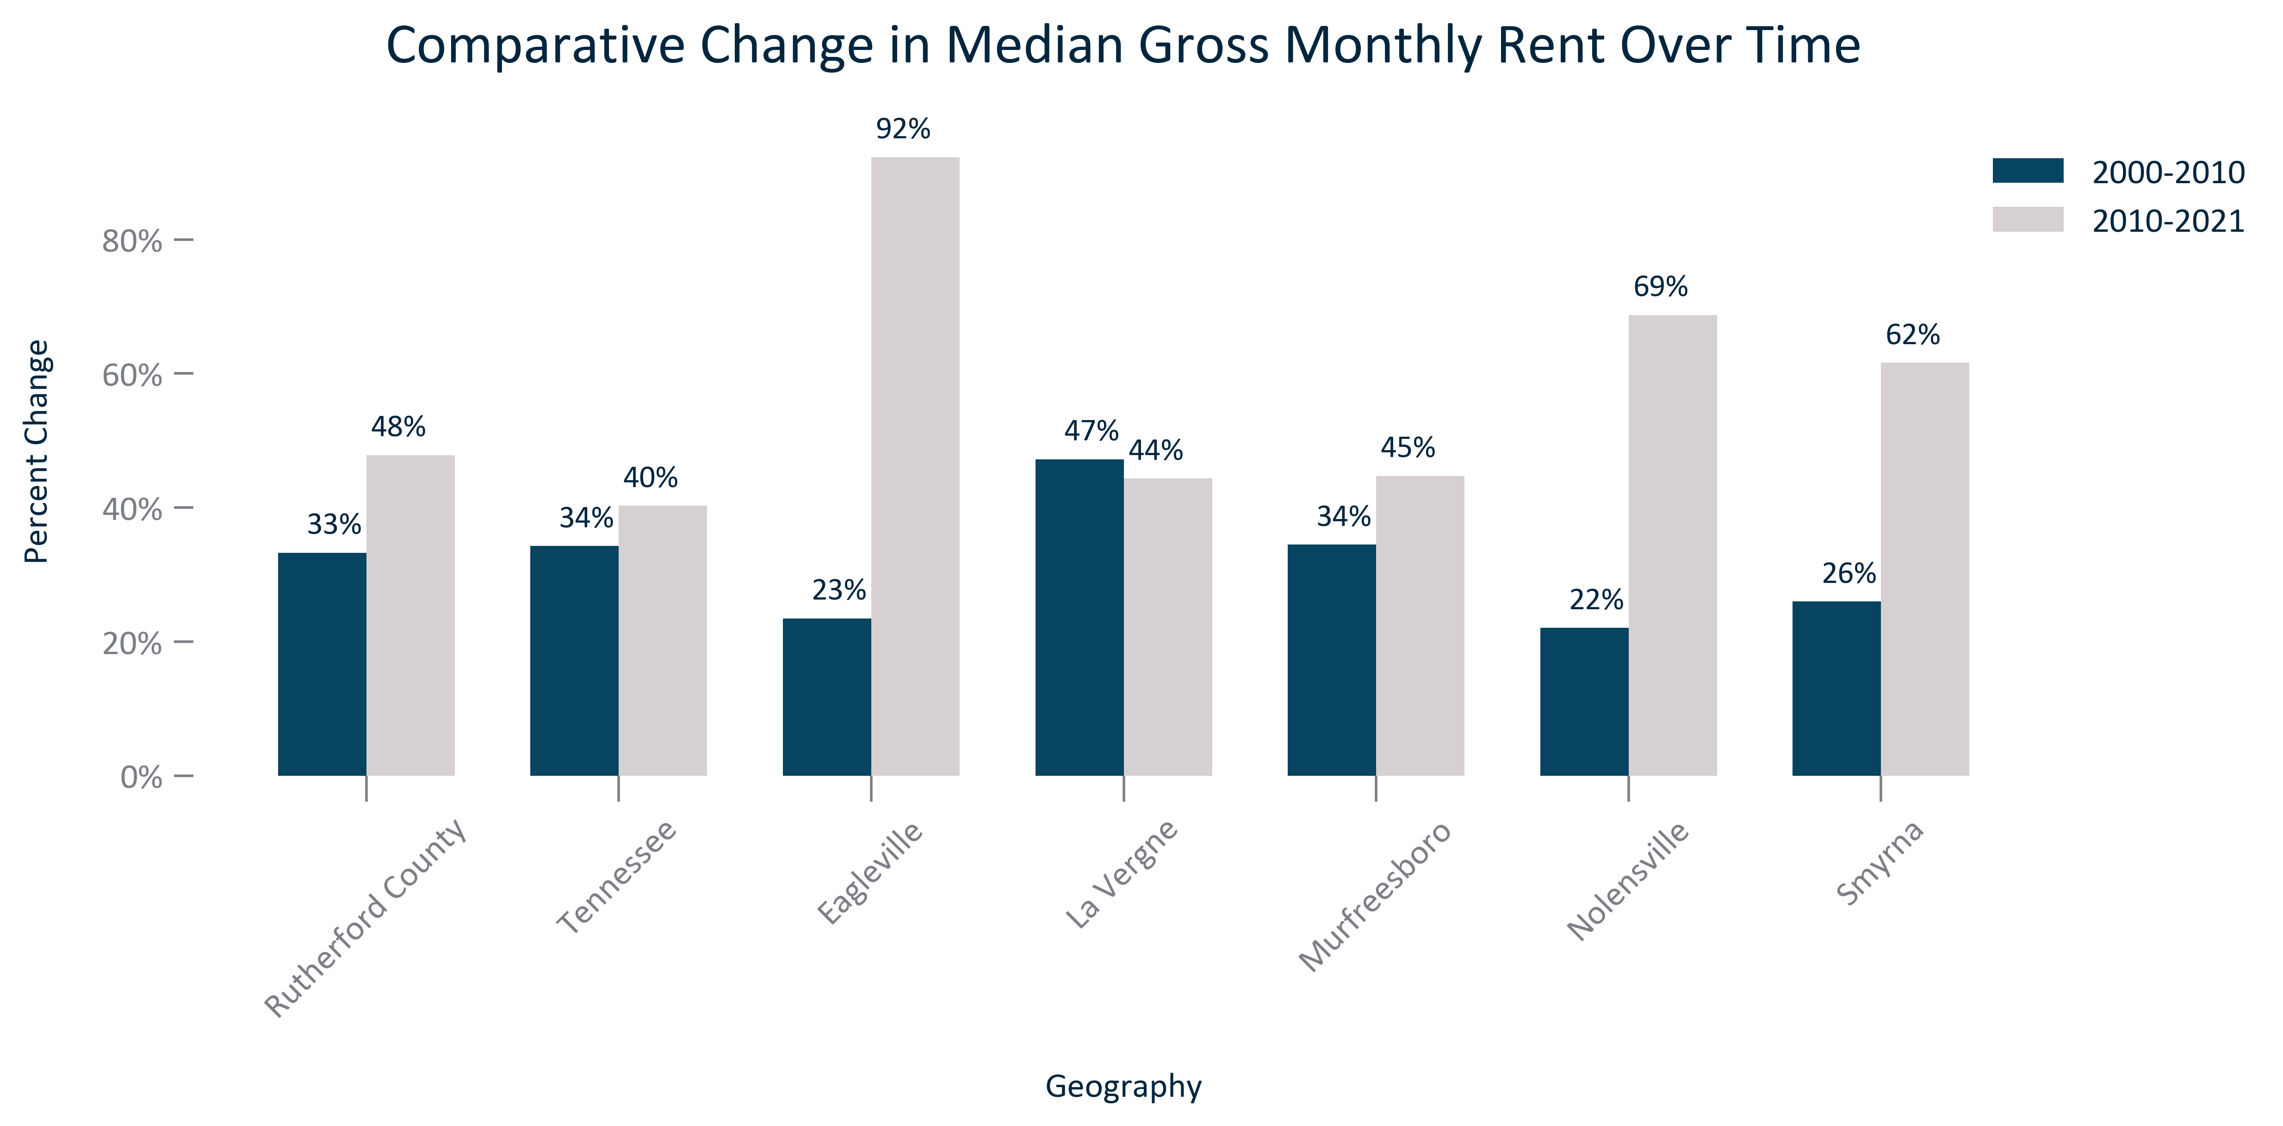

Citation: 2000 Decennial Census, 2006-2010 and 2017-2021 ACS 5-Year Estimates

### TENURECOST_line_geocomparative_ZILLOWannualaveragerent_overtime:

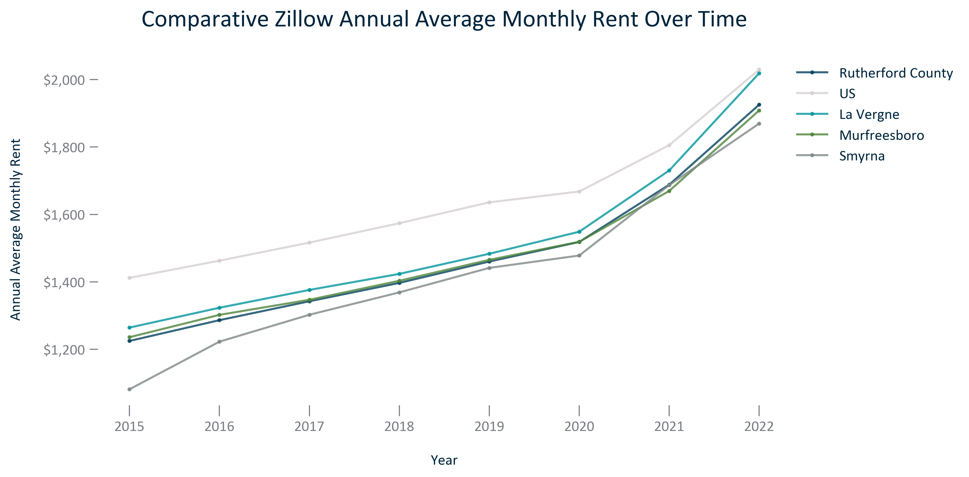

Citation: Zillow, 2015-2022

### TENURECOST_clusterbar_geocomparative_ZILLOWpercentchangeannualaveragerent_overtime:

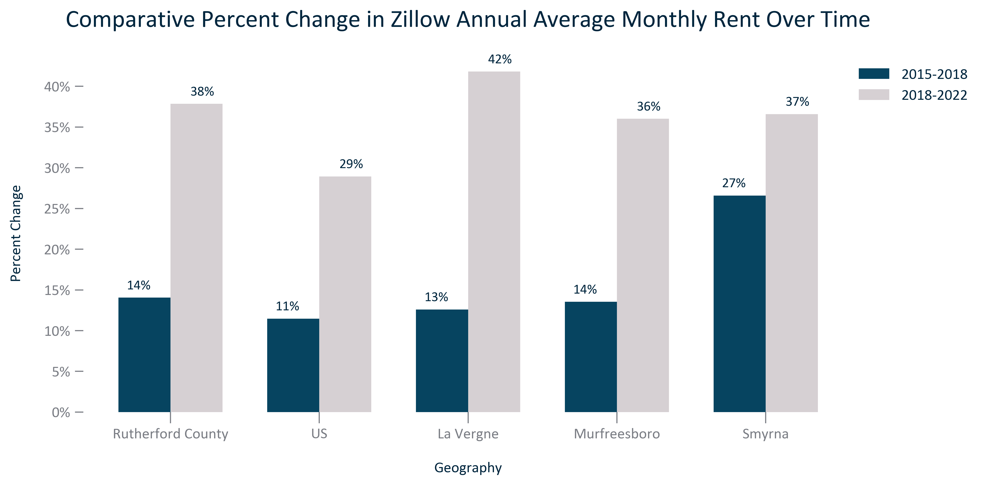

Citation: Zillow, 2015-2022

### TENURECOST_clusterbar_primarygeo_ownercostsbymortgagestatus_overtime:

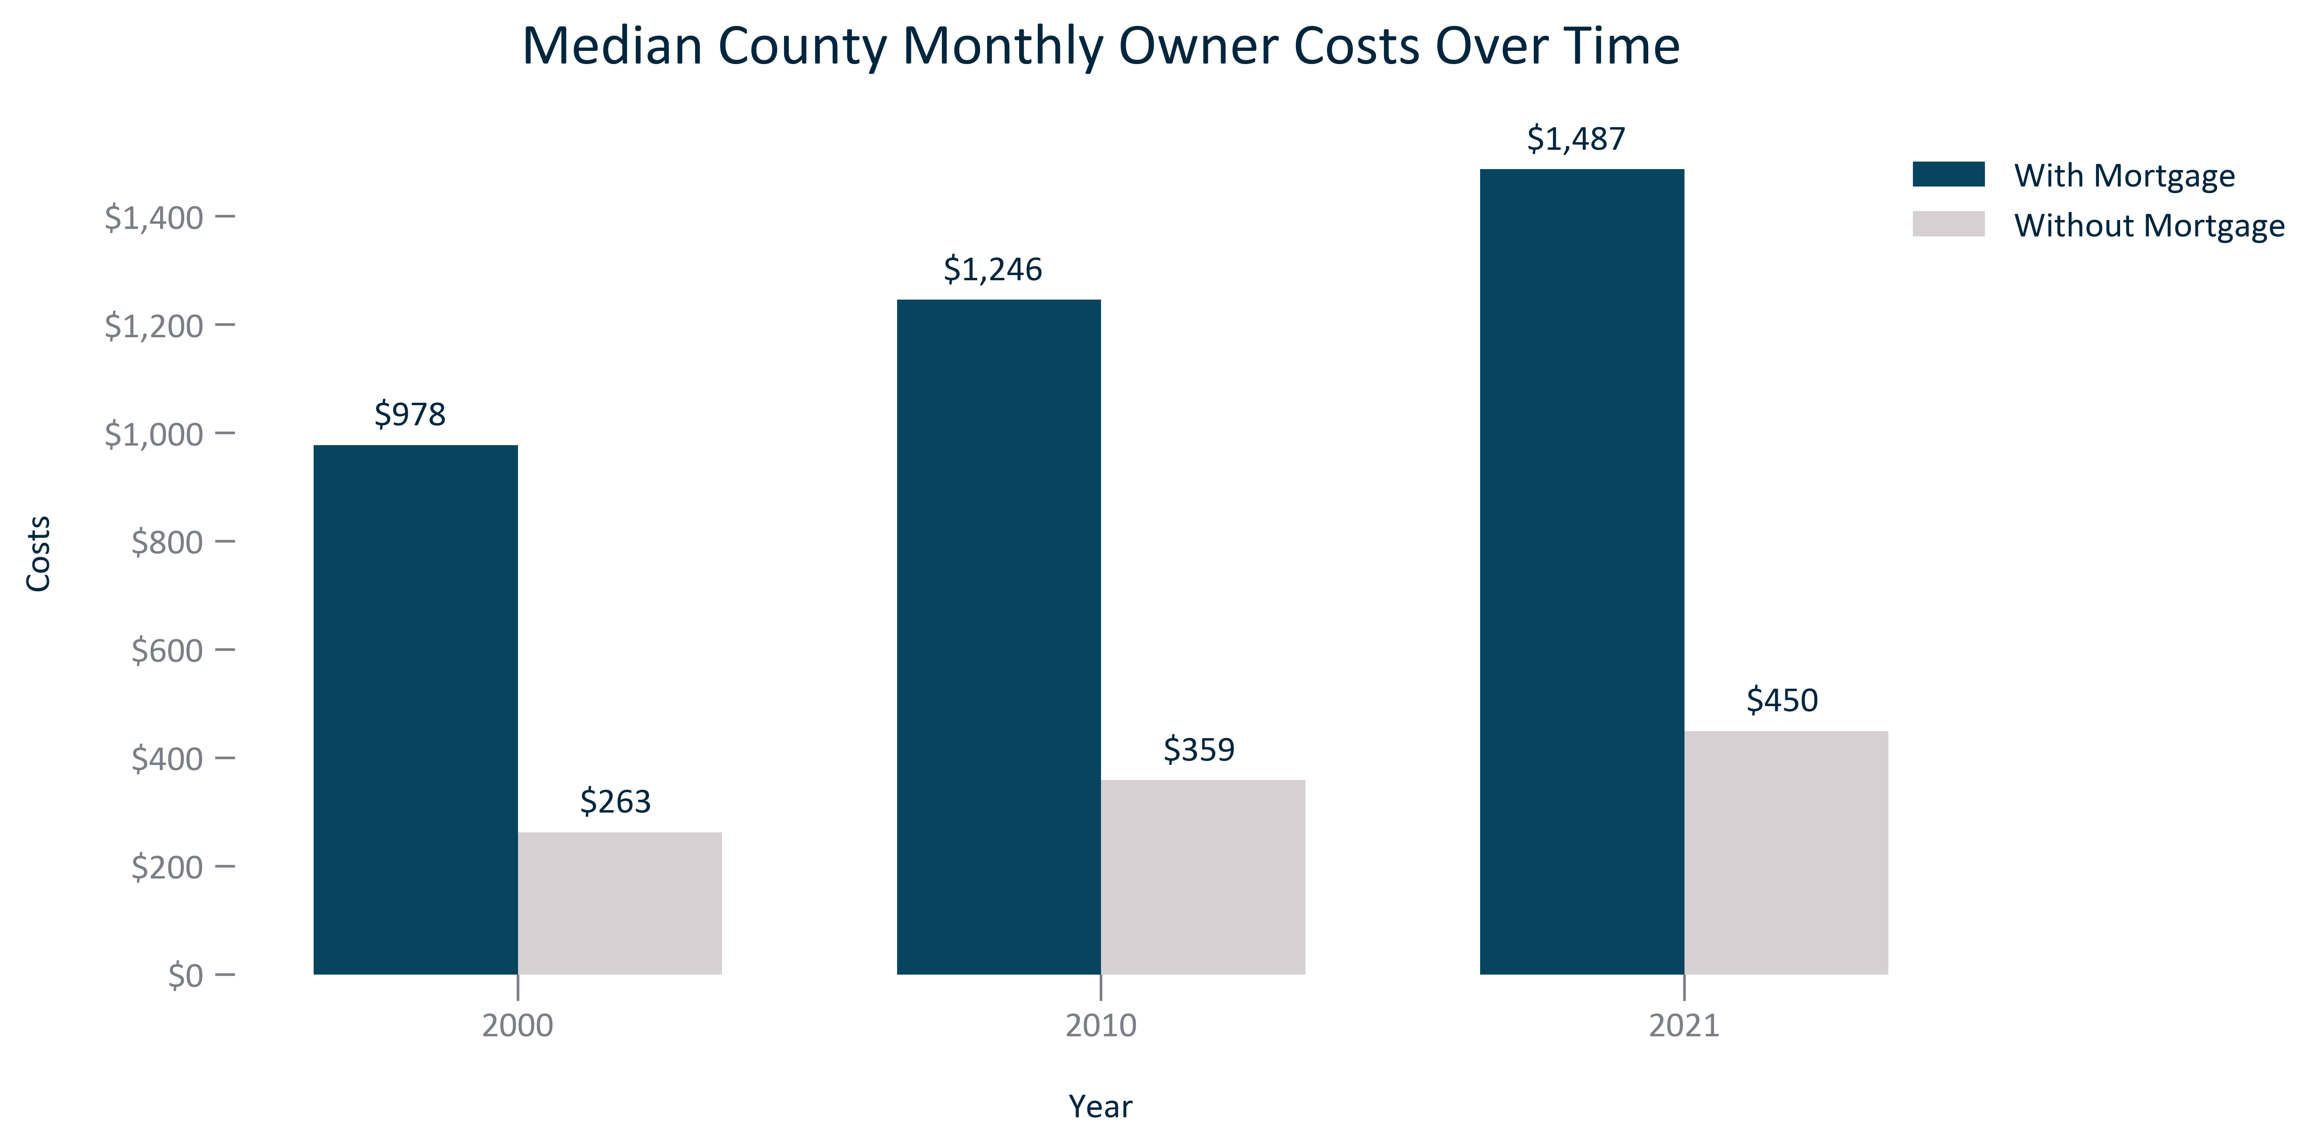

Citation: 2000 Decennial Census, 2006-2010 and 2017-2021 ACS 5-Year Estimates

### TENURECOST_clusterbar_geocomparative_changemedianownerwithmortgagecost_overtime:

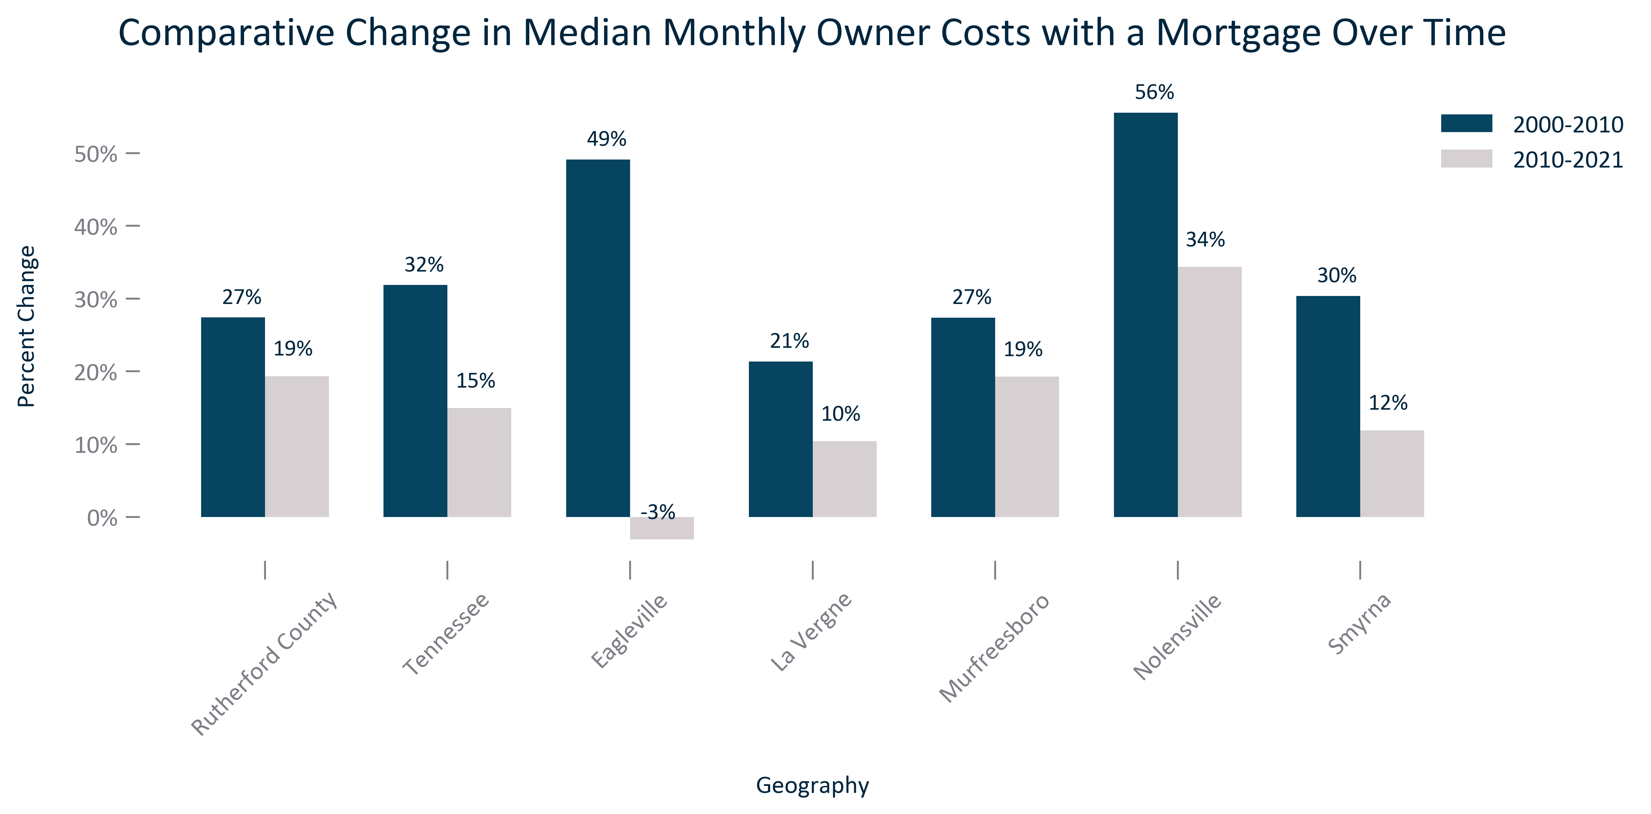

Citation: 2000 Decennial Census, 2006-2010 and 2017-2021 ACS 5-Year Estimates

### TENURECOST_bar_primarygeo_valueowneroccupiedhousing_overtime:

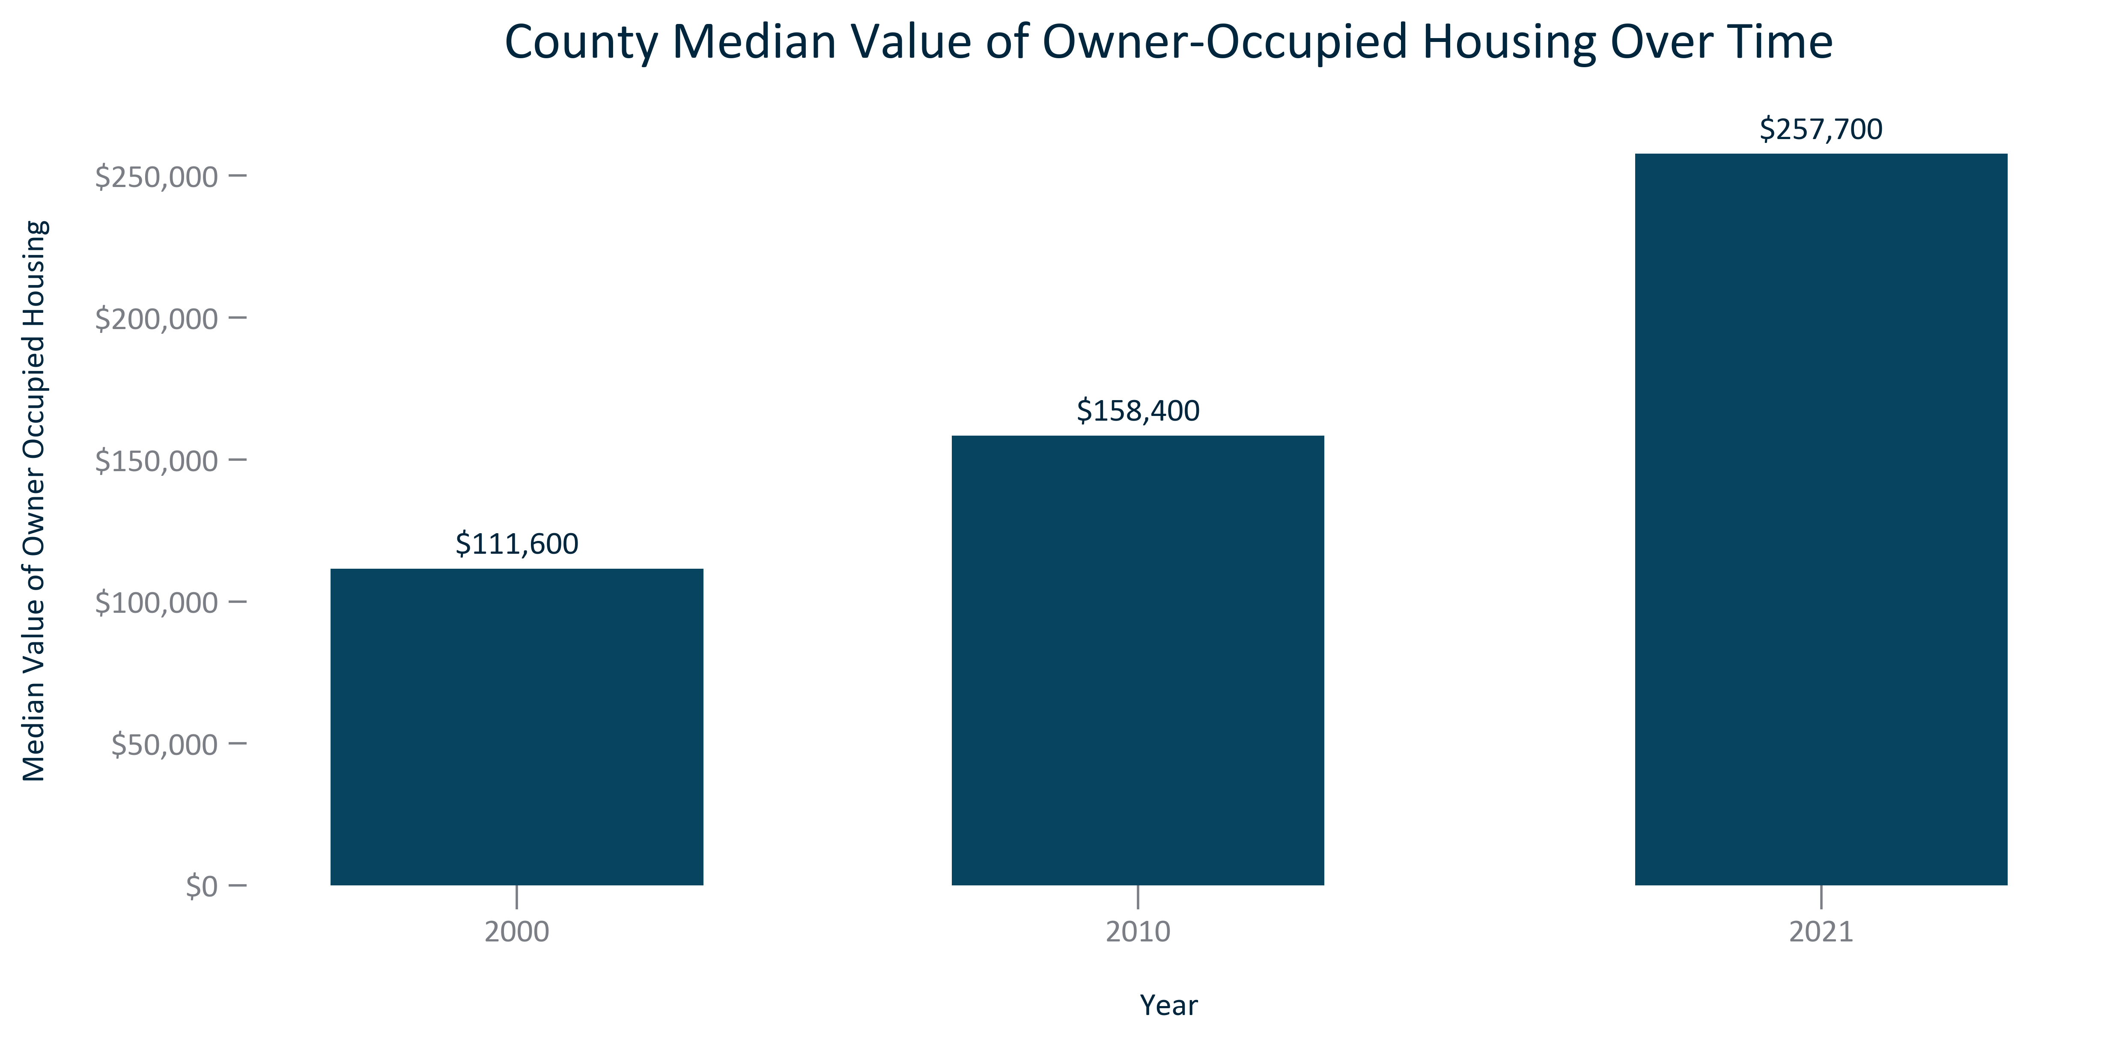

Citation: 2000 Decennial Census, 2006-2010 and 2017-2021 ACS 5-Year Estimates

### TENURECOST_clusterbar_geocomparative_changemedianhomevalueowneroccupied_overtime:

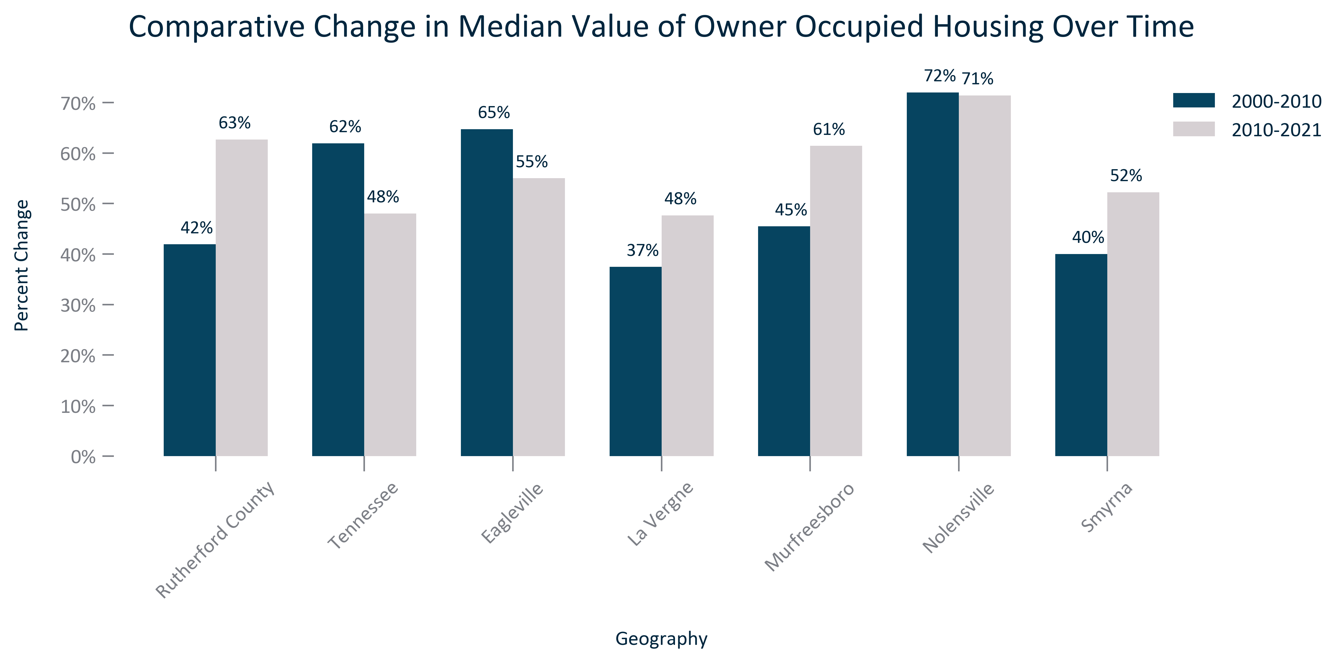

Citation: 2000 Decennial Census, 2006-2010 and 2017-2021 ACS 5-Year Estimates

### TENURECOST_line_geocomparative_ZILLOWannualhomevalueestimates_overtime:

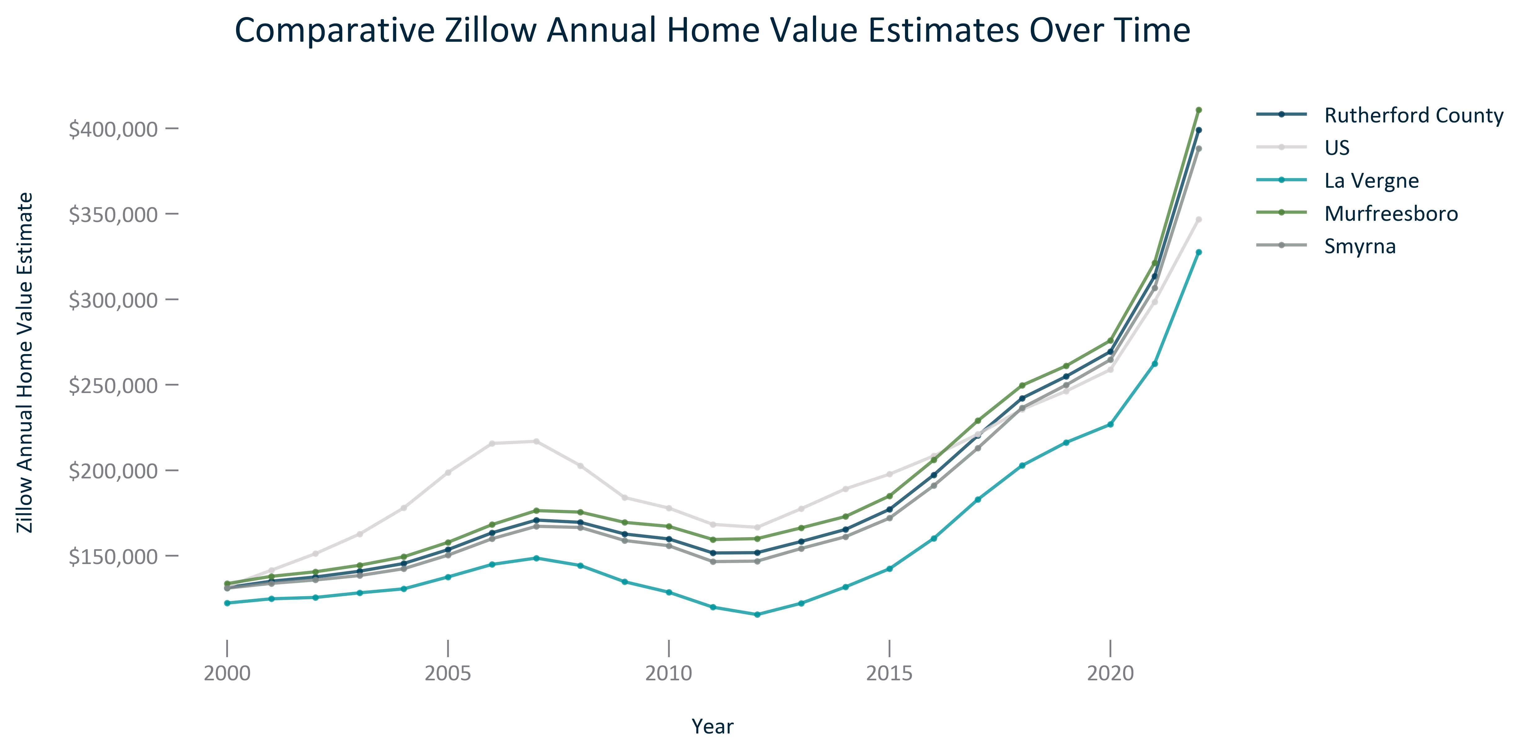

Citation: Zillow, 2000-2022

### TENURECOST_bar_primarygeo_costburdenedhouseholds_overtime:

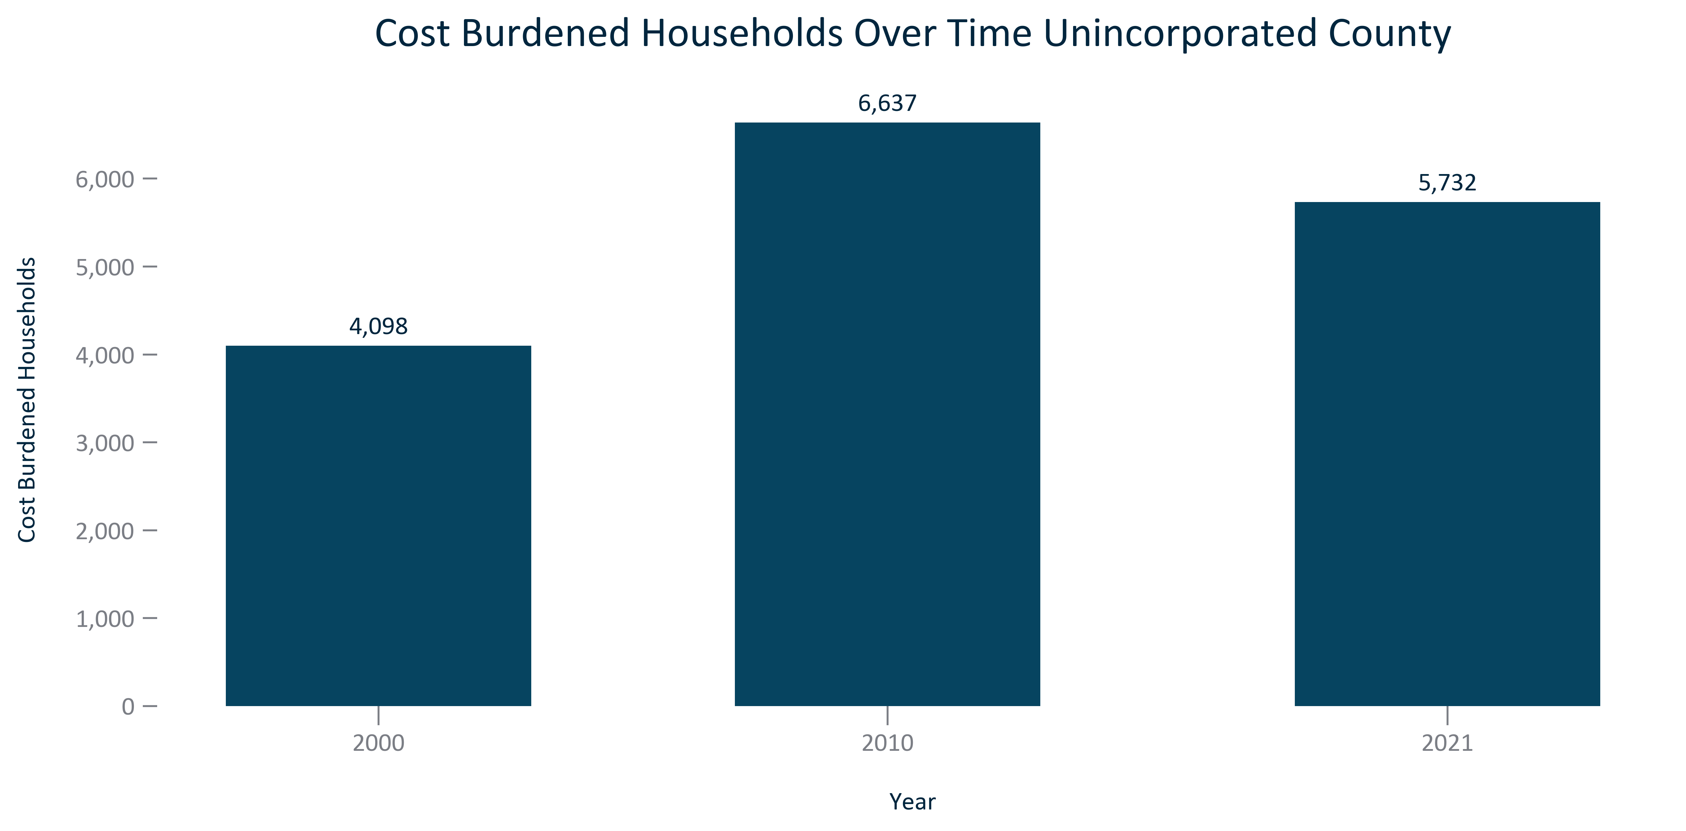

Citation: 2000 Decennial Census, 2006-2010 and 2017-2021 ACS 5-Year Estimates

### TENURECOST_bar_primarygeo_sharehouseholdscostburdened_overtime:

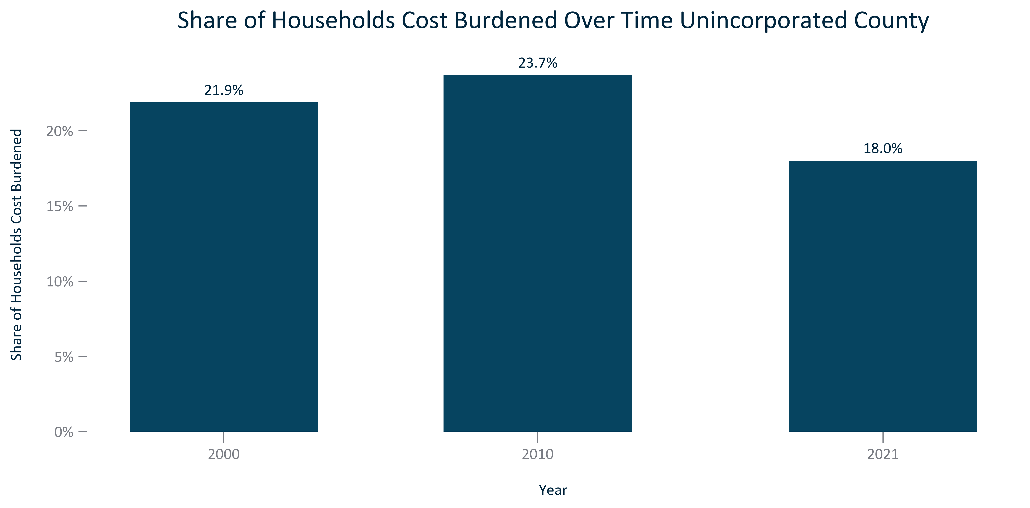

Citation: 2000 Decennial Census, 2006-2010 and 2017-2021 ACS 5-Year Estimates

### TENURECOST_bar_primarygeo_costburdenedownerocchouseholds_overtime:

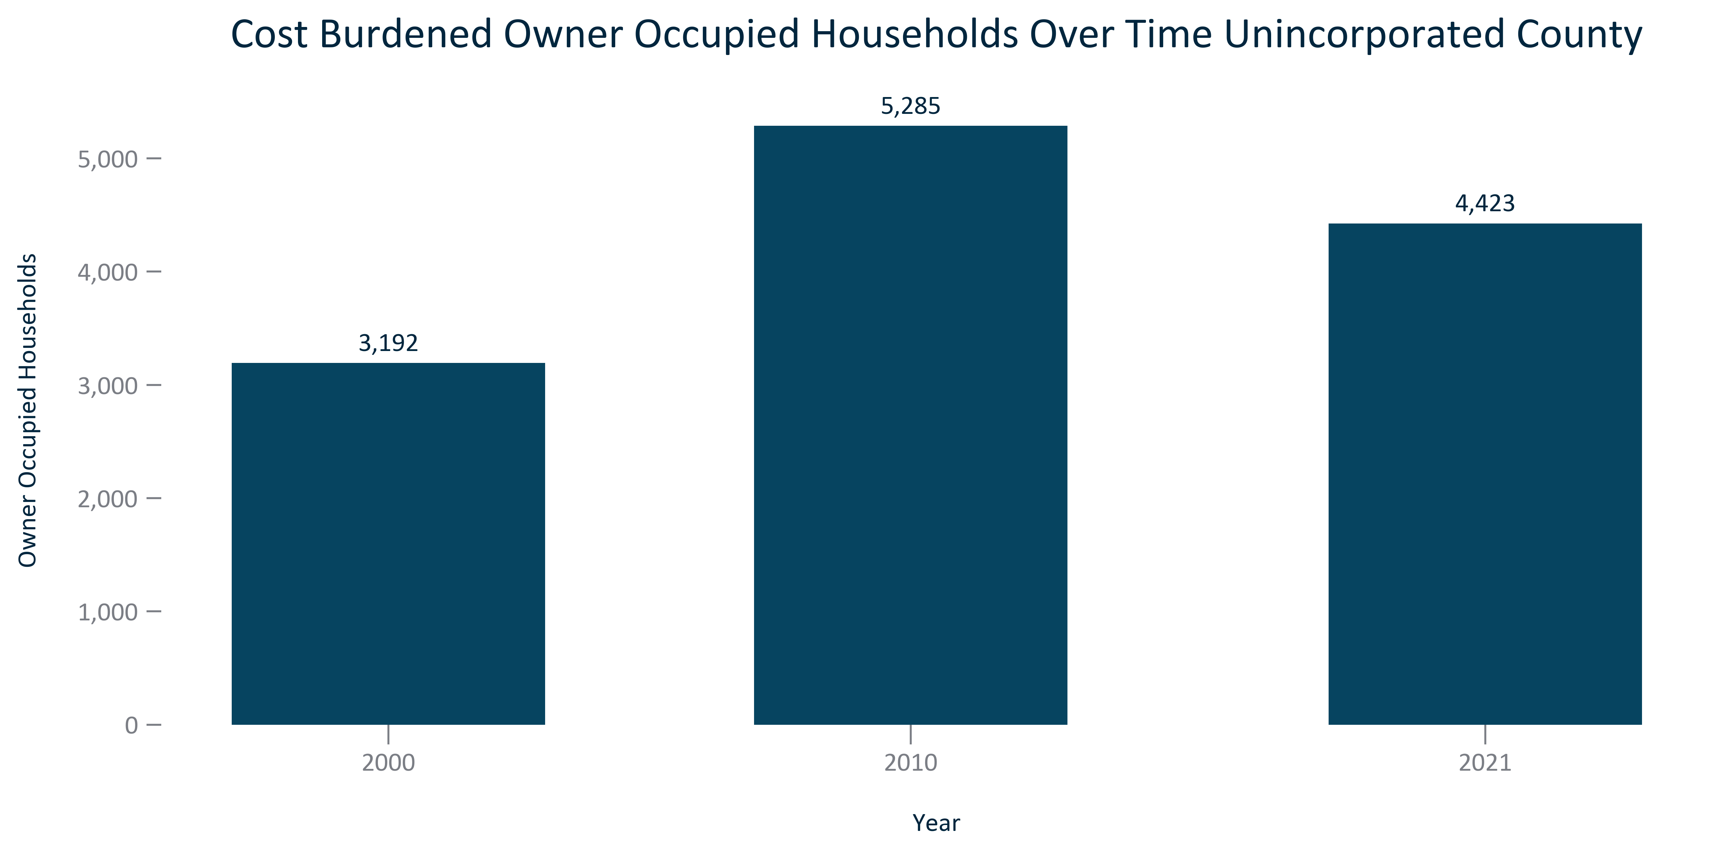

Citation: 2000 Decennial Census, 2006-2010 and 2017-2021 ACS 5-Year Estimates

### TENURECOST_bar_primarygeo_shareownerocchouseholdscostburdened_overtime:

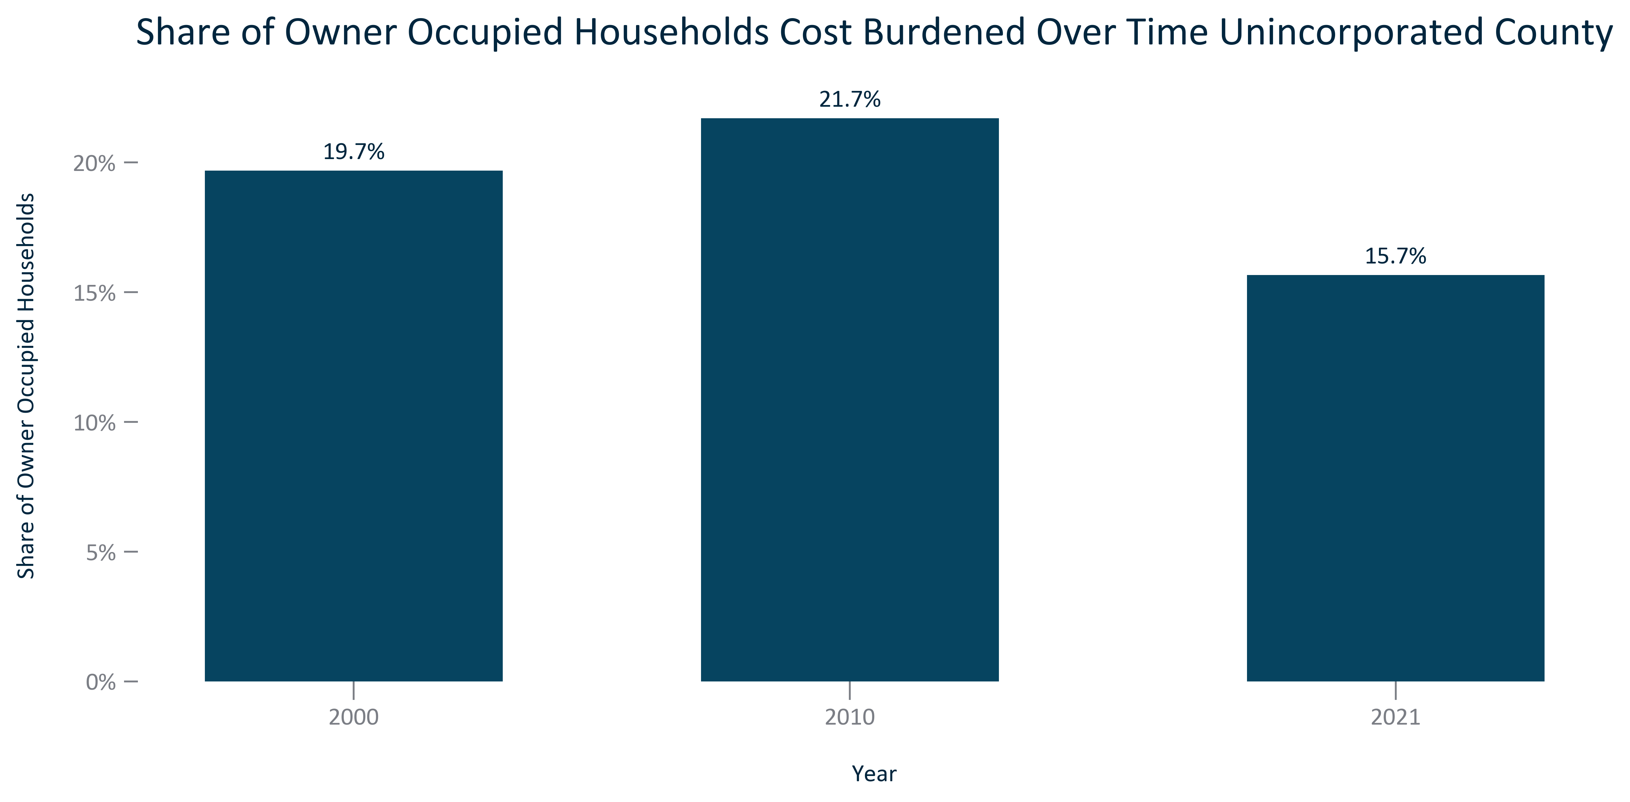

Citation: 2000 Decennial Census, 2006-2010 and 2017-2021 ACS 5-Year Estimates

### TENURECOST_bar_primarygeo_costburdenedrenterocchouseholds_overtime:

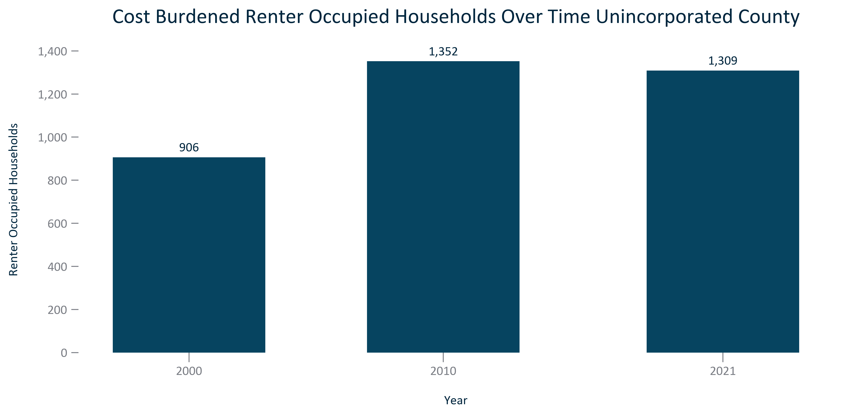

Citation: 2000 Decennial Census, 2006-2010 and 2017-2021 ACS 5-Year Estimates

### TENURECOST_bar_primarygeo_sharerenterocchouseholdscostburdened_overtime:

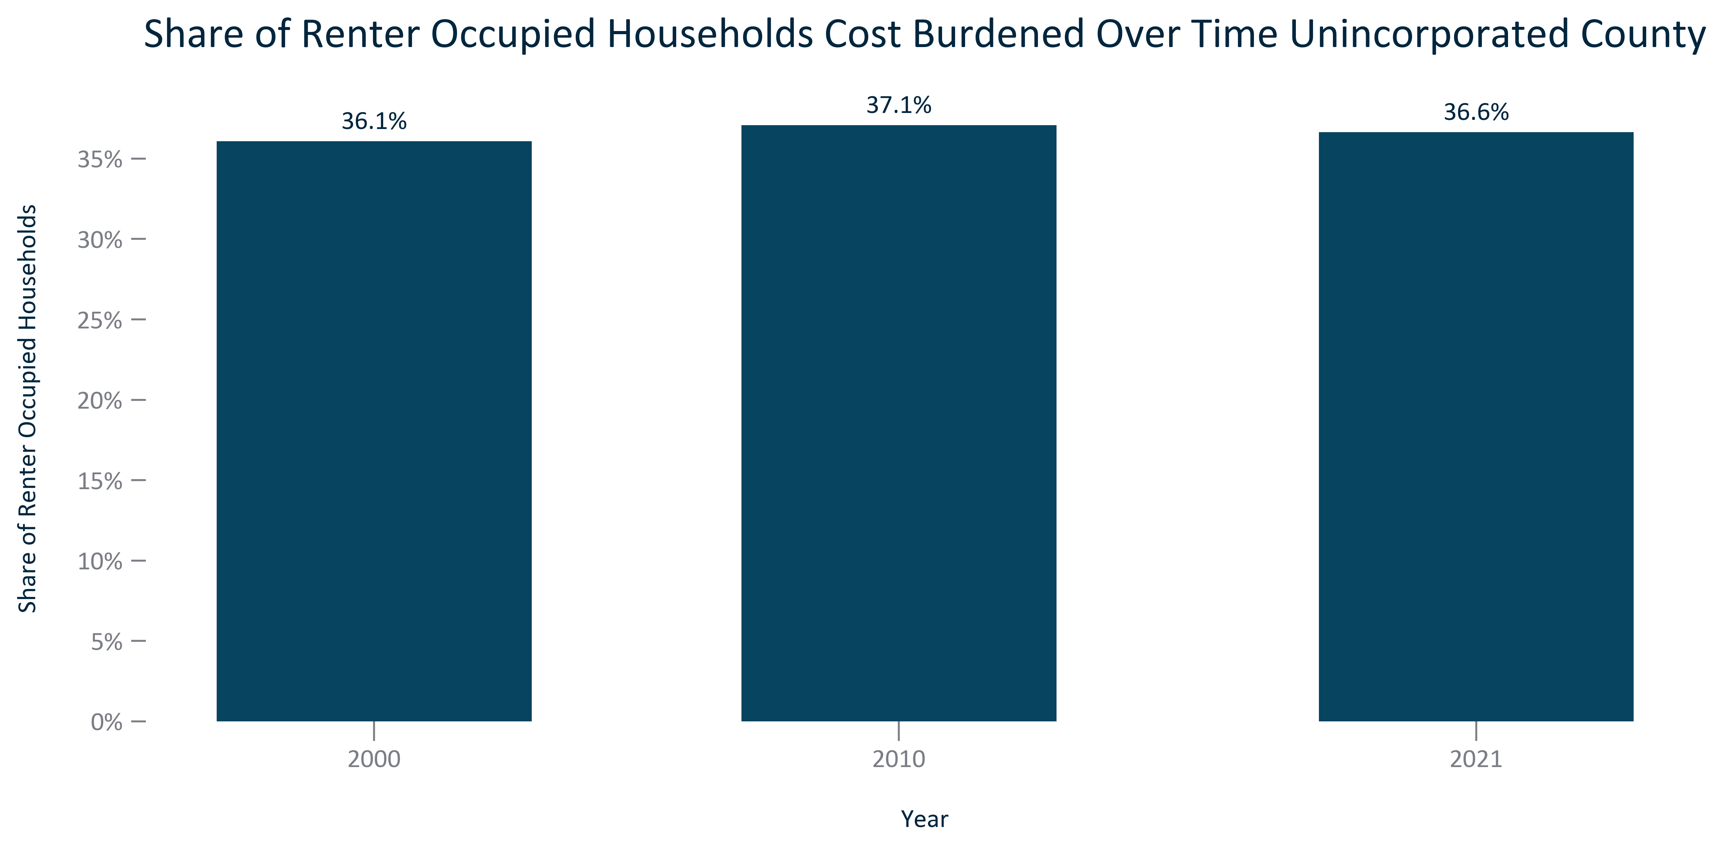

Citation: 2000 Decennial Census, 2006-2010 and 2017-2021 ACS 5-Year Estimates

### TENURECOST_stackedbar_geocomparative_costburdenbytenure_2021:

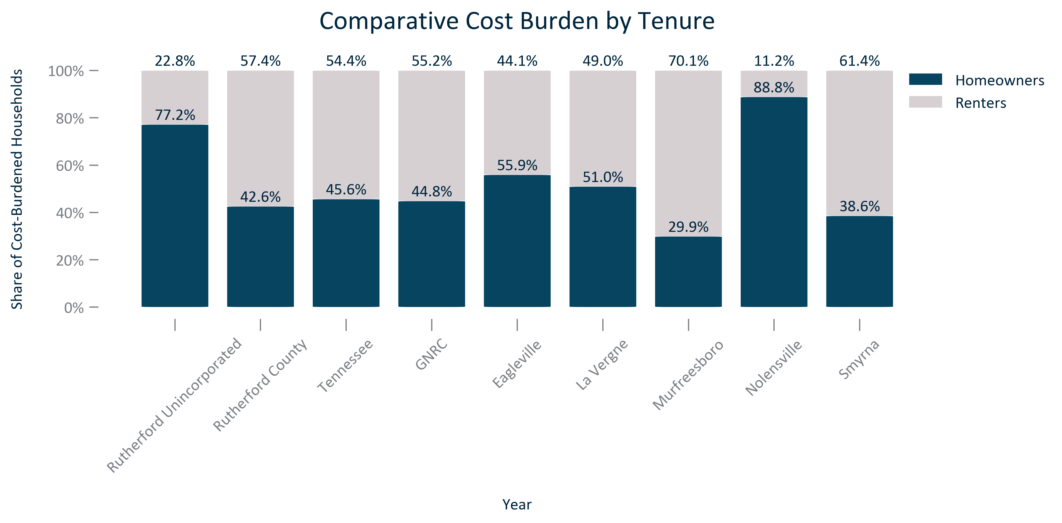

Citation: 2000 Decennial Census, 2006-2010 and 2017-2021 ACS 5-Year Estimates

### TENURECOST_stackedbar_geocomparative_severecostburdenbytenure_2021:

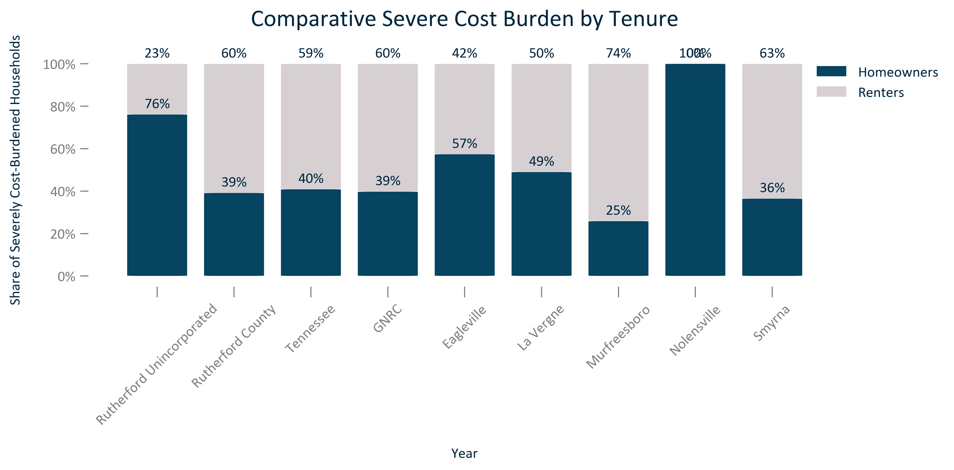

Citation: 2000 Decennial Census, 2006-2010 and 2017-2021 ACS 5-Year Estimates

### TENURECOST_table_primarygeo_allcostburdennumberandpercent_overtime:

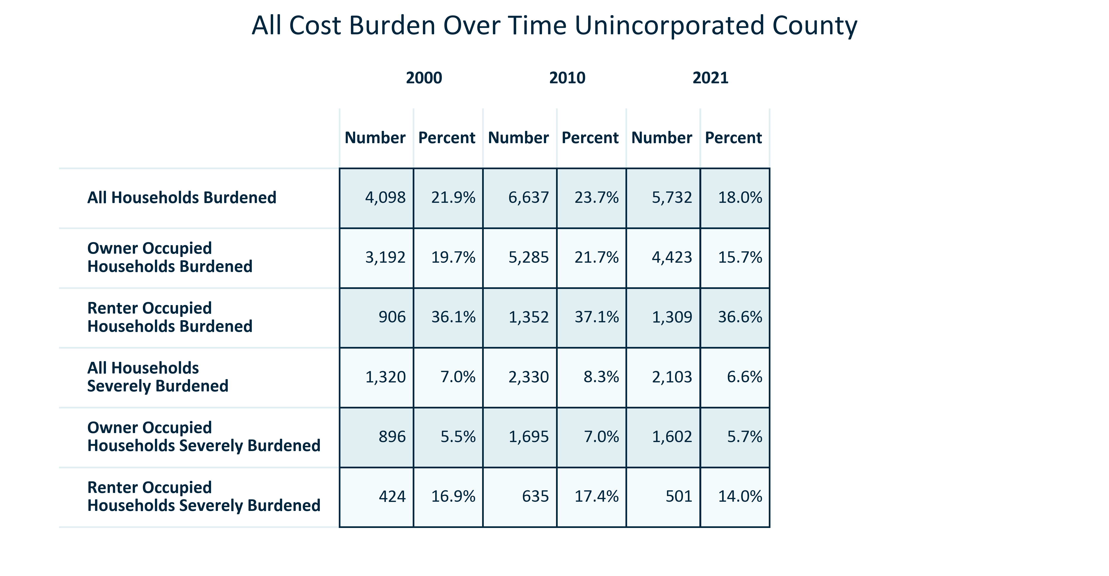

Citation: 2000 Decennial Census, 2006-2010 and 2017-2021 ACS 5-Year Estimates

### TENURECOST_clusterbar_primarygeo_allcostburdenpercentchange_overtime:

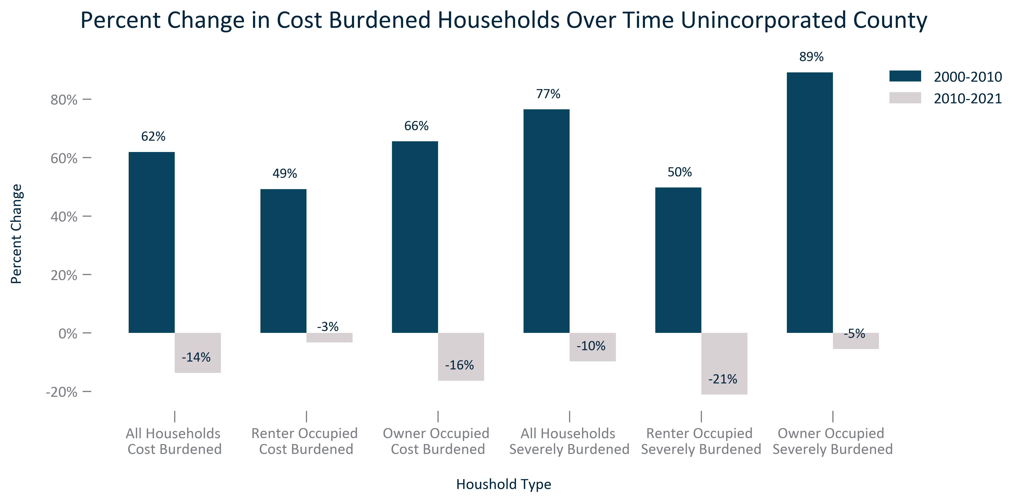

Citation: 2000 Decennial Census, 2006-2010 and 2017-2021 ACS 5-Year Estimates

### TENURECOST_clusterbar_primarygeo_allcostburdenrealchange_overtime:

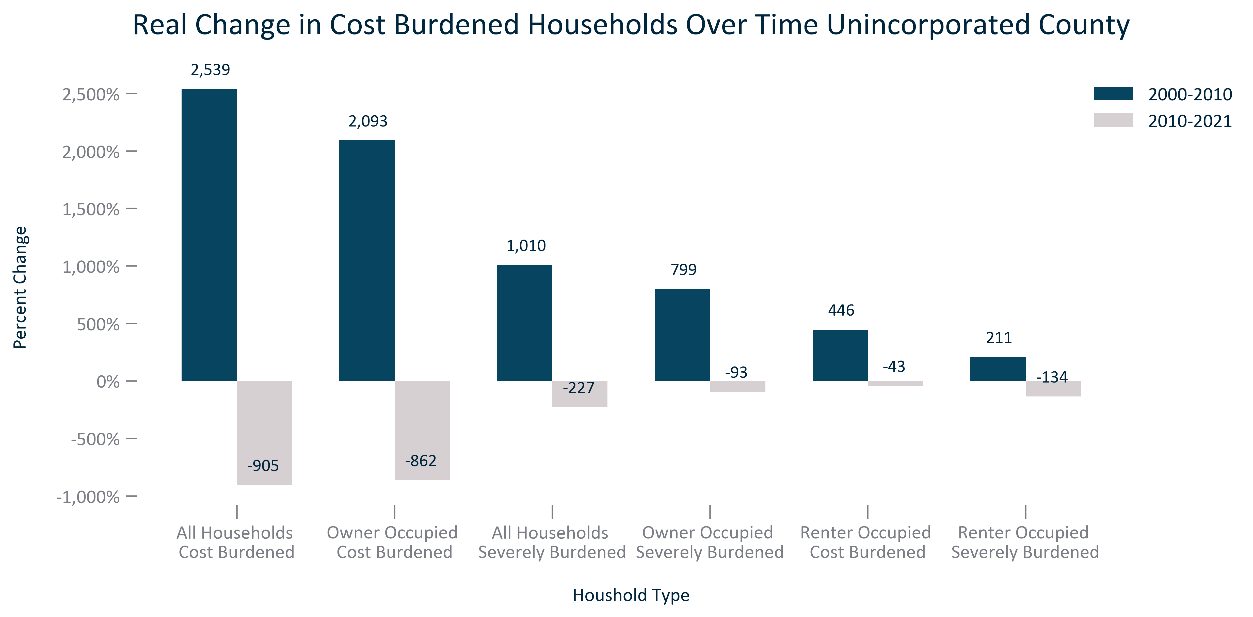

Citation: 2000 Decennial Census, 2006-2010 and 2017-2021 ACS 5-Year Estimates

### TENURECOST_clusterbar_geocomparative_CNThtpercentofincome_2019:

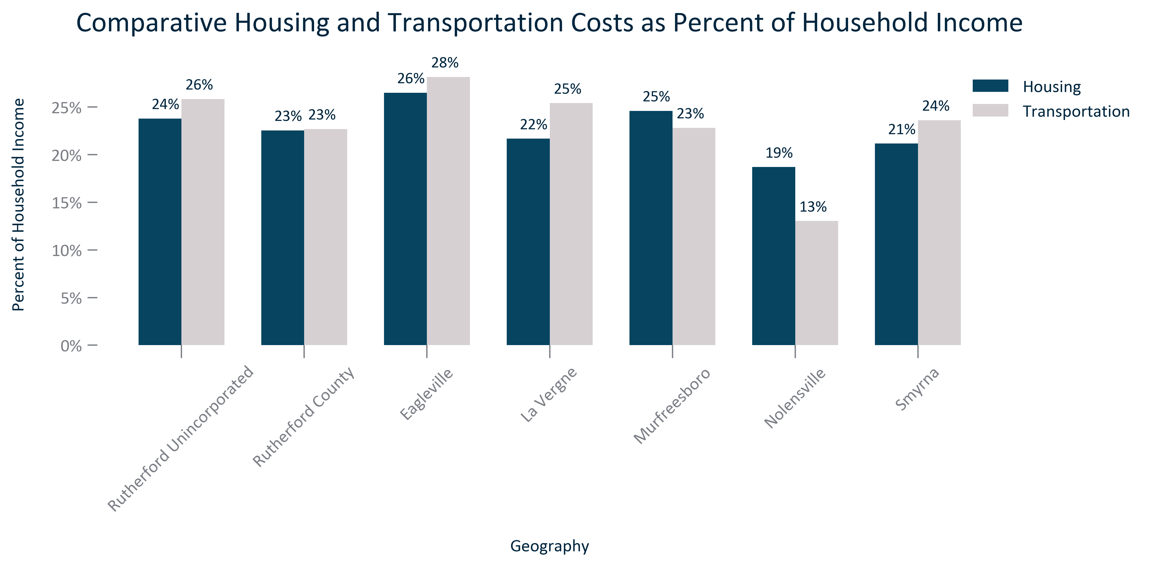

Citation: Center for Neighborhood Technology, 2019 Housing and Transportation Index

### TENURECOST_stackedbar_geocomparative_CNThousingplustransportationcosts_2019:

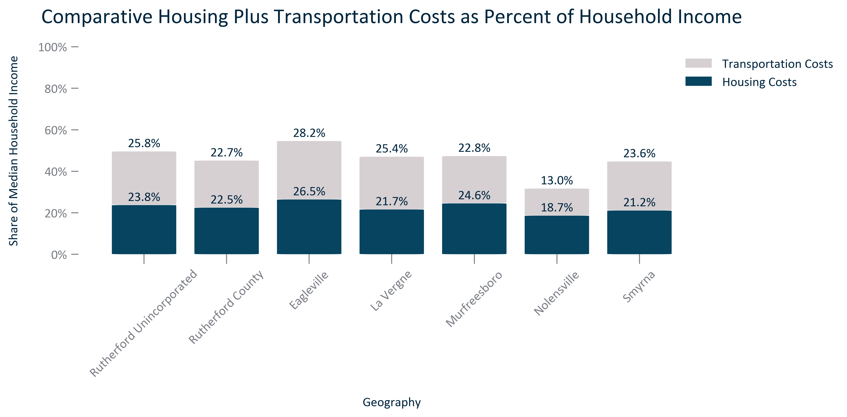

Citation: Center for Neighborhood Technology, 2019 Housing and Transportation Index

### TENURECOST_table_geocomparative_CNThousingandtransportation_2019:

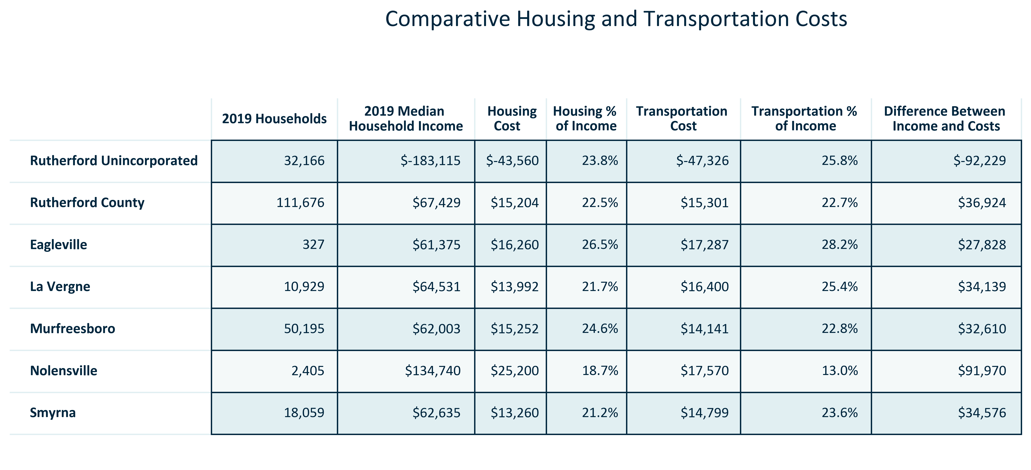

Citation: Center for Neighborhood Technology, 2019 Housing and Transportation Index, median household income is 2015-2019 ACS 5-Year to match

# Education

### EDUCATION_stackedbar_primarygeo_highestattainment_overtime:

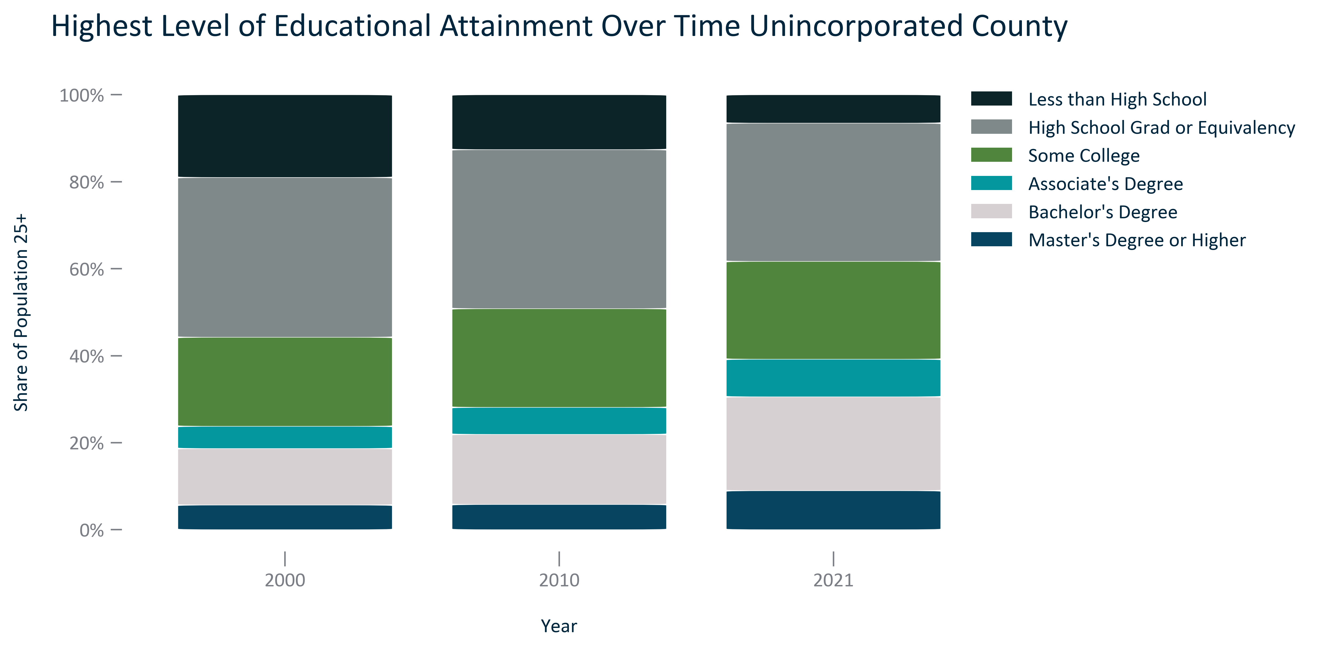

Citation: 2000 Decennial Census, 2006-2010 and 2017-2021 ACS 5-Year Estimates

### EDUCATION_table_primarygeo_attainmentnumberandpercent_overtime:

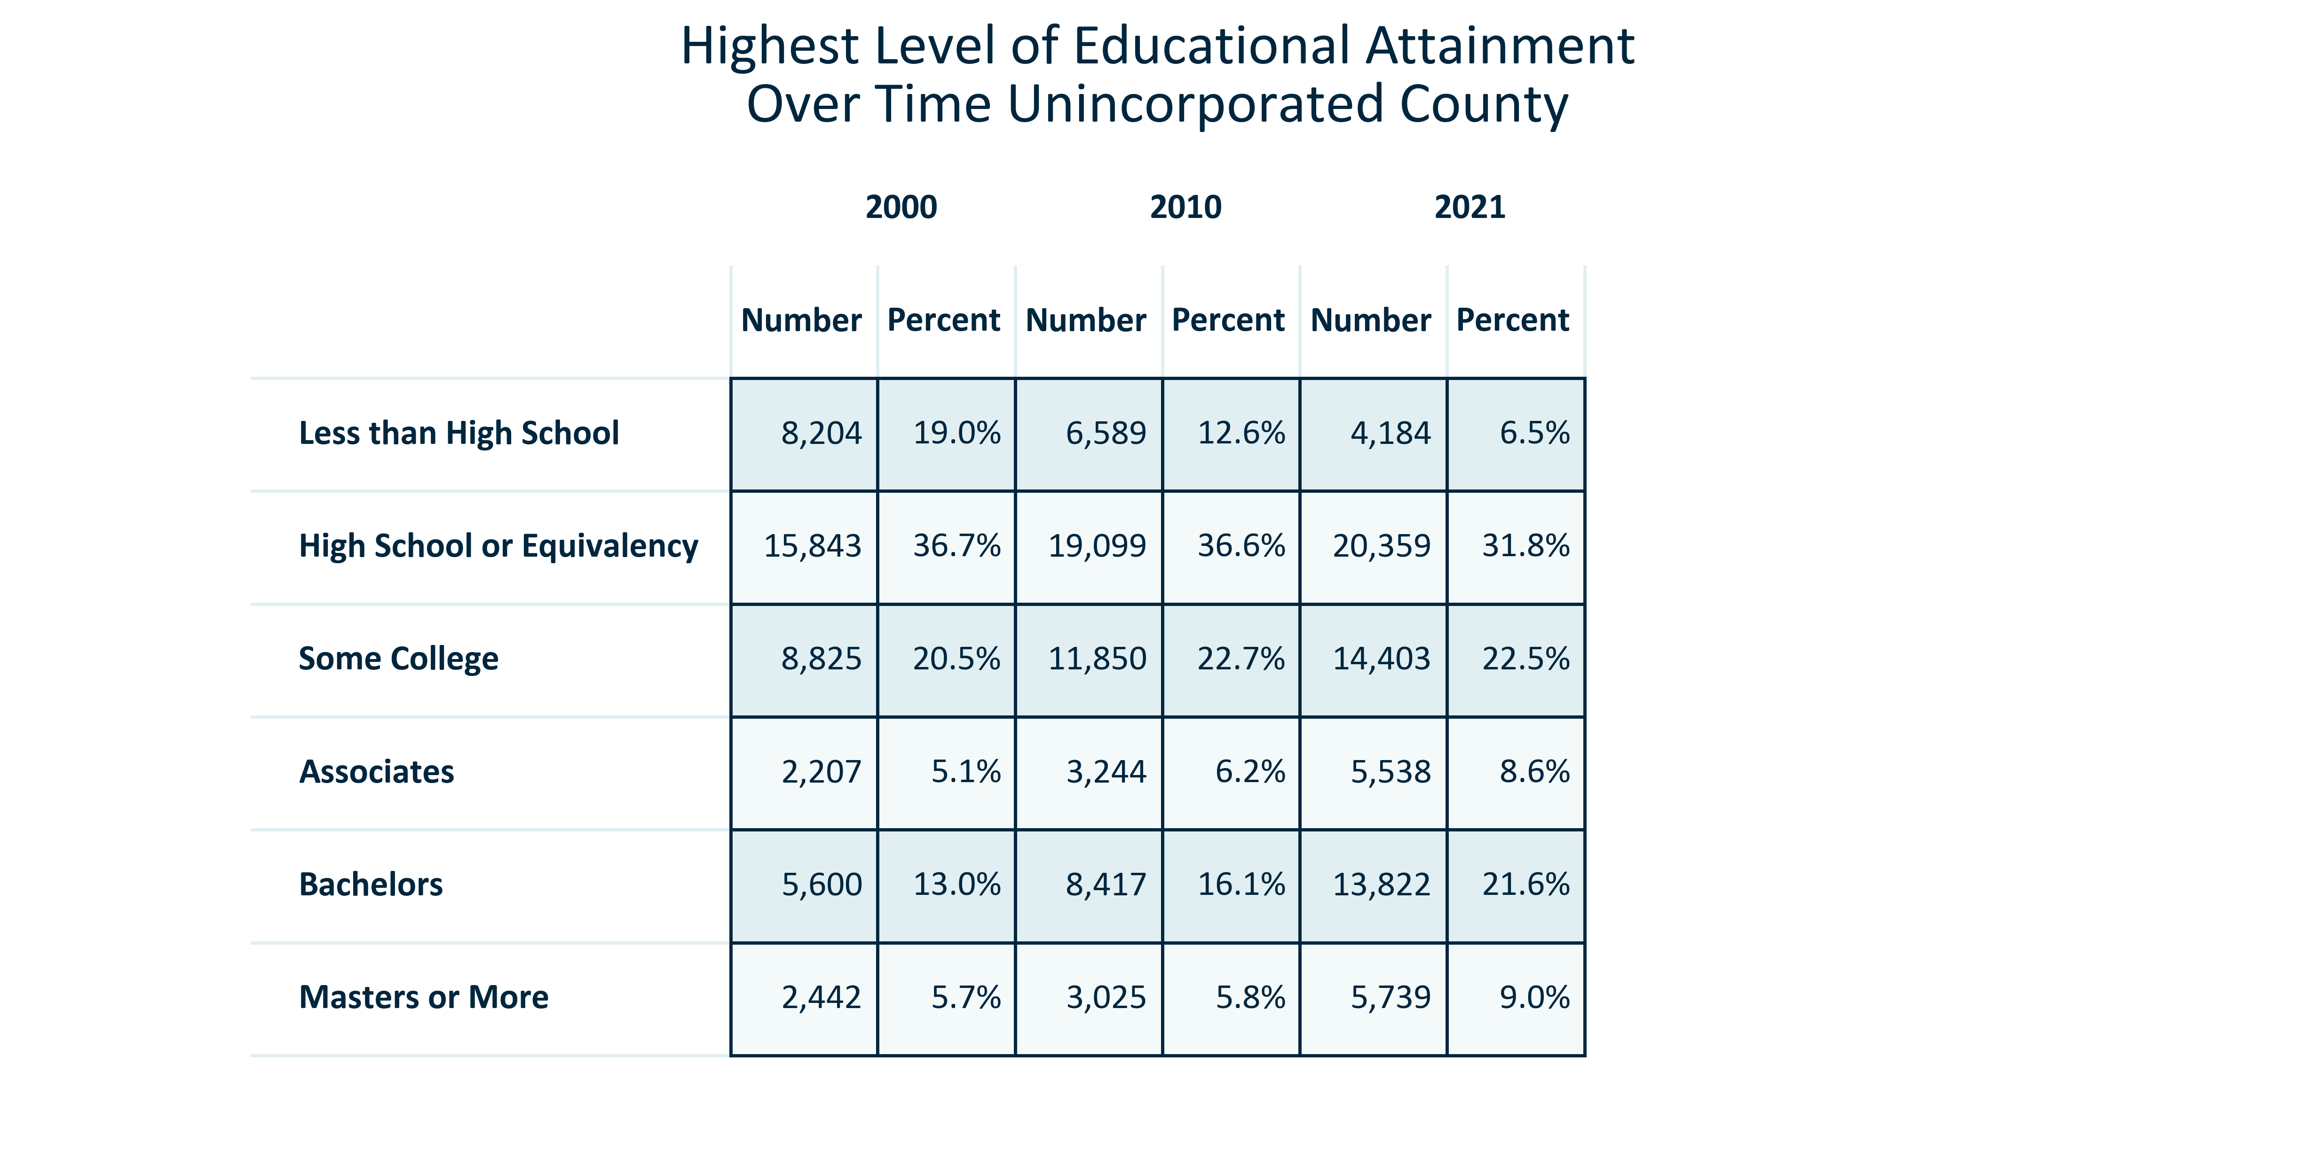

Citation: 2000 Decennial Census, 2006-2010 and 2017-2021 ACS 5-Year Estimates

### EDUCATION_stackedbar_geocomparative_highestattainment_2021:

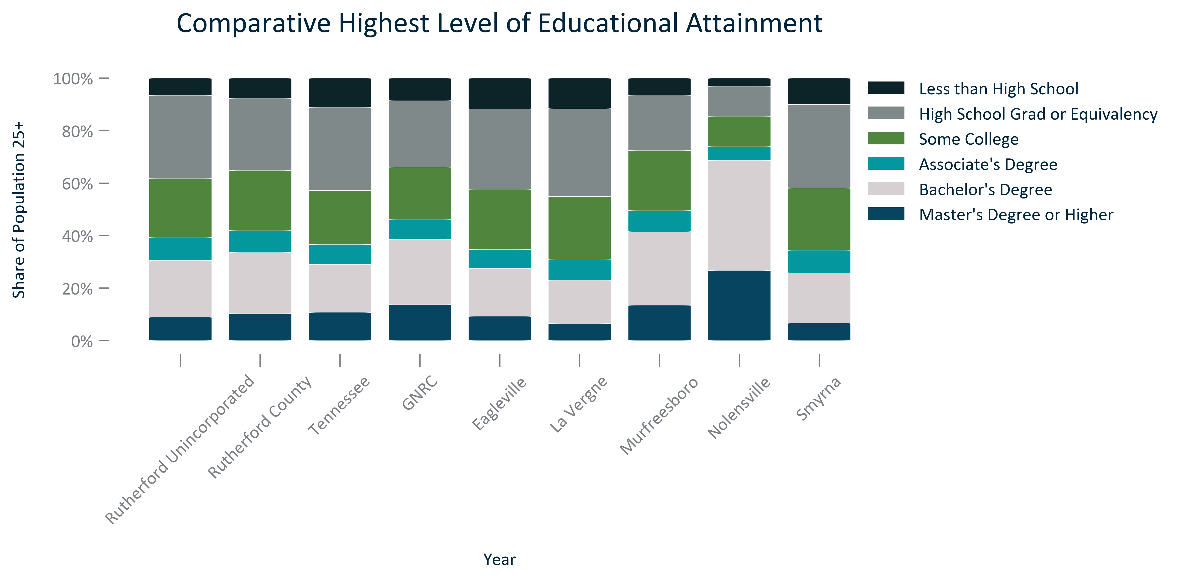

Citation: 2017-2021 ACS 5-Year Estimates

### EDUCATION_table_geocomparative_attainment_2021:

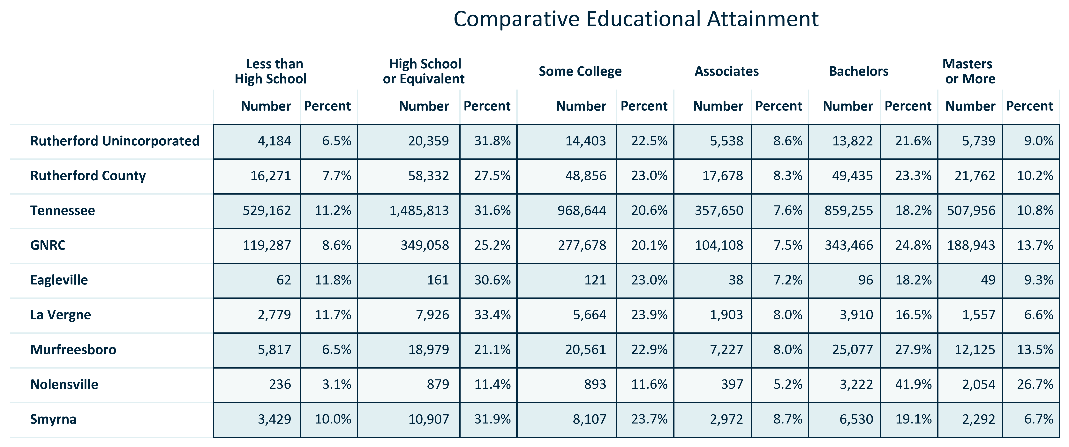

Citation: 2017-2021 ACS 5-Year Estimates

### EDUCATION_bar_primarygeo_highschoolandabove_overtime:

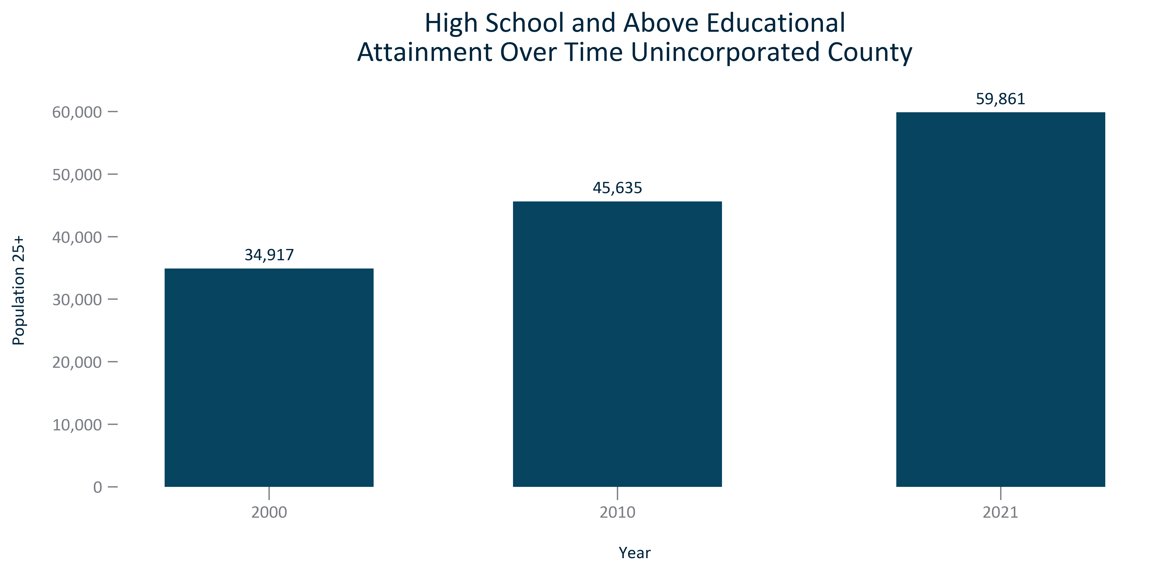

Citation: 2000 Decennial Census, 2006-2010 and 2017-2021 ACS 5-Year Estimates

### EDUCATION_bar_primarygeo_sharehighschoolandabove_overtime:

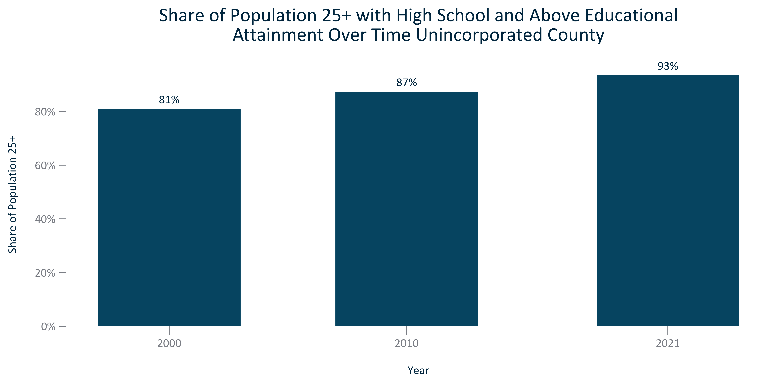

Citation: 2000 Decennial Census, 2006-2010 and 2017-2021 ACS 5-Year Estimates

### EDUCATION_bar_geocomparative_highschoolorhigherattainment_2021:

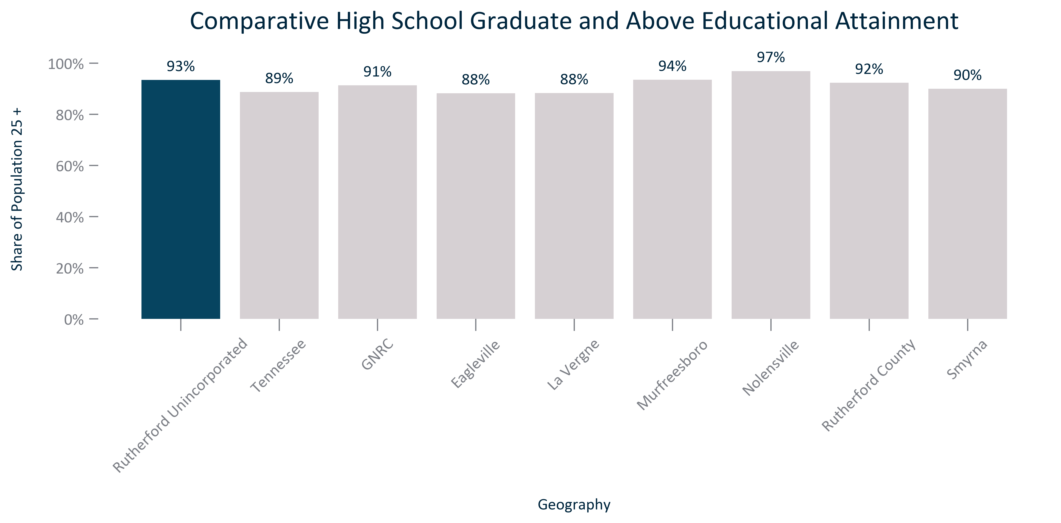

Citation: 2017-2021 ACS 5-Year Estimates

### EDUCATION_bar_primarygeo_bachelorsandabove_overtime:

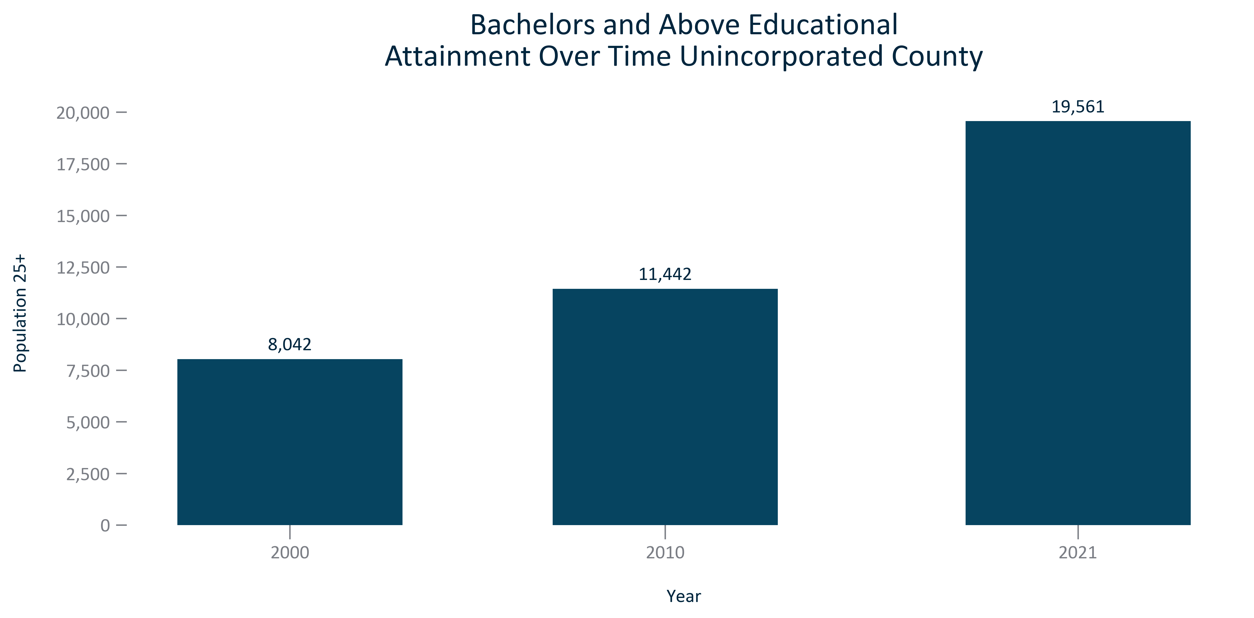

Citation: 2000 Decennial Census, 2006-2010 and 2017-2021 ACS 5-Year Estimates

### EDUCATION_bar_primarygeo_sharebachelorsandabove_overtime:

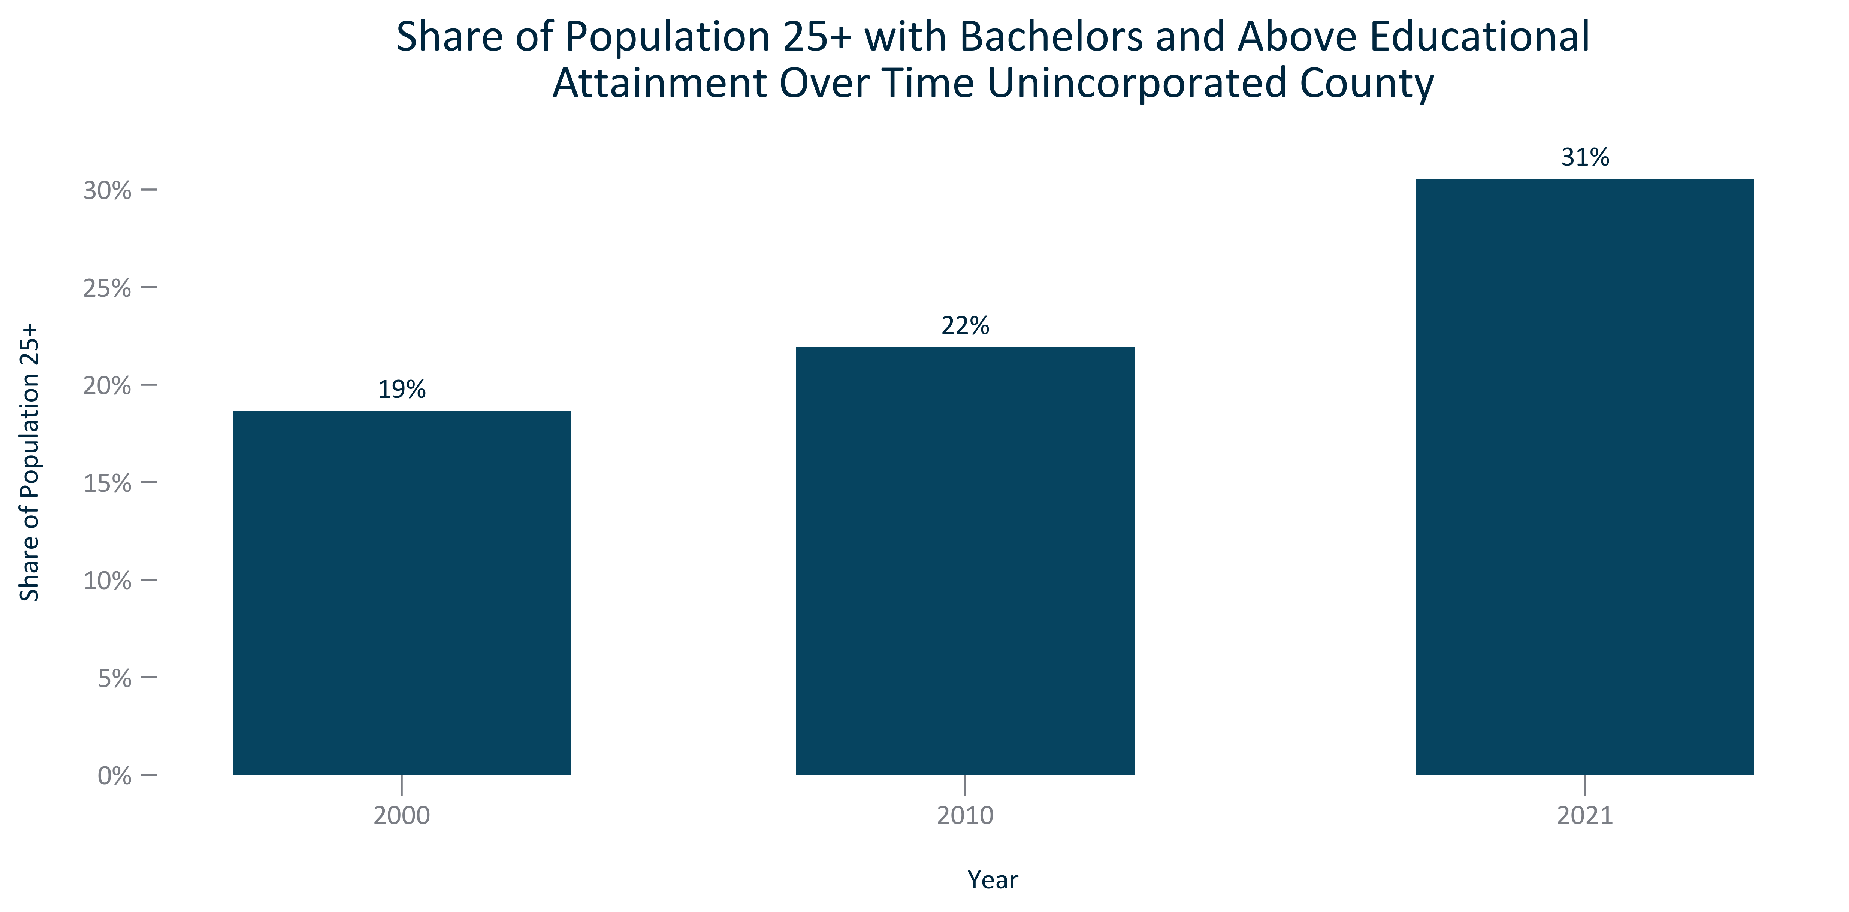

Citation: 2000 Decennial Census, 2006-2010 and 2017-2021 ACS 5-Year Estimates

### EDUCATION_bar_geocomparative_bachelorsorhigherattainment_2021:

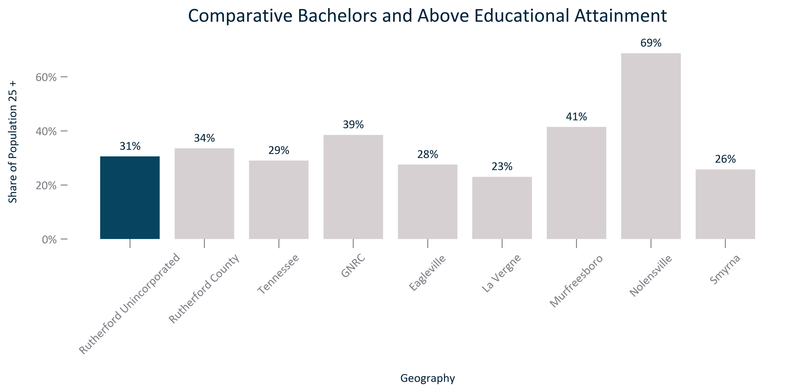

Citation: 2017-2021 ACS 5-Year Estimates

# Employment and Economy

5.494649, This is the percent of workers living in the unincorporated county that work in the unincorporated county.

47.307272, This is the percent of workers living in the unincorporated county that work in the county.

89.030356, This is the percent of workers living in the unincorporated county that work in the 13 county region.

### EMP_bar_primarygeo_numindustryemployment_2021:

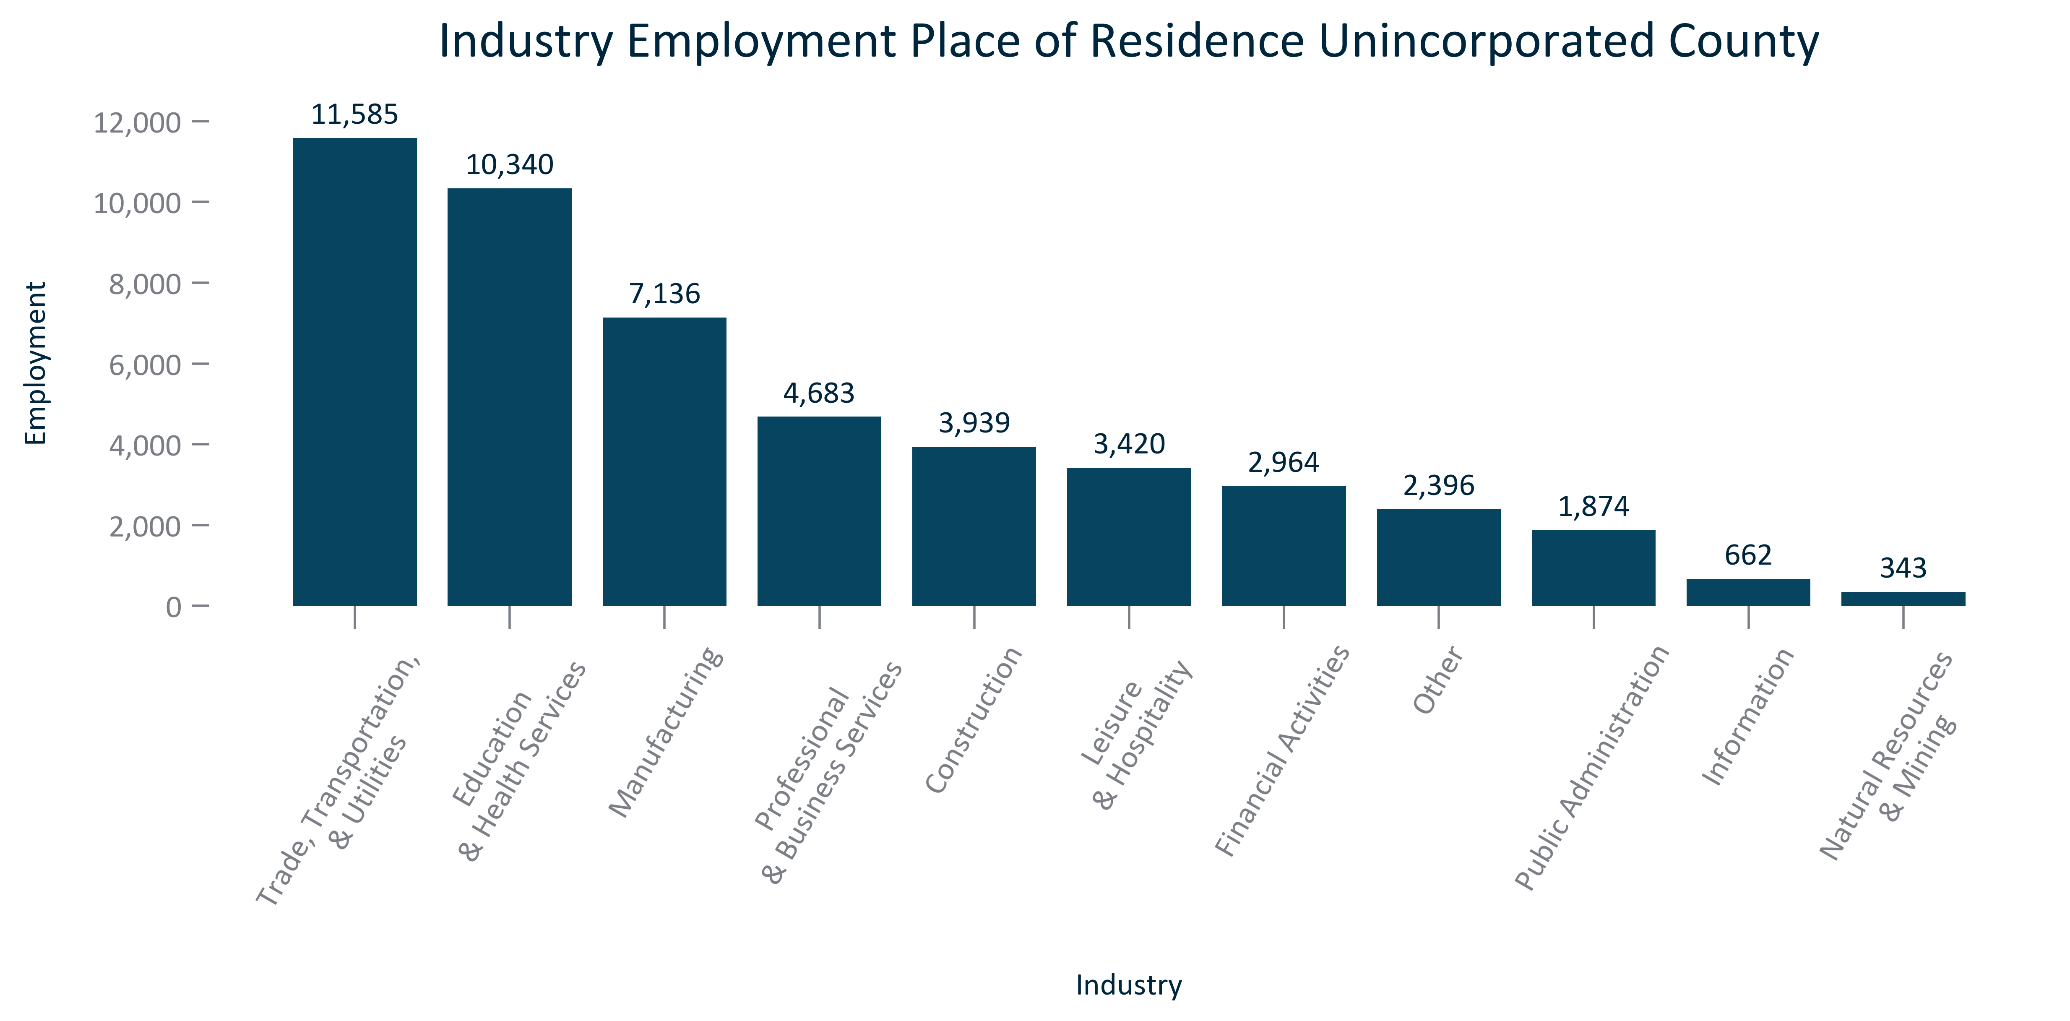

Citation: 2017-2021 ACS 5-Year Estimates

### EMP_bar_primarygeo_shareindustryemployment_2021:

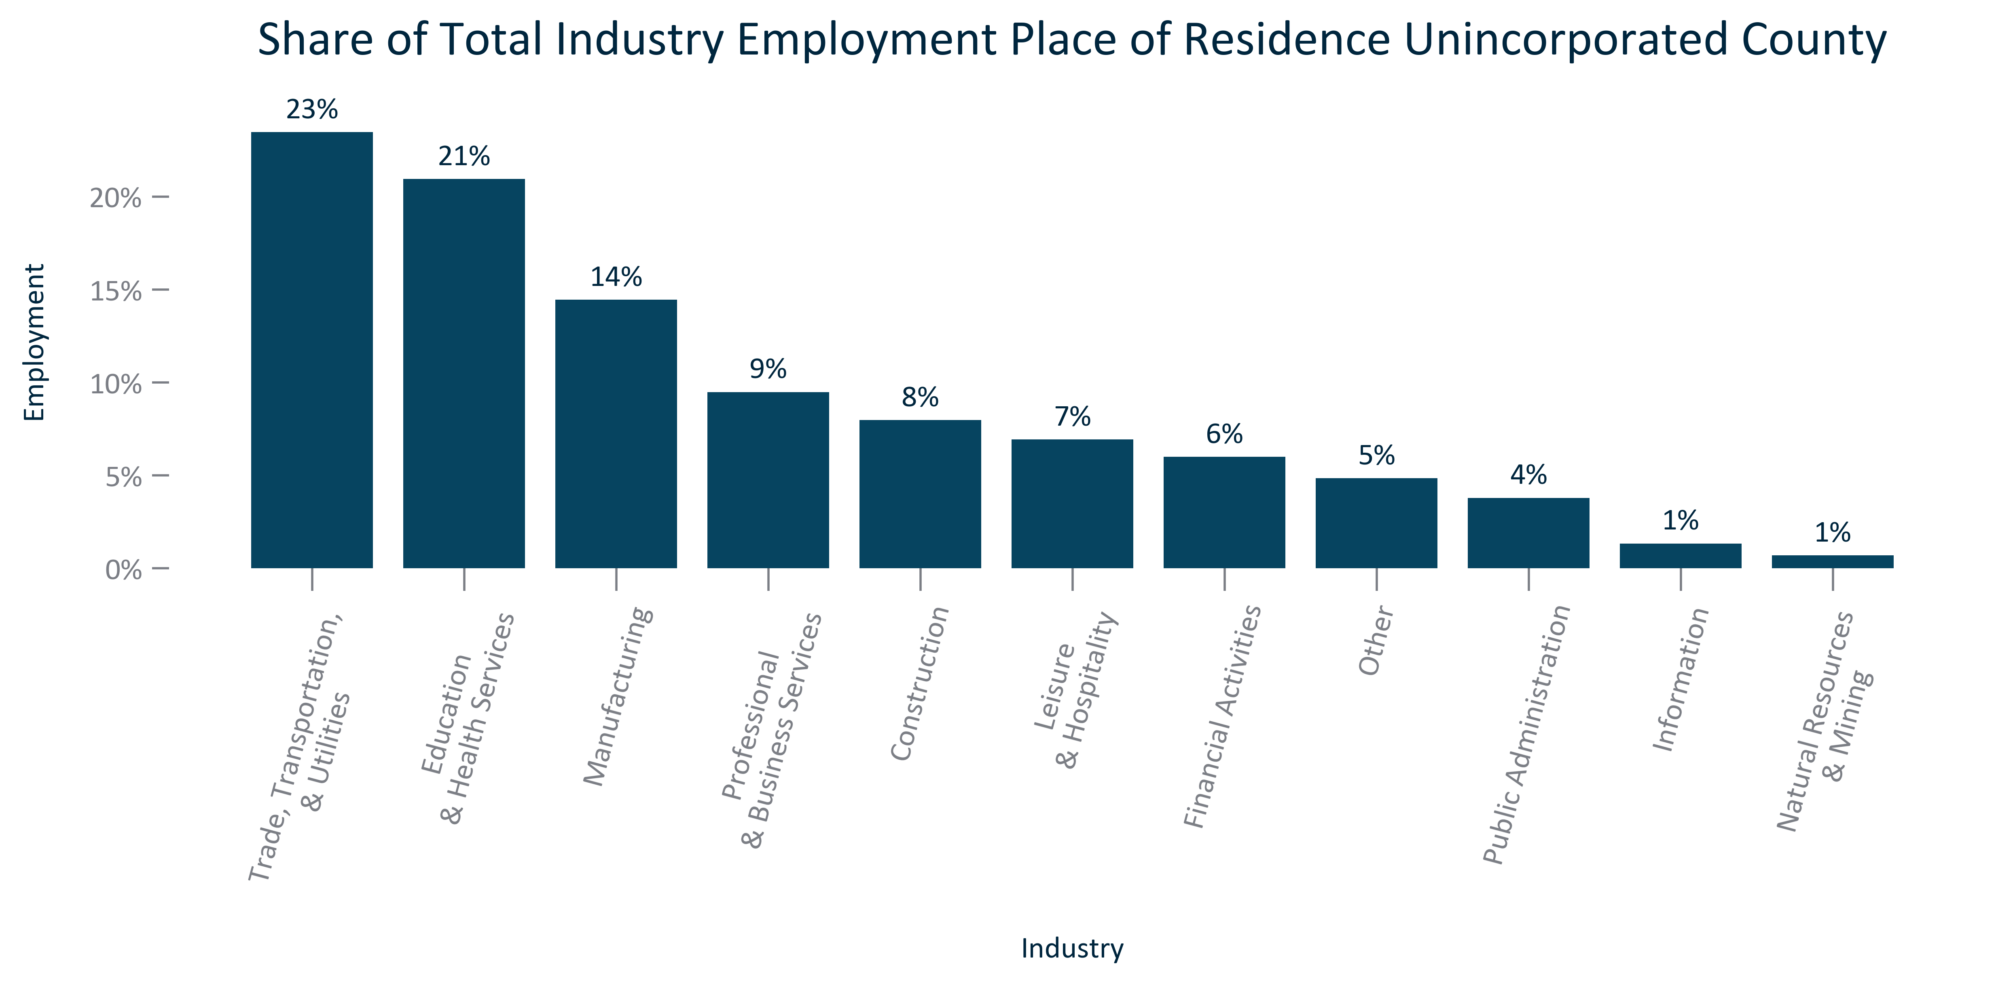

Citation: 2017-2021 ACS 5-Year Estimates

### EMP_clusterbar_primarygeo_realchangeindustryemployment_overtime:

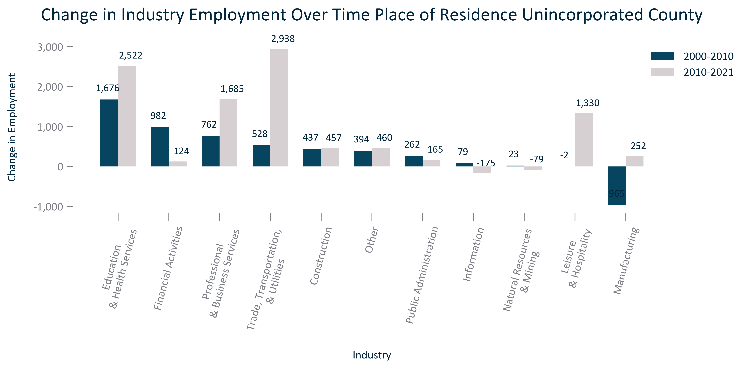

Citation: 2000 Decennial Census, 2006-2010 and 2017-2021 ACS 5-Year Estimates

### EMP_clusterbar_primarygeo_percentchangeindustryemployment_overtime:

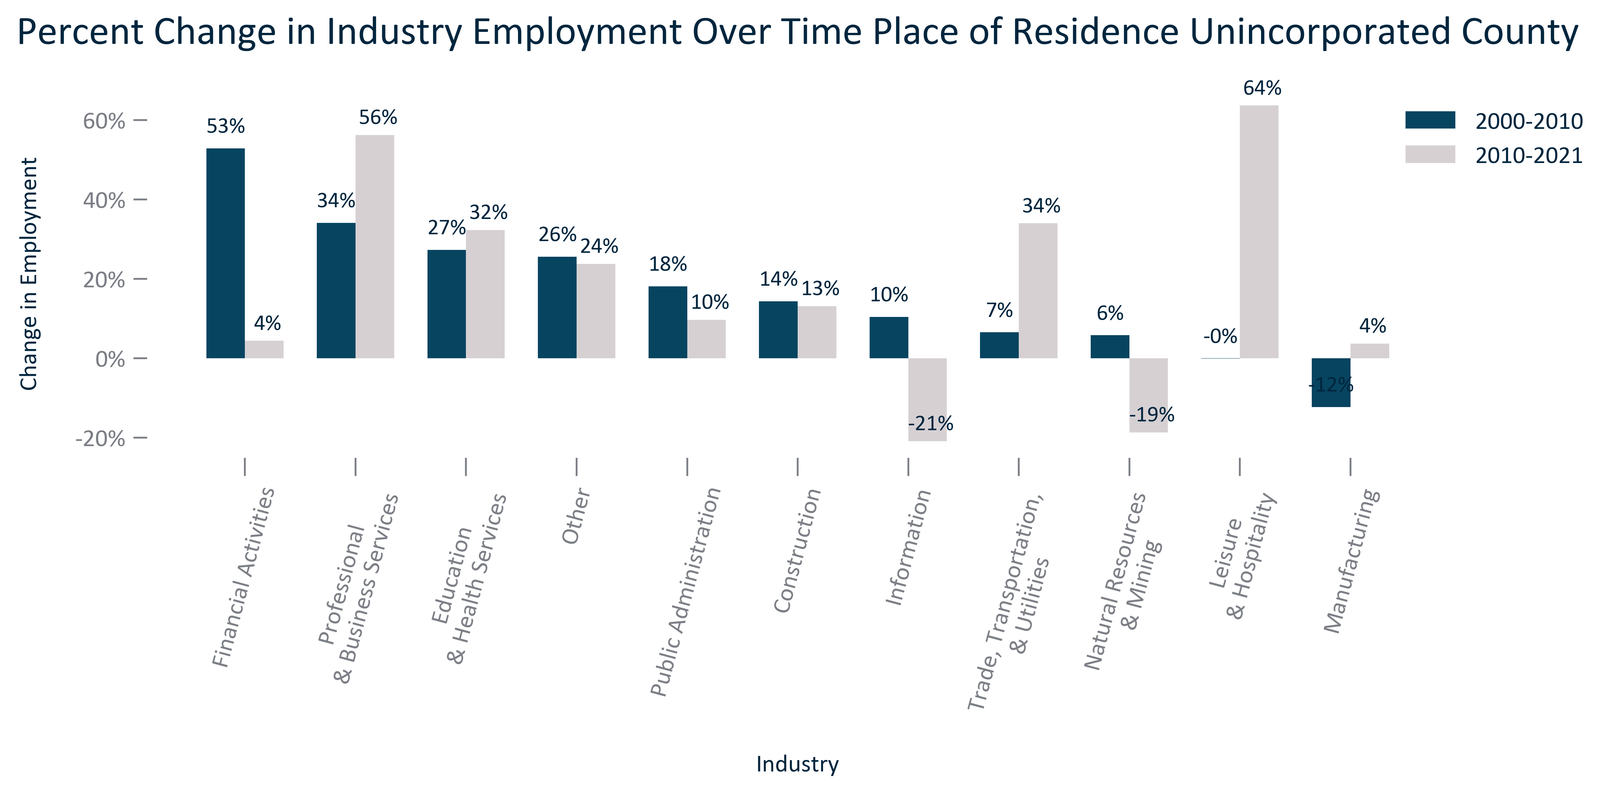

Citation: 2000 Decennial Census, 2006-2010 and 2017-2021 ACS 5-Year Estimates

### EMP_table_primarygeo_industryemployment_overtime:

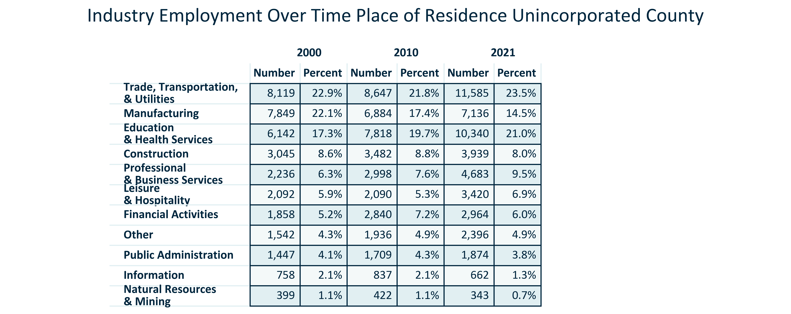

Citation: 2000 Decennial Census, 2006-2010 and 2017-2021 ACS 5-Year Estimates

### EMP_pyramid_primarygeo_powporemploymentpyramid_2019:

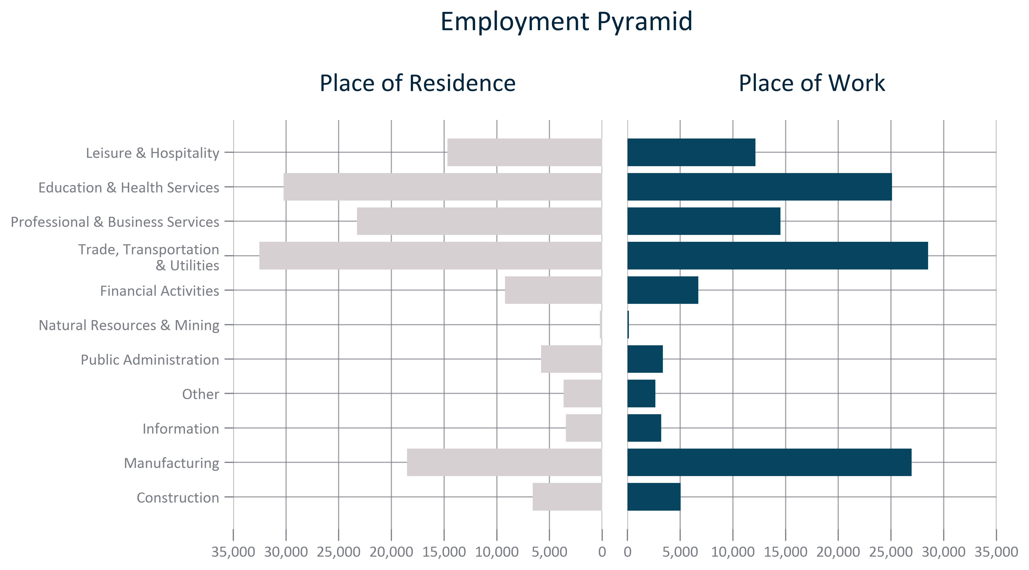

Citation: 2019 LEHD

### EMP_table_geocomparative_topemploymentcounties_2019:

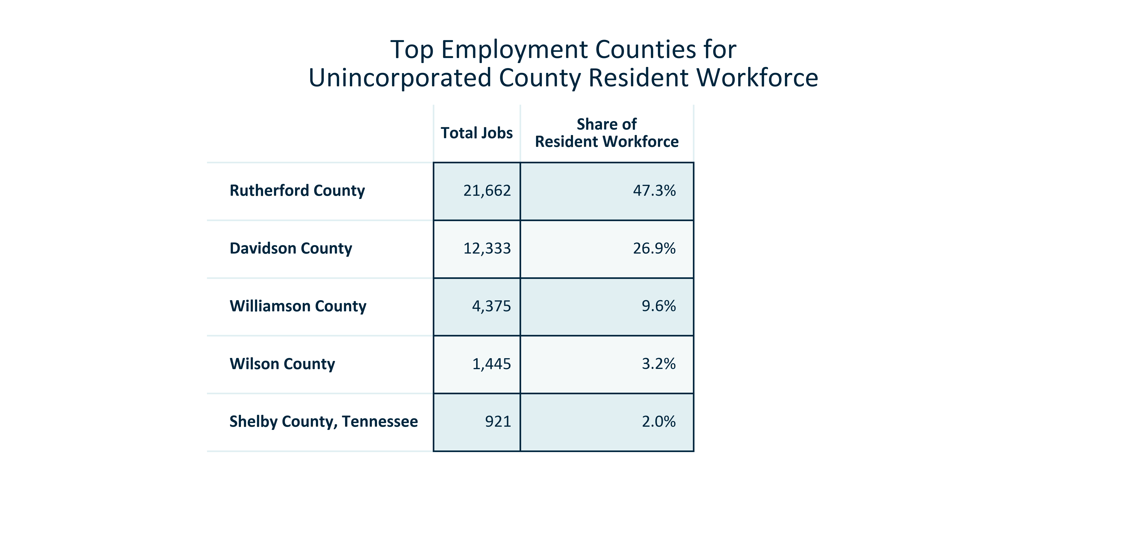

Citation: 2019 LEHD

### EMP_table_geocomparative_topemploymentcountiesage_2019:

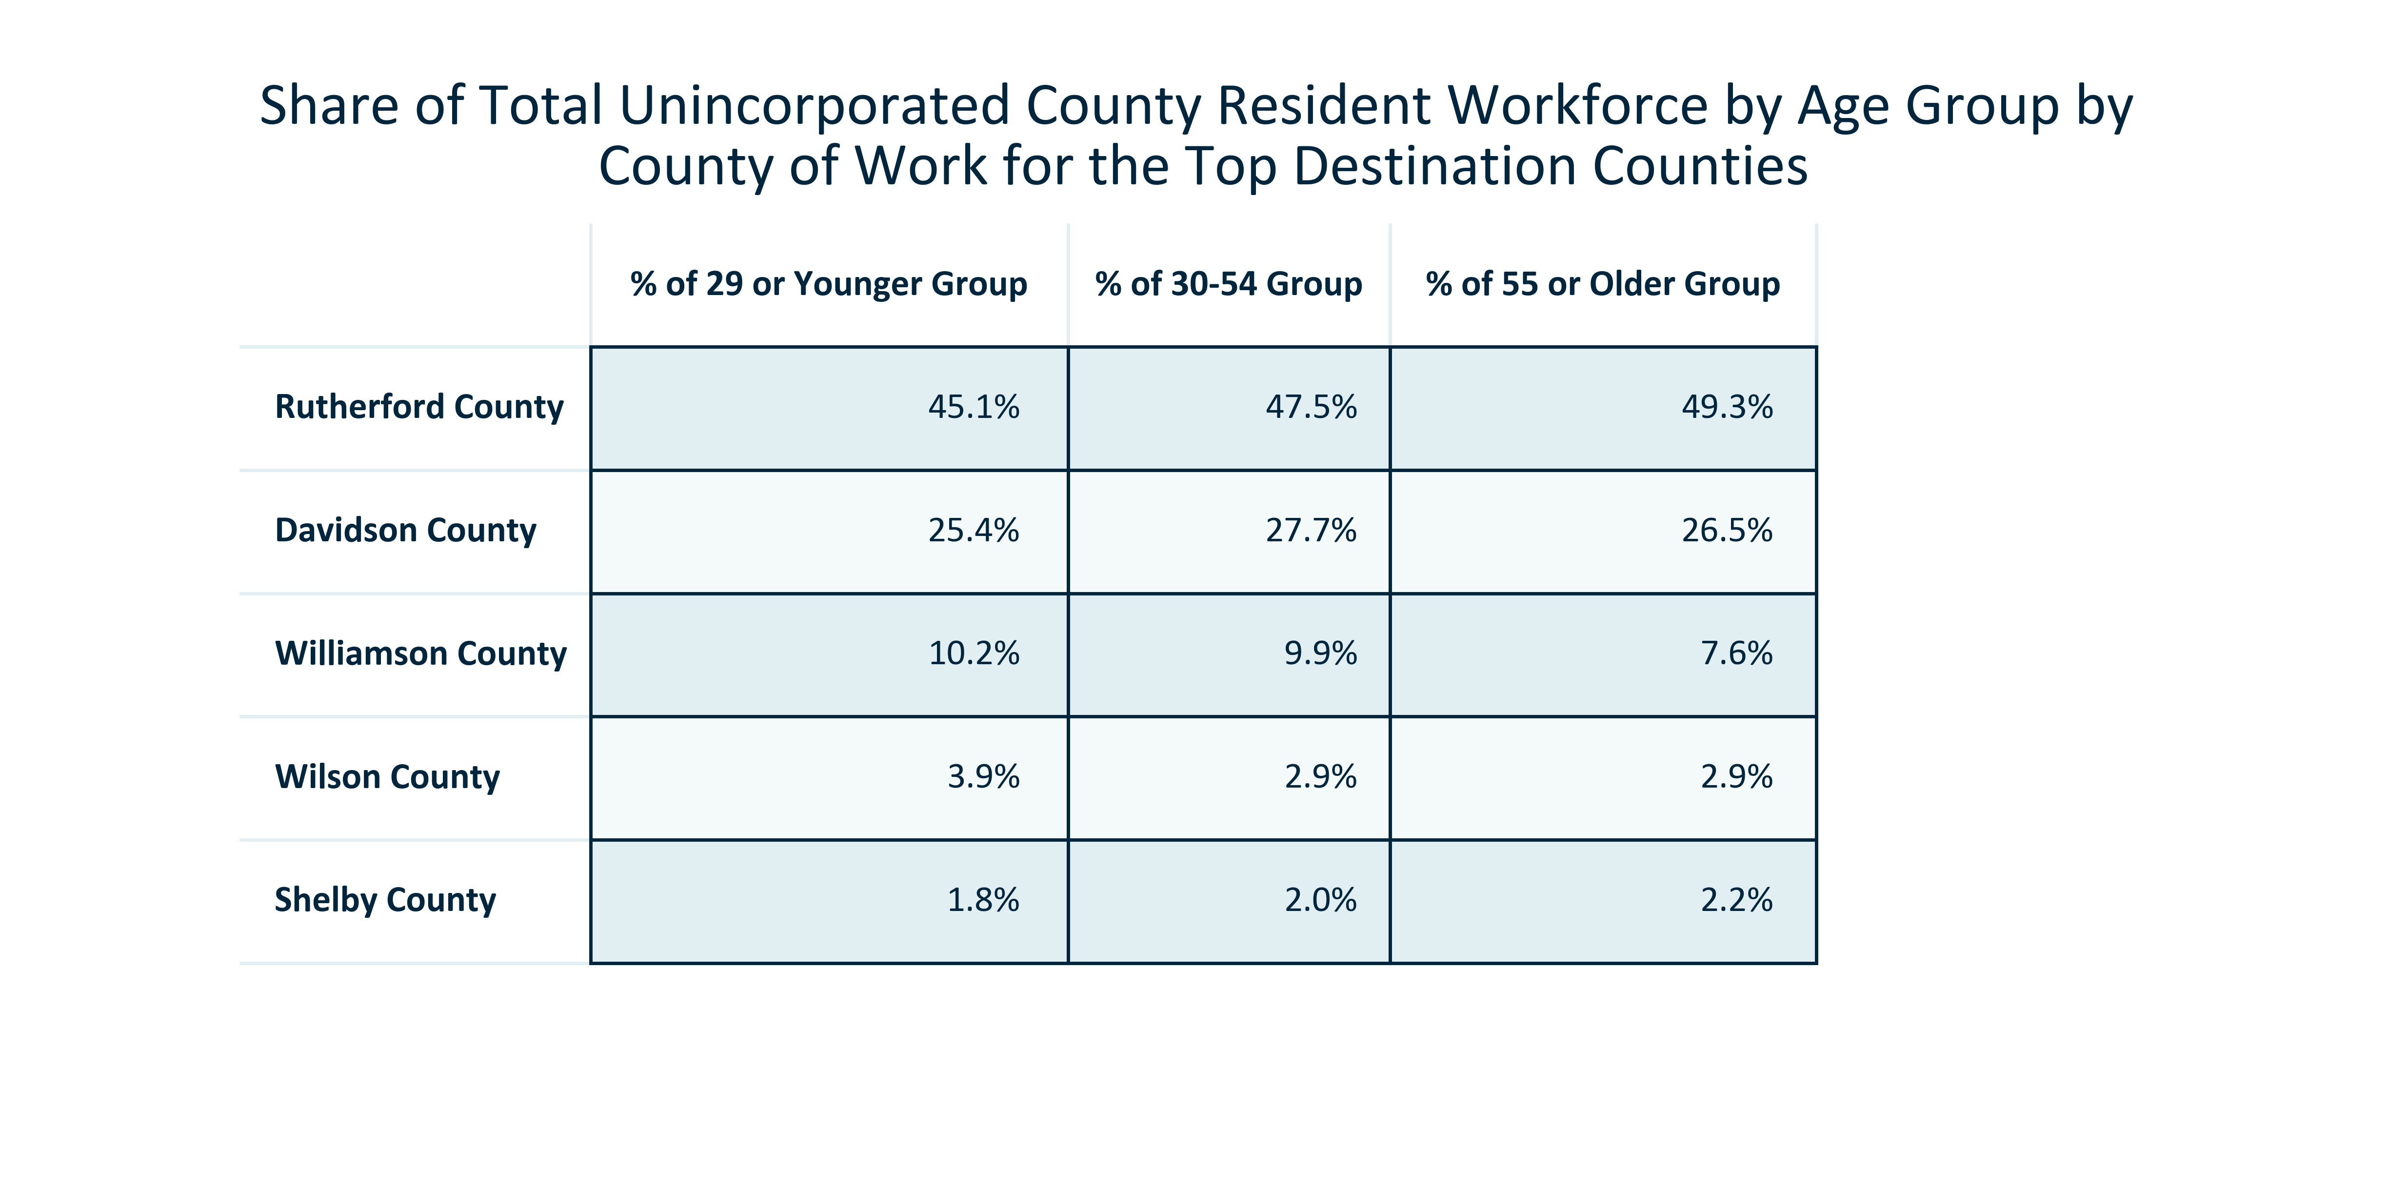

Citation: 2019 LEHD

### EMP_table_geocomparative_topemploymentcountiessupersector_2019:

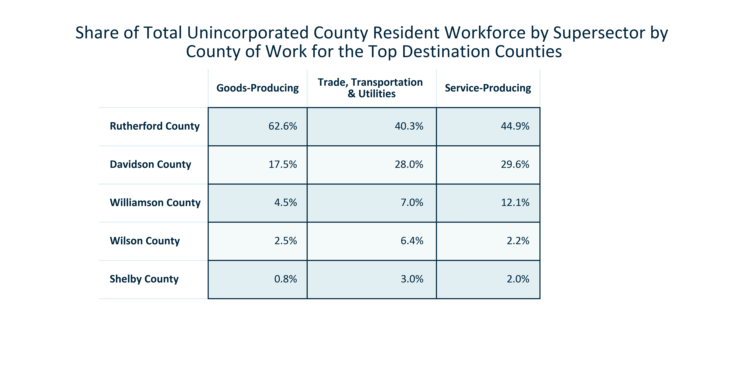

Citation: 2019 LEHD

### EMP_table_geocomparative_topemploymentplaces_2019:

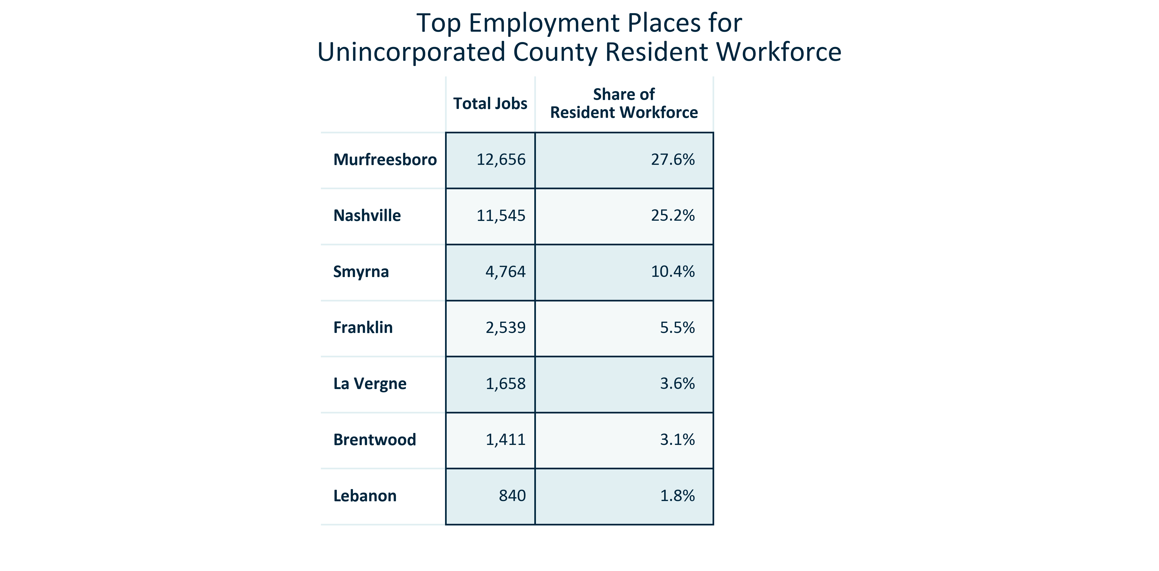

Citation: 2019 LEHD

### EMP_table_geocomparative_topemploymentplacesage_2019:

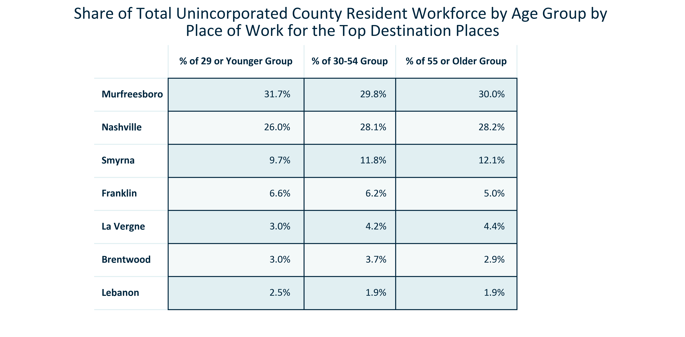

Citation: 2019 LEHD

### EMP_table_geocomparative_topemploymentplacessupersector_2019:

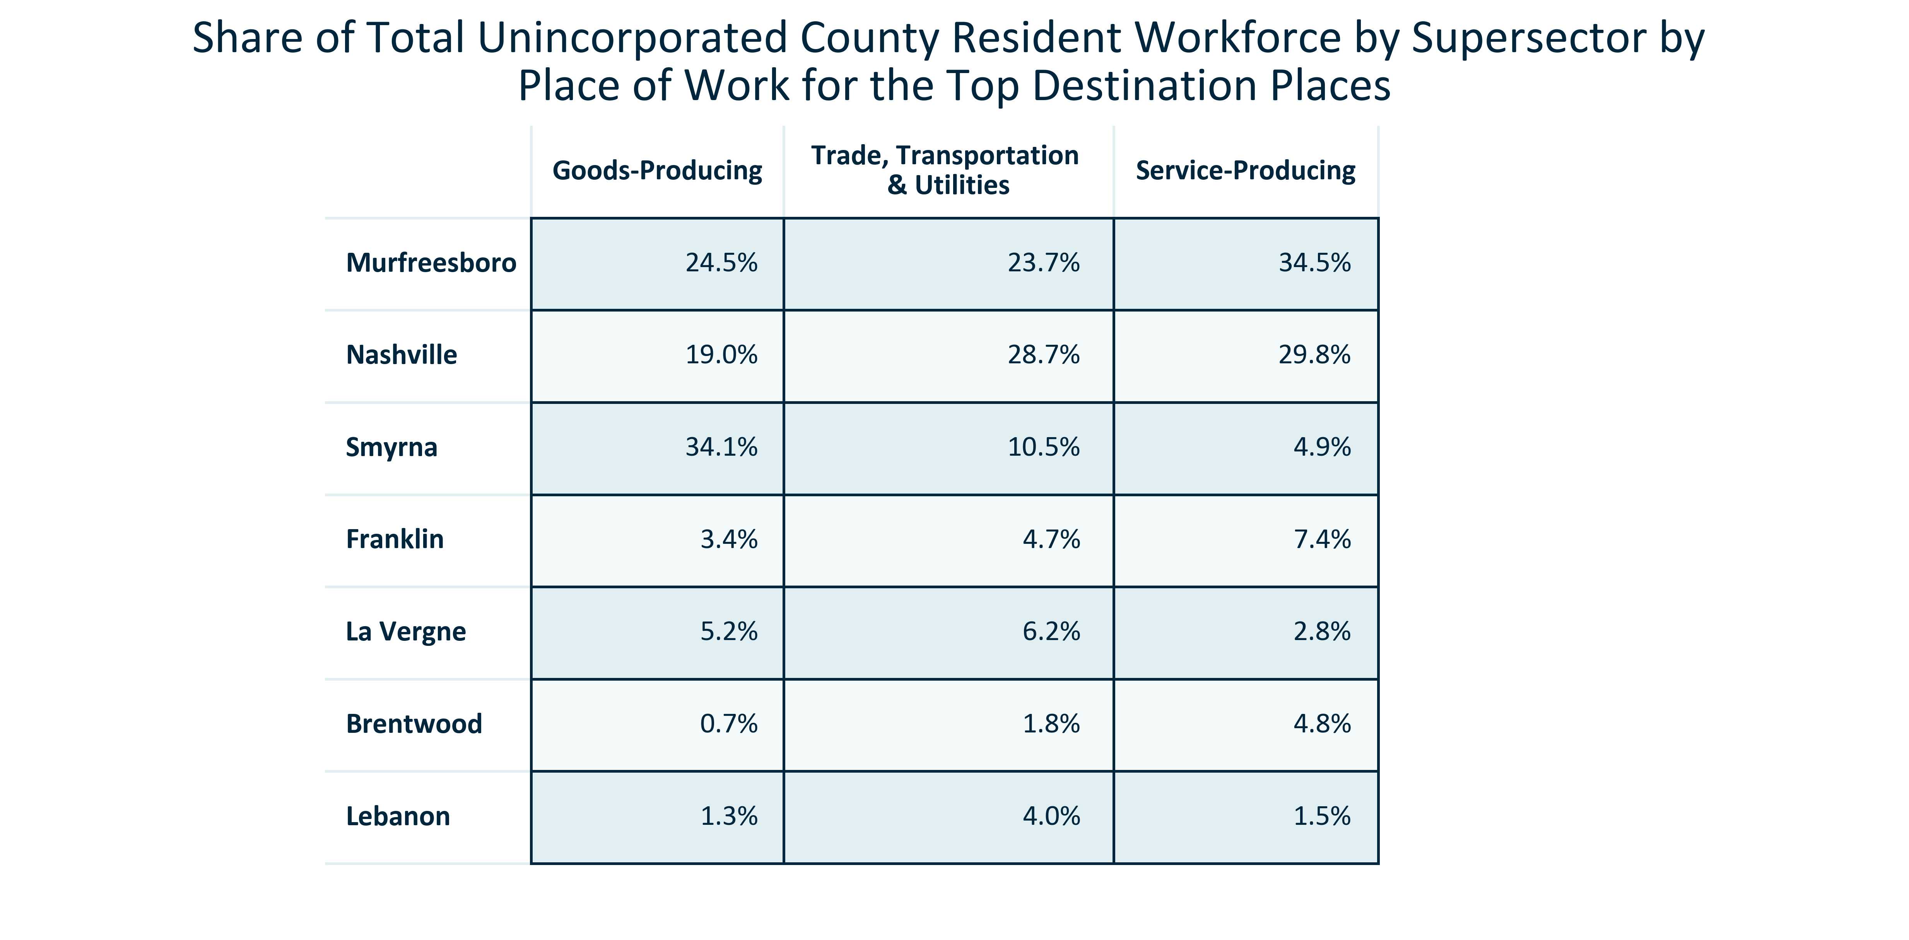

Citation: 2019 LEHD

### EMP_line_primarygeo_historicalemploymentplace_overtime:

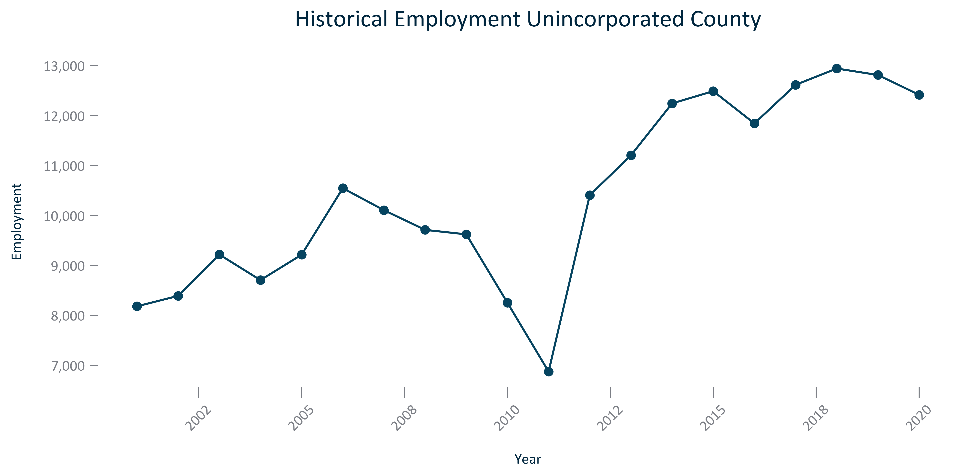

Citation: JobsEQ

### EMP_line_primarygeo_historicalemploymentbyindustryplace_overtime:

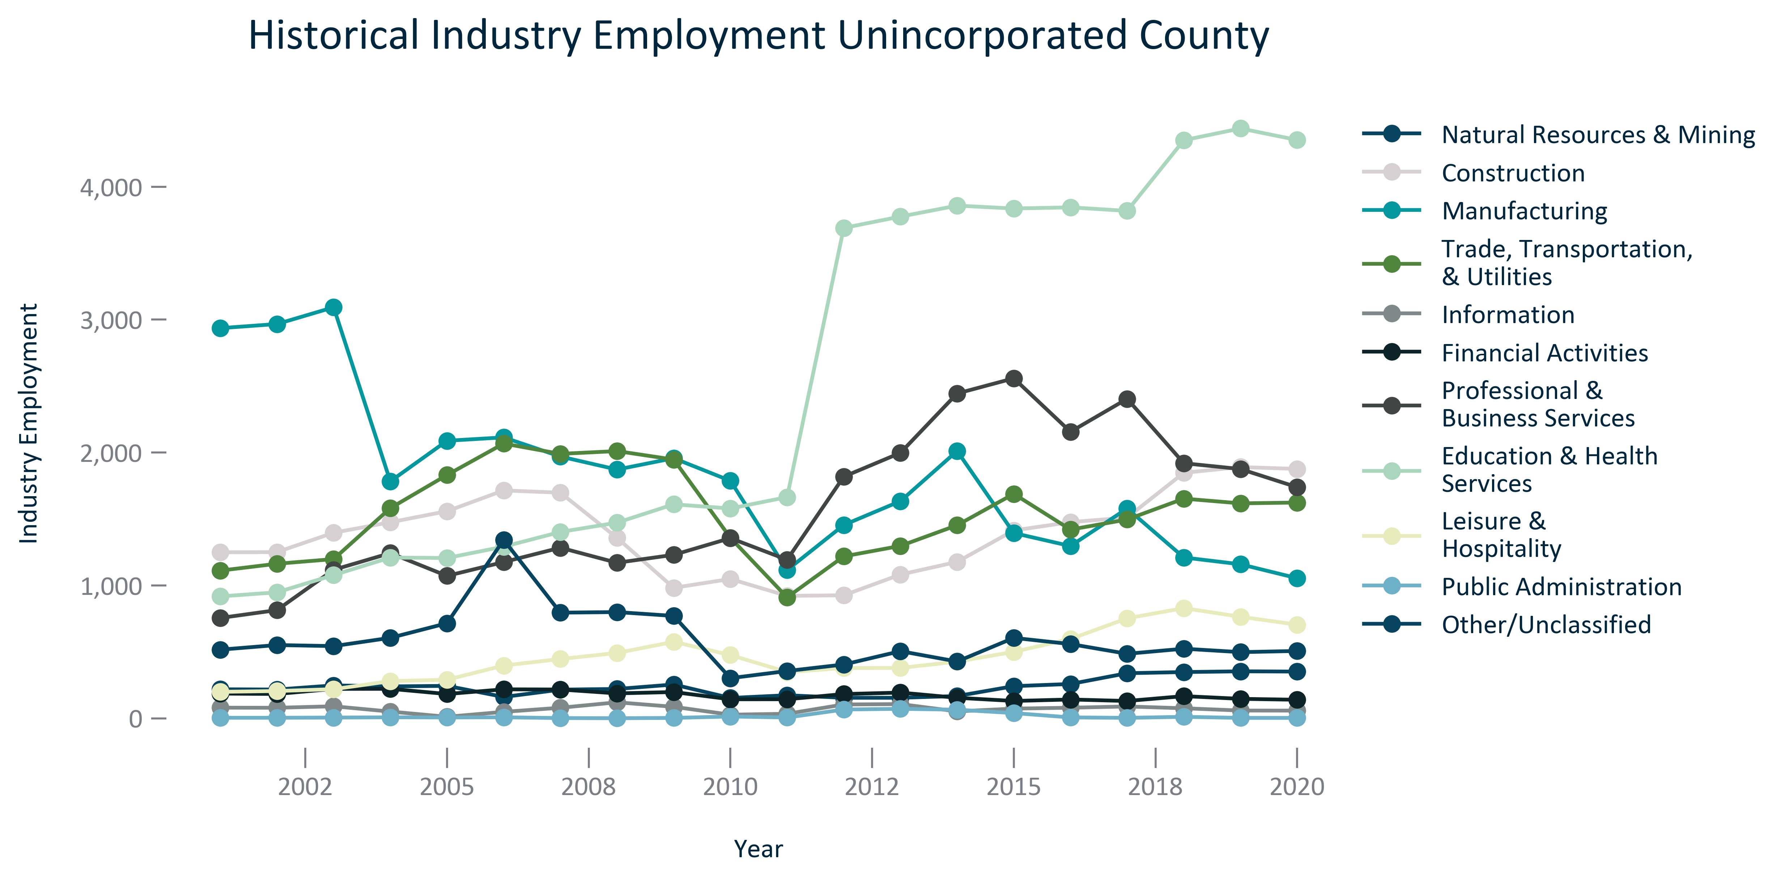

Citation: JobsEQ

### EMP_stackedbar_primarygeo_supersectoremploymentplace_overtime:

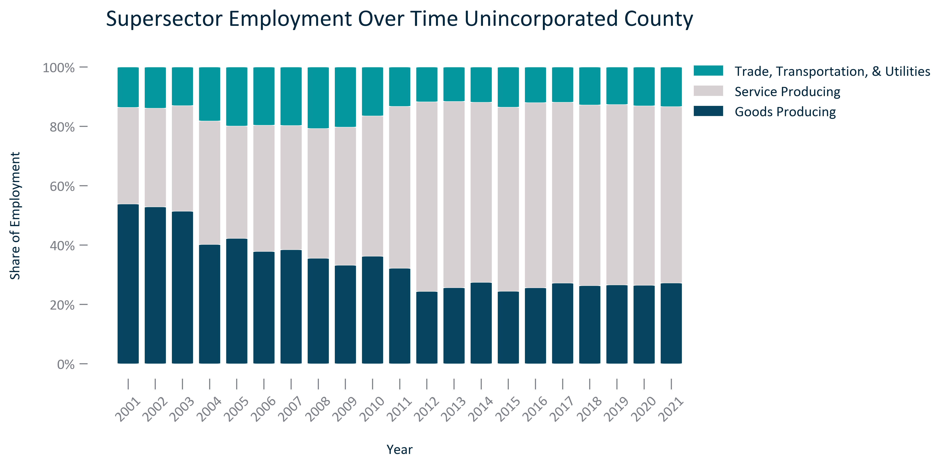

Citation: JobsEQ

### EMP_line_primarygeo_employmentquarterlycovid19_overtime:

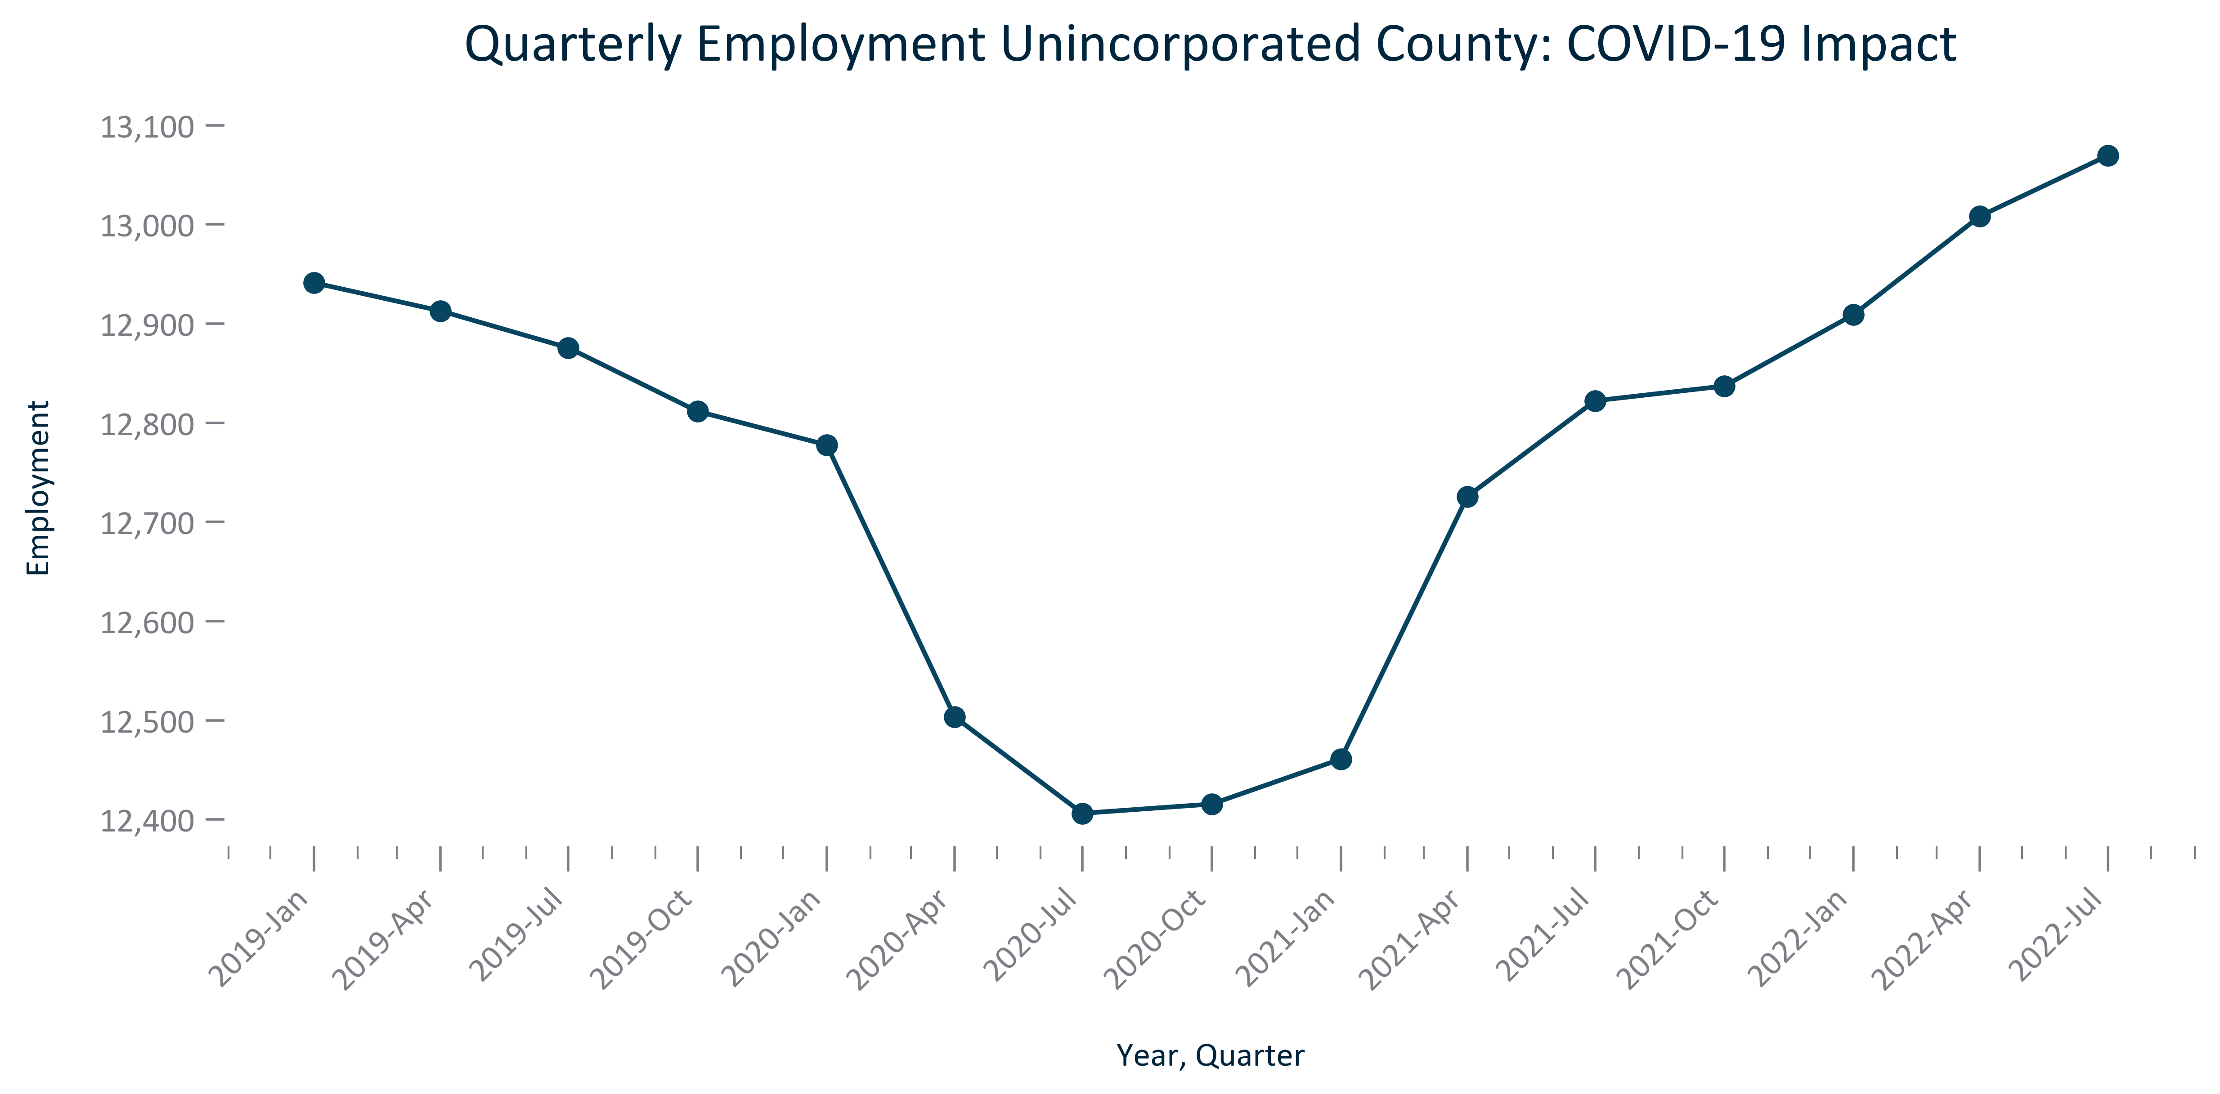

Citation: QCEW via JobsEQ

### EMP_line_county_employmentquarterlycovid19countyforplace_overtime:

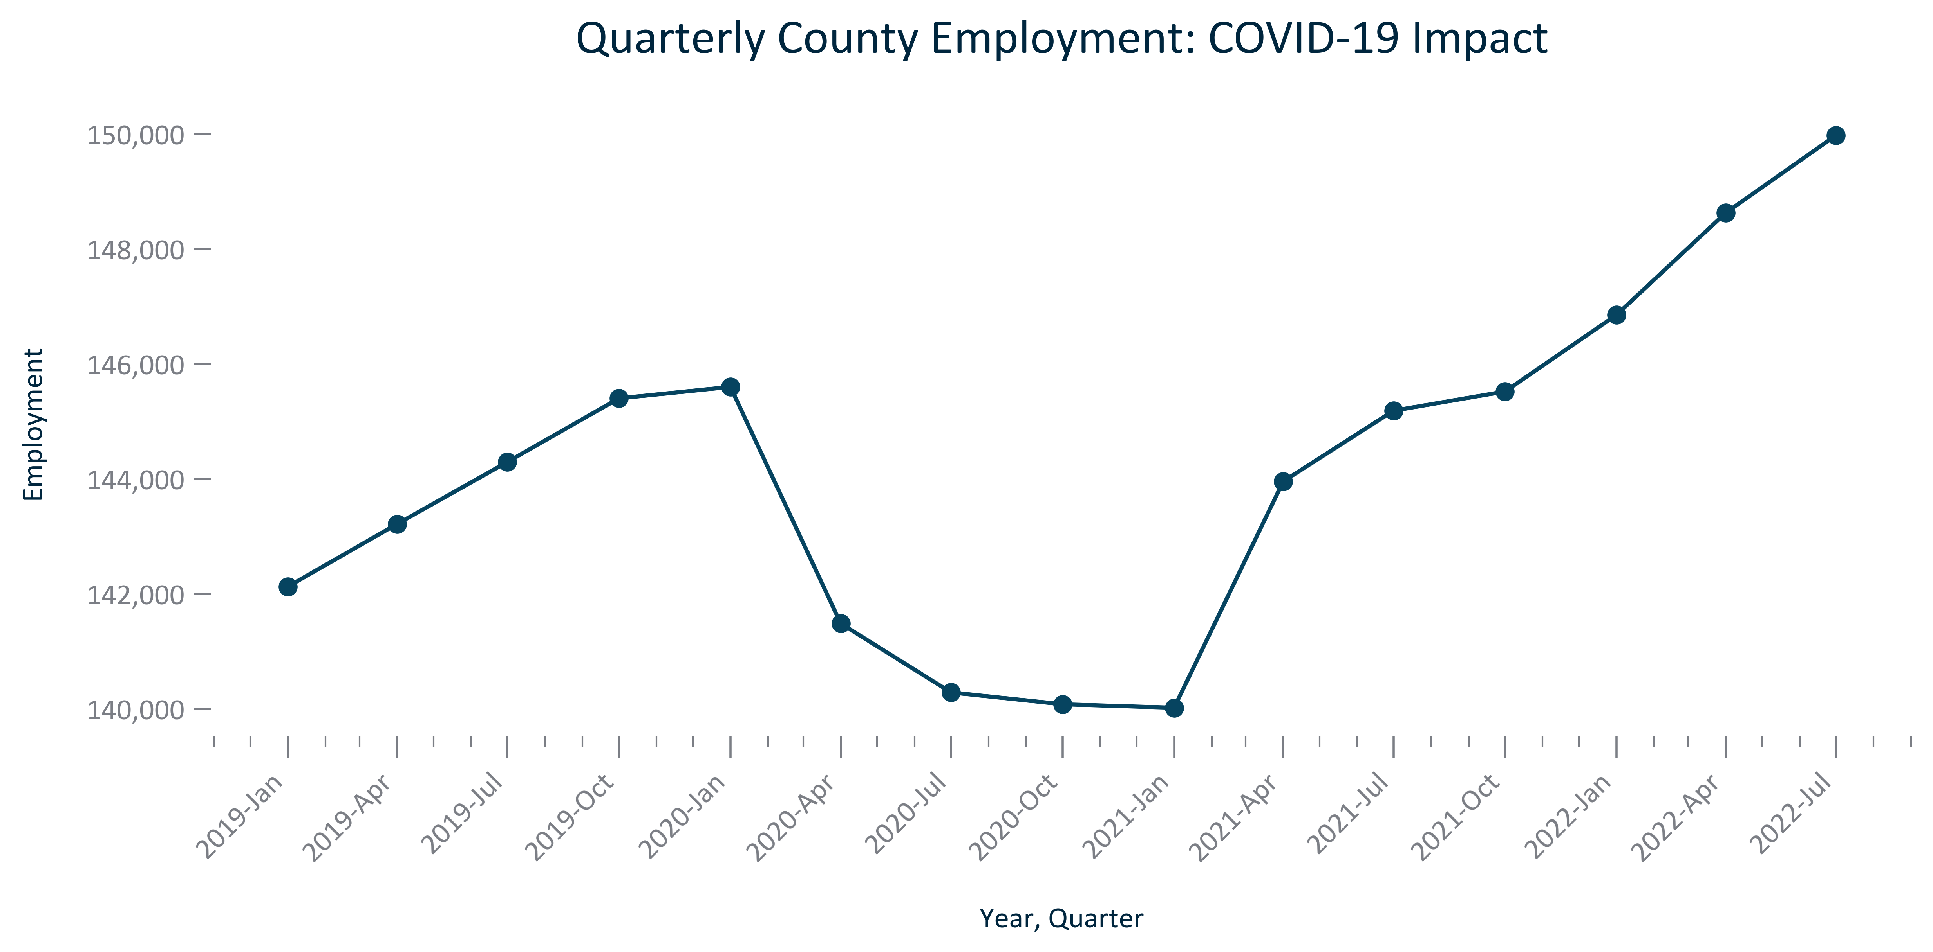

Citation: QCEW via JobsEQ

### EMP_line_geocomparative_unemploymentmonthly_overtime:

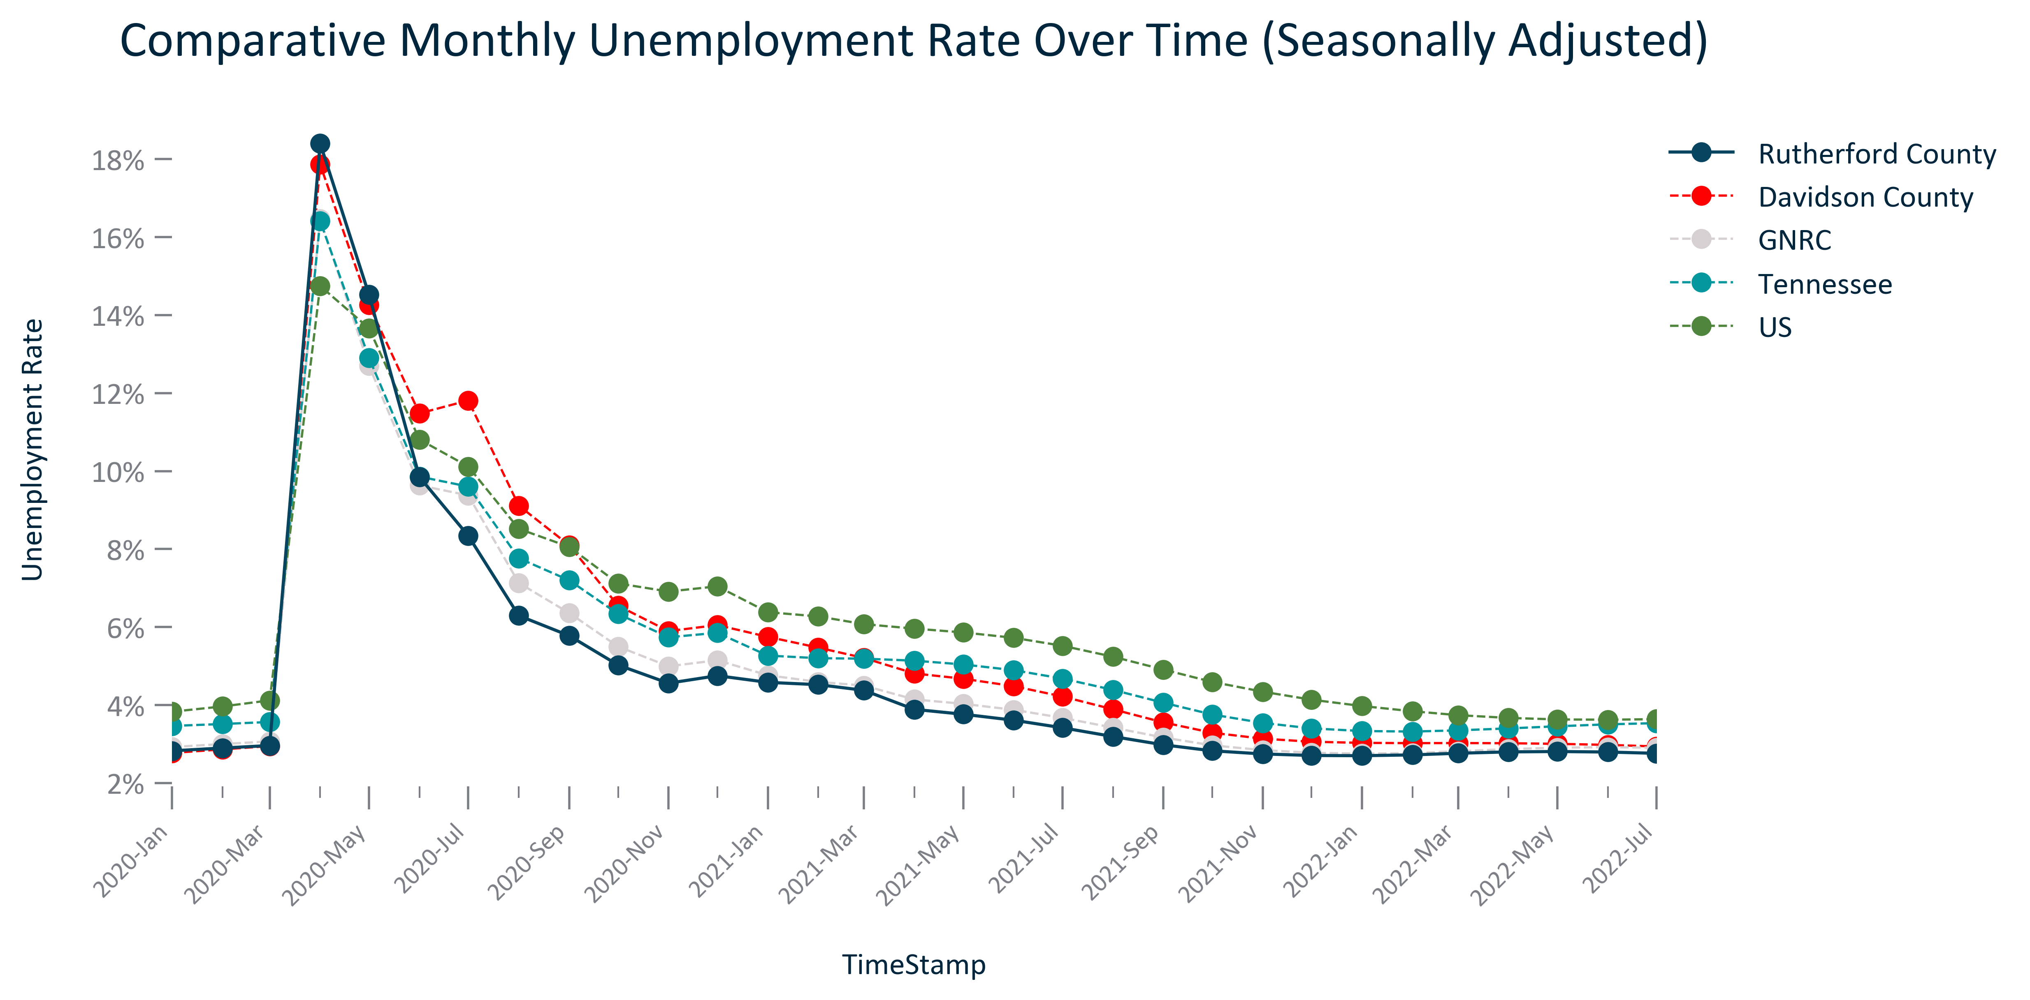

Citation: LAUS via JobsEQ

### EMP_table_primarygeo_industryemploymentplace_2020:

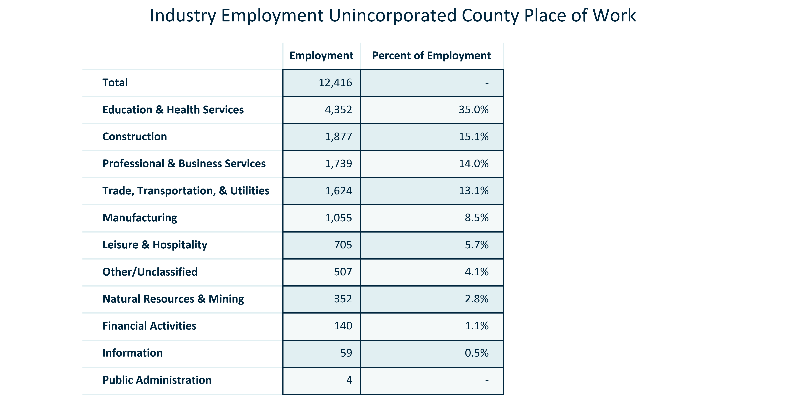

Citation: QCEW via JobsEQ

### EMP_bar_primarygeo_projectedemployment_overtime:

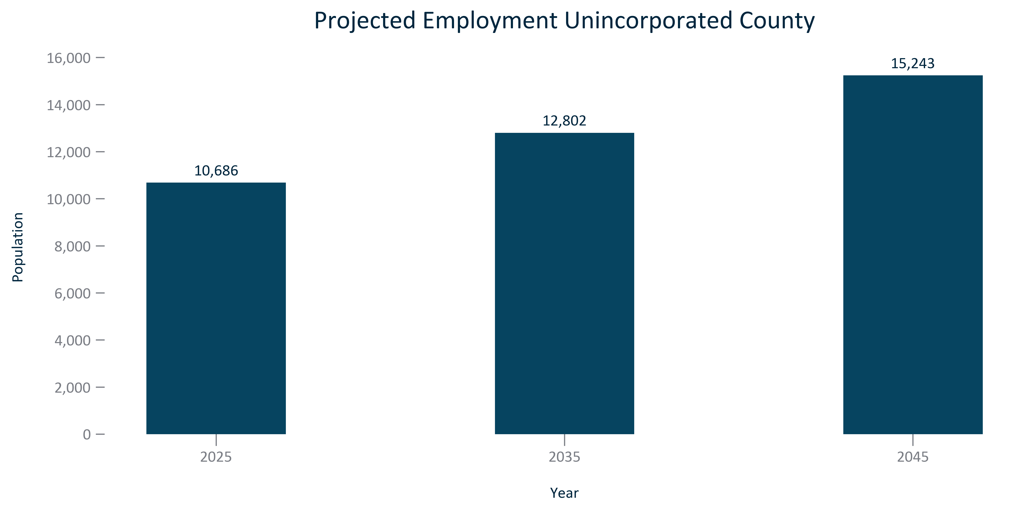

Citation: Woods and Poole Population Projections

### EMP_bar_primarygeo_percentchangeprojectedemployment_overtime:

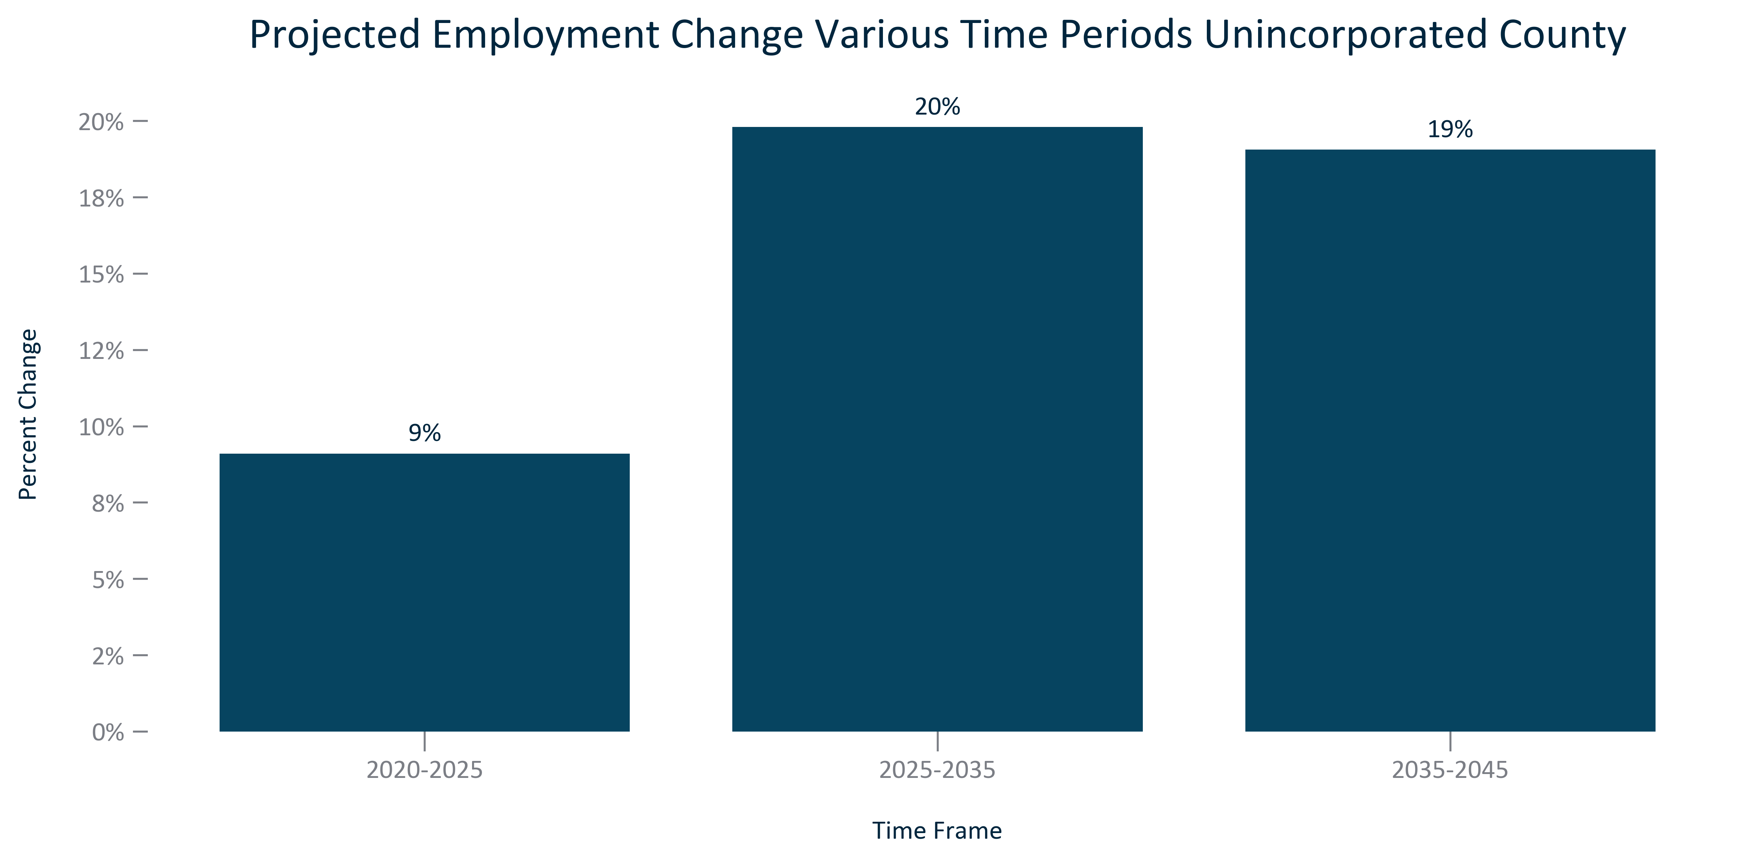

Citation: Woods and Poole Population Projections

### EMP_bar_geocomparative_projectedemploymentchange_overtime:

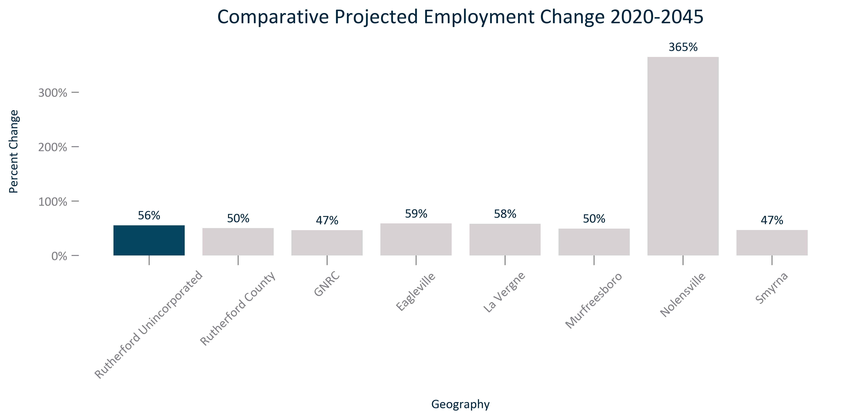

Citation: Woods and Poole Population Projections

### EMP_table_geocomparative_employmentprojectionandchange_overtime:

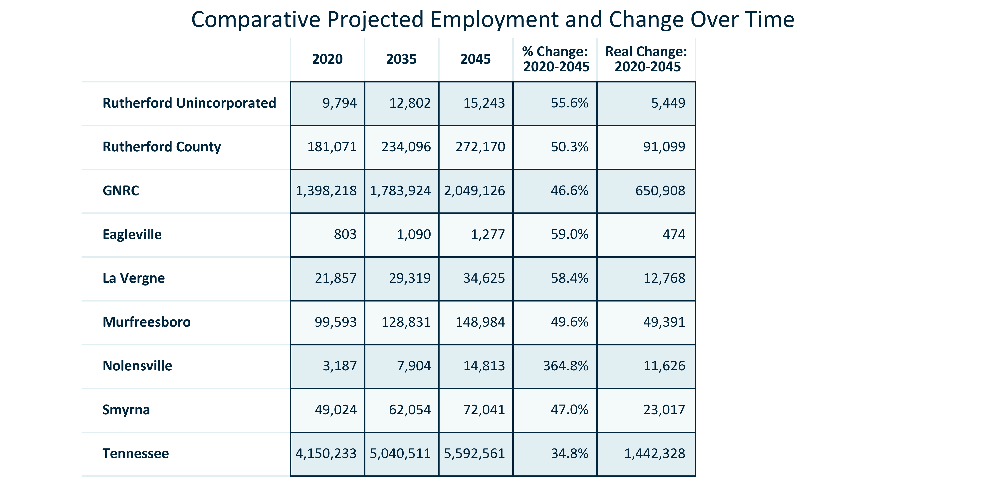

Citation: Woods and Poole Population Projections

### EMP_table_primarygeo_industryemploymentoutlook_2022Q3:

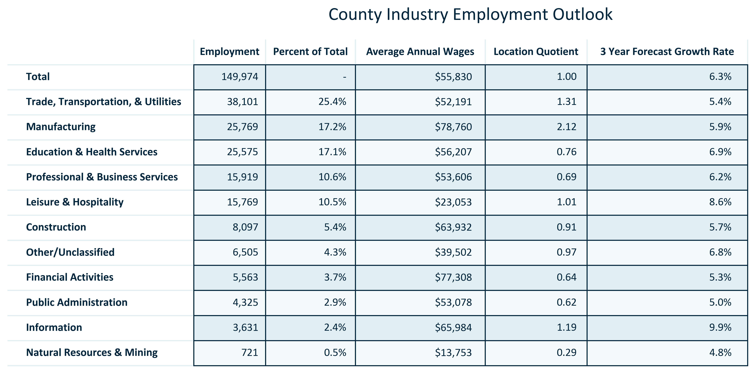

Citation: JobsEQ

### EMP_table_primarygeo_topcountyemployers_current:

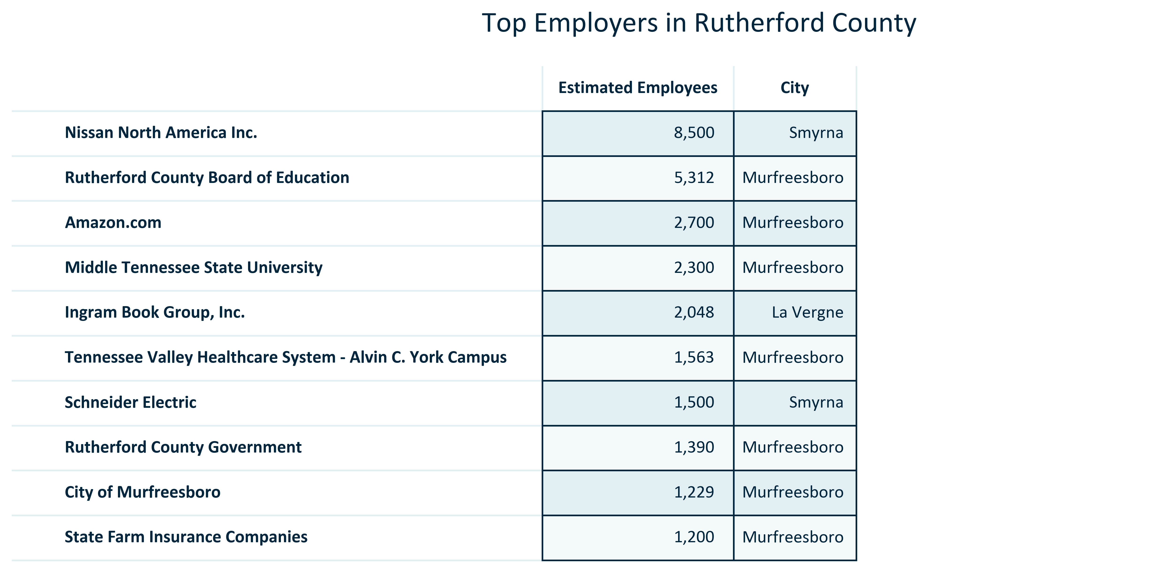

Citation: TNECD

### EMP_stackedbar_primarygeo_classofworker_overtime:

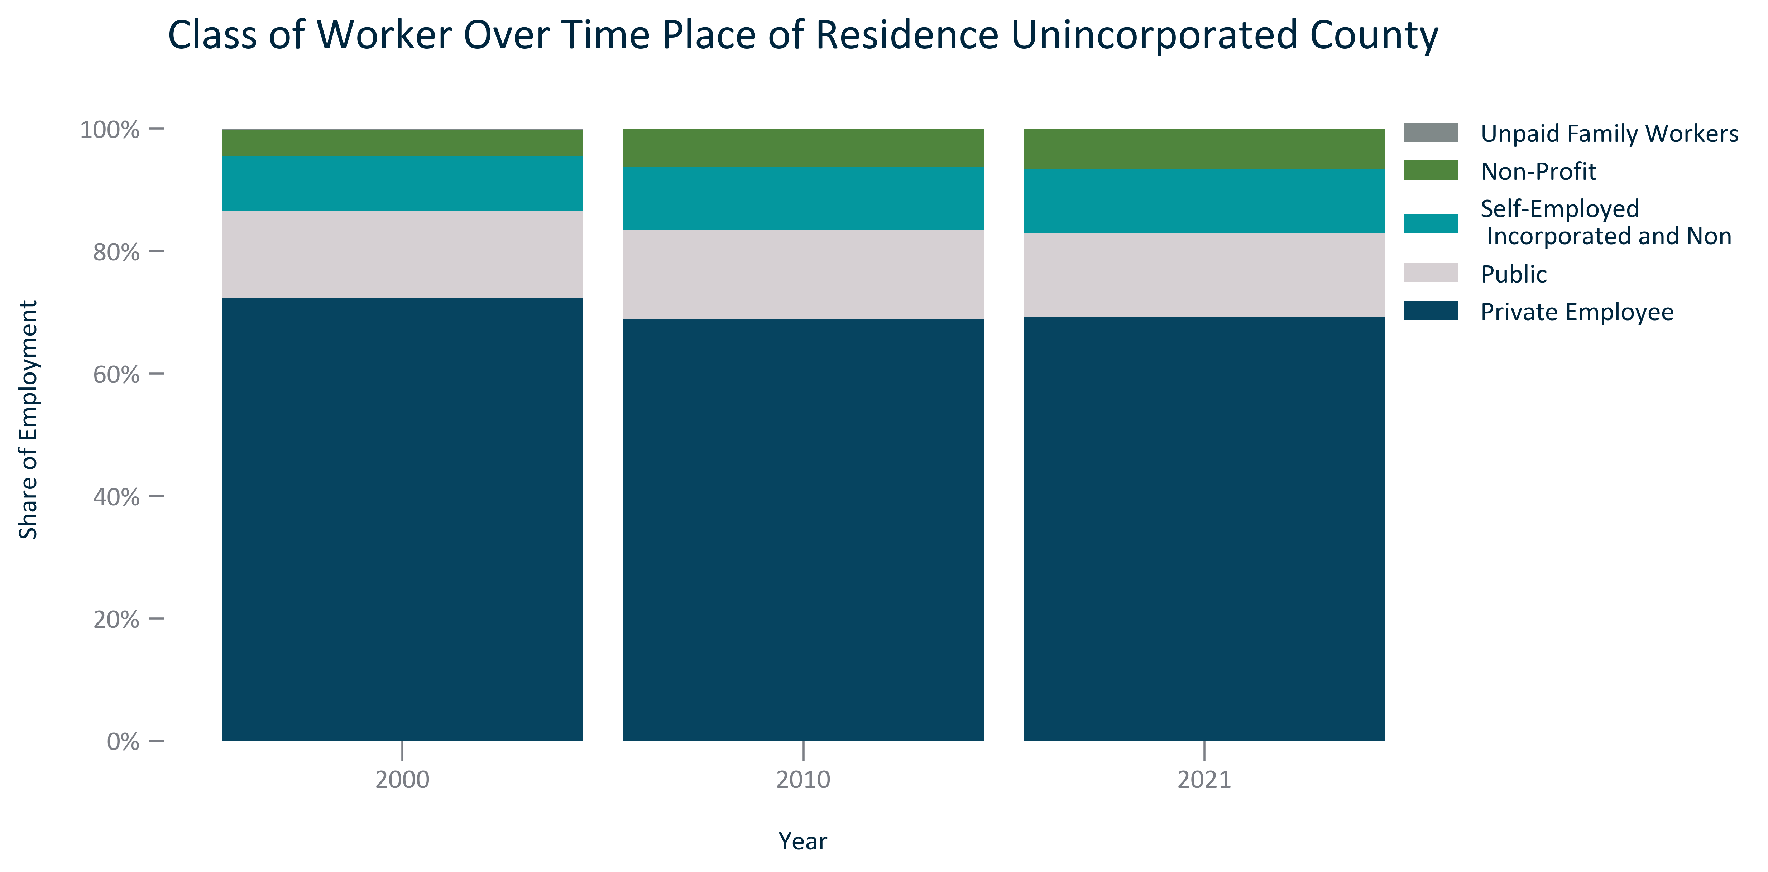

Citation: 2000 Decennial Census, 2006-2010 and 2017-2021 ACS 5-Year Estimates

### EMP_bar_primarygeo_numoccupationalemployment_2021:

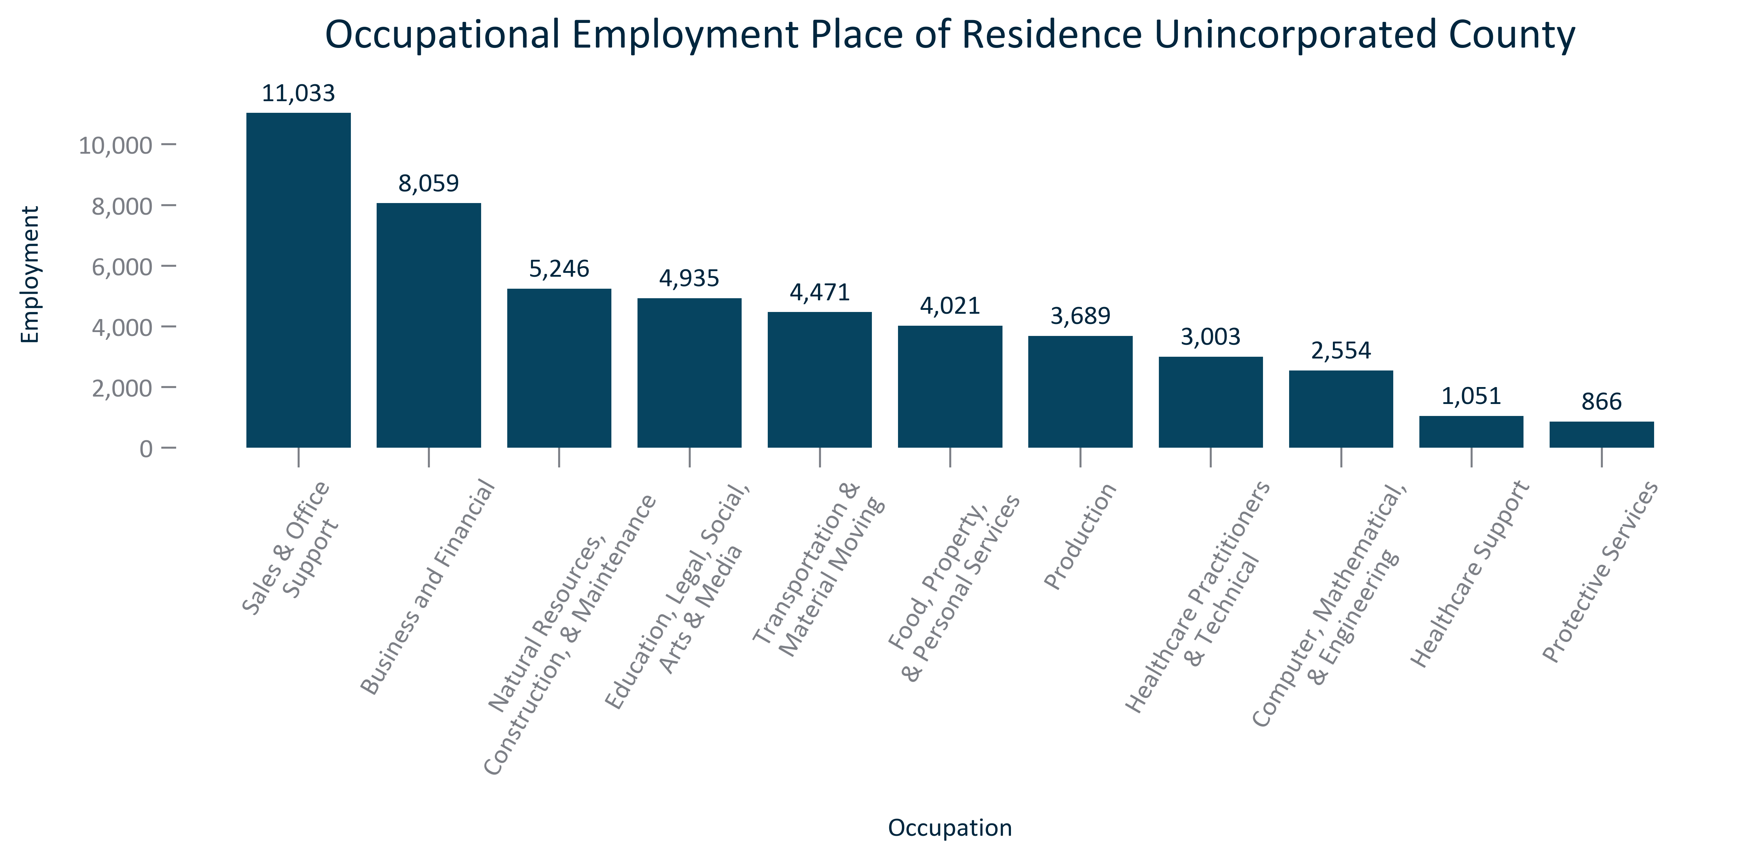

Citation: 2017-2021 ACS 5-Year Estimates

### EMP_bar_primarygeo_shareoccupationalemployment_2021:

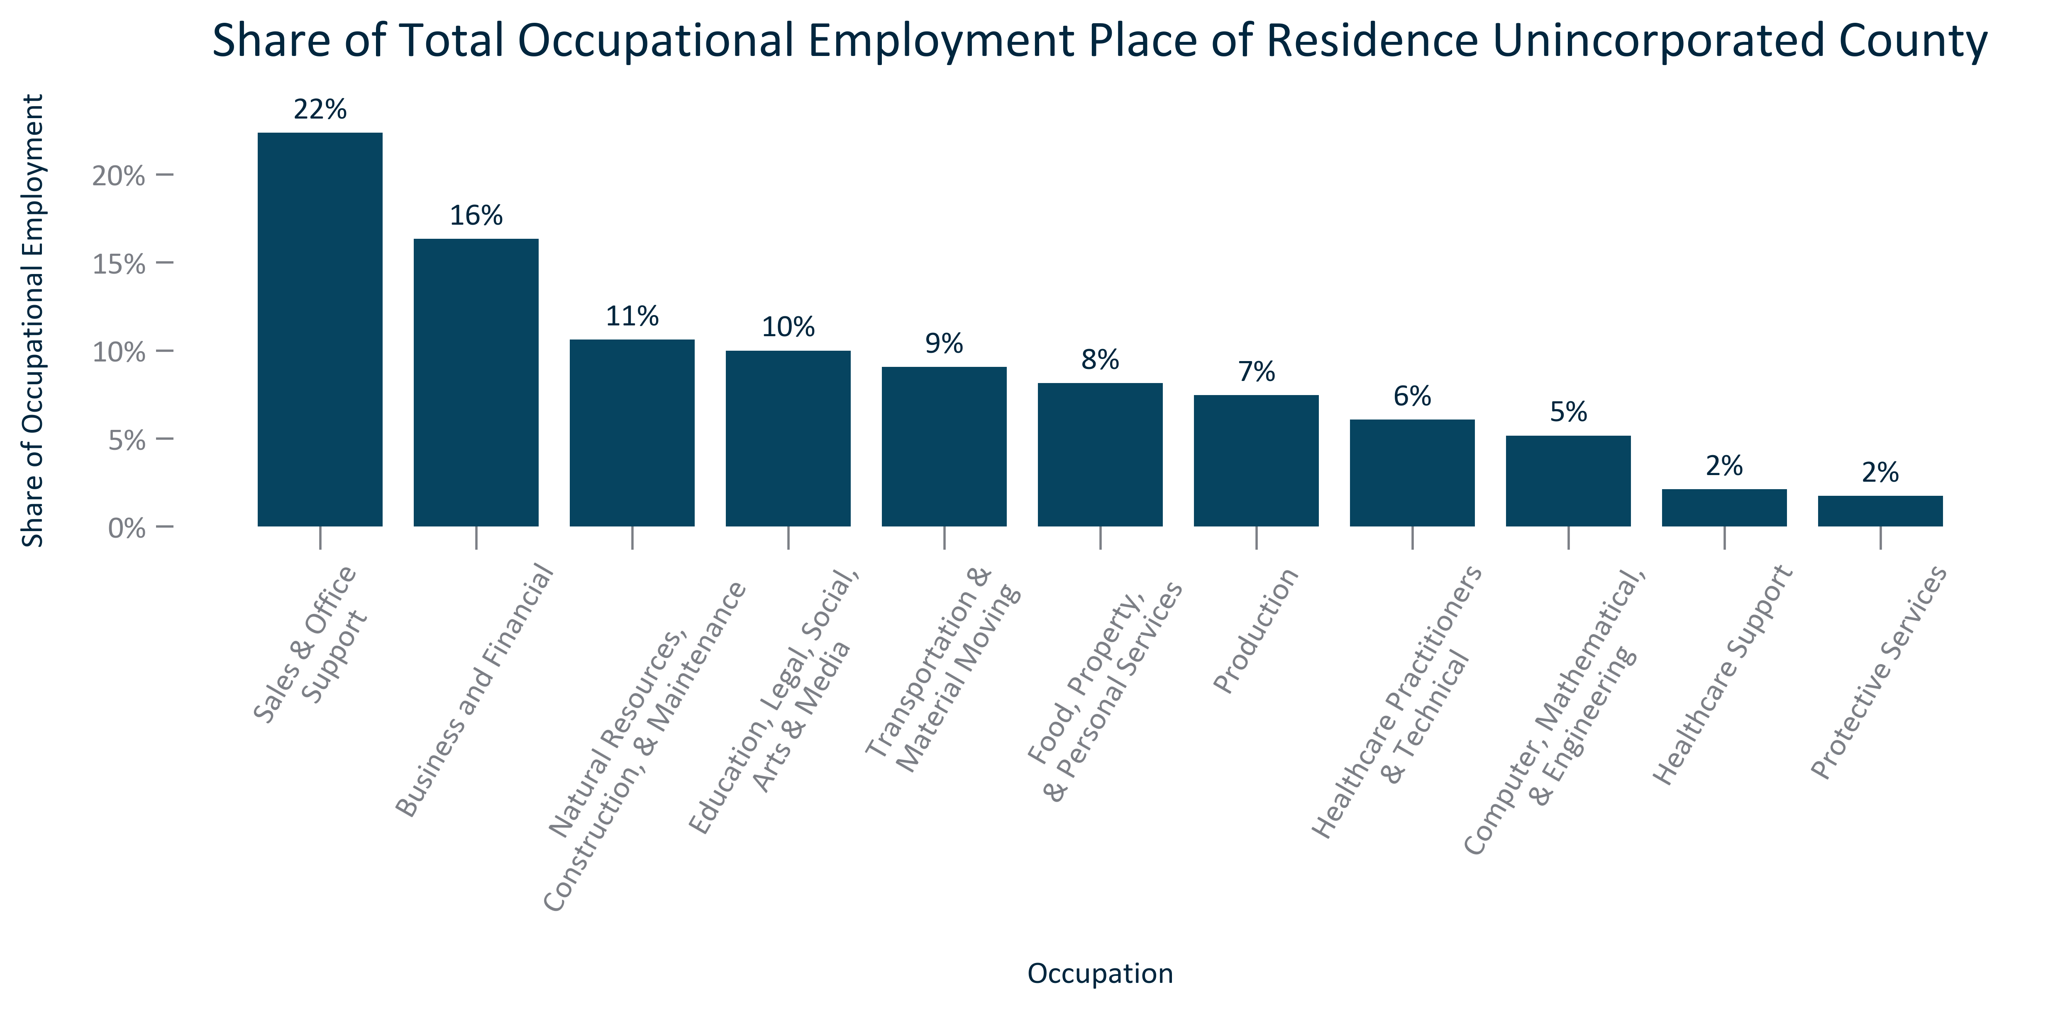

Citation: 2017-2021 ACS 5-Year Estimates

### EMP_clusterbar_primarygeo_realchangeoccupationalemployment_overtime:

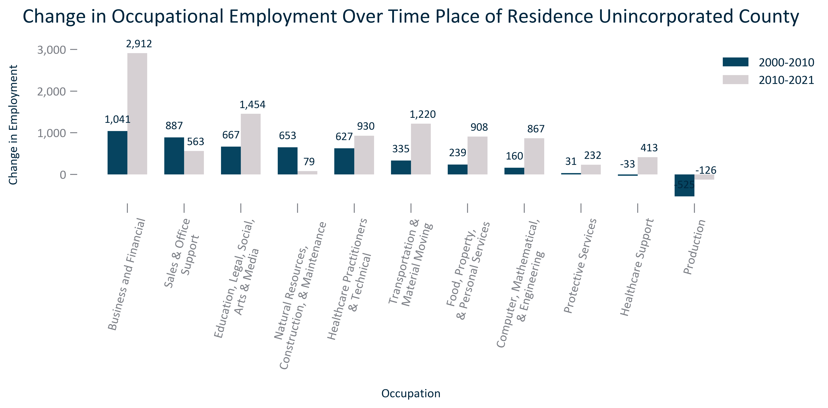

Citation: 2000 Decennial Census, 2006-2010 and 2017-2021 ACS 5-Year Estimates

### EMP_clusterbar_primarygeo_percentchangeOccupationalemployment_overtime:

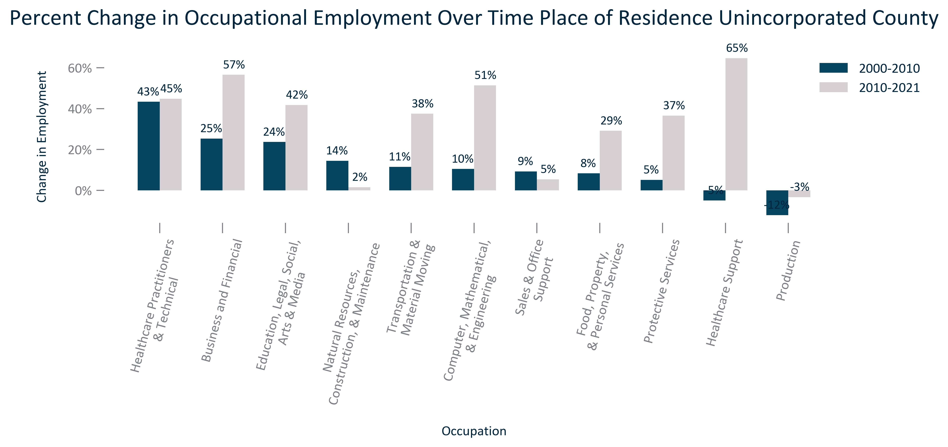

Citation: 2000 Decennial Census, 2006-2010 and 2017-2021 ACS 5-Year Estimates

### EMP_table_primarygeo_occupationalemployment_overtime:

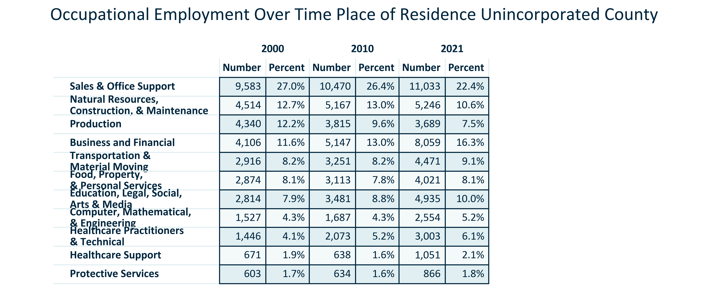

Citation: 2000 Decennial Census, 2006-2010 and 2017-2021 ACS 5-Year Estimates

### EMP_line_primarygeo_historicalemploymentbyoccupation_overtime:

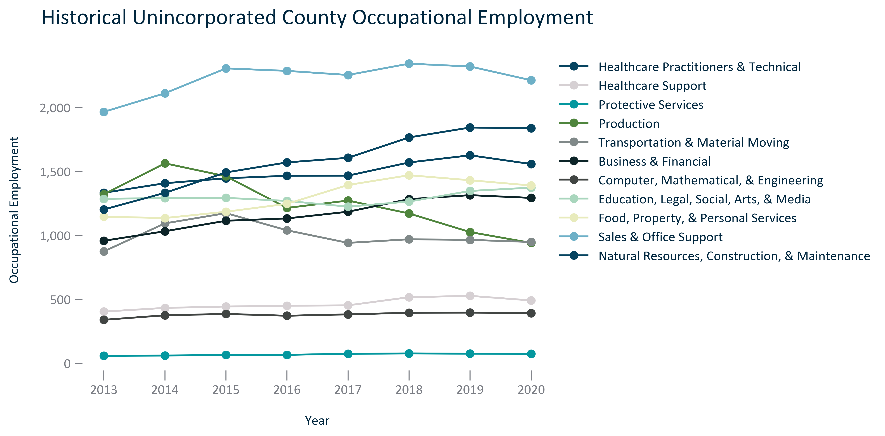

Citation: JobsEQ

### EMP_table_primarygeo_occupationalemploymentoutlook_2022Q3:

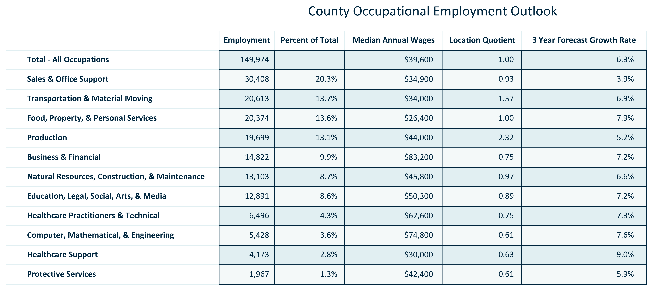

Citation: JobsEQ

### EMP_line_county_awardsgranted_overtime:

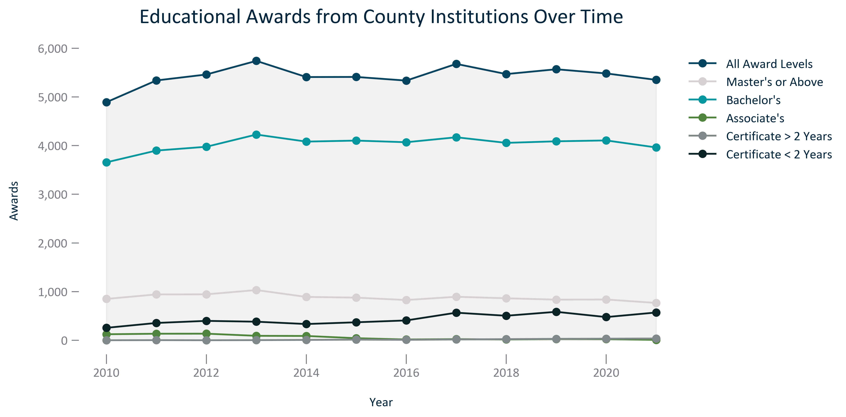

Citation: National Center for Education Statistics via JobsEQ

### EMP_line_geocomparative_topcountiesedawards_overtime:

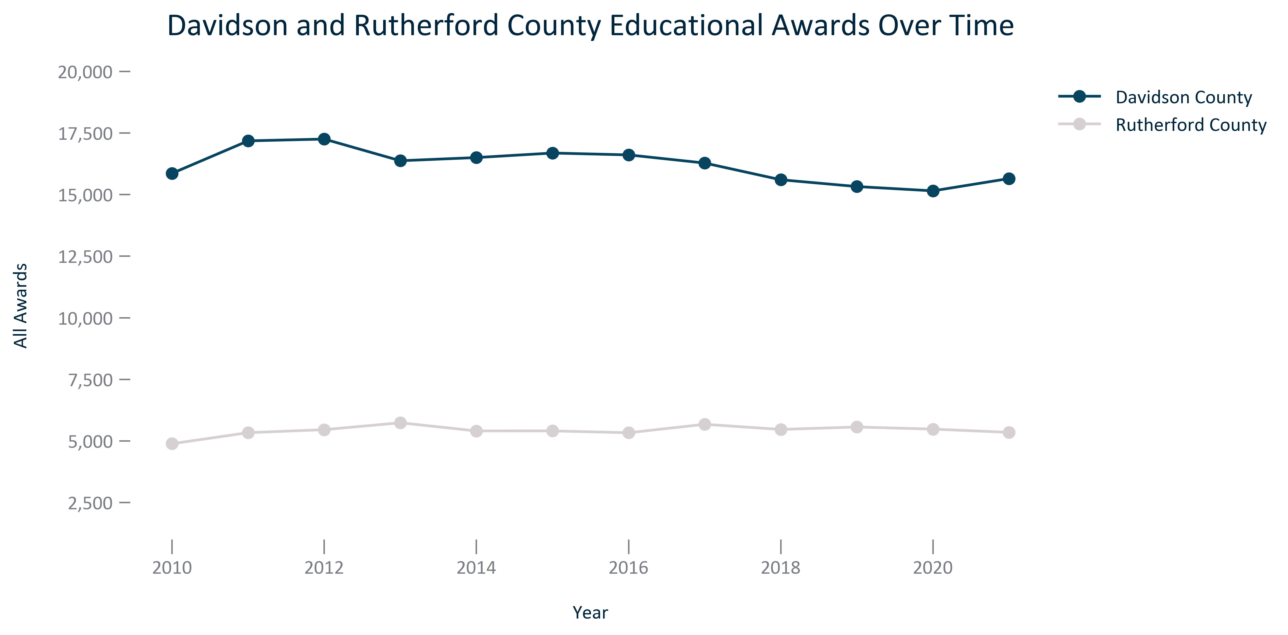

Citation: National Center for Education Statistics via JobsEQ

### EMP_line_geocomparative_allawardscounties_overtime:

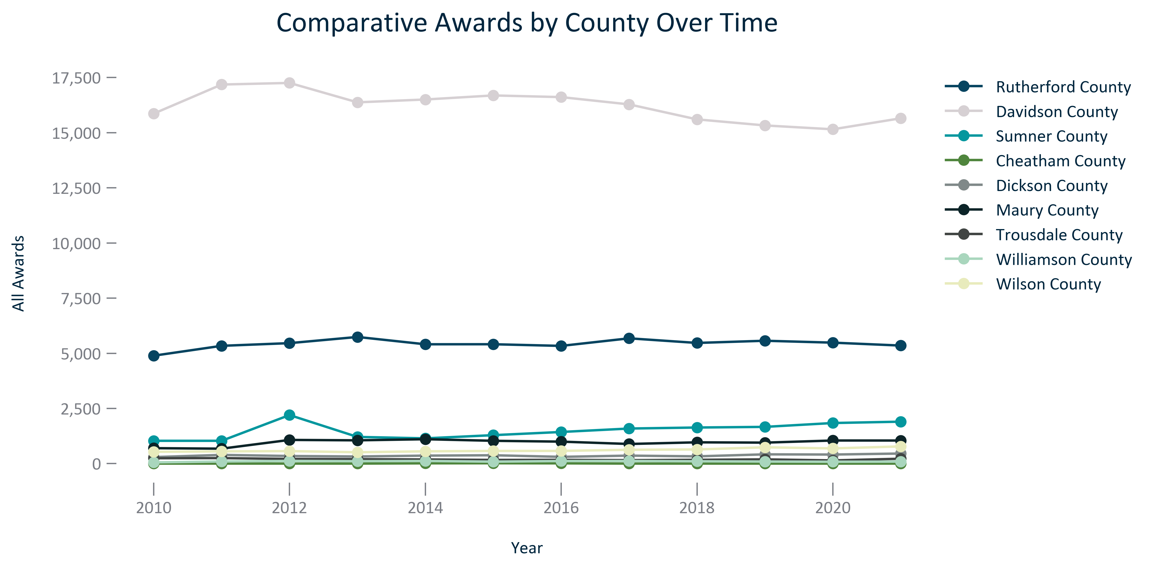

Citation: National Center for Education Statistics via JobsEQ

### EMP_bar_primarygeo_numlfstatus_2021:

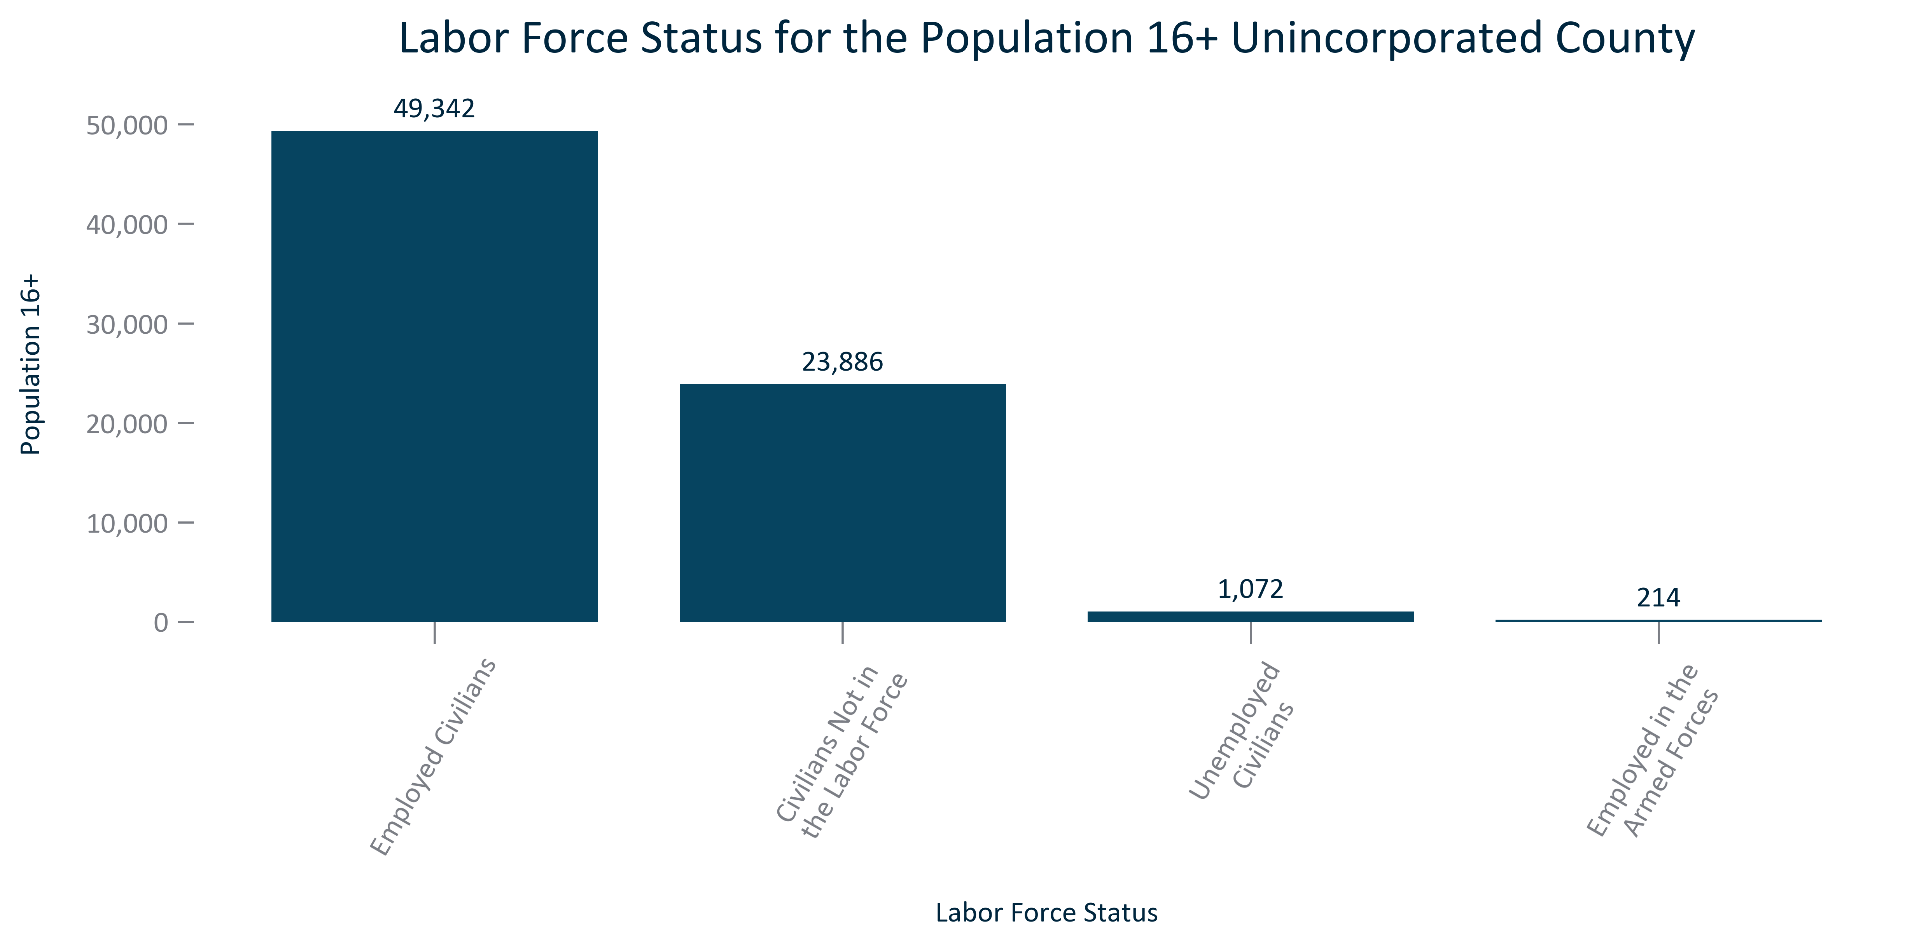

Citation: 2017-2021 ACS 5-Year Estimates

### EMP_bar_primarygeo_percentlfstatus_2021:

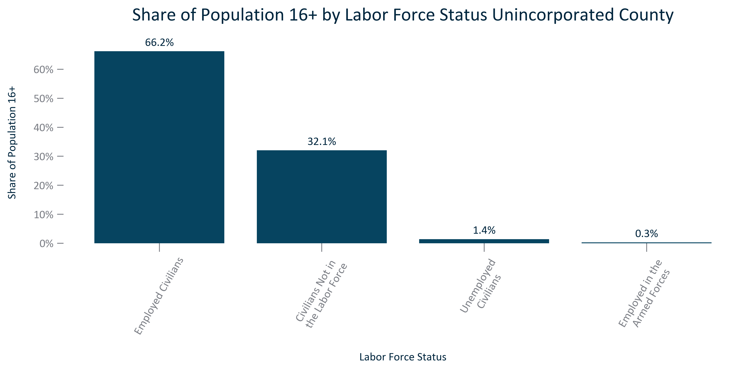

Citation: 2017-2021 ACS 5-Year Estimates

### EMP_clusterbar_primarygeo_realchangelfstatus_overtime:

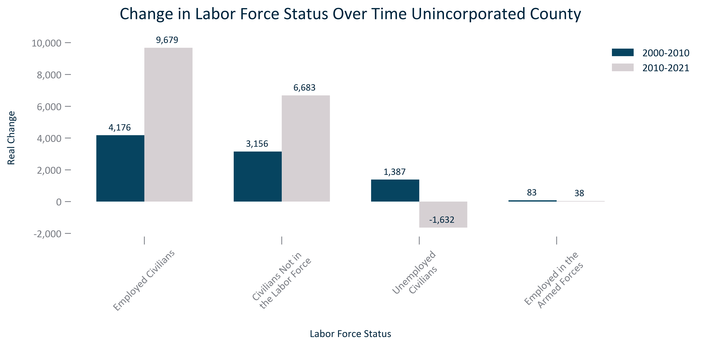

Citation: 2000 Decennial Census, 2006-2010 and 2017-2021 ACS 5-Year Estimates

### EMP_clusterbar_primarygeo_percentchangelfstatus_overtime:

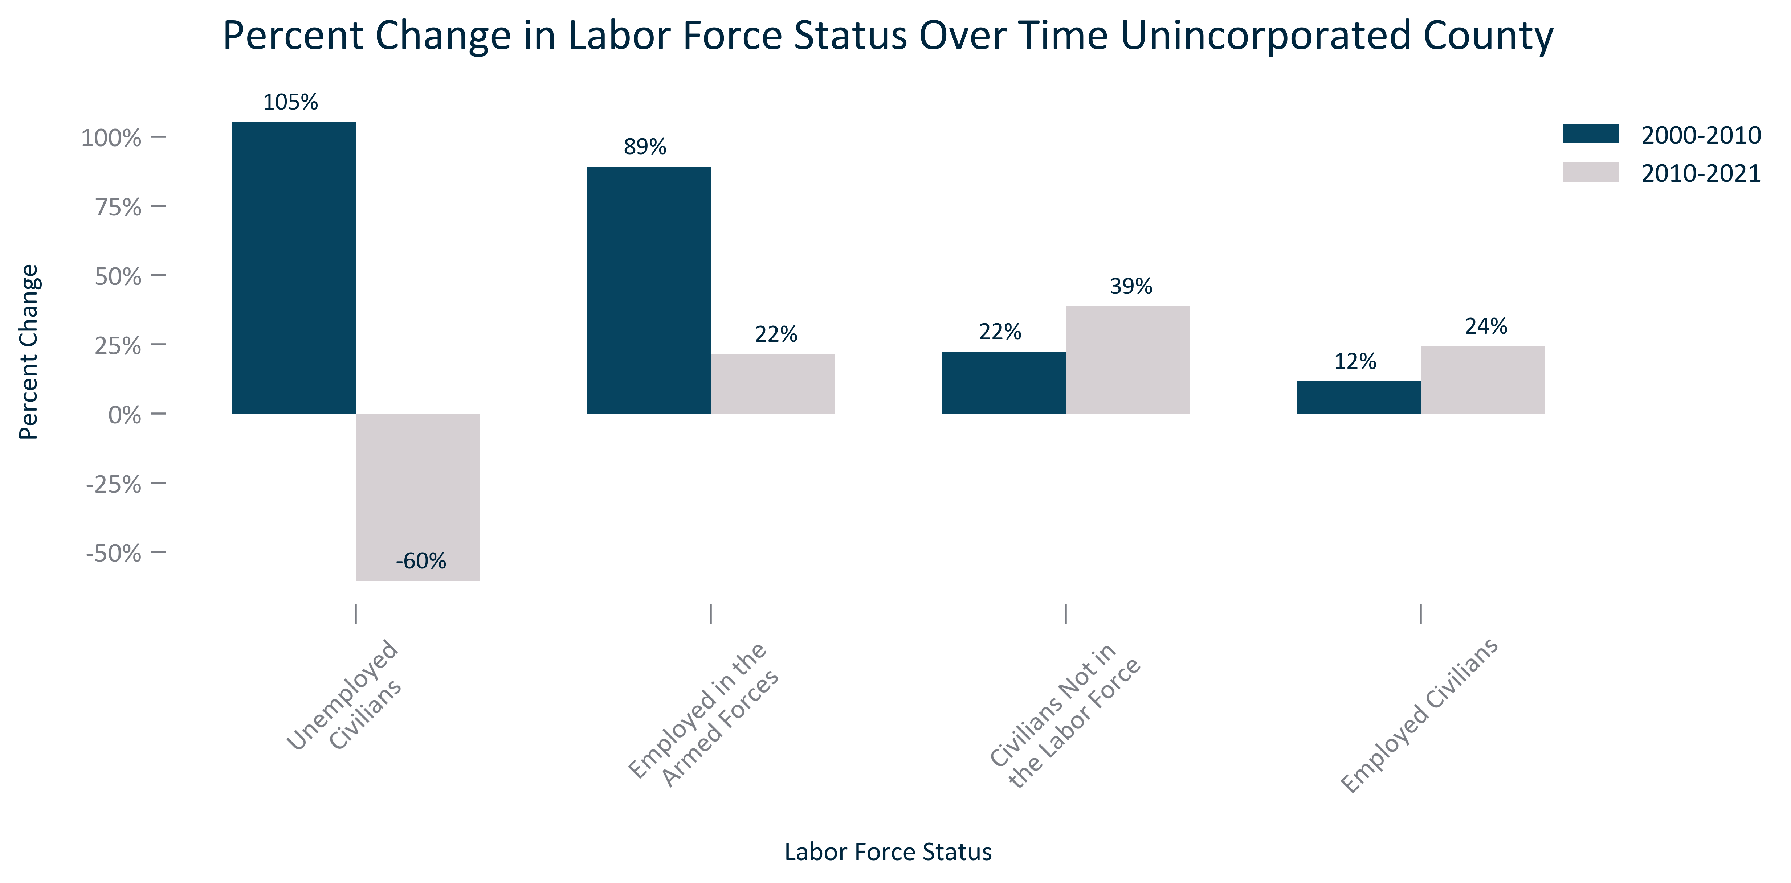

Citation: 2000 Decennial Census, 2006-2010 and 2017-2021 ACS 5-Year Estimates

### EMP_stackedbar_primarygeo_lfparticipation_overtime:

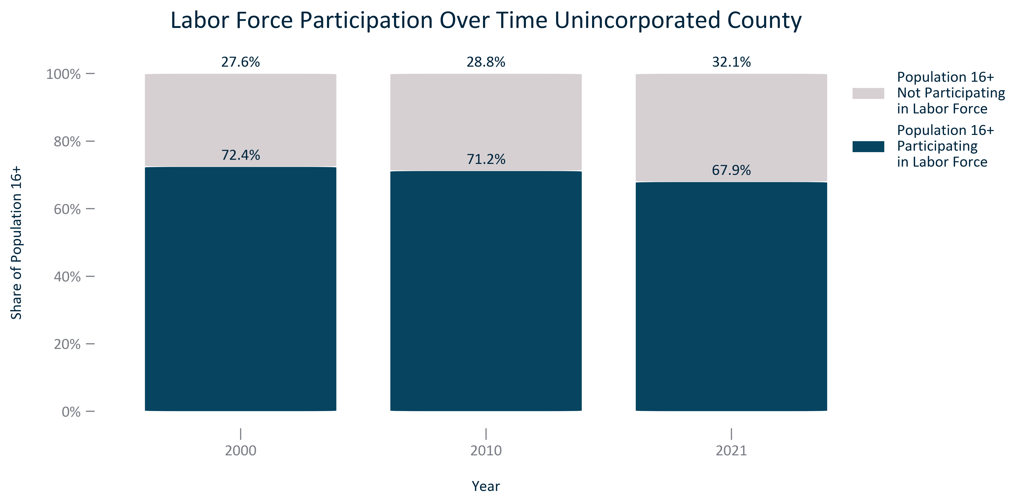

Citation: 2000 Decennial Census, 2006-2010 and 2017-2021 ACS 5-Year Estimates

### EMP_stackedbar_primarygeo_civilianemploymentstatus_overtime:

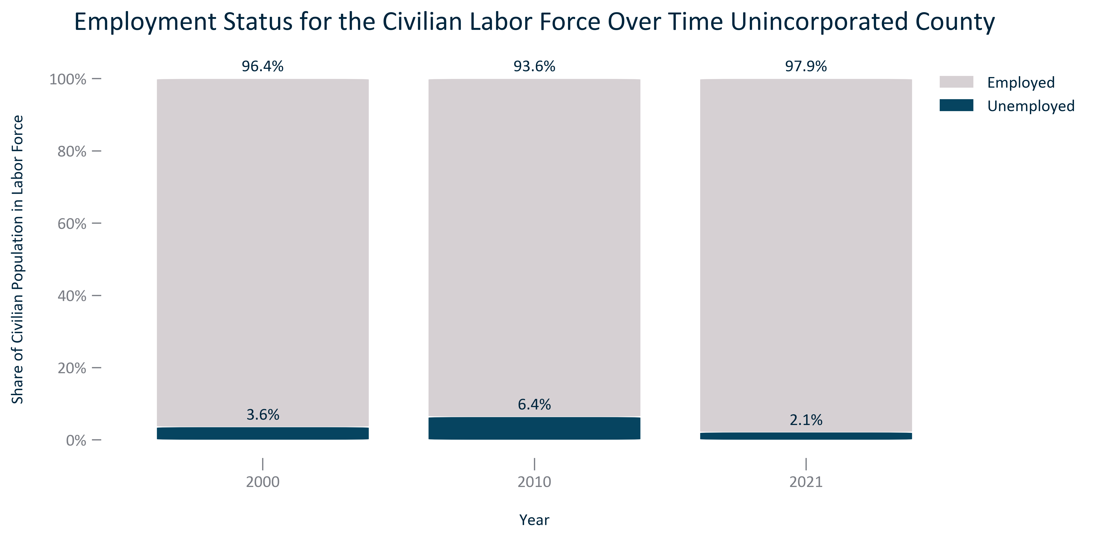

Citation: 2000 Decennial Census, 2006-2010 and 2017-2021 ACS 5-Year Estimates

### EMP_line_geocomparative_unemploymentcounties_overtime:

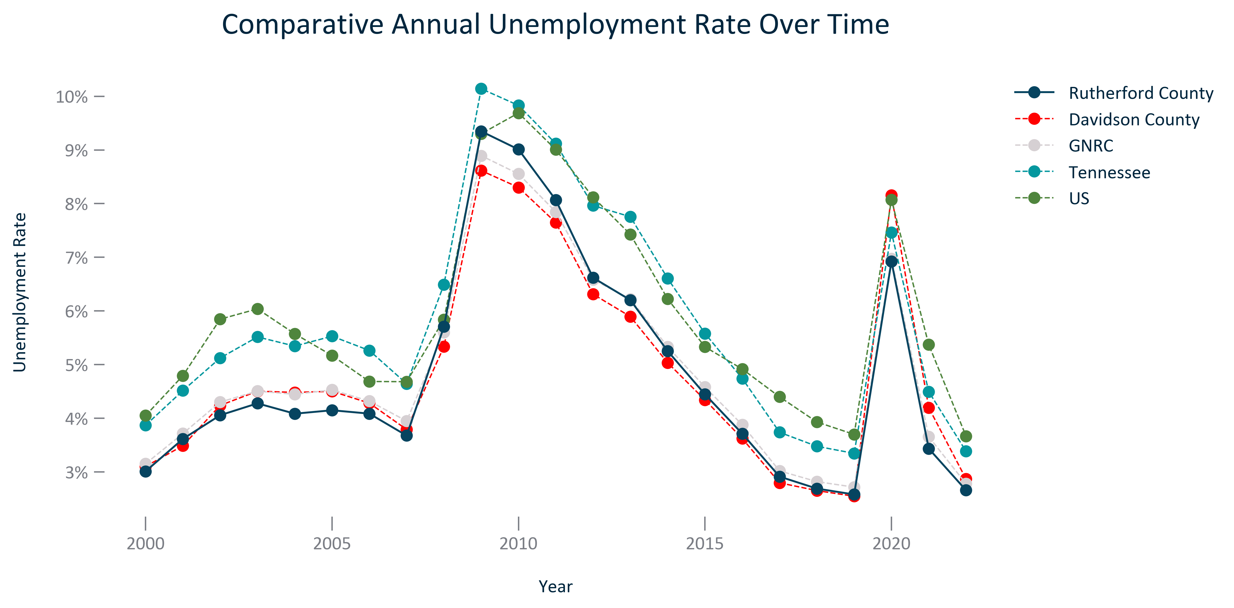

Citation: LAUS

### EMP_bar_geocomparative_civilianunemploymentrate_2021:

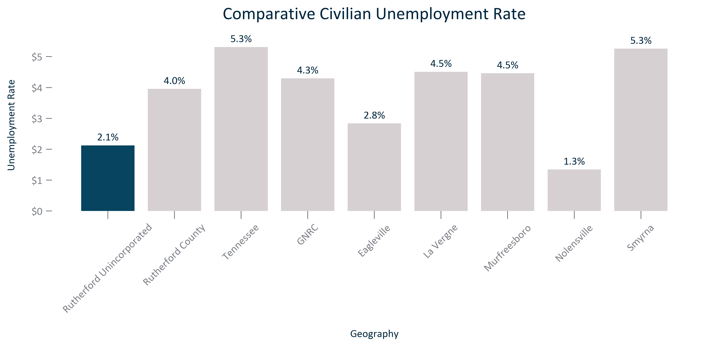

Citation: 2017-2021 ACS 5-Year Estimates

### EMP_bar_primarygeo_medianannualearningsallworkers_overtime:

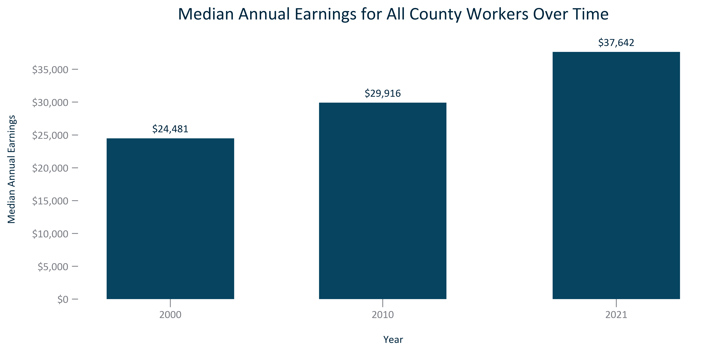

Citation: 2000 Decennial Census, 2006-2010 and 2017-2021 ACS 5-Year Estimates

### EMP_bar_primarygeo_medianannualearningsfulltimeworkers_overtime:

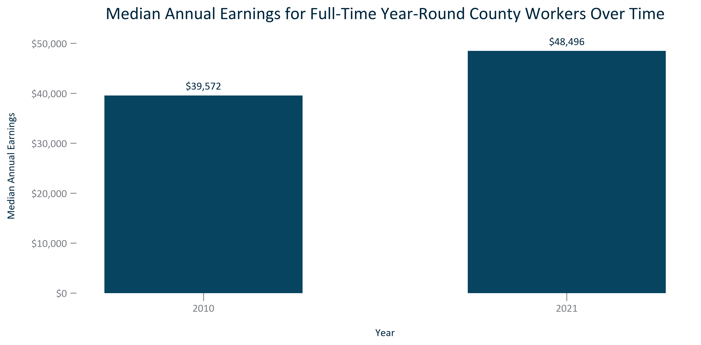

Citation: 2006-2010 and 2017-2021 ACS 5-Year Estimates

### EMP_bar_primarygeo_medianearningsallworkerscount_2021:

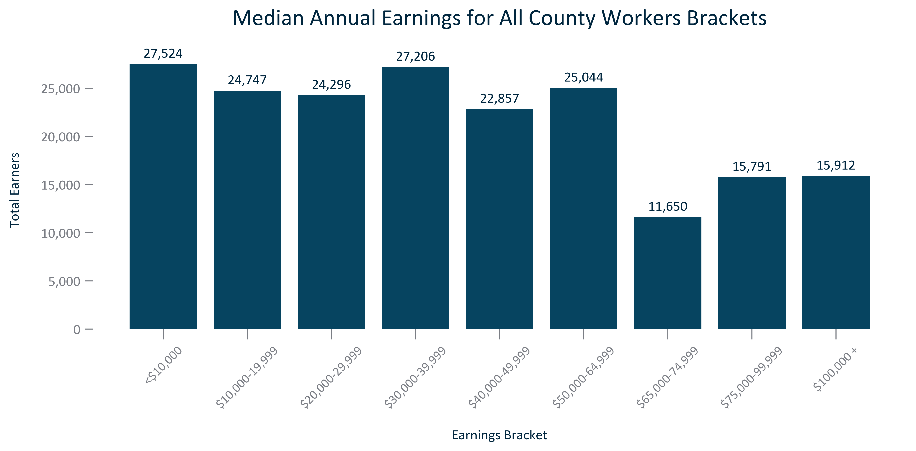

Citation: 2017-2021 ACS 5-Year Estimates

### EMP_bar_primarygeo_medianearningsdistributionallworkers_2021:

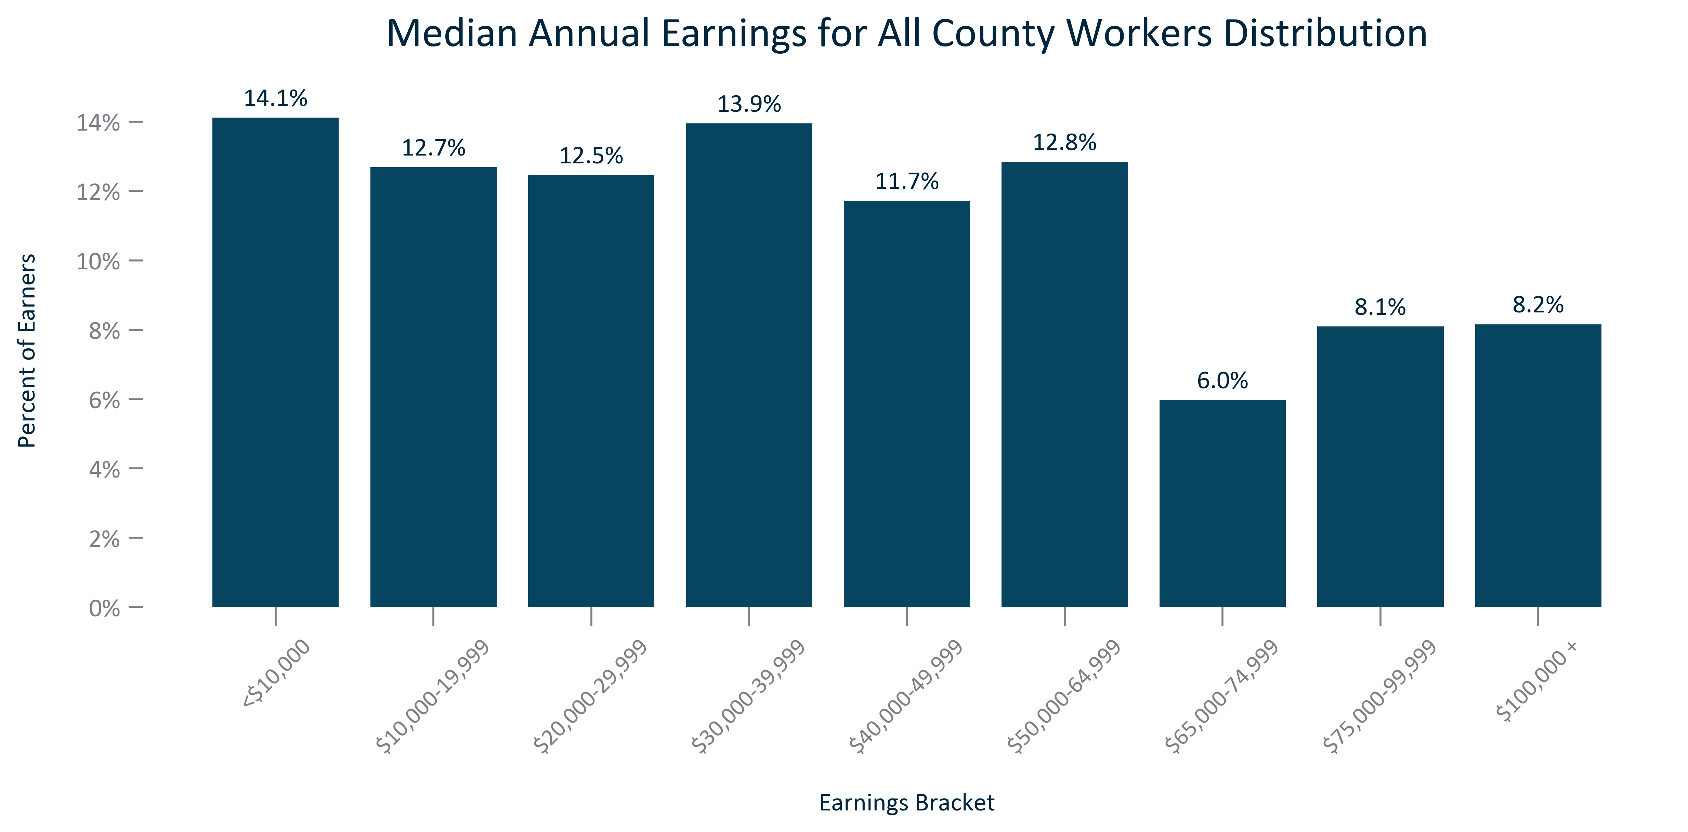

Citation: 2017-2021 ACS 5-Year Estimates

### EMP_bar_primarygeo_medianearningsfulltimeworkerscount_2021:

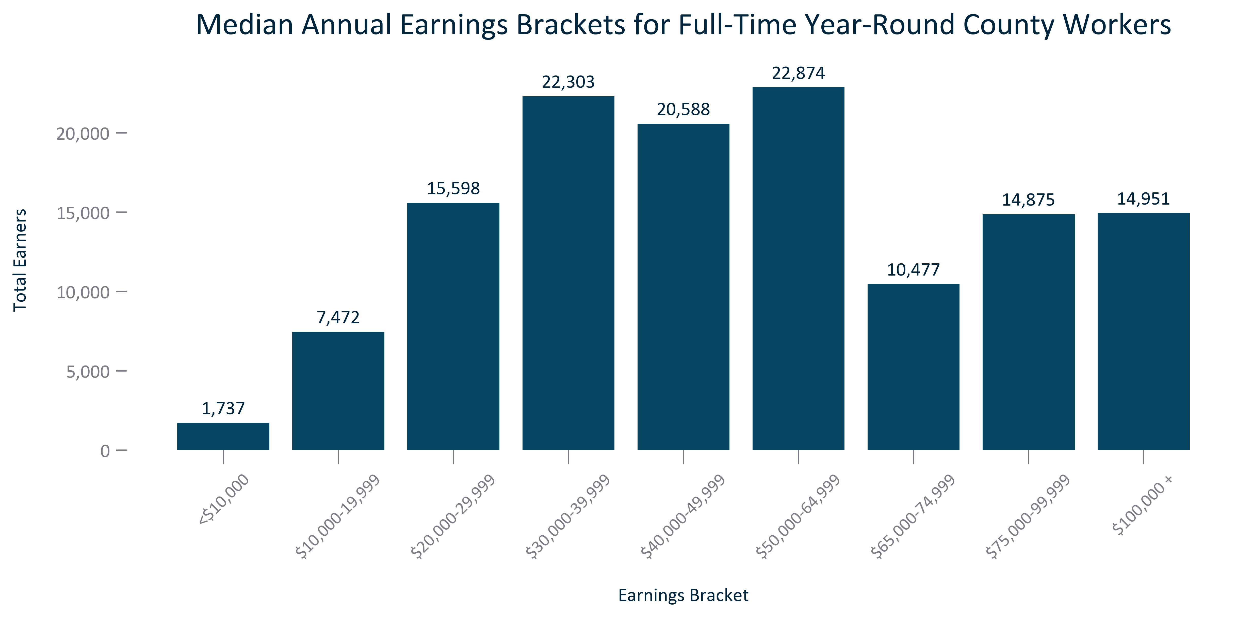

Citation: 2017-2021 ACS 5-Year Estimates

### EMP_bar_primarygeo_medianearningsdistributionfulltimeworkers_2021:

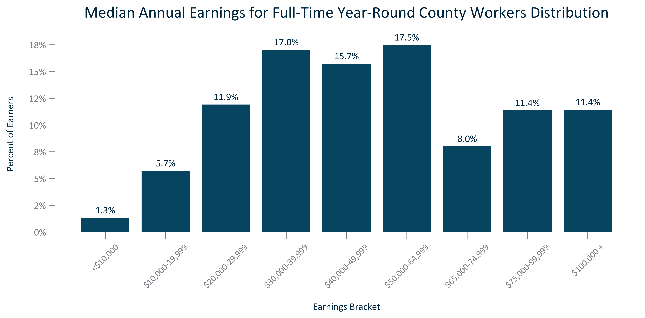

Citation: 2017-2021 ACS 5-Year Estimates

### EMP_bar_geocomparative_medianannualearningsfulltimeworkers_2021:

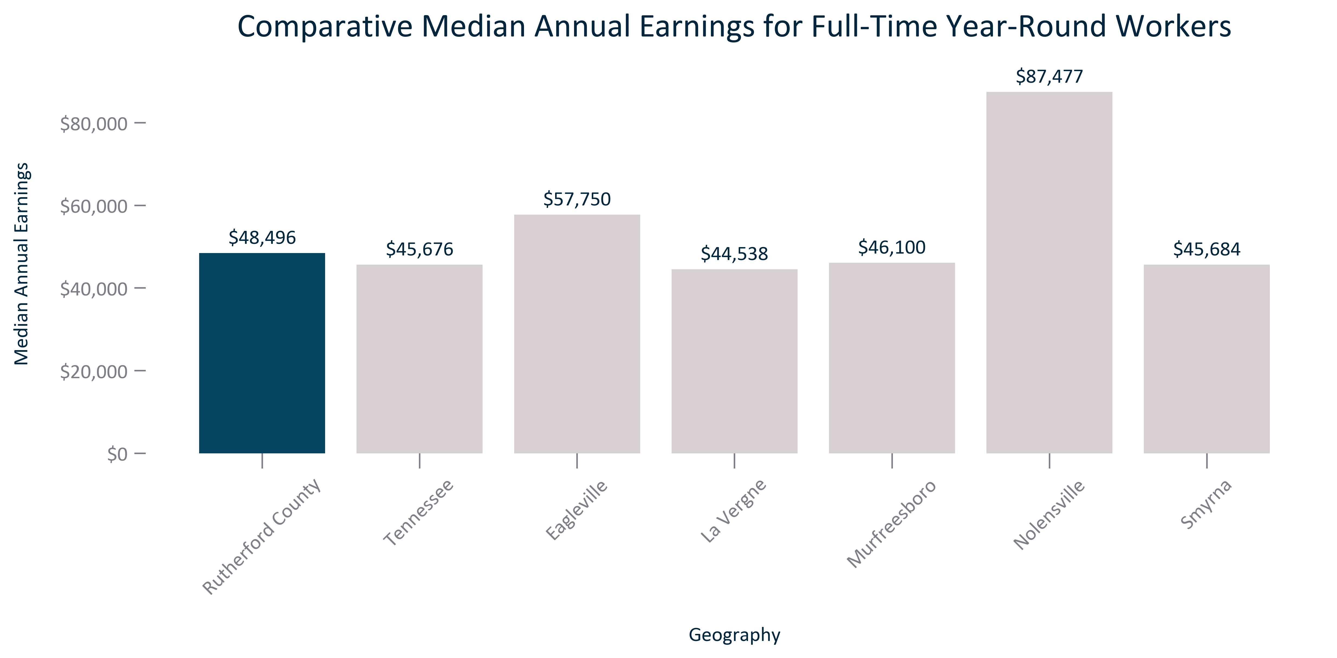

Citation: 2017-2021 ACS 5-Year Estimates

### EMP_bar_primarygeo_medianannualearningsraceethallworkers_2021:

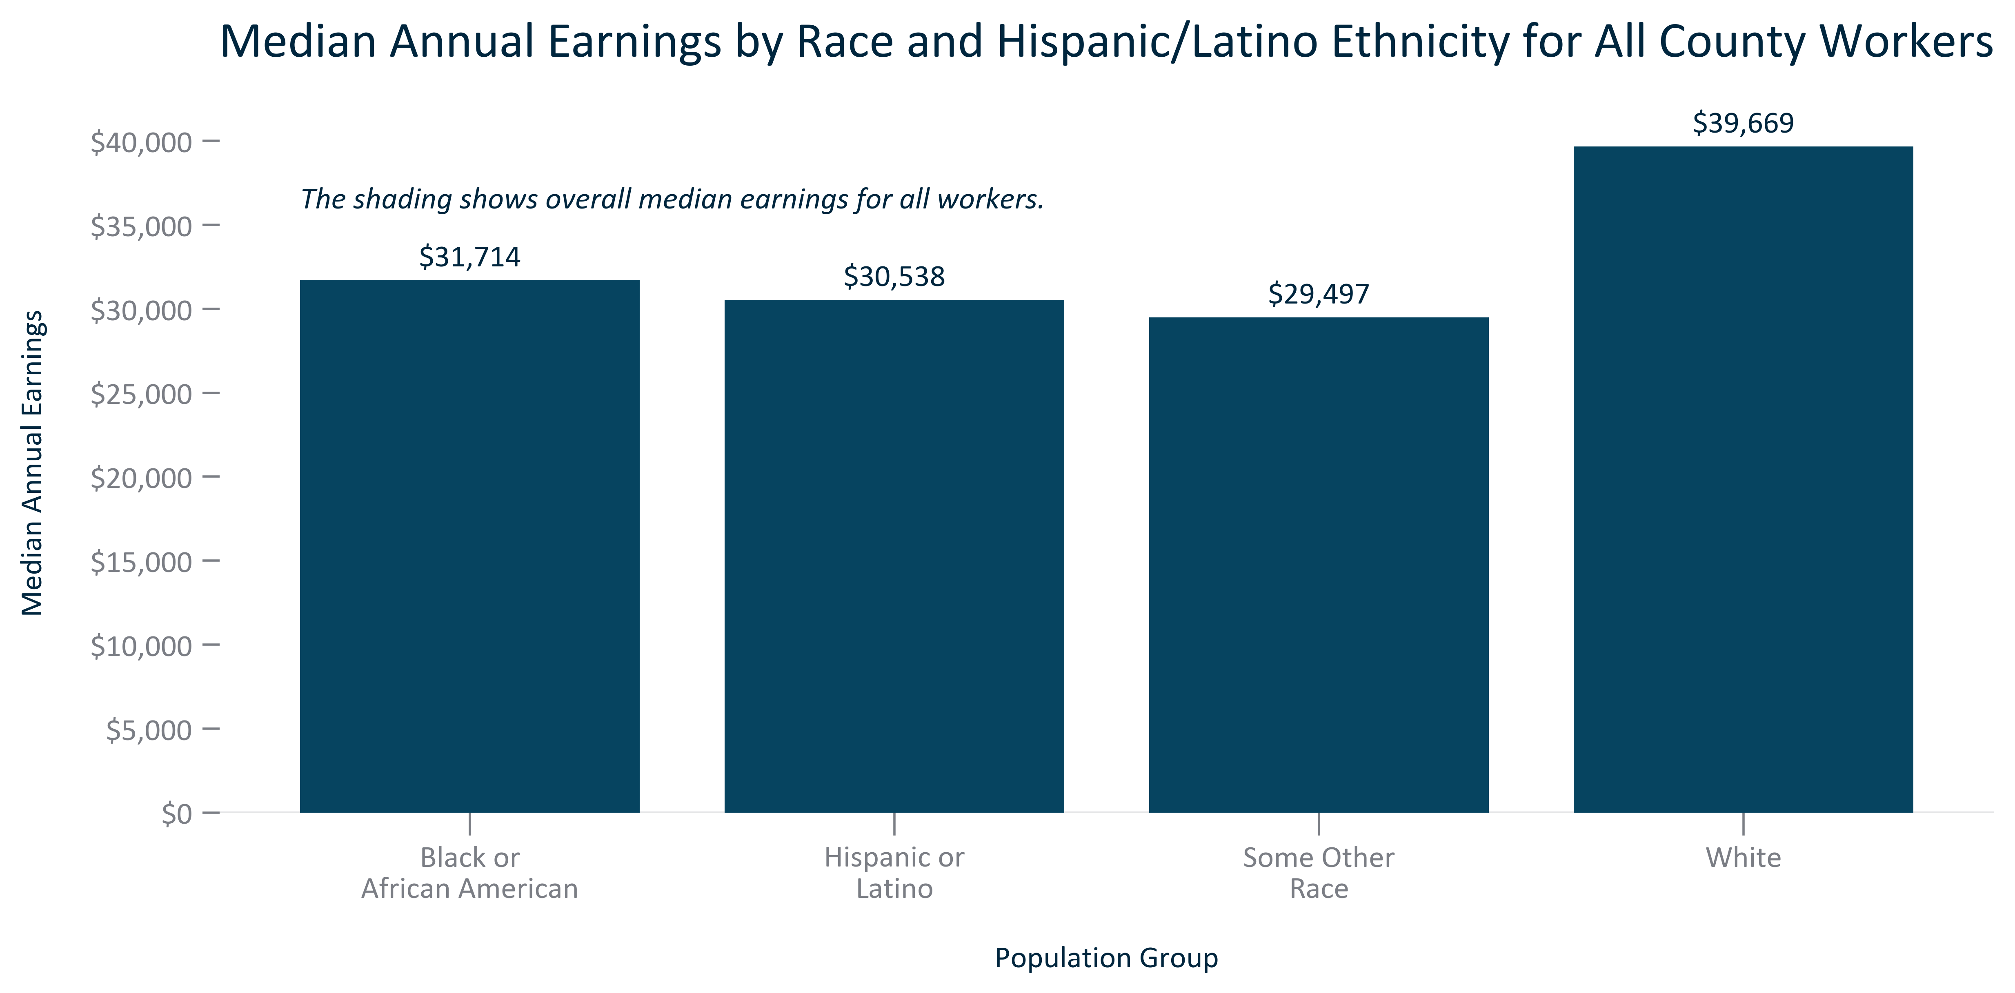

Citation: 2017-2021 ACS 5-Year Estimates

### EMP_bar_primarygeo_percapitaincome_overtime:

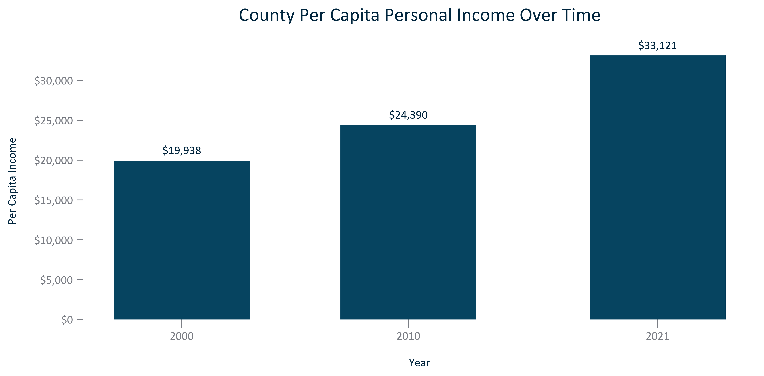

Citation: 2000 Decennial Census, 2006-2010 and 2017-2021 ACS 5-Year Estimates

### EMP_bar_geocomparative_percapitaincome_2021:

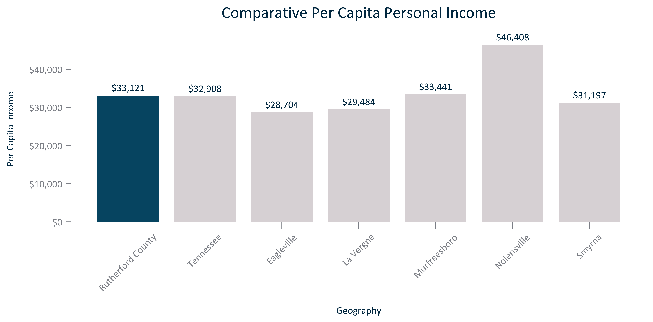

Citation: 2017-2021 ACS 5-Year Estimates

### EMP_line_primarygeo_gdpcounty_overtime:

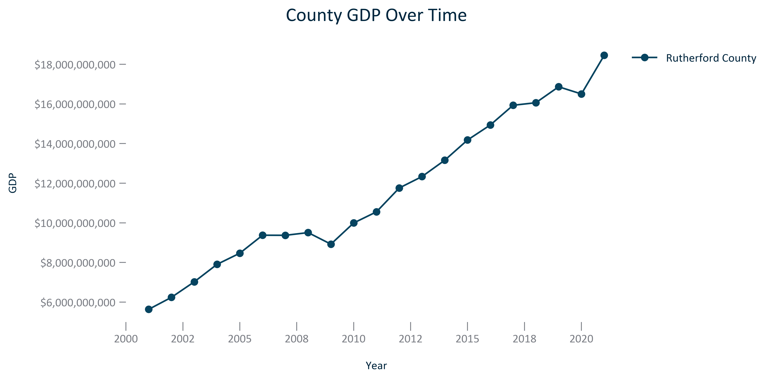

Citation: BEA via JobsEQ

### EMP_line_geocomparative_gdpcounties_overtime:

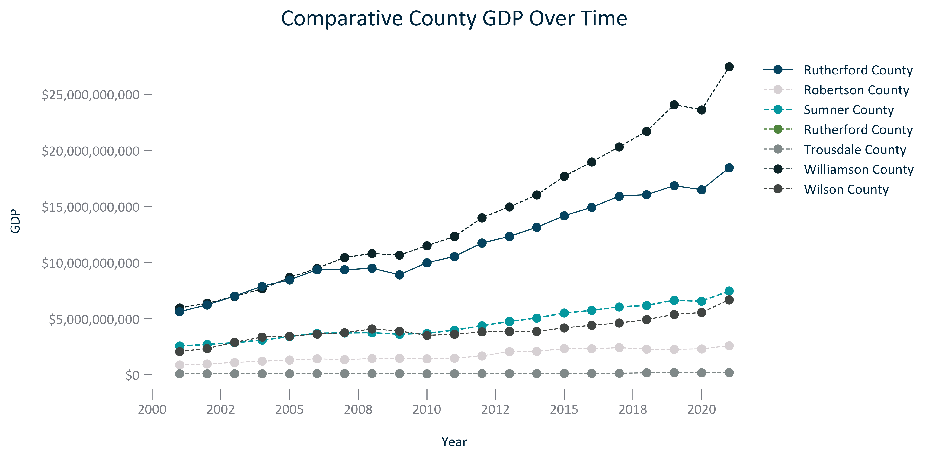

Citation: BEA via JobsEQ

### EMP_line_primarygeo_gdpcountydavidson_overtime:

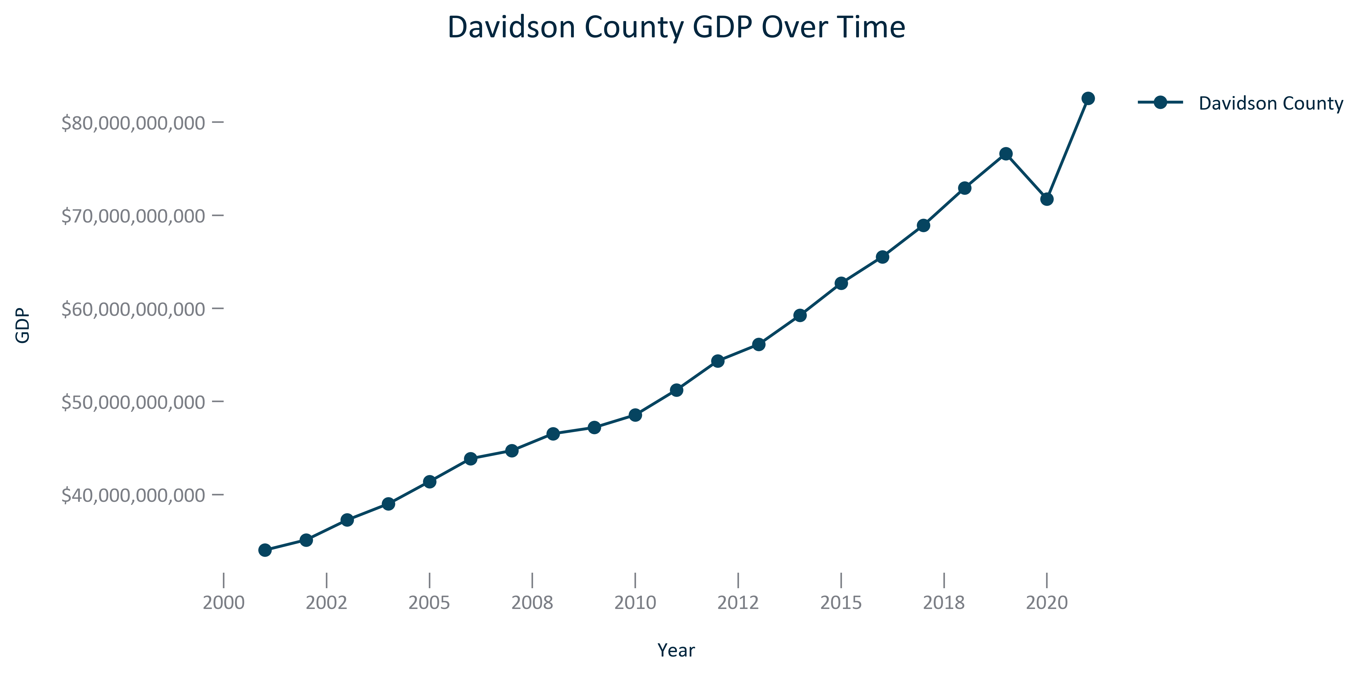

Citation: BEA via JobsEQ

# Transportation

### TRANSPO_table_geocomparative_totalcrashes_overtime:

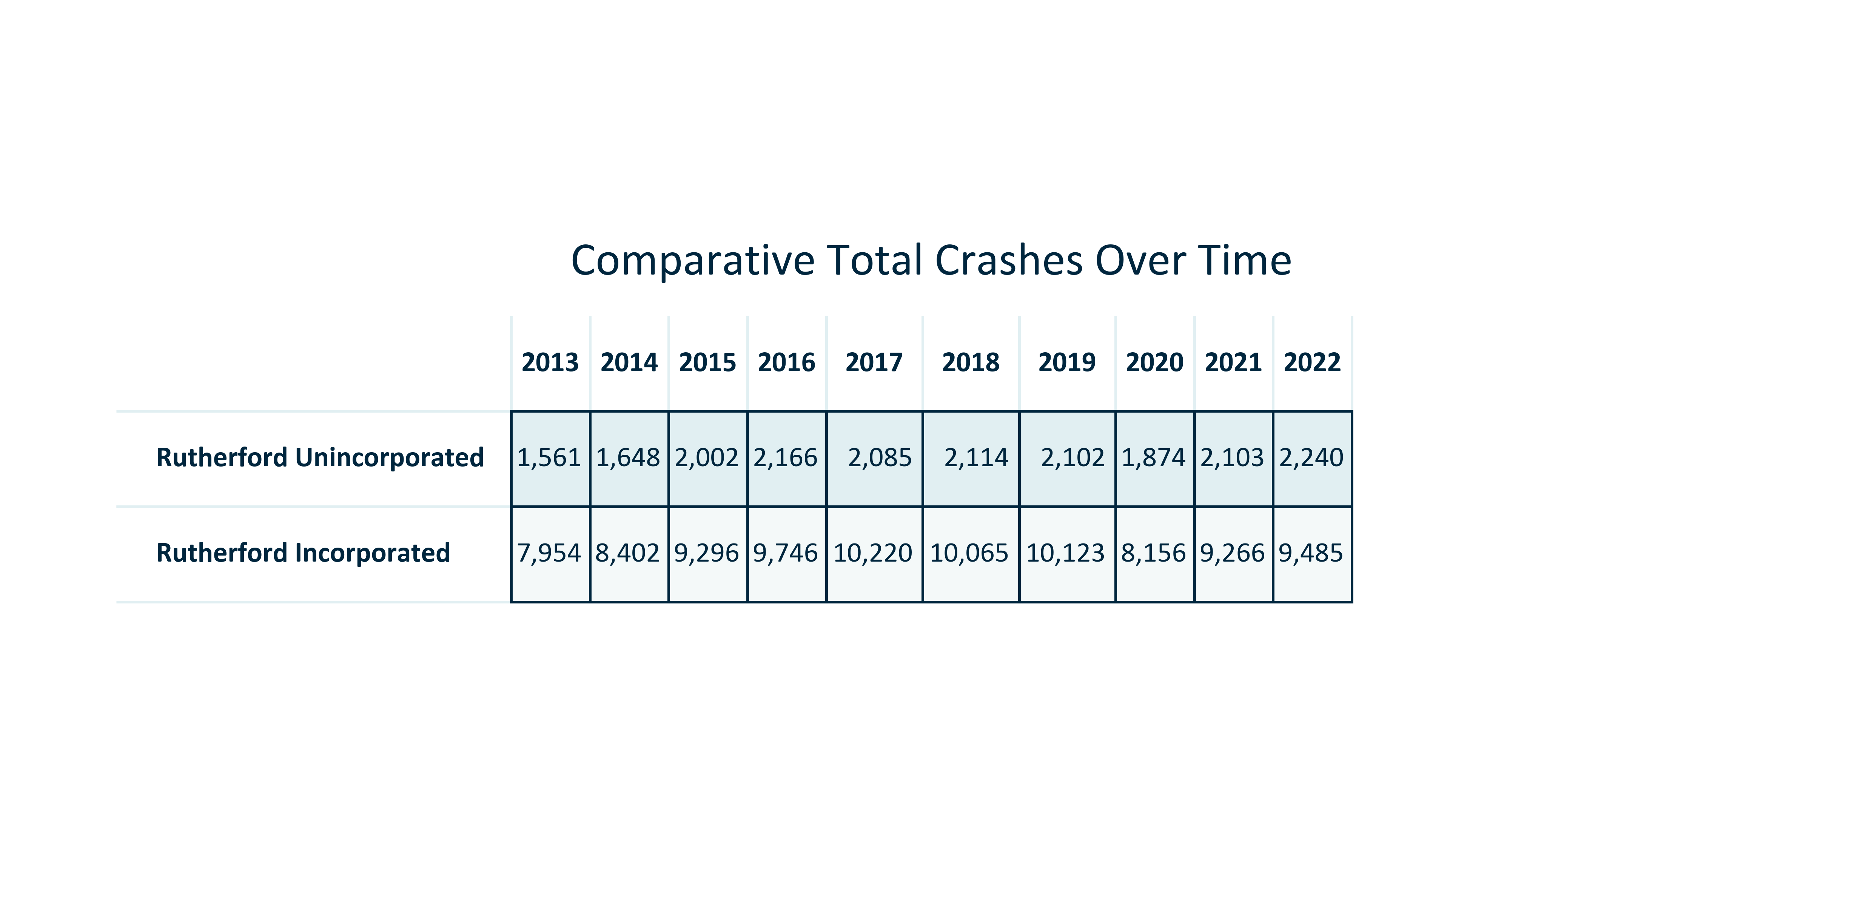

Citation: Crash Data

### TRANSPO_table_primarygeo_fatalcrashes_overtime:

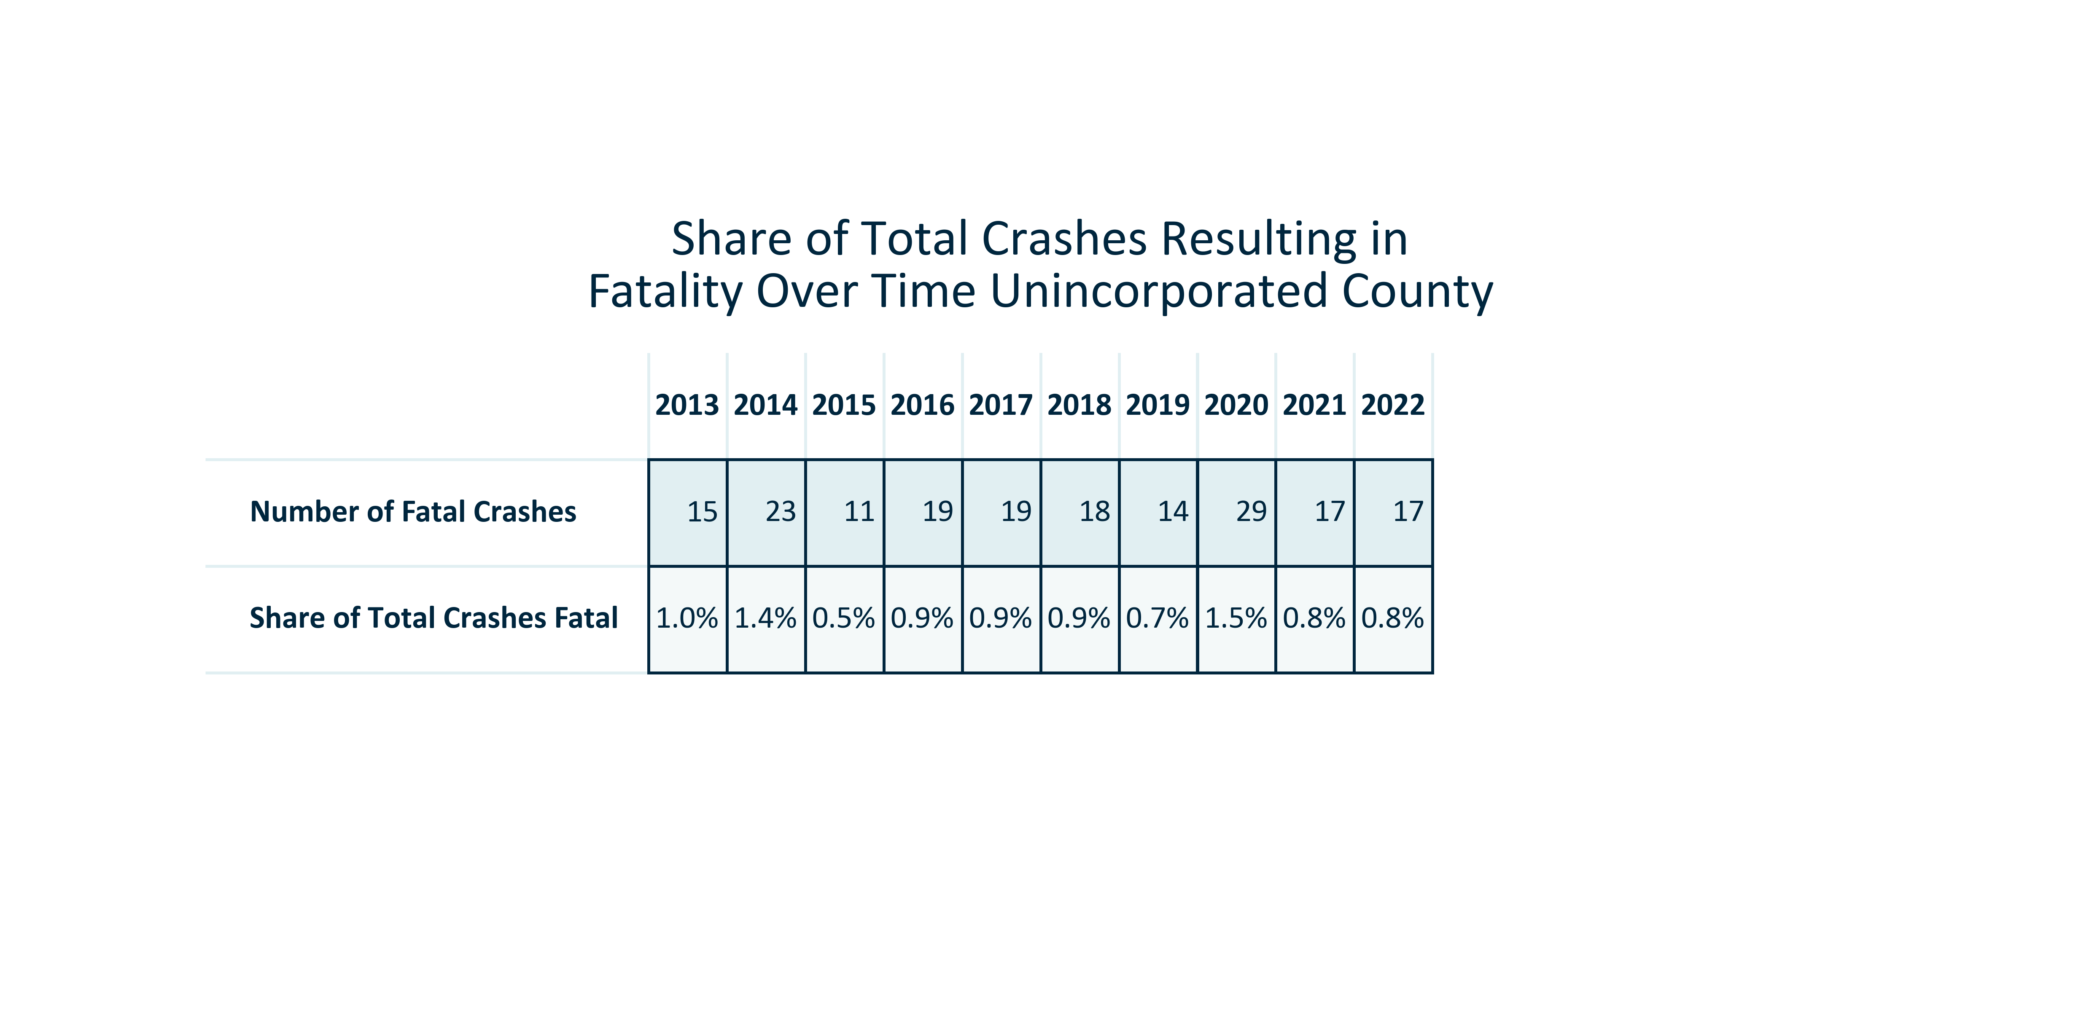

Citation: Crash Data

### TRANSPO_table_primarygeo_seriousinjurycrashes_overtime:

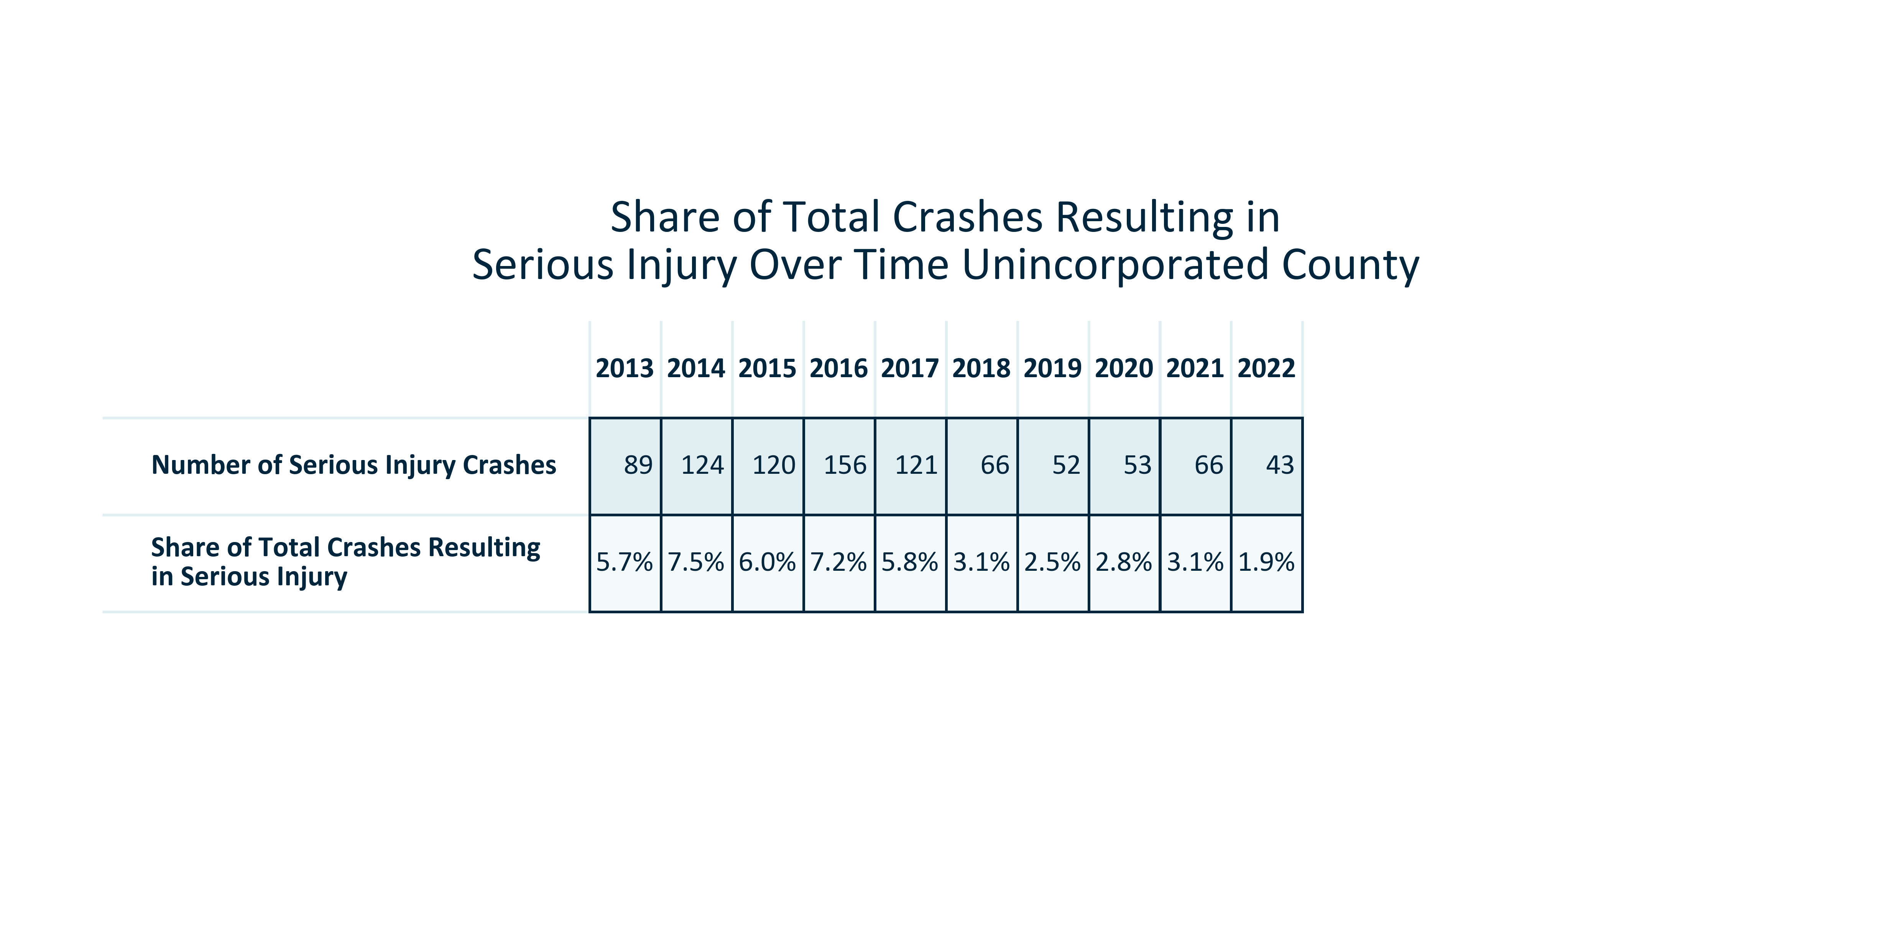

Citation: Crash Data

### TRANSPO_line_geocomparative_totalcrashes_overtime:

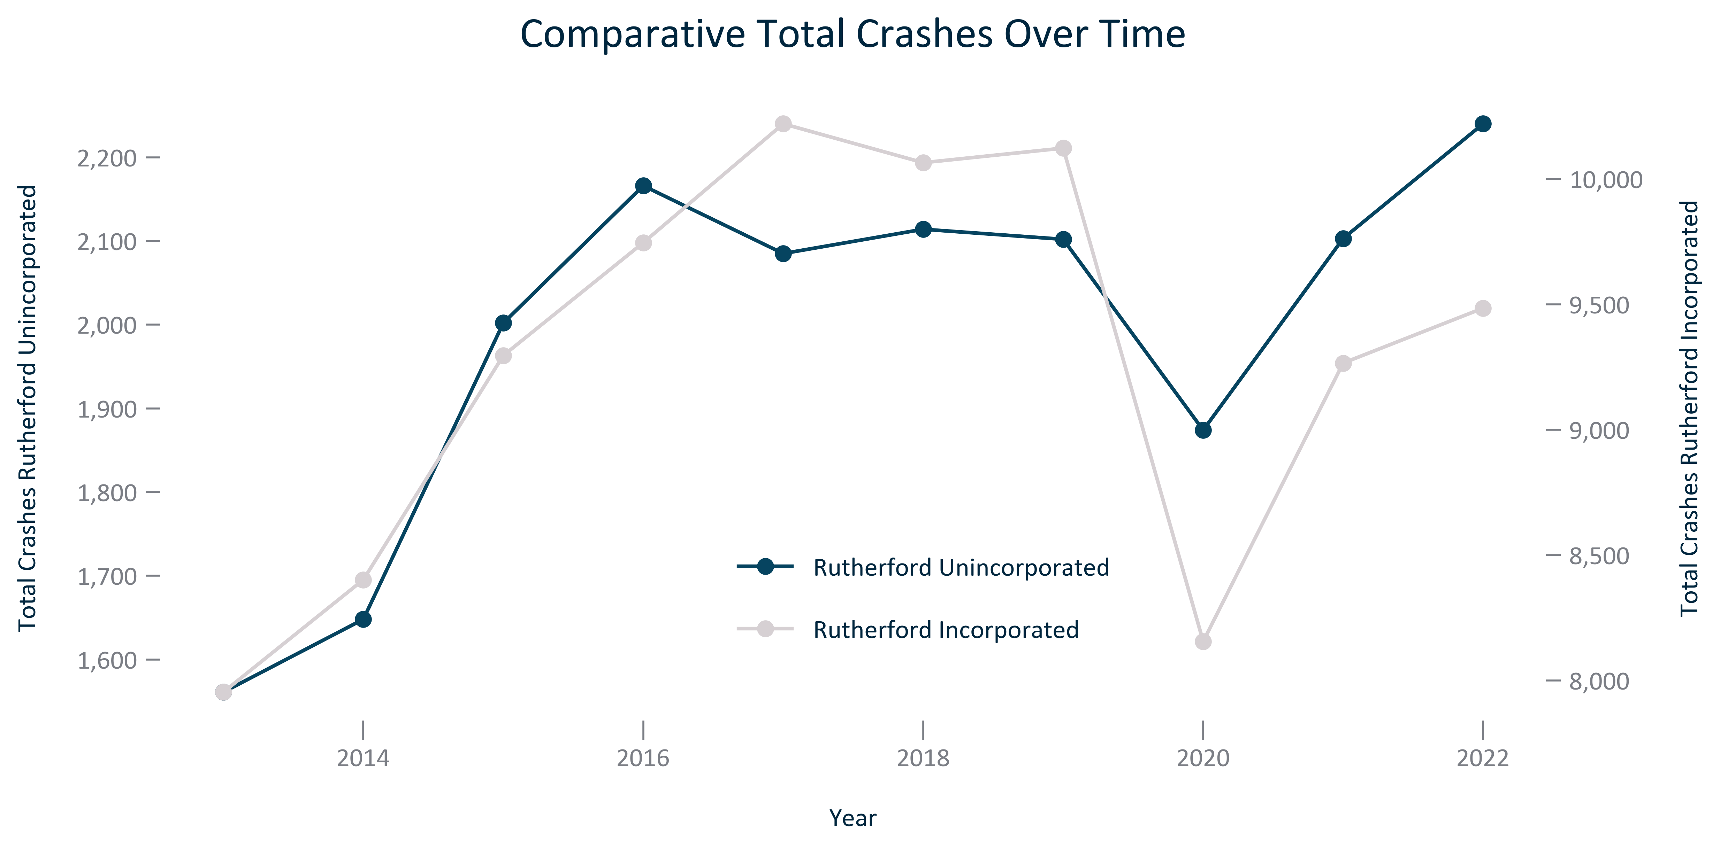

Citation: Crash Data

### TRANSPO_line_geocomparative_fatalcrashes_overtime:

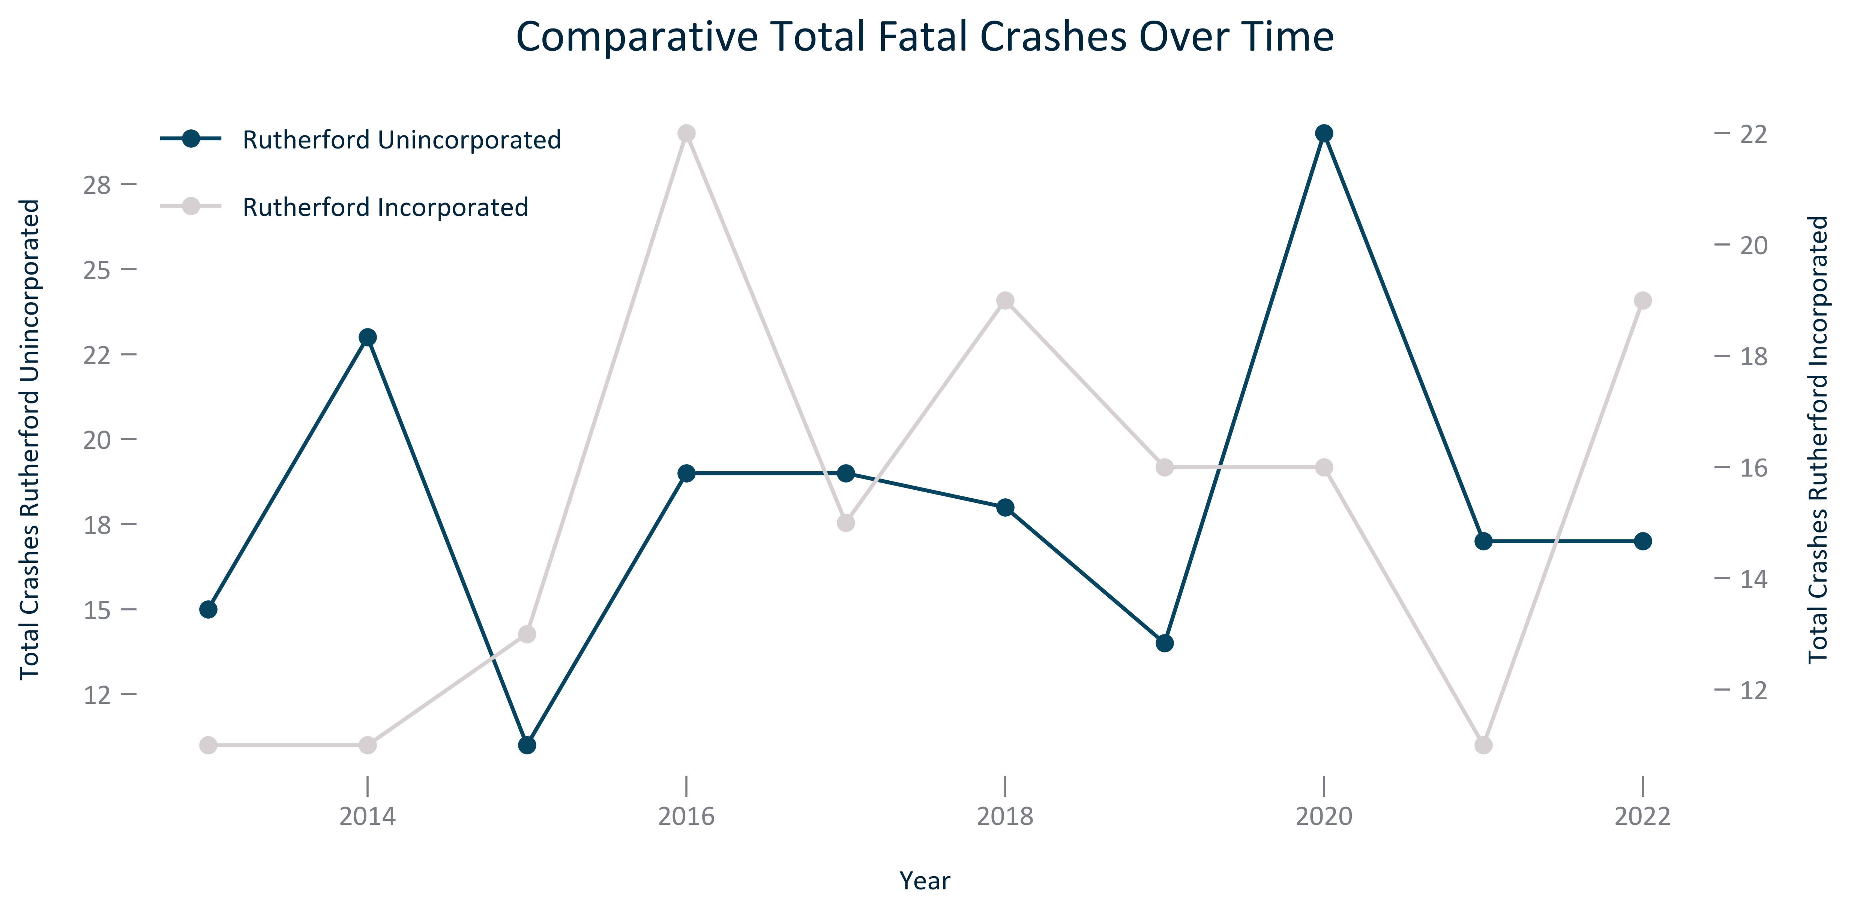

Citation: Crash Data

### TRANSPO_line_geocomparative_percentfatalcrashes_overtime:

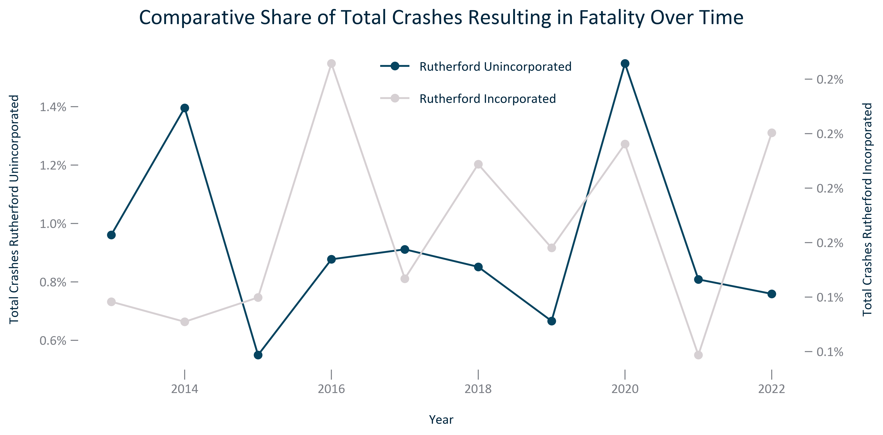

Citation: Crash Data

### TRANSPO_line_geocomparative_seriousinjurycrashes_overtime:

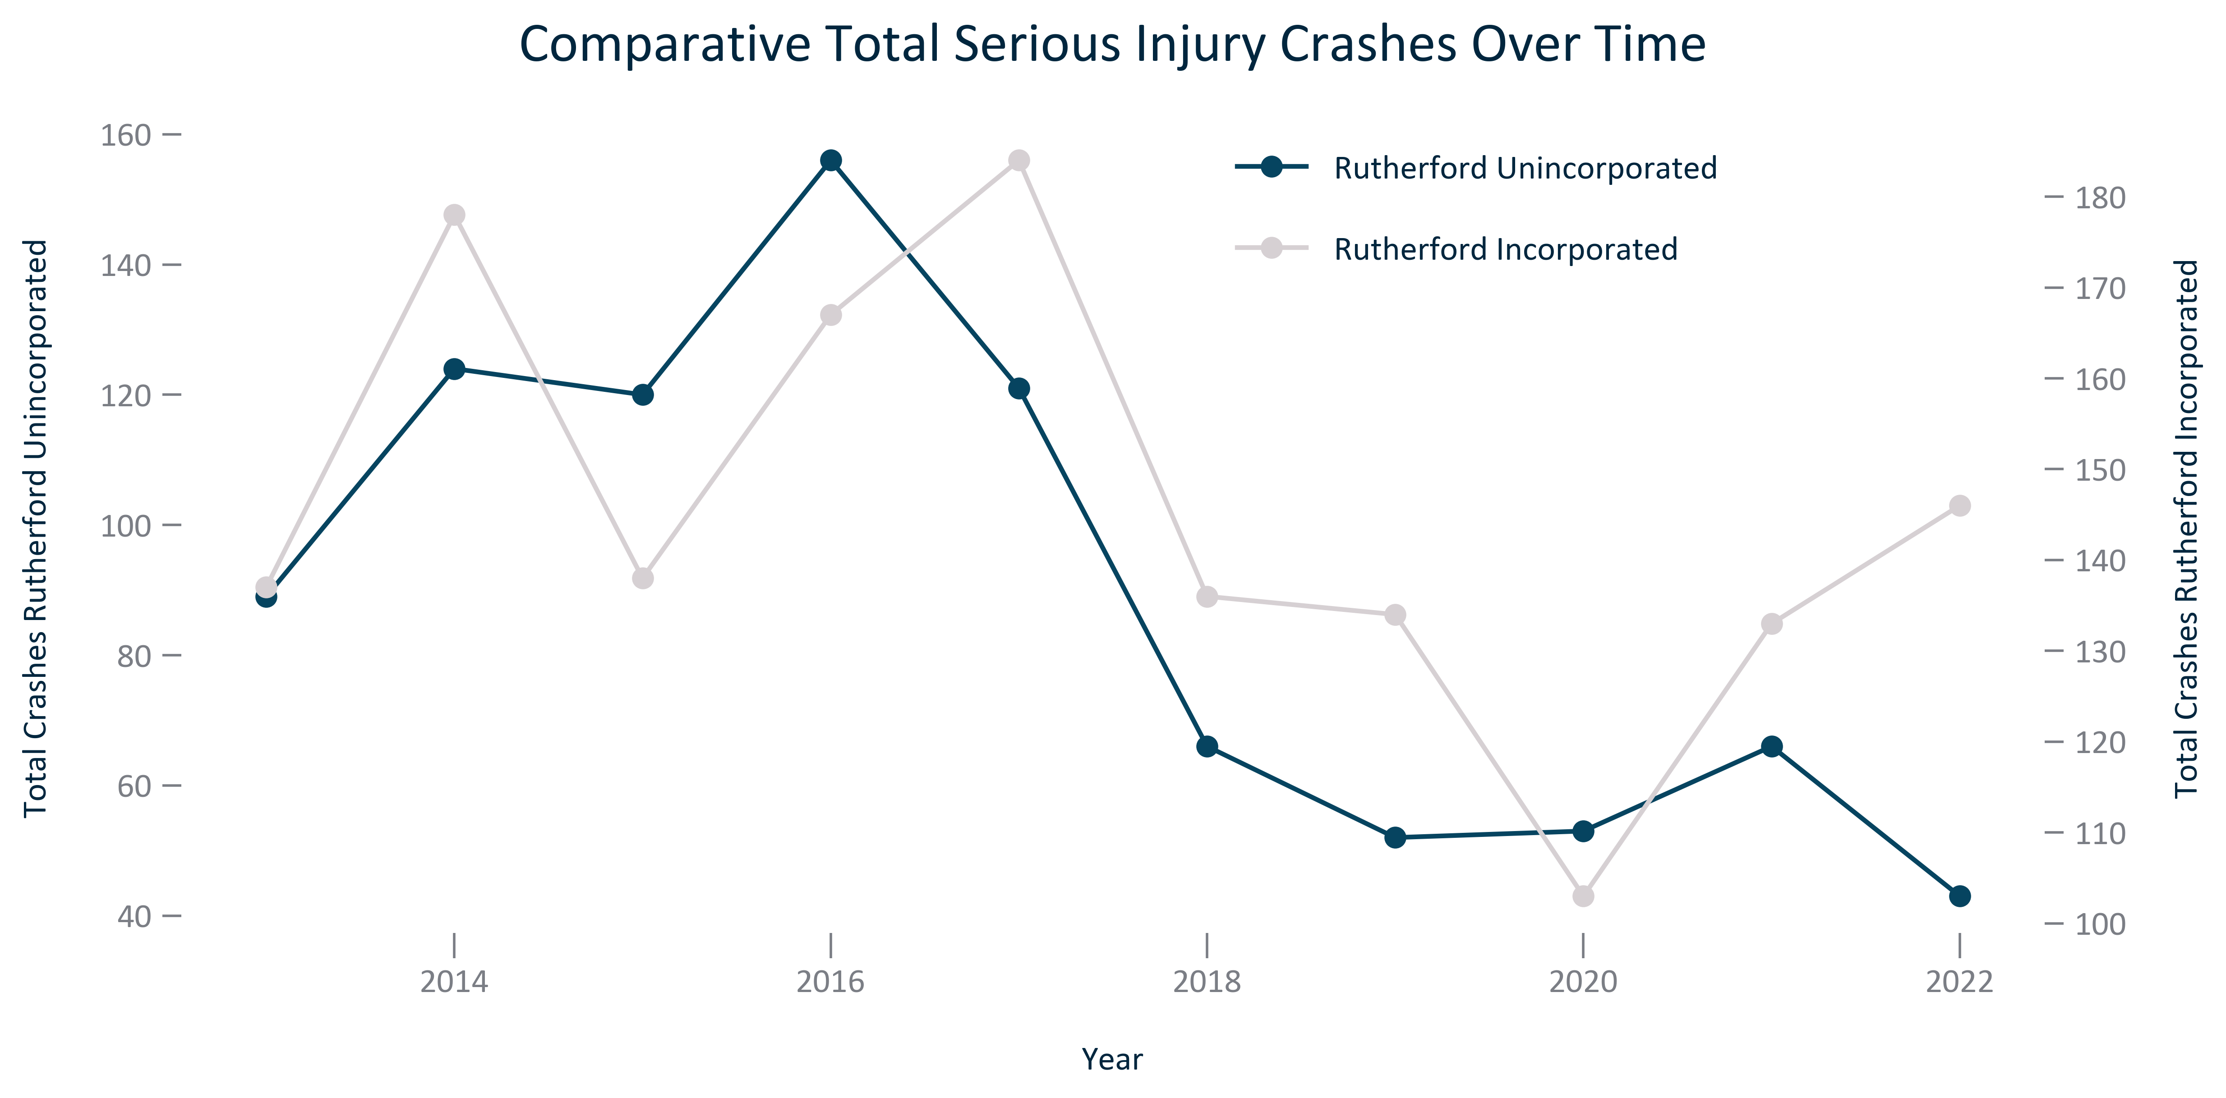

Citation: Crash Data

### TRANSPO_line_geocomparative_percentseriousinjurycrashes_overtime:

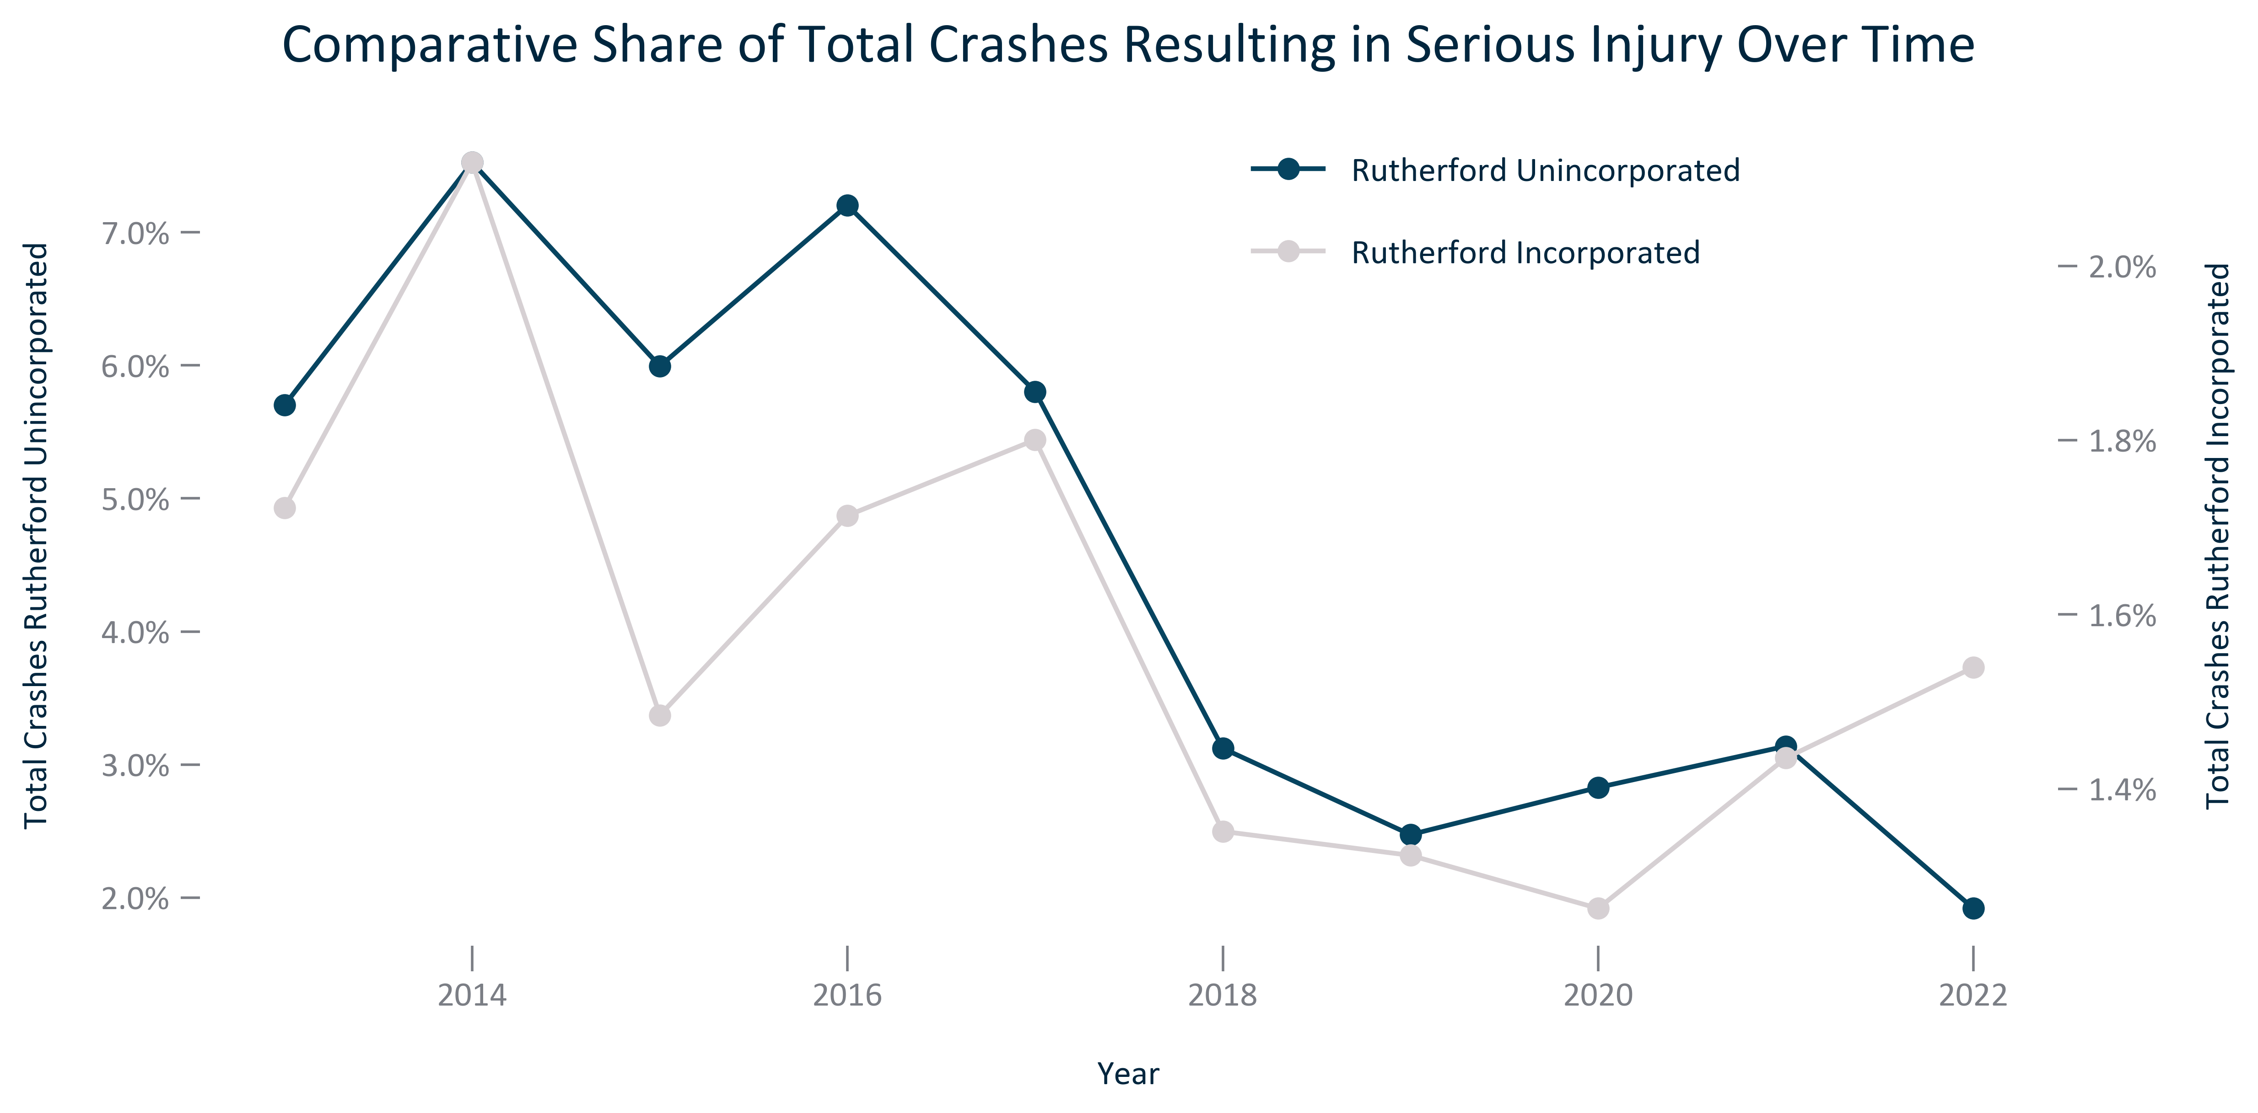

Citation: Crash Data

### TRANSPO_bar_primarygeo_meansoftransportationtowork_2021:

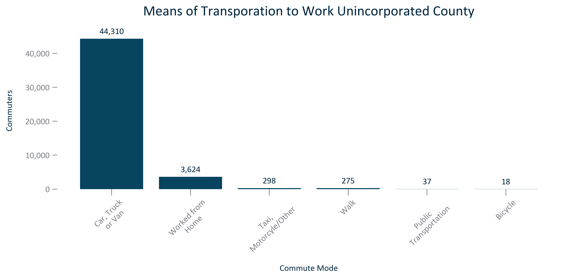

Citation: 2017-2021 ACS 5-Year Estimates

### TRANSPO_bar_primarygeo_sharemeansoftransportationtowork_2021:

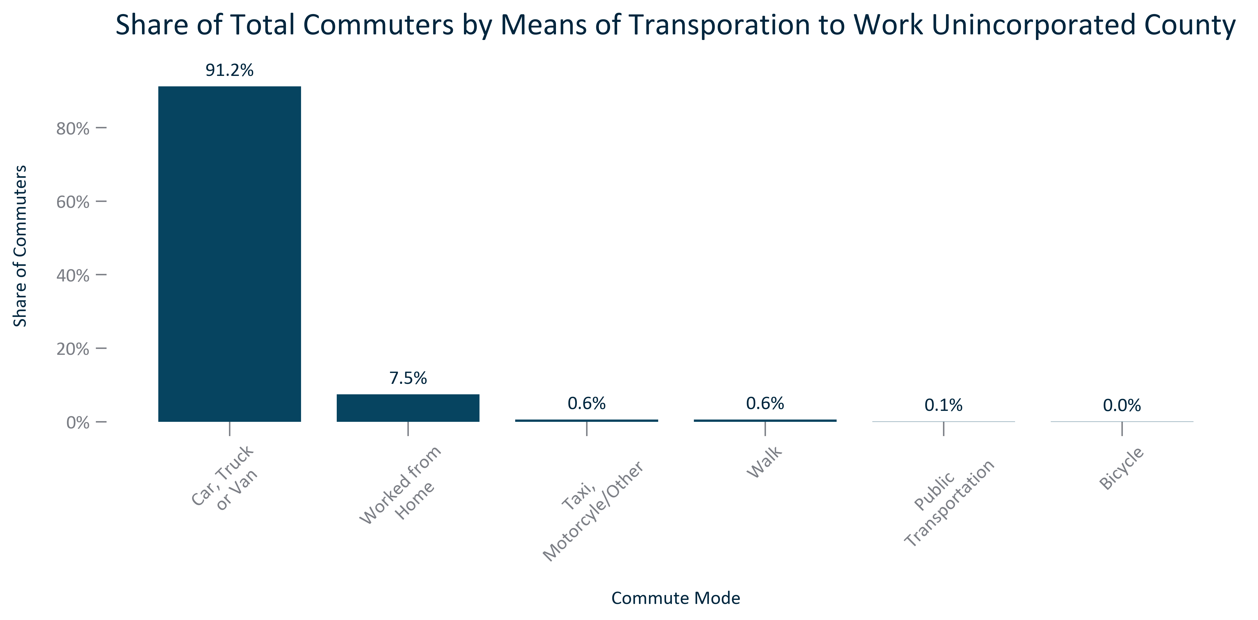

Citation: 2017-2021 ACS 5-Year Estimates

### TRANSPO_stackedbar_primarygeo_sharecommutemodes_overtime:

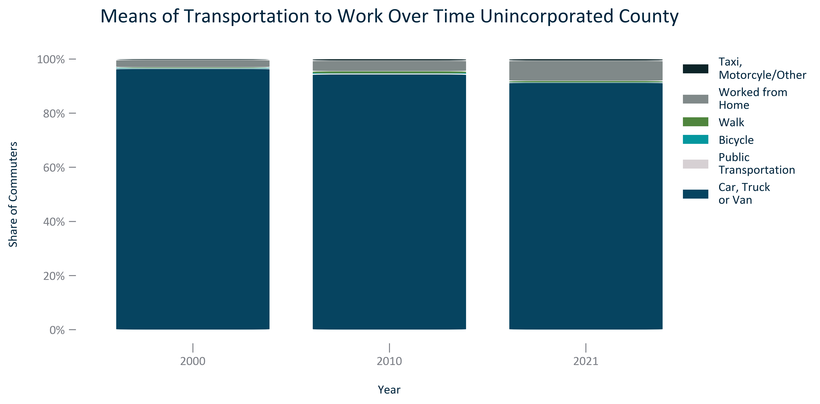

Citation: 2000 Decennial Census, 2006-2010 and 2017-2021 ACS 5-Year Estimates

### TRANSPO_stackedbar_geocomparative_sharecommutemodes_2021:

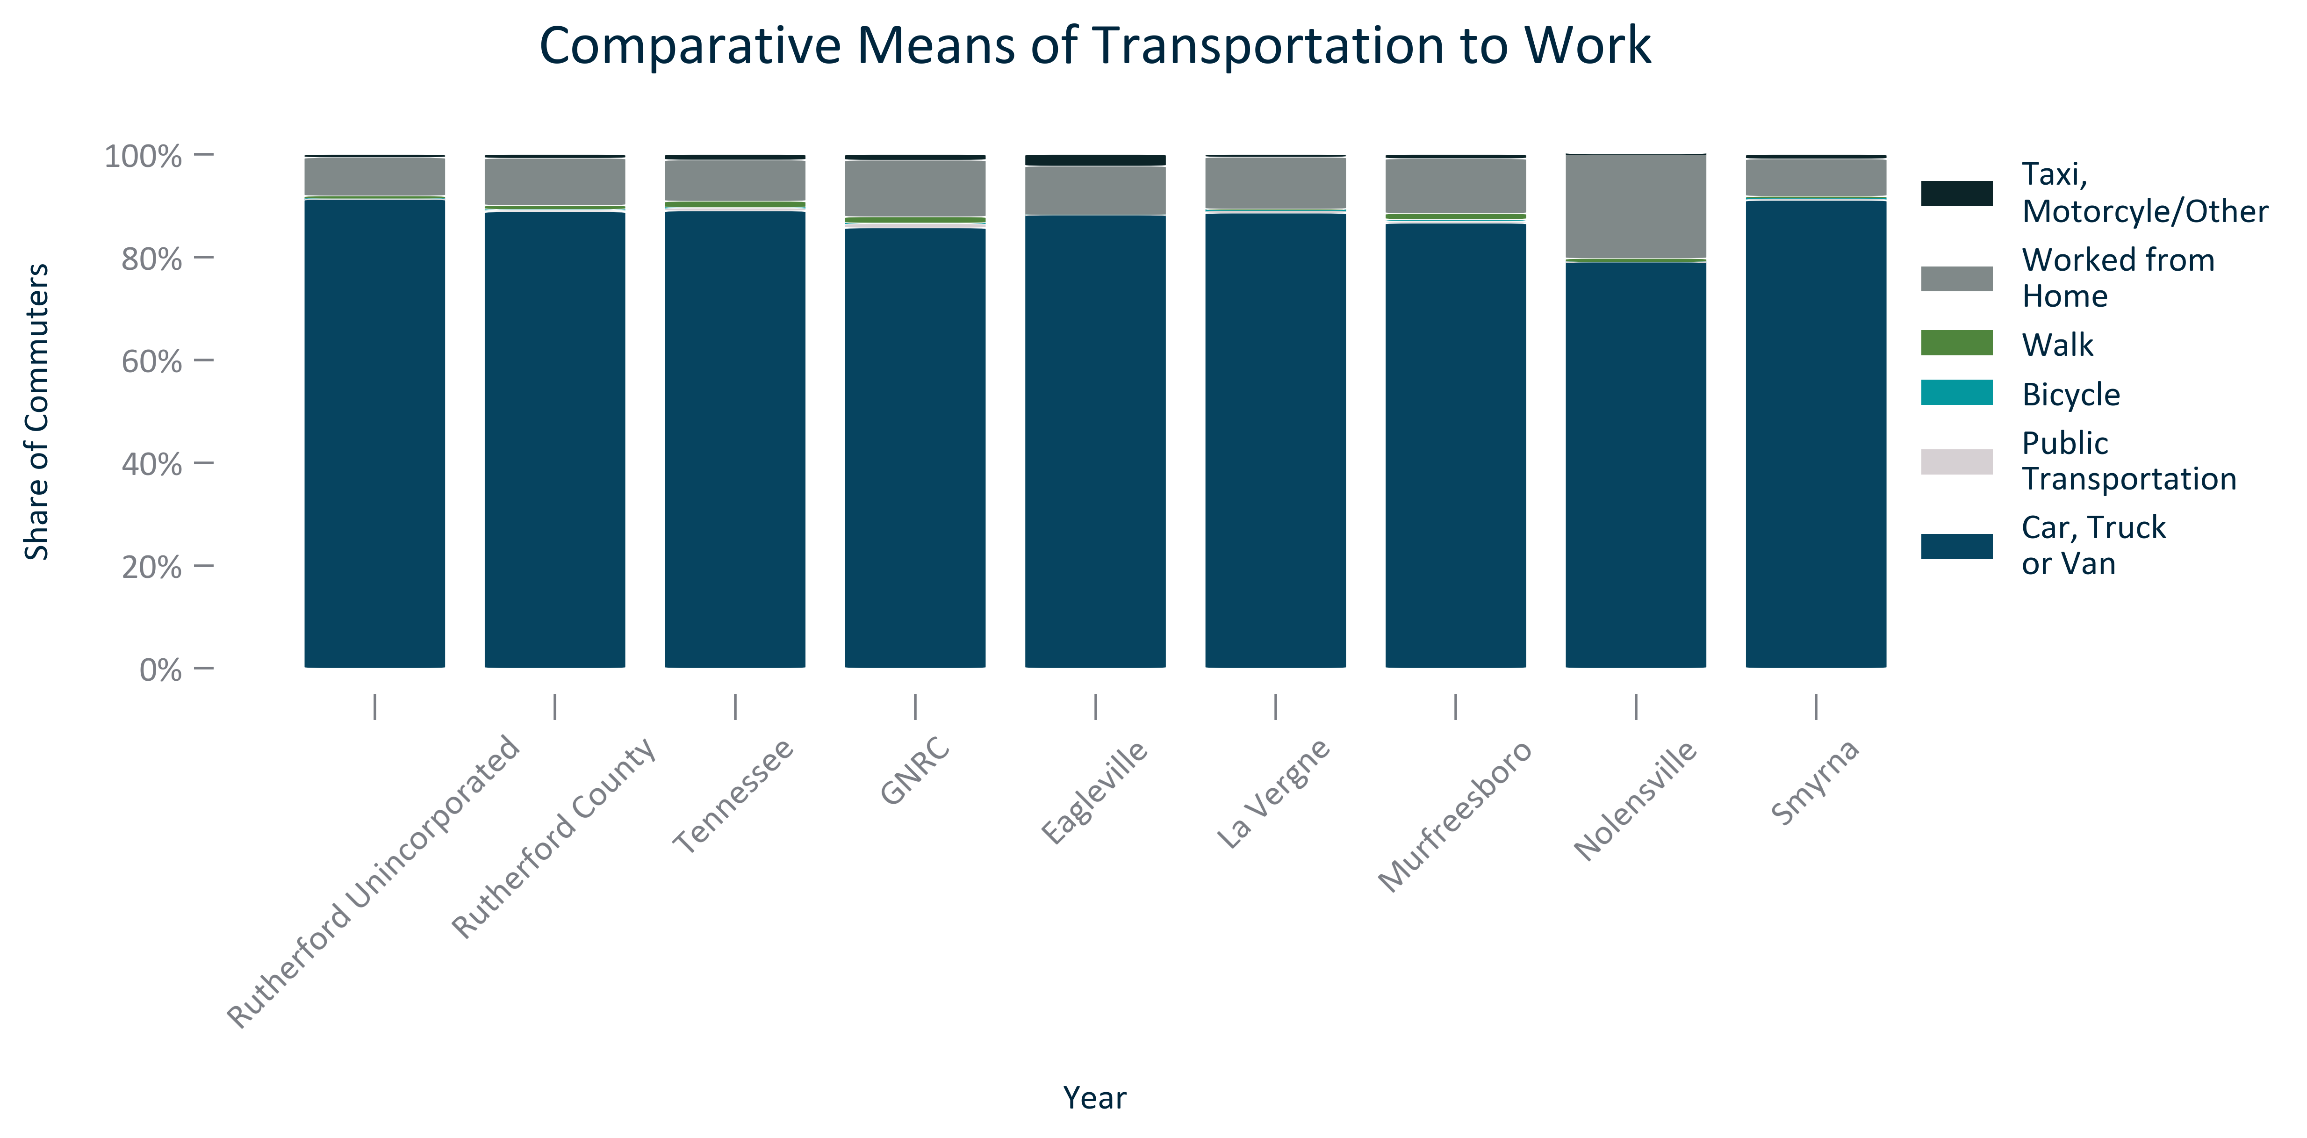

Citation: 2017-2021 ACS 5-Year Estimates

### TRANSPO_line_geocomparative_commutetime_overtime:

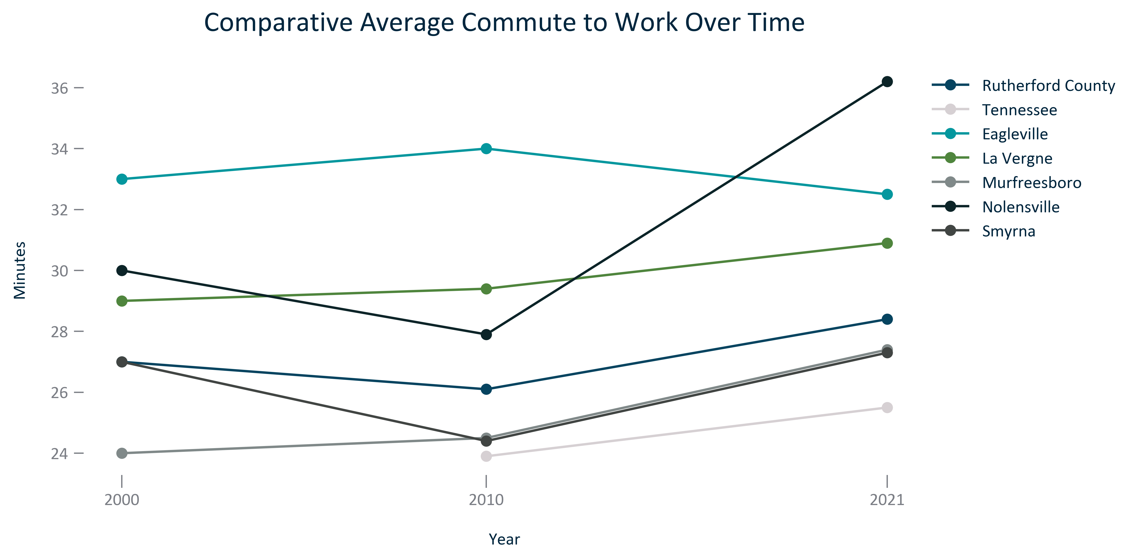

Citation: 2006-2010 and 2017-2021 ACS 5-Year Estimates

### TRANSPO_bar_primarygeo_extremelylongcommutetime_overtime:

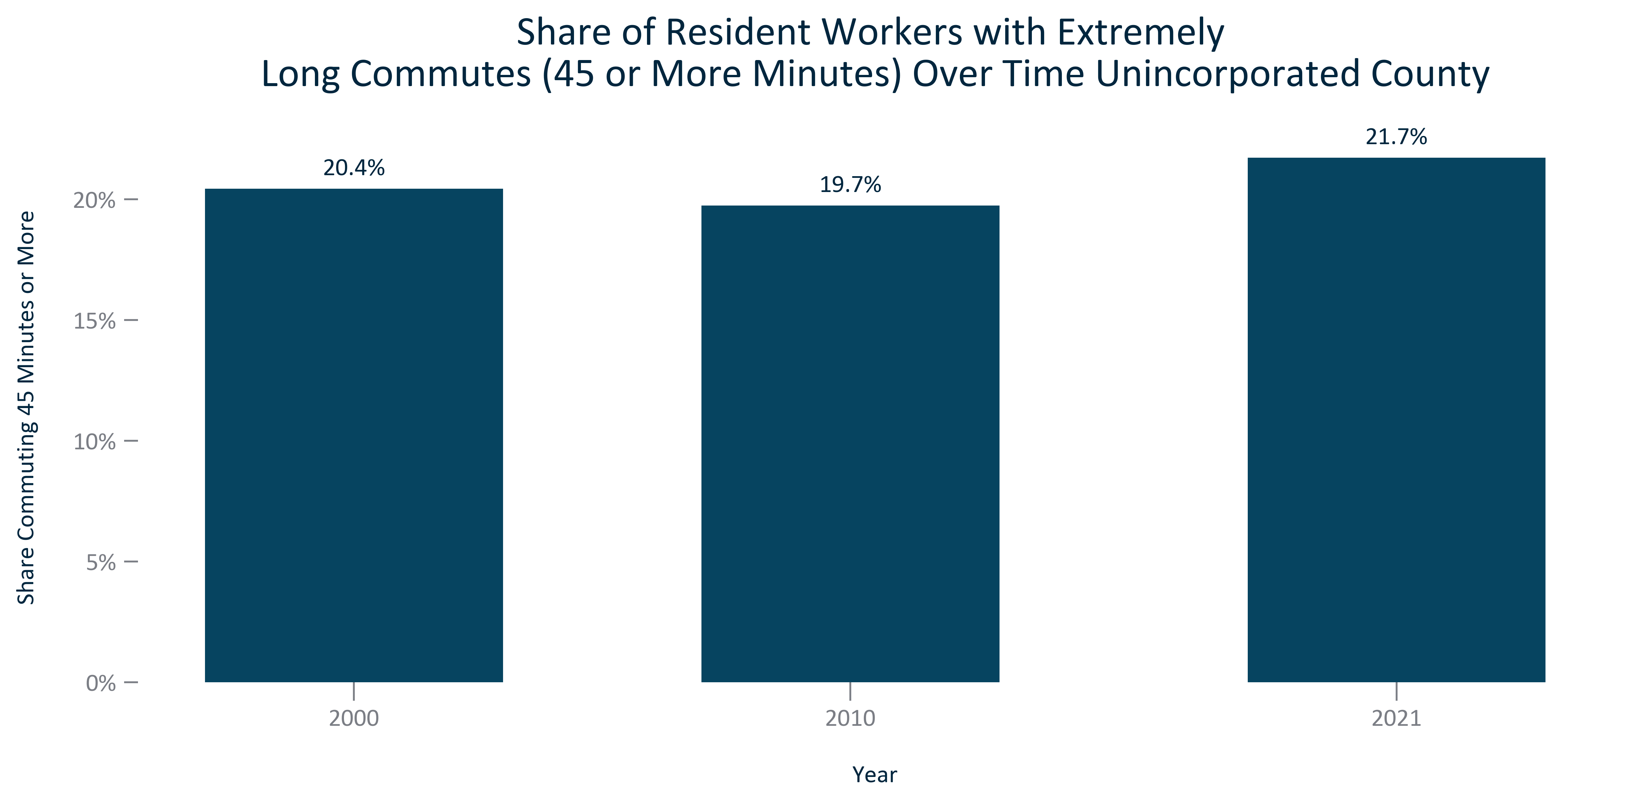

Citation: 2006-2010 and 2017-2021 ACS 5-Year Estimates

### TRANSPO_line_geocomparative_extremelylongcommutetime_overtime:

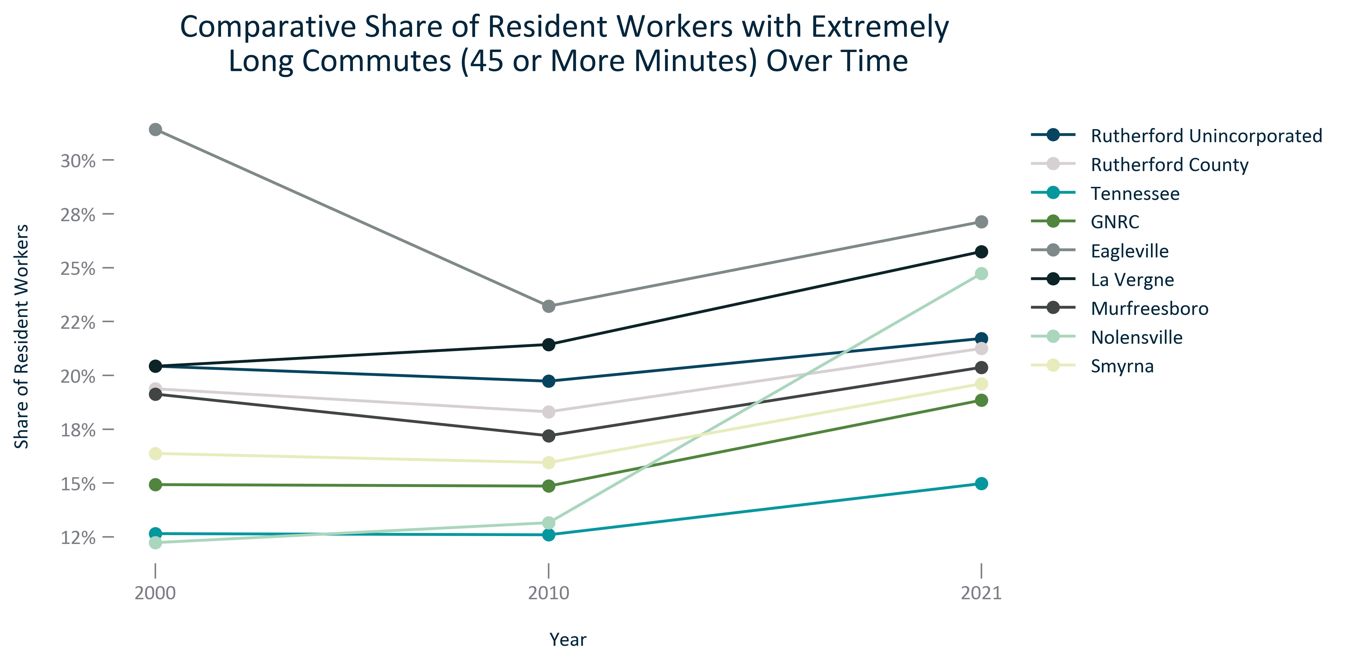

Citation: 2006-2010 and 2017-2021 ACS 5-Year Estimates

### TRANSPO_bar_primarygeo_workfromhome_overtime:

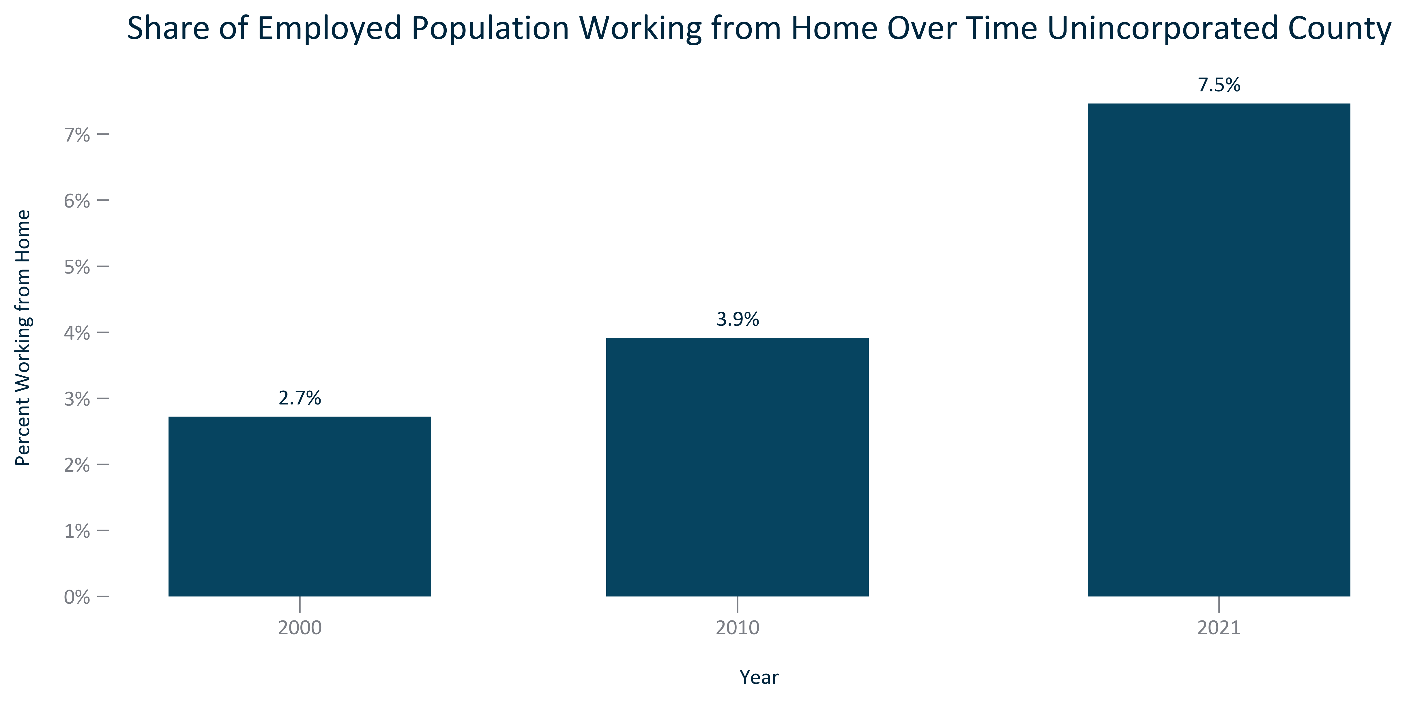

Citation: 2000 Decennial Census, 2006-2010 and 2017-2021 ACS 5-Year Estimates

### TRANSPO_line_geocomparative_shareworkfromhome_overtime:

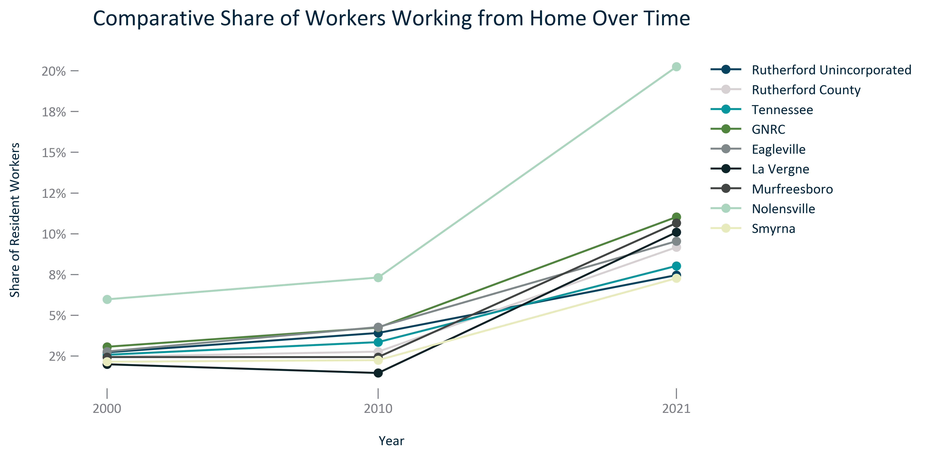

Citation: 2006-2010 and 2017-2021 ACS 5-Year Estimates

### TRANSPO_bar_primarygeo_novehicleavailable_overtime:

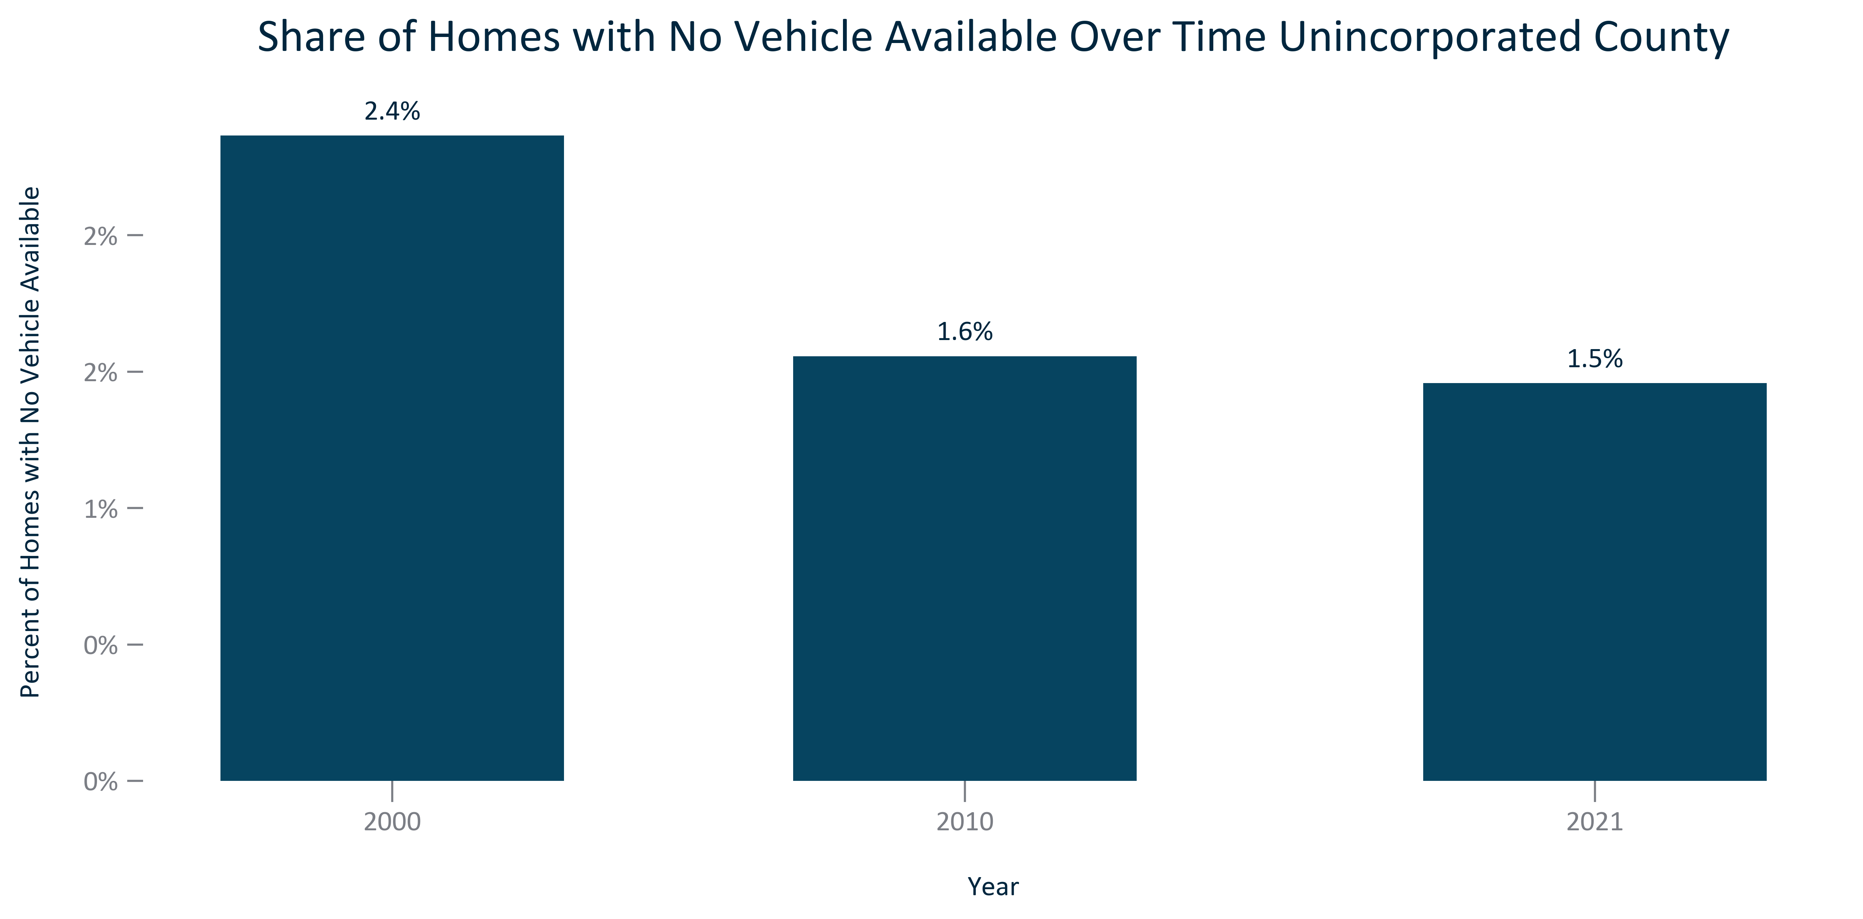

Citation: 2000 Decennial Census, 2006-2010 and 2017-2021 ACS 5-Year Estimates

### TRANSPO_line_geocomparative_novehicleavailable_overtime:

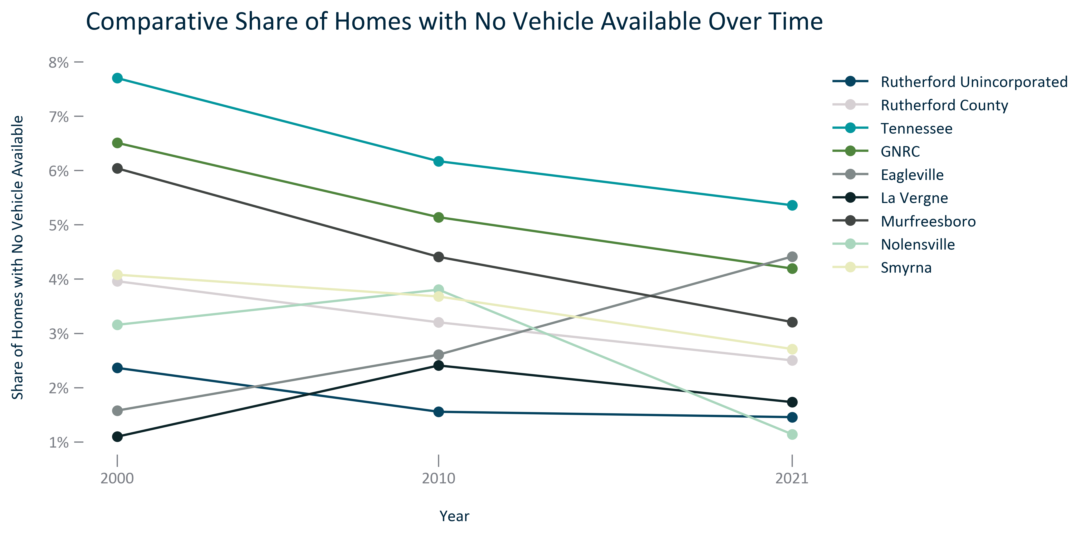

Citation: 2000 Decennial Census, 2006-2010 and 2017-2021 ACS 5-Year Estimates

# Health

### HEALTH_bar_geocomparative_sharepopulationnohealthcoverage_2021:

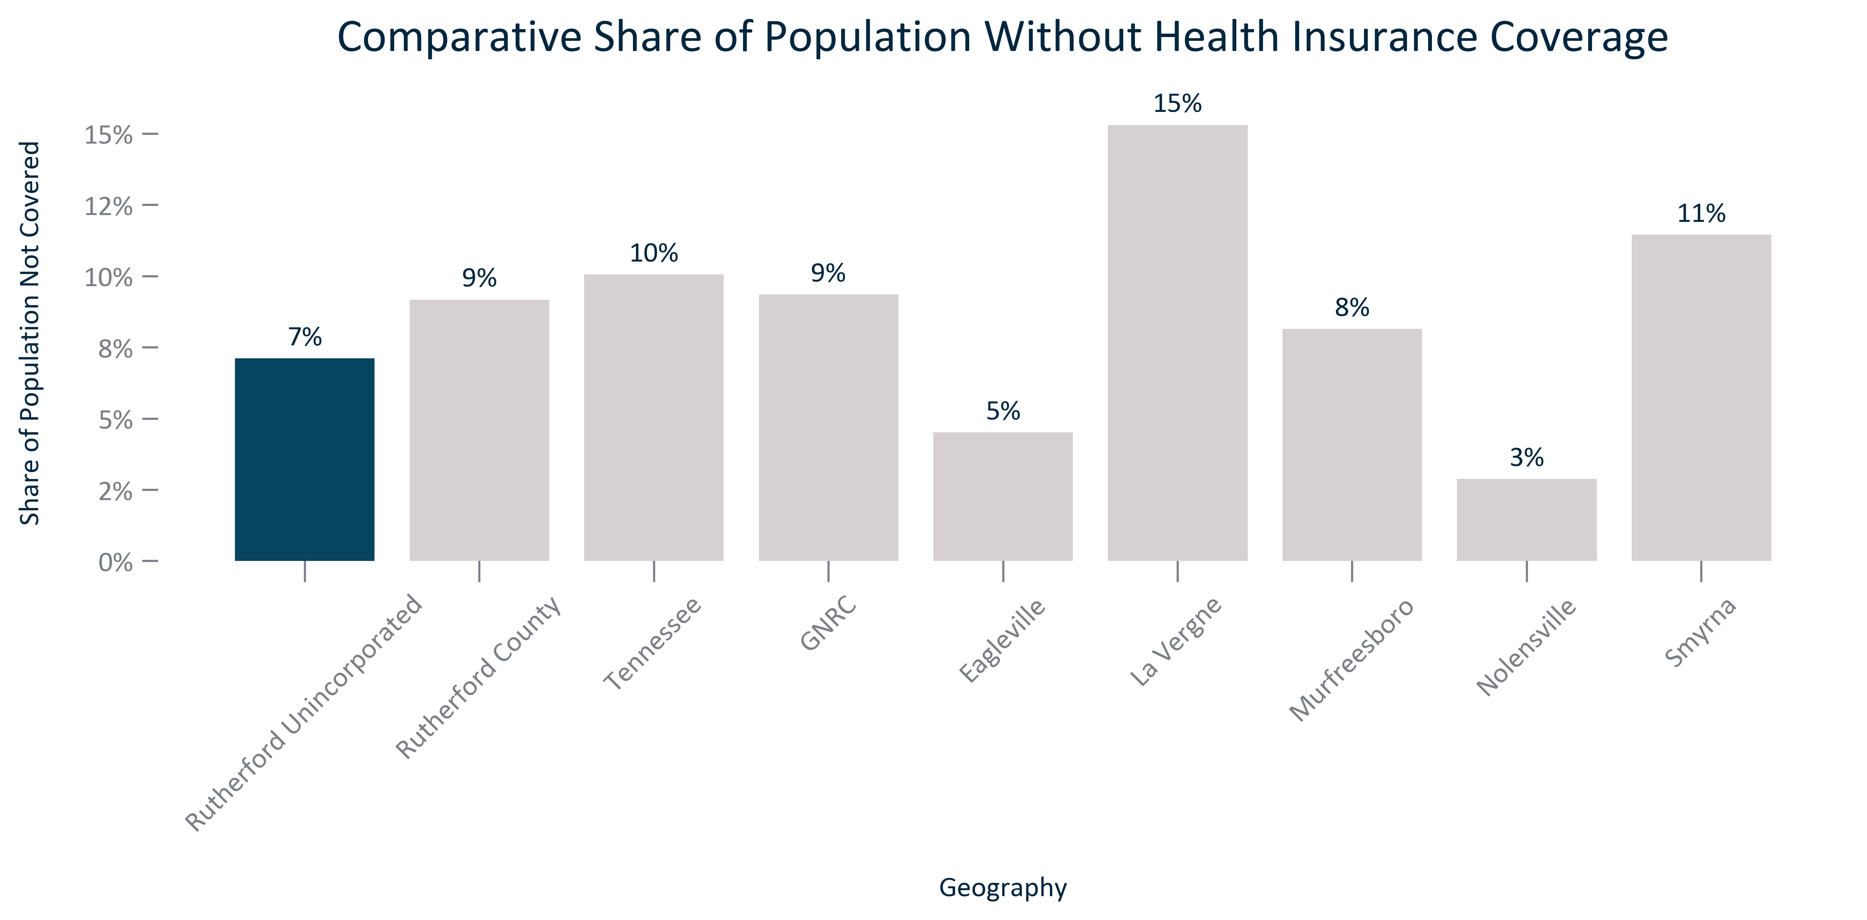

Citation: 2017-2021 ACS 5-Year Estimates

### HEALTH_stackedbar_geocomparative_sharewithandwithouthealthcarecoverage_2021:

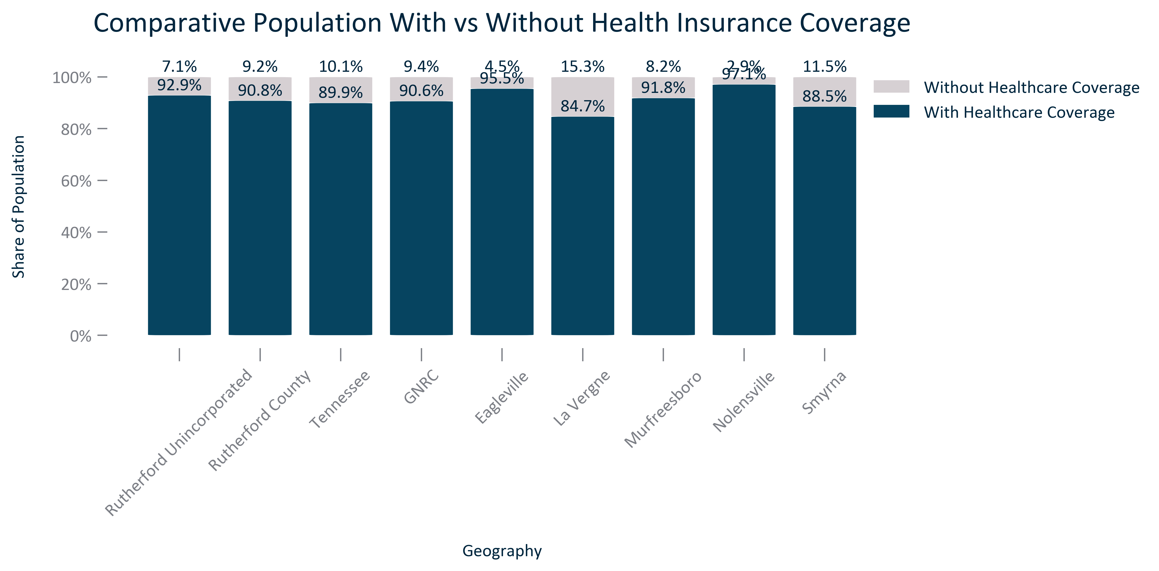

Citation: 2017-2021 ACS 5-Year Estimates

### HEALTH_clusterbar_geocomparative_publicandprivatehealthinsurancecoverage_2021:

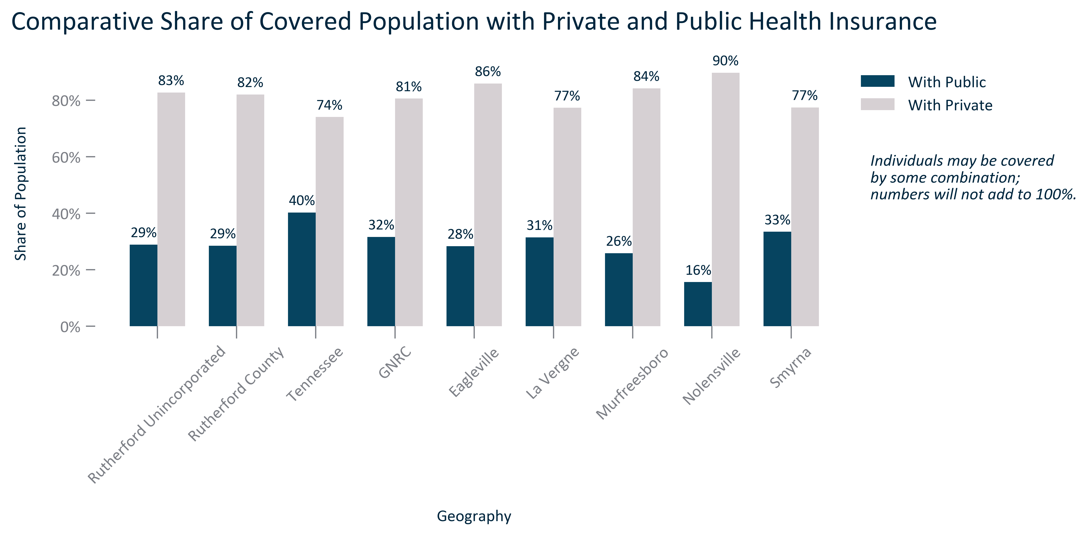

Citation: 2017-2021 ACS 5-Year Estimates

### HEALTH_table_geocomparative_healthinsurancebytype_2021:

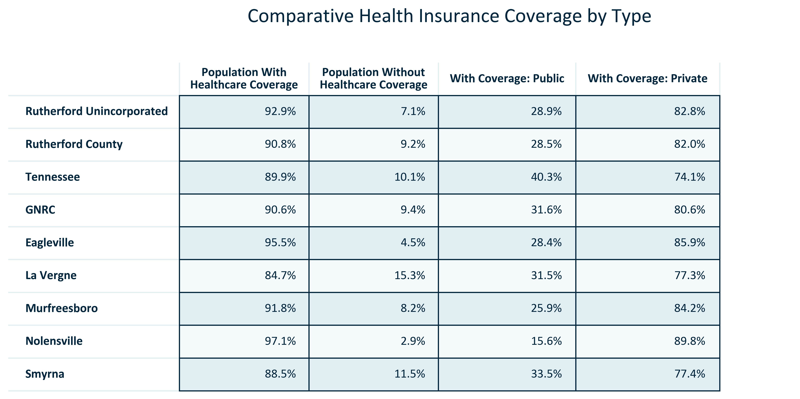

Citation: 2017-2021 ACS 5-Year Estimates

### HEALTH_bar_geocomparative_countyhealthoutcomes_2022:

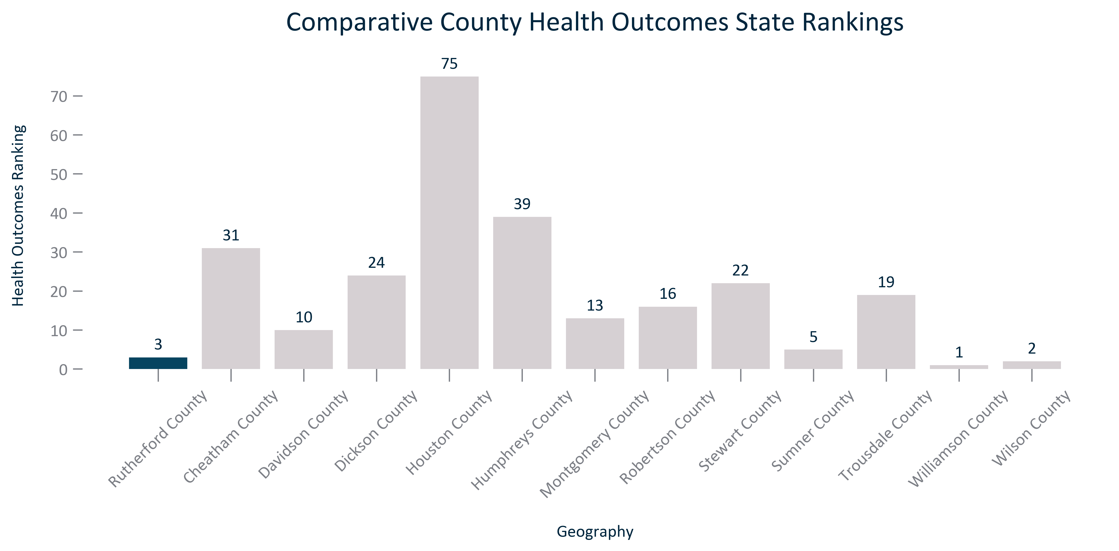

Citation: University of Wisconsin County Health Rankings

### HEALTH_bar_geocomparative_countyhealthfactors_2022:

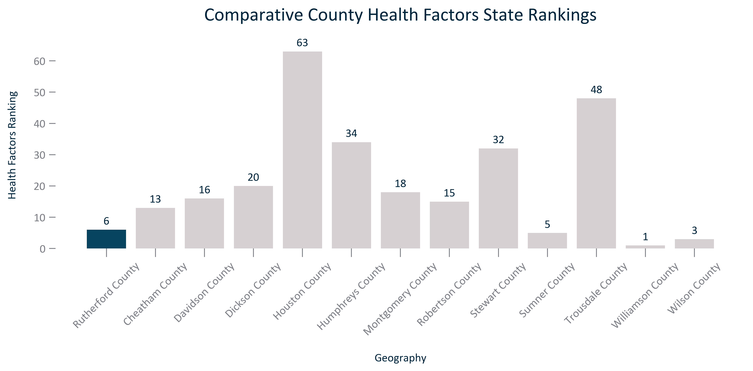

Citation: University of Wisconsin County Health Rankings

### HEALTH_bar_geocomparative_countyaveragelifeexpectancy_2022:

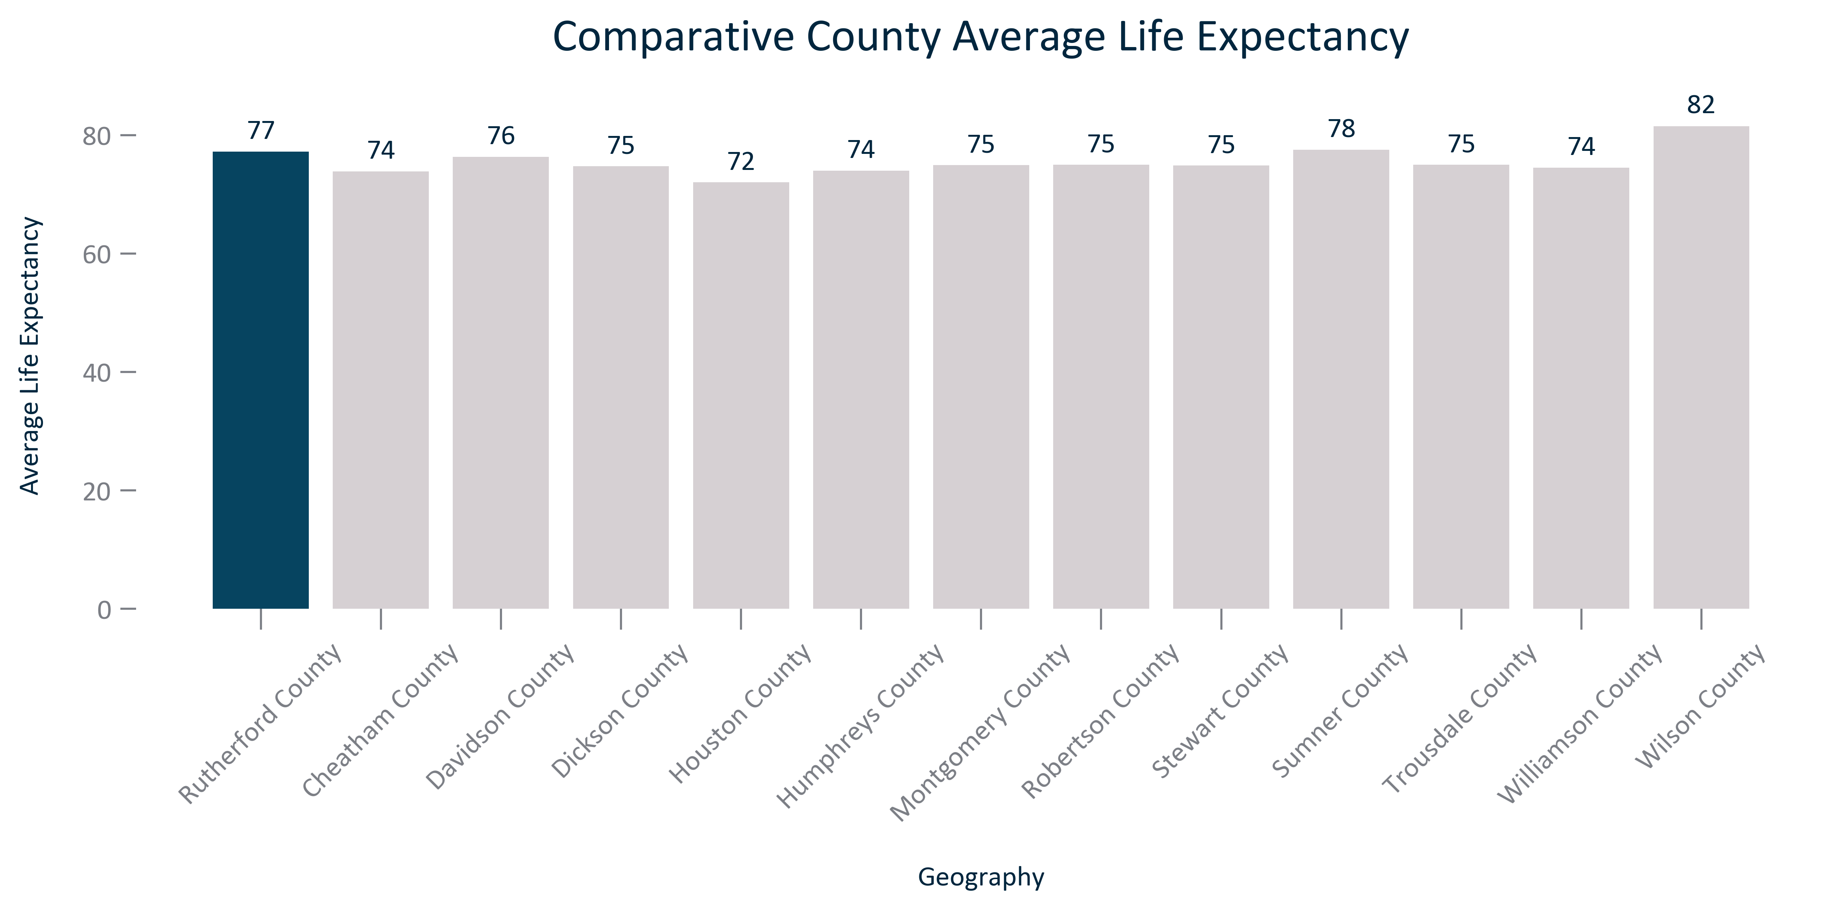

Citation: University of Wisconsin County Health Rankings

### HEALTH_bar_geocomparative_frequentphysicaldistress_2022:

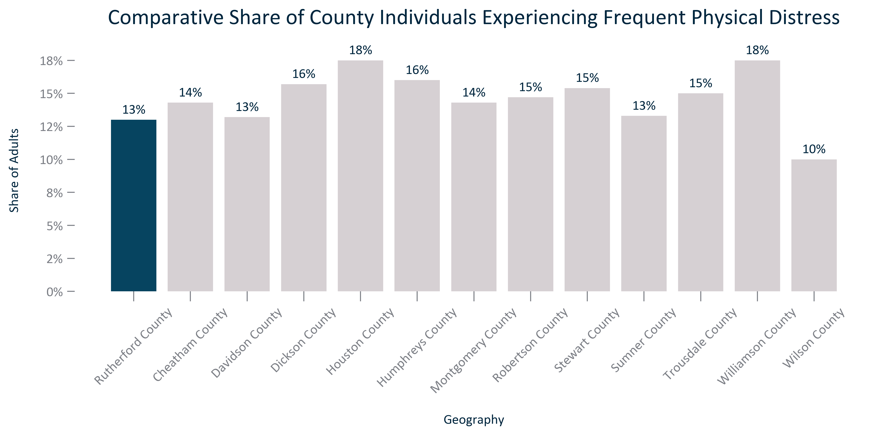

Citation: University of Wisconsin County Health Rankings

### HEALTH_bar_geocomparative_frequentmentaldistress_2022:

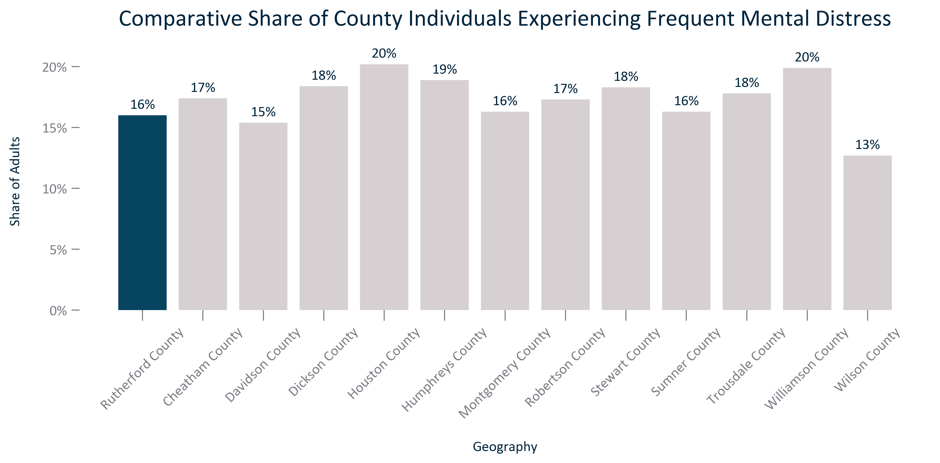

Citation: University of Wisconsin County Health Rankings

# Crime

### CRIME_bar_geocomparative_crimerate_2021:

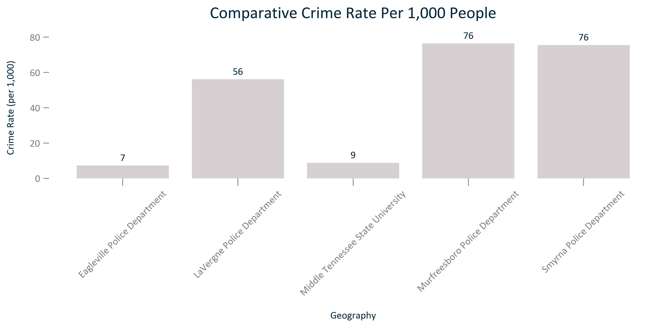

Citation: Tennessee Bureau of Investigation

### CRIME_bar_geocomparative_crimecount_2021:

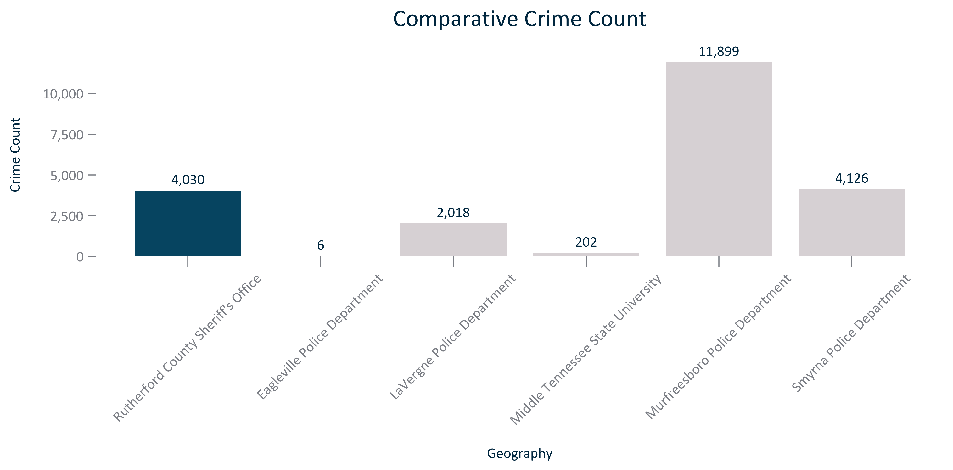

Citation: Tennessee Bureau of Investigation

### CRIME_bar_primarygeo_crimetype_2021:

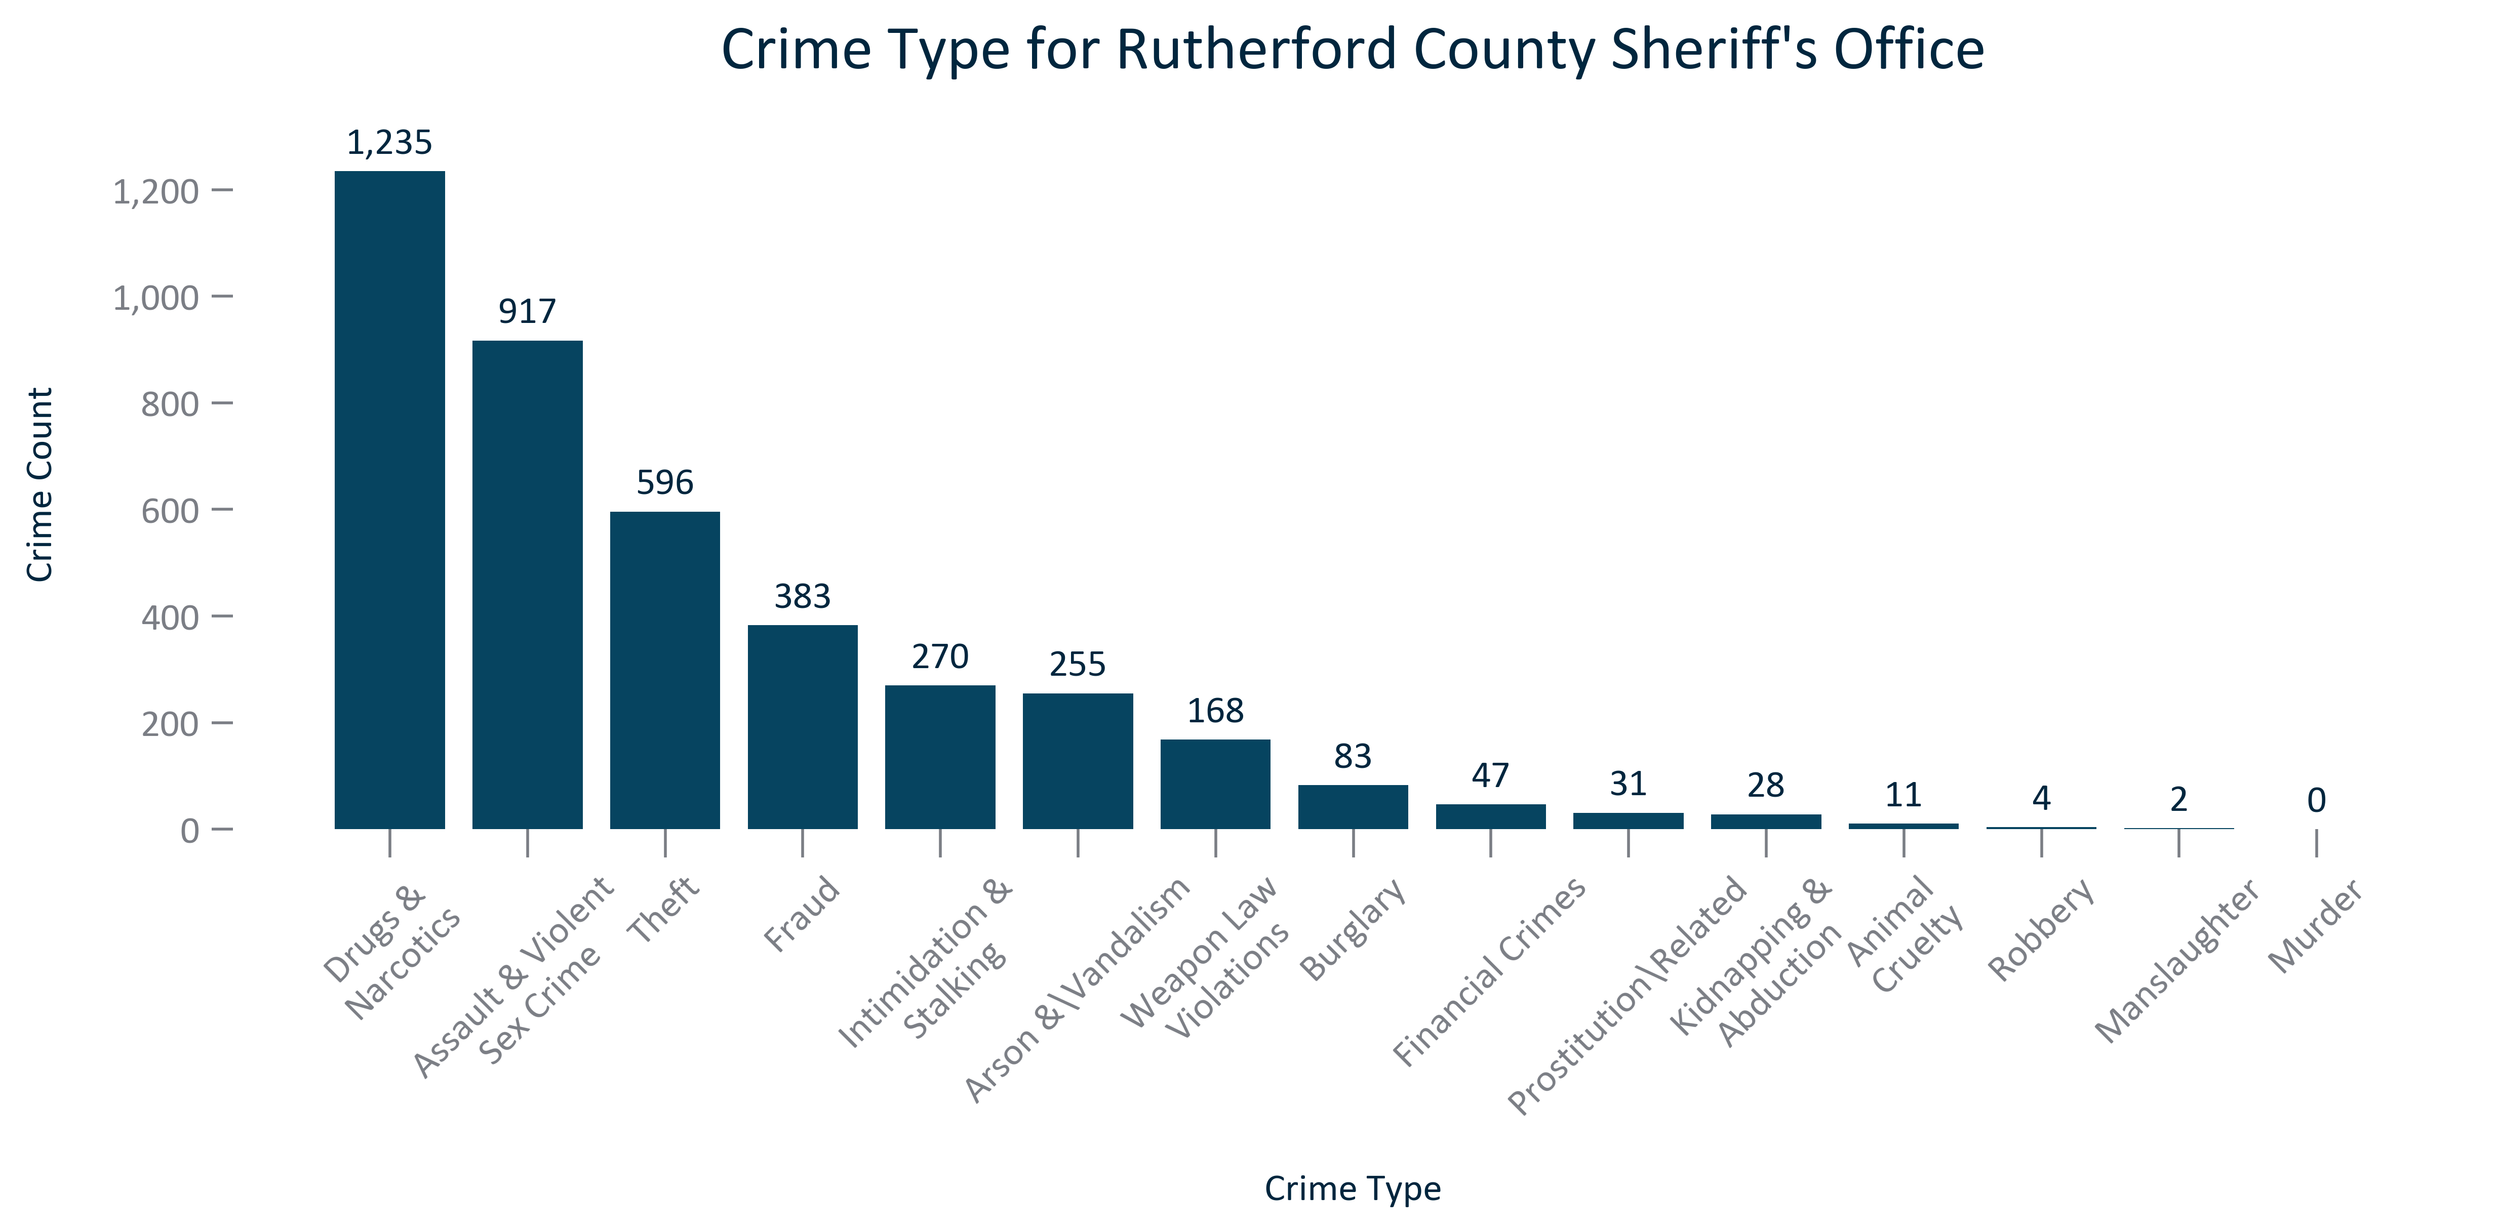

Citation: Tennessee Bureau of Investigation